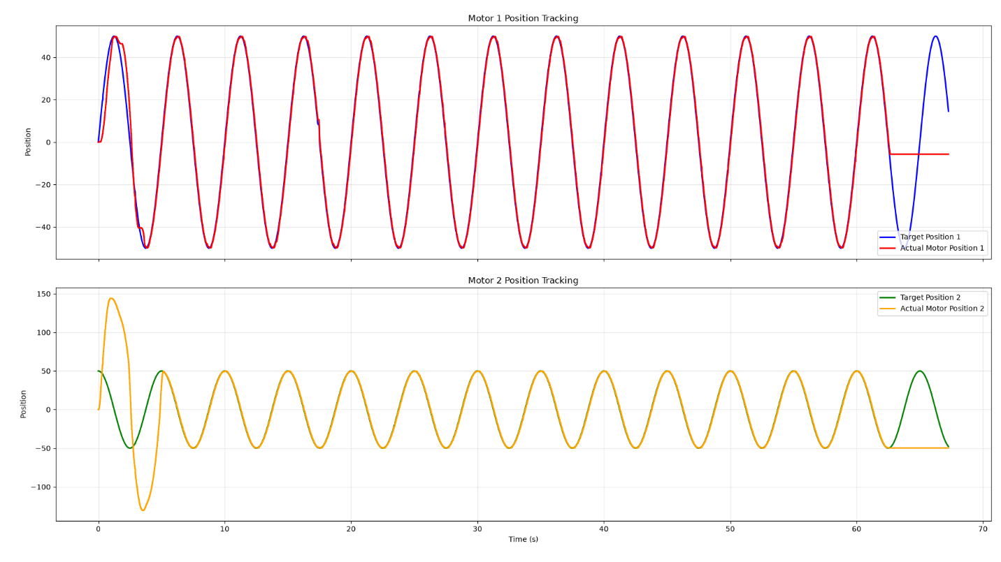
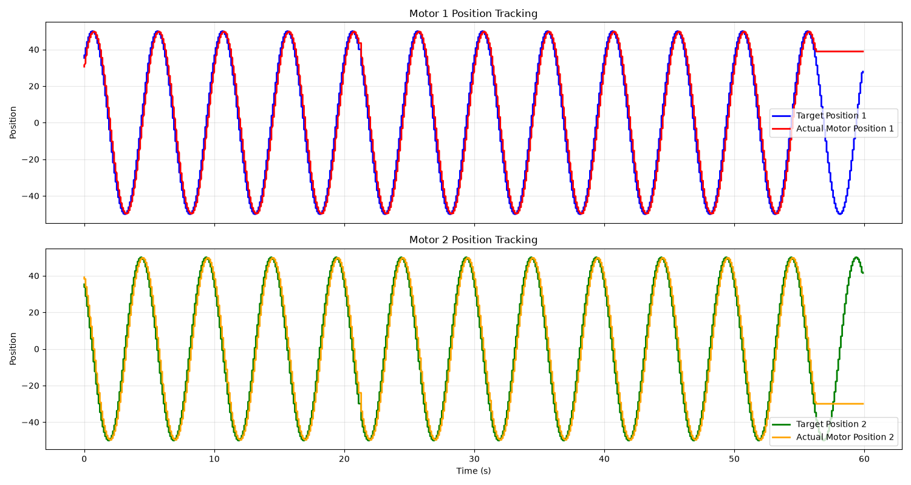
Sinewave – 50 deg, 0.2hz, position control

Sinewave – 50 deg, 0.2hz, position – velocity control

Sinewave – 50 deg, 1hz, position velocity control
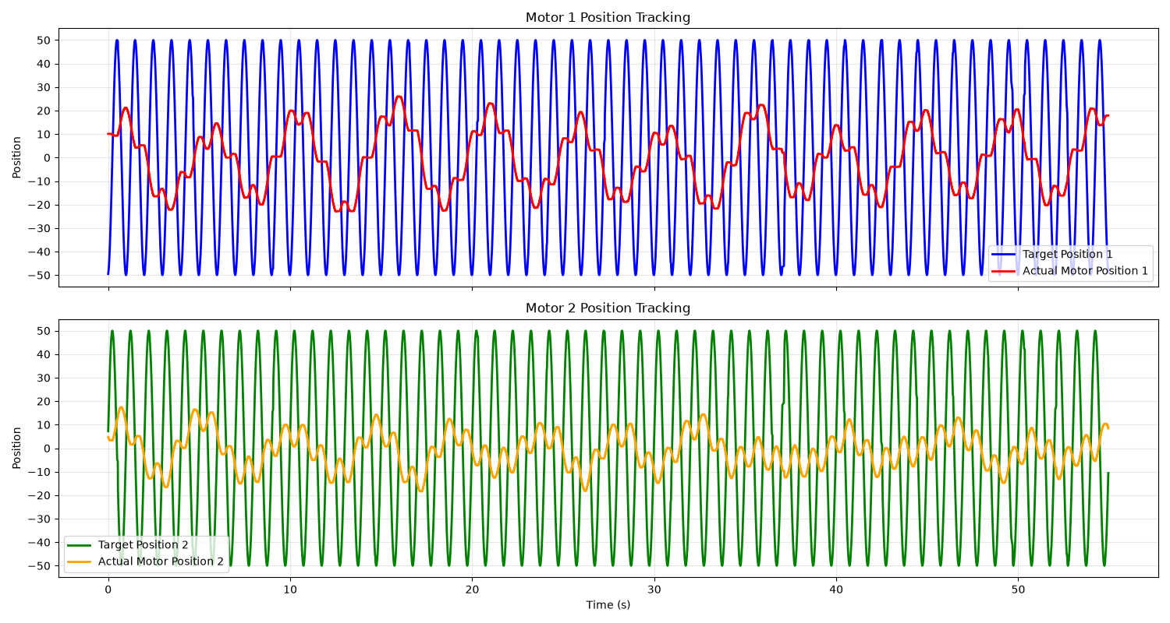

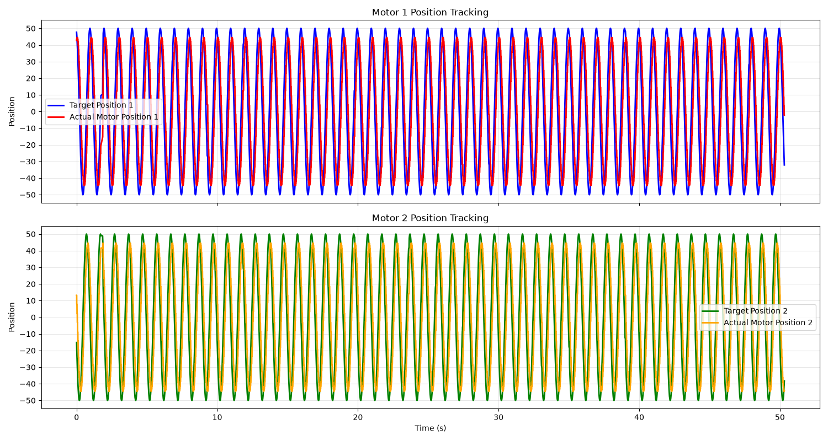
Sinewave – 50 deg, 1hz, position control

Joystick – Position -velocity control
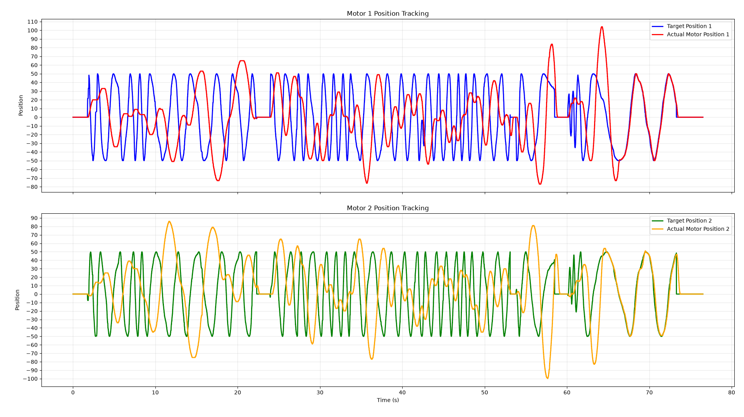
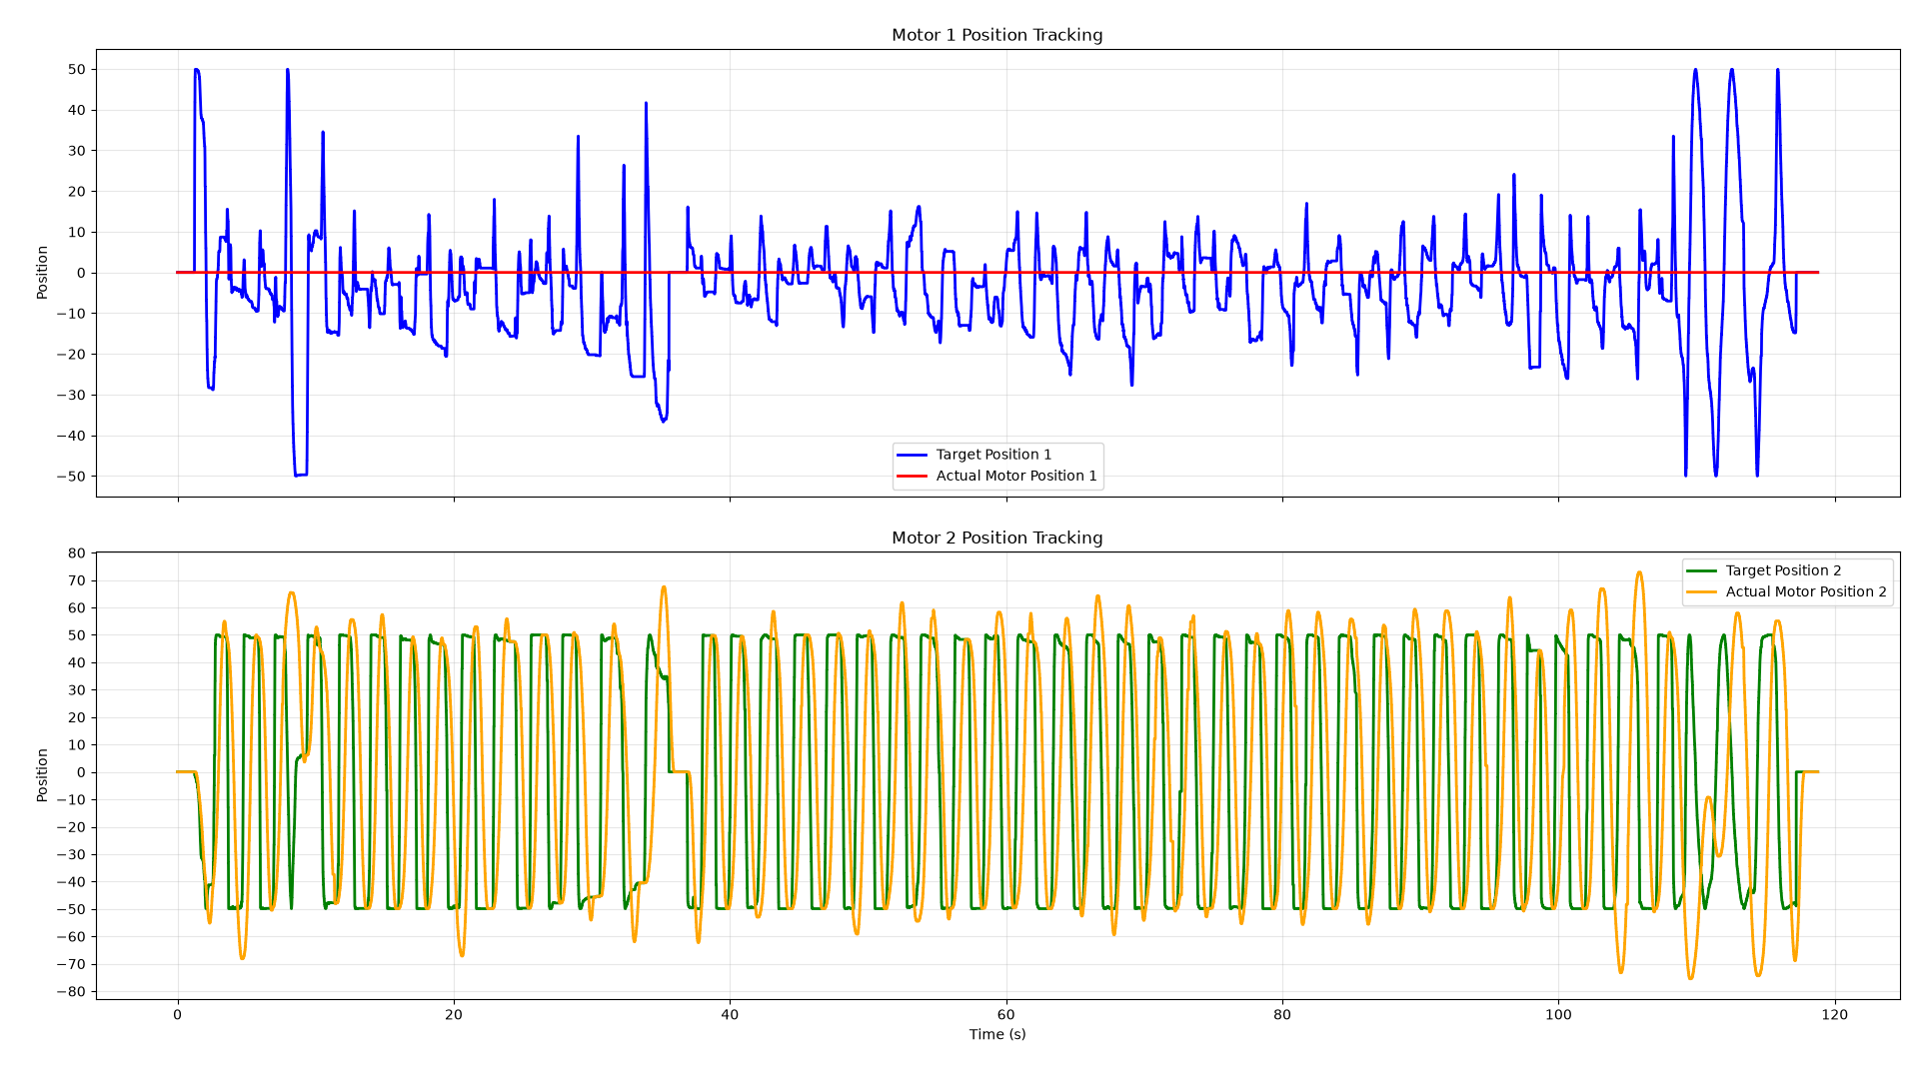
Joystick – motor 2 – position velocity control

Joystick – Position control
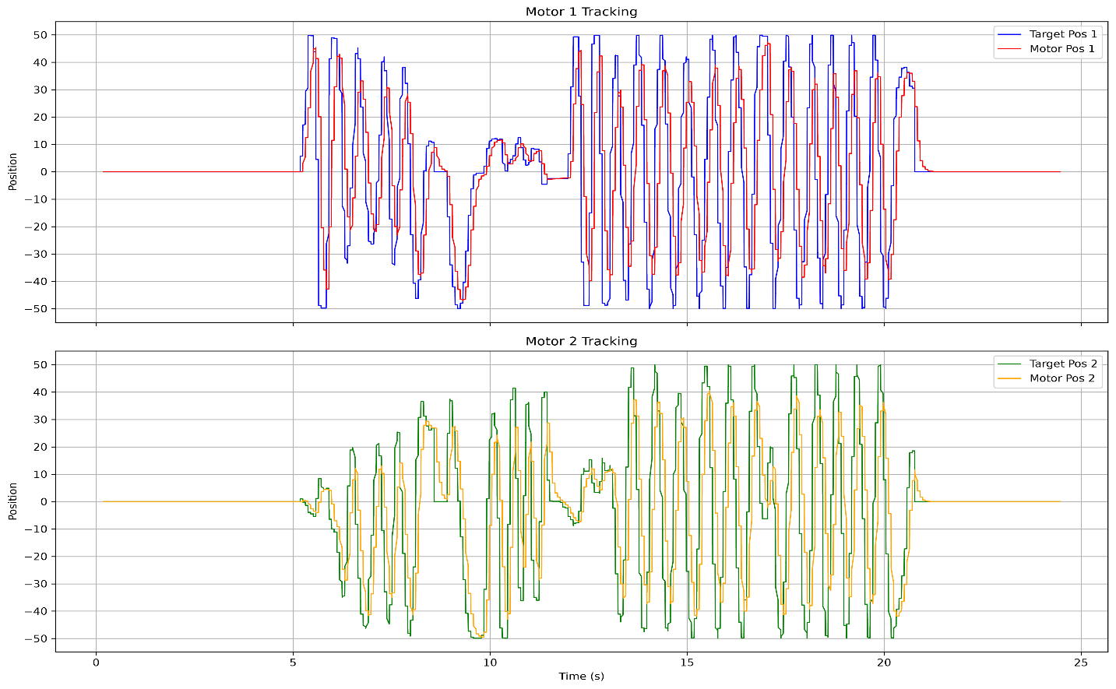

Random frequency – Position velocity control
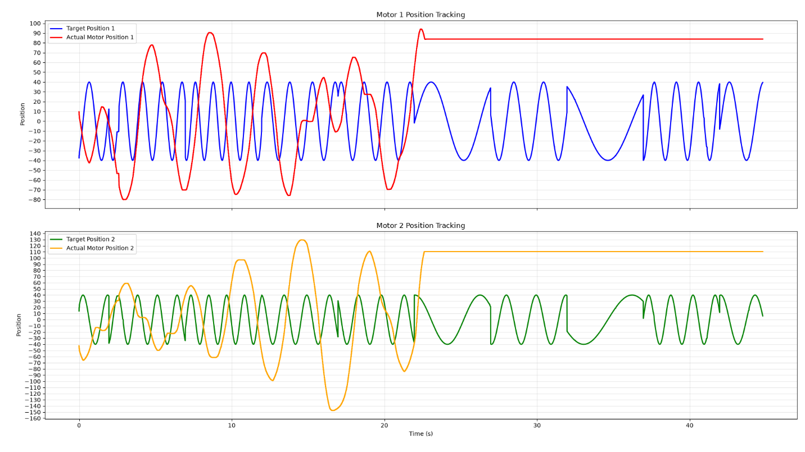
Position velocity control via serial monitor
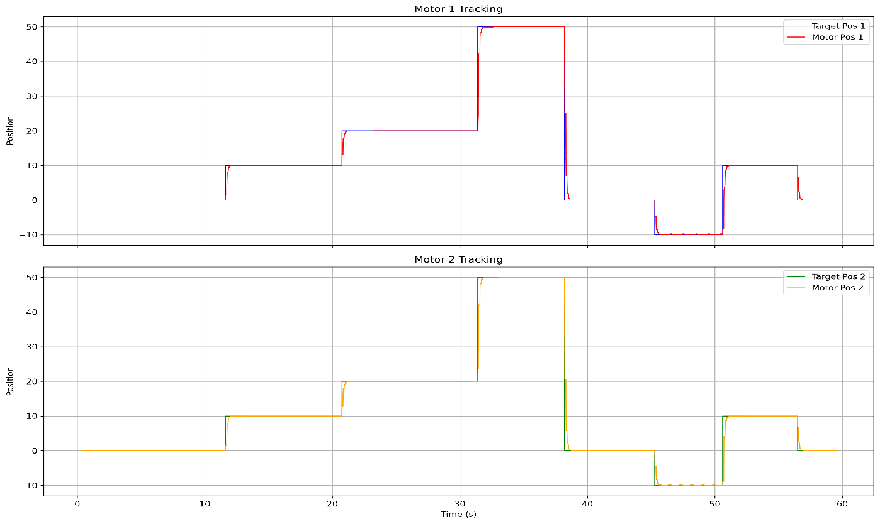
Position control via serial monitor
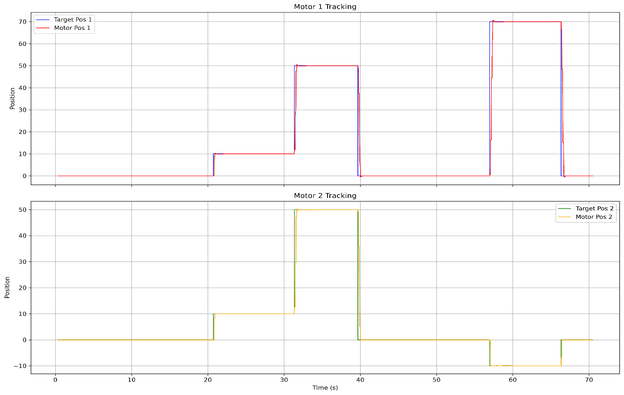

Position velocity control via cubemars app
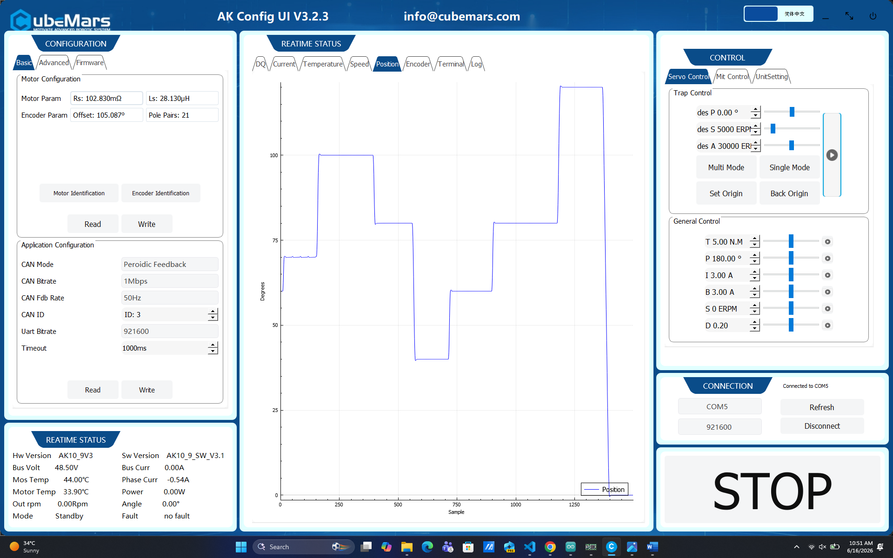
Position control via cubemars app
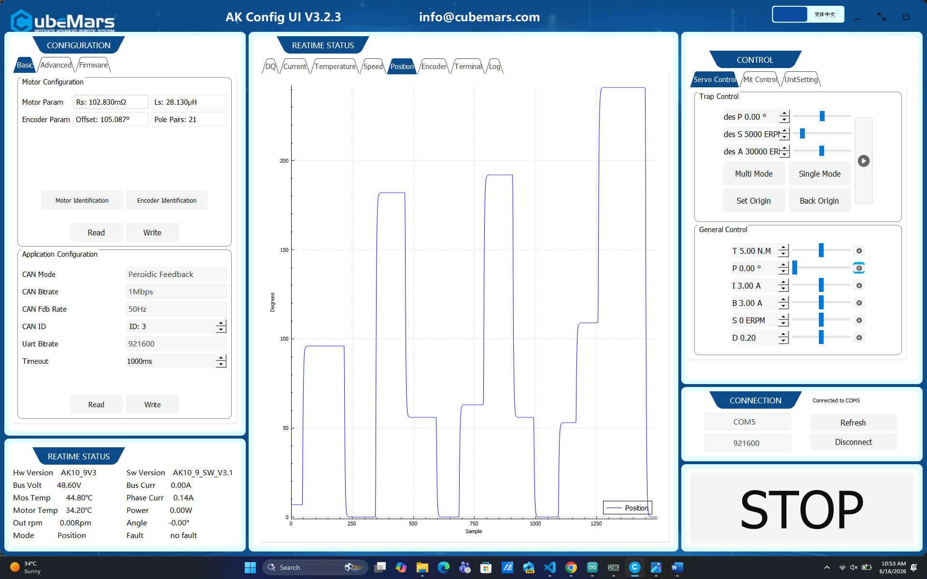
Freq = 0.2 Hz, Amp = 10 deg
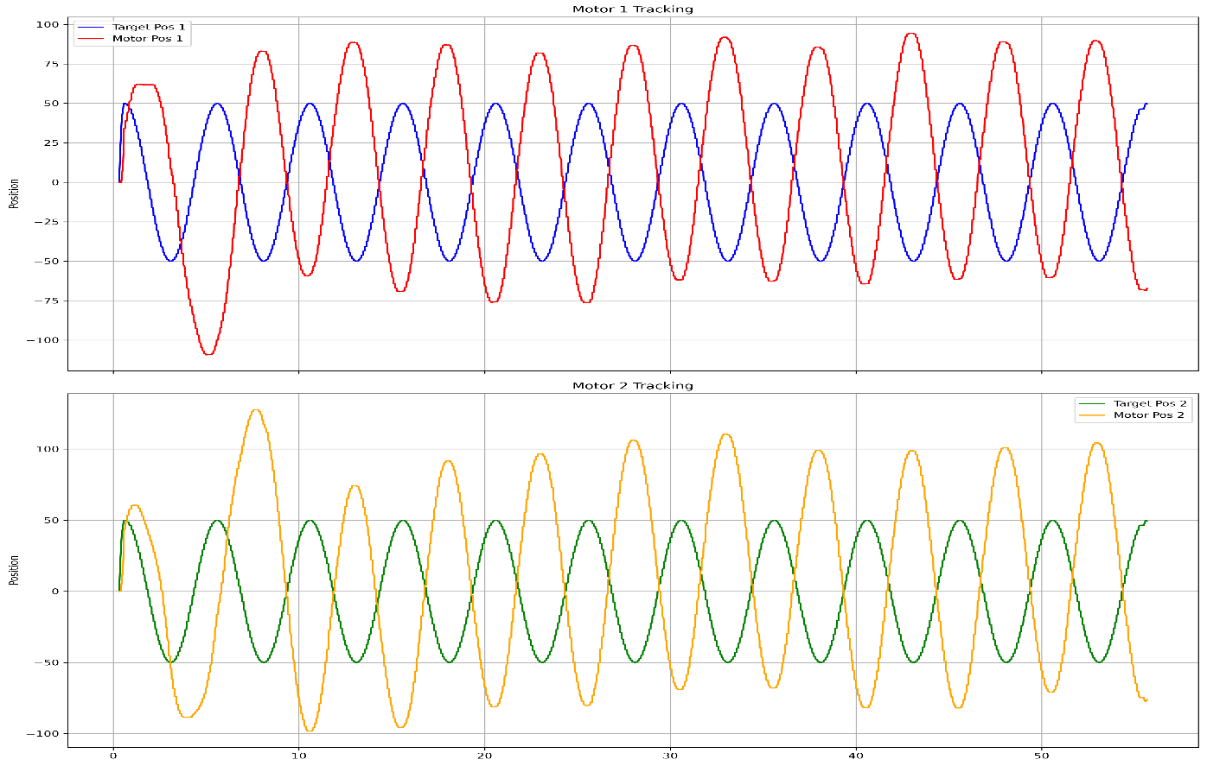
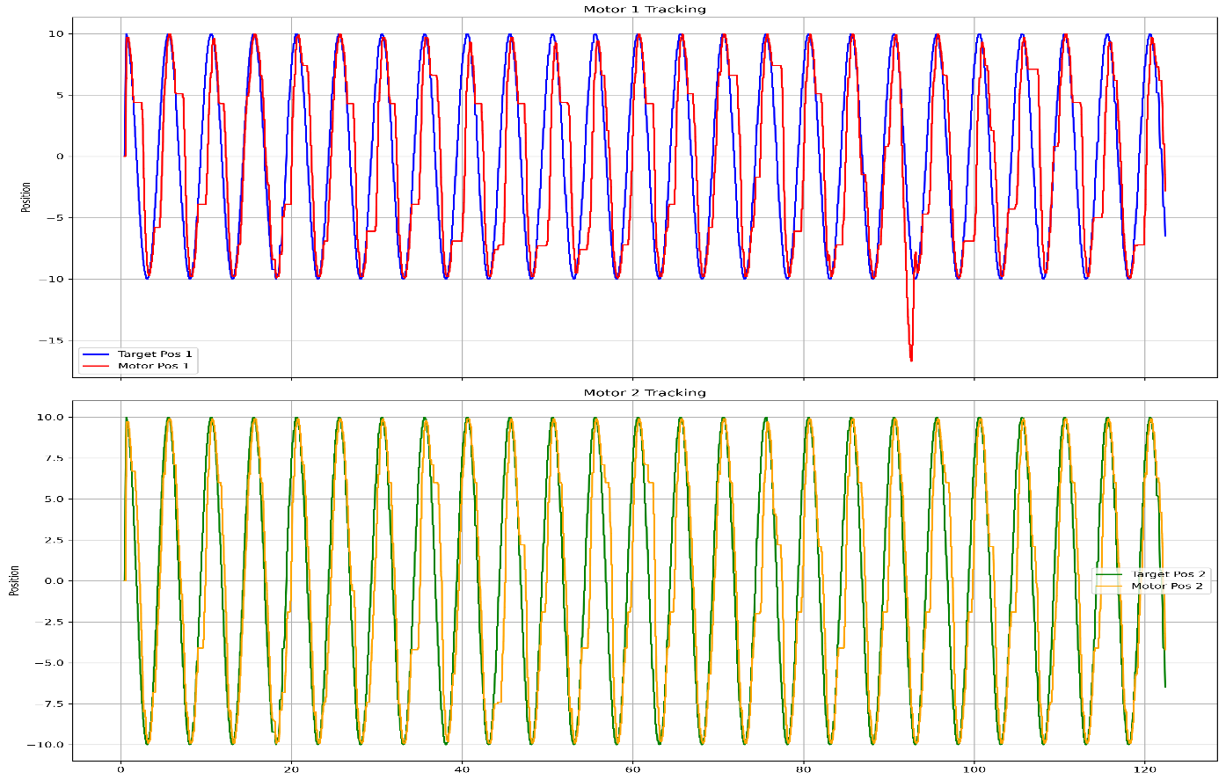
Freq = 0.2 Hz, Amp = 50 deg
Freq = 0.5Hz, Amp = 10 deg
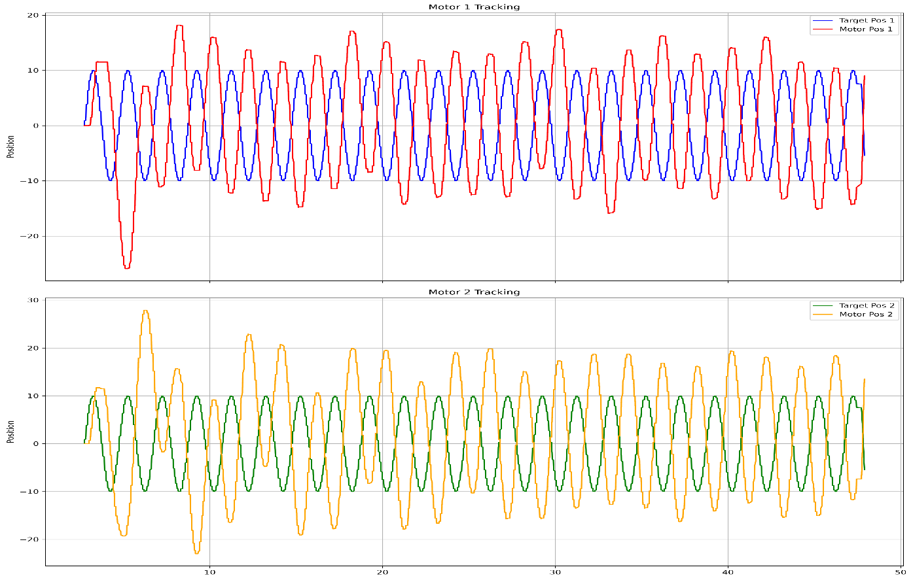
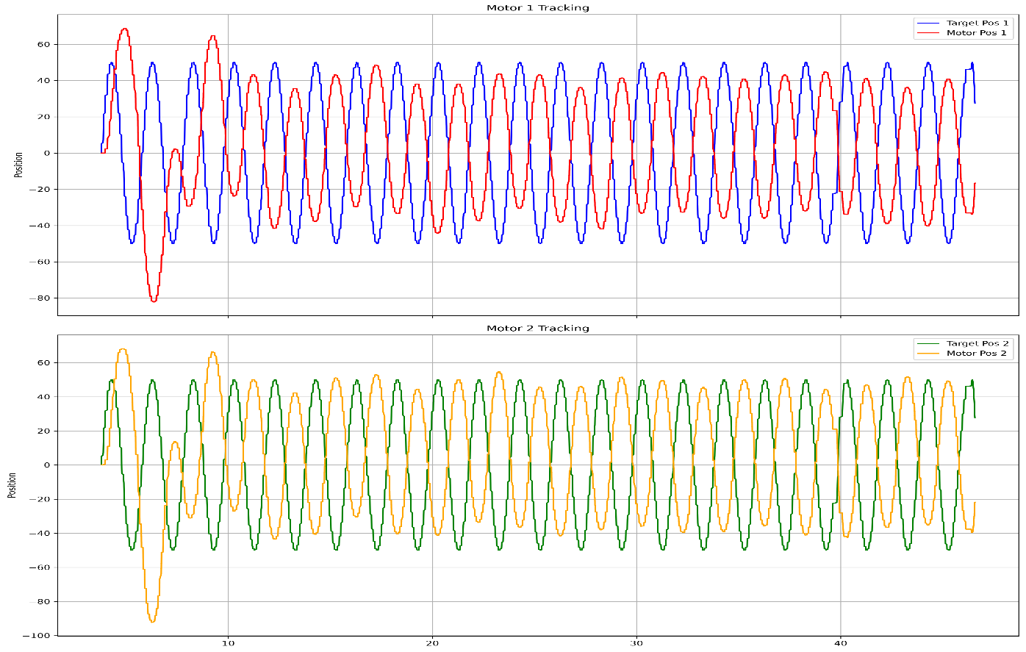
Freq = 0.5 Hz, Amp = 50 deg
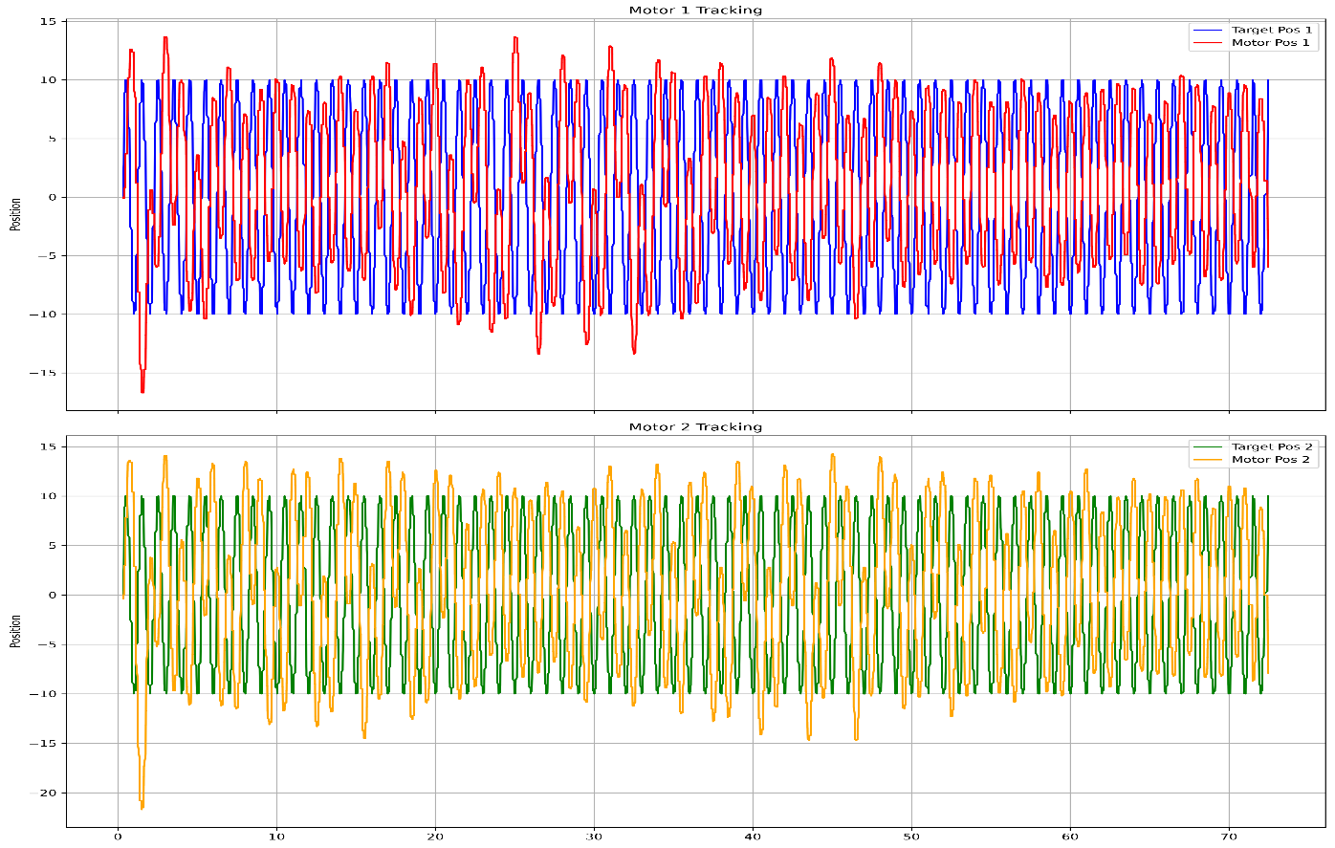
Freq = 1Hz, Amp = 10 deg
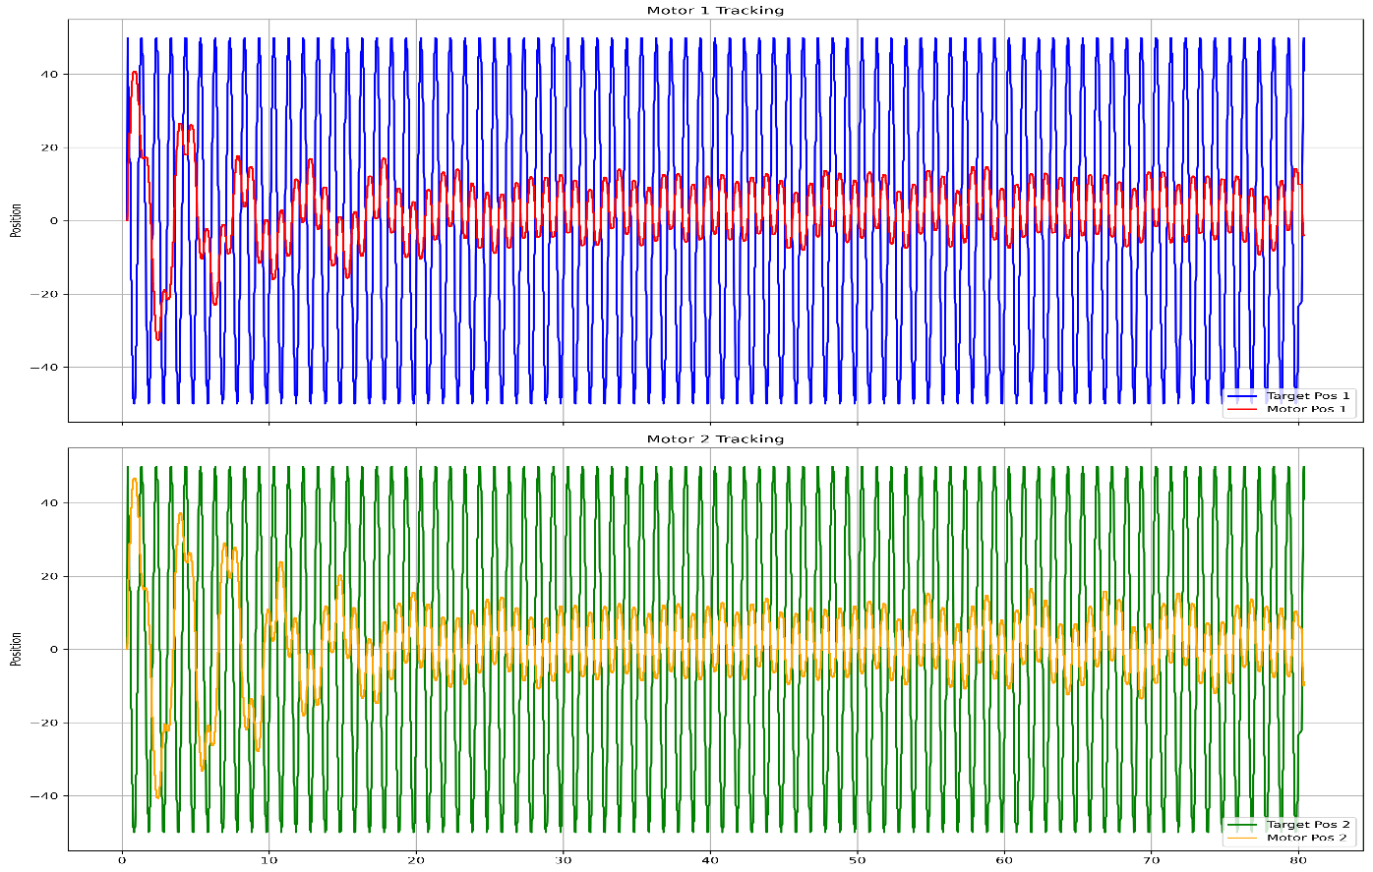
Freq = 1 Hz, Amp = 50 deg

