Abstract
Breast cancer is one of the most prevalent cancers worldwide, and human epidermal growth factor receptor 2 (HER2) is an important molecular target associated with the development and progression of HER2-positive breast cancer. The present study aimed to identify potential medicinal phytochemical compounds targeting HER2 using an integrated computer-aided drug discovery approach. Disease-associated pathways and therapeutic targets were investigated using biological databases, including KEGG and the Therapeutic Target Database (TTD), while PubChem and PubMed were utilized for compound information and supporting literature. A collection of medicinal phytochemicals was compiled, and their chemical structures and SMILES were retrieved for computational screening. The selected compounds were subjected to in silico ADMET analysis to evaluate their pharmacokinetic properties and identify compounds with favourable drug-like characteristics. The shortlisted compounds were further evaluated for predicted toxicity using ProTox. Based on the combined ADMET and toxicity screening results, potential candidates were selected for molecular docking against the HER2 protein. Docking analysis was performed using a PyRx based workflow to evaluate the binding affinity and binding orientation of the selected compounds within the target binding site. The promising protein–ligand complexes were subsequently visualized and analyzed using PyMOL to identify interacting amino acid residues and characterize relevant non-covalent interactions. The integrated analysis provides a systematic computational strategy for prioritizing medicinal phytochemicals with favourable pharmacokinetic, toxicity, and HER2-binding profiles. The identified candidates may serve as potential leads for further experimental investigation and validation against HER2-associated breast cancer.
Introduction
1.1 Breast Cancer
Breast cancer is one of the most commonly diagnosed malignancies among women worldwide and remains a leading cause of cancer-related morbidity and mortality. It develops when normal breast epithelial cells undergo genetic and epigenetic alterations that result in uncontrolled cell proliferation and the formation of malignant tumors (1,5).
Although breast cancer predominantly affects women, it can also occur in men, accounting for approximately 1% of all breast cancer cases. The disease most commonly originates from the epithelial cells lining the milk ducts or the milk-producing lobules, with invasive ductal carcinoma being the most frequently diagnosed histological subtype (1,2).
Breast cancer is considered a heterogeneous disease because tumors differ in their molecular characteristics, clinical behavior, prognosis, and response to treatment. This heterogeneity has led to the classification of breast cancer into four major molecular subtypes: Luminal A, Luminal B, HER2-positive, and Triple-Negative Breast Cancer (TNBC), each requiring different therapeutic approaches (2,3).
The development of breast cancer is influenced by multiple genetic, hormonal, environmental, and lifestyle-related factors. Major risk factors include increasing age, family history, inherited mutations in the BRCA1 and BRCA2 genes, prolonged estrogen exposure, obesity, alcohol consumption, physical inactivity, and reproductive factors (1,4).
Several cellular signaling pathways play essential roles in breast cancer initiation and progression. Dysregulation of pathways such as PI3K-AKT, MAPK, p53, Cell Cycle, and ErbB signaling promotes uncontrolled cell growth, inhibition of apoptosis, angiogenesis, and metastasis, ultimately contributing to tumor progression (1,2).
The diagnosis of breast cancer involves clinical examination, imaging techniques such as mammography and magnetic resonance imaging (MRI), histopathological examination, and molecular biomarker analysis. Biomarkers including estrogen receptor (ER), progesterone receptor (PR), and human epidermal growth factor receptor 2 (HER2) are widely used for disease classification, prognosis, and treatment selection (1,3).
Current treatment strategies include surgery, chemotherapy, radiotherapy, hormone therapy, targeted therapy, and immunotherapy. Although these therapeutic approaches have significantly improved patient survival, treatment resistance, tumor recurrence, and metastasis continue to present major clinical challenges (1,3).
1.2 Disease Overview
Breast cancer is a malignant disease that originates from the epithelial cells of the breast tissue, primarily in the milk ducts or milk-producing lobules. It occurs when genetic and epigenetic alterations disrupt the normal regulation of cell growth, resulting in uncontrolled cell proliferation and tumor formation. If left untreated, breast cancer can invade surrounding tissues and metastasize to distant organs such as the lungs, liver, bones, and brain, making it one of the leading causes of cancer-related deaths worldwide (1,2).
Breast cancer is a heterogeneous disease characterized by diverse molecular and clinical features. Based on receptor expression and gene profiling, it is classified into distinct molecular subtypes, each with different biological behavior, prognosis, and therapeutic response (2,3).
1.3 Types of Breast Cancer
- Ductal Carcinoma in situ
- Invasive Ductal Carcinoma
- Invasive Lobular Carcinoma
- Triple Negative Breast Cancer
- HER2 Positive Breast Cancer
- Inflammatory Breast Cancer
1.4 Risk Factors and Molecular Alterations
Breast cancer develops through the accumulation of genetic mutations and epigenetic changes that alter normal cellular functions. Although the exact cause is not fully understood, several biological mechanisms contribute to disease development (1,2).
Major risk factors and molecular alterations associated with breast cancer include:
- Mutations in BRCA1 and BRCA2 genes.
- HER2 gene amplification.
- TP53 mutations.
- Hormonal imbalance, particularly prolonged estrogen exposure.
- DNA damage caused by environmental and lifestyle factors.
- Abnormal activation of signaling pathways such as PI3K-AKT and MAPK (1,2,4).
1.5 Symptoms
Common symptoms include:
- Painless breast lump
- Swelling in the breast or underarm
- Change in breast size or shape
- Skin dimpling
- Nipple inversion
- Bloody or abnormal nipple discharge
- Persistent breast pain
- Redness or thickening of breast skin
- Enlarged axillary lymph nodes
Advanced breast cancer may cause:
- Bone pain
- Difficulty breathing
- Liver dysfunction
- Neurological symptoms due to brain metastasis (1,3).
Diagnosis
Early diagnosis significantly improves survival and treatment outcomes. Several diagnostic methods are routinely used.
Clinical Examination
The physician performs a physical examination of the breast and nearby lymph nodes to detect lumps or abnormalities (1).
Mammography
Mammography is the primary screening method for early breast cancer detection and can identify tumors before they become clinically palpable (1,3).
Ultrasonography
Ultrasound helps differentiate solid tumors from fluid-filled cysts and is commonly used alongside mammography (1).
Magnetic Resonance Imaging (MRI)
MRI provides high-resolution images and is particularly useful in high-risk patients and for assessing tumor extent (1).
Biopsy
Biopsy is the gold standard for confirming breast cancer diagnosis. Tissue samples are examined microscopically to determine the presence and type of cancer cells (1,3).
Molecular Biomarker Analysis
Biomarkers such as ER, PR, and HER2 are evaluated using immunohistochemistry (IHC) or fluorescence in situ hybridization (FISH). These biomarkers are essential for molecular classification and selection of targeted therapies (2,3).

1.6 Molecular Mechanism of Breast Cancer
Breast cancer develops through a multistep process involving the accumulation of genetic and epigenetic alterations that disrupt the normal regulation of cell proliferation, differentiation, apoptosis, and DNA repair. These molecular abnormalities transform normal breast epithelial cells into malignant cells capable of uncontrolled growth, invasion, and metastasis. The progression of breast cancer is driven by interactions between genetic mutations, dysregulated signaling pathways, hormonal influences, and the tumor microenvironment (1,2).
Under normal physiological conditions, cell growth and division are tightly regulated by signaling molecules and tumor suppressor genes. Growth factor receptors located on the cell surface receive extracellular signals and activate intracellular pathways that control cell proliferation only when required. Tumor suppressor genes, including TP53, BRCA1, and BRCA2, maintain genomic stability by repairing DNA damage and eliminating abnormal cells through apoptosis. When these regulatory mechanisms are disrupted by mutations or abnormal gene expression, uncontrolled cellular proliferation occurs, leading to tumor formation (1,2).
One of the earliest molecular events in breast cancer is the activation of oncogenes together with the loss of function of tumor suppressor genes. Amplification of the ERBB2 (HER2) gene results in excessive expression of the HER2 receptor, which continuously activates signaling pathways that promote cell growth and survival. Similarly, activating mutations in PIK3CA and loss of the tumor suppressor PTEN lead to persistent activation of the PI3K-AKT signaling pathway, enabling cancer cells to proliferate and resist apoptosis. Mutations in TP53 impair DNA damage repair and allow genetically unstable cells to survive and accumulate additional mutations (1,3).
Several intracellular signaling pathways contribute to breast cancer progression. The PI3K-AKT-mTOR pathway regulates cell growth, metabolism, protein synthesis, and survival. Persistent activation of this pathway enhances cellular proliferation and inhibits programmed cell death. The MAPK signaling pathway stimulates cell division through sequential phosphorylation of protein kinases, while the ErbB signaling pathway activates multiple downstream signaling cascades following stimulation of epidermal growth factor receptors, including HER2. Dysregulation of these pathways promotes uncontrolled tumor growth and disease progression (2,3).
Hormonal signaling also plays an important role in breast cancer development. Estrogen binds to the Estrogen Receptor (ER), and progesterone binds to the Progesterone Receptor (PR), activating transcription factors that regulate genes involved in cell proliferation. Continuous hormonal stimulation may contribute to uncontrolled cell growth in hormone receptor-positive breast cancer. Consequently, endocrine therapies targeting estrogen signaling have become an important component of breast cancer treatment (2,4).
As the tumor enlarges, rapidly proliferating cancer cells require increased oxygen and nutrients. To support continued growth, tumor cells stimulate the production of Vascular Endothelial Growth Factor (VEGF), promoting the formation of new blood vessels through angiogenesis. Newly formed blood vessels supply oxygen and nutrients to the tumor while also providing routes for cancer cells to enter the bloodstream and spread to distant organs (1,4).
Breast cancer progression is further influenced by the tumor microenvironment, which consists of immune cells, fibroblasts, endothelial cells, extracellular matrix proteins, cytokines, and growth factors. Communication between cancer cells and surrounding stromal cells promotes tumor growth, immune evasion, invasion, and therapeutic resistance. Chronic inflammation within the tumor microenvironment also contributes to genomic instability and cancer progression (1,4).
During advanced stages, breast cancer cells undergo epithelial-mesenchymal transition (EMT), a biological process in which epithelial cells lose their cell-cell adhesion properties and acquire migratory characteristics. EMT enables cancer cells to invade surrounding tissues, penetrate blood and lymphatic vessels, and metastasize to distant organs such as the bones, lungs, liver, and brain. Metastasis is the primary cause of mortality among breast cancer patients (1,2).
The molecular mechanisms underlying breast cancer have facilitated the identification of several clinically important therapeutic targets. Proteins such as HER2 (ERBB2), EGFR, PI3K, AKT, mTOR, Cyclin-Dependent Kinases (CDK4/6), Estrogen Receptor (ER), and VEGF are now targeted by specific anticancer therapies. Furthermore, bioinformatics databases such as KEGG, Therapeutic Target Database (TTD), UniProt, and Protein Data Bank (PDB) provide comprehensive information regarding these signaling pathways and therapeutic targets, supporting computational drug discovery and molecular docking studies (2,3).
Overall, breast cancer is a multifactorial disease driven by complex interactions among genetic mutations, hormonal regulation, dysregulated signaling pathways, and the tumor microenvironment. Understanding these molecular mechanisms is essential for identifying novel therapeutic targets and developing more effective treatment strategies. In the present study, these molecular pathways will be explored using the KEGG database to identify potential therapeutic targets for subsequent computational drug discovery.
1.7 HER2 as a Therapeutic Target
Human epidermal growth factor receptor 2 (HER2), also known as ErbB2, is a transmembrane receptor tyrosine kinase encoded by the ERBB2 gene. It plays an important role in regulating cell proliferation, survival, and growth. Amplification of the ERBB2 gene or overexpression of HER2 can result in excessive activation of downstream signaling pathways, particularly the PI3K–AKT–mTOR and RAS–RAF–MEK–ERK/MAPK pathways, promoting tumor growth and progression. HER2 is a clinically validated therapeutic target in HER2-positive breast cancer, with several targeted therapies, including trastuzumab, pertuzumab, lapatinib, tucatinib, and trastuzumab deruxtecan, developed to inhibit HER2-mediated signaling or target HER2-expressing cancer cells. The availability of three-dimensional HER2 structures in the Protein Data Bank (PDB) also supports its application in structure-based drug discovery. Therefore, HER2 was selected as the molecular target in the present study for the computational evaluation of medicinal phytochemicals using ADMET screening, toxicity prediction, molecular docking, and protein–ligand interaction analysis.

1.8 Phytochemicals and Drug Discovery
Medicinal plants are important sources of bioactive compounds with diverse chemical structures and biological activities. Phytochemicals such as flavonoids, phenolic compounds, terpenoids, alkaloids, and other secondary metabolites have been investigated for their potential anticancer, antioxidant, anti-inflammatory, and antiproliferative activities. Their structural diversity makes them valuable candidates for the discovery of novel therapeutic molecules. However, the identification of promising phytochemicals through experimental screening alone can be time-consuming and resource-intensive. Computational approaches provide an efficient strategy for the preliminary screening and prioritization of potential bioactive compounds. By evaluating molecular properties, pharmacokinetic characteristics, toxicity, and interactions with specific protein targets, computational methods can help identify compounds with favorable drug-development potential.
In the present study, medicinal phytochemicals were therefore investigated as potential HER2-targeting compounds using an integrated computational workflow involving compound screening, ADMET prediction, toxicity assessment, molecular docking, and protein–ligand interaction analysis.

1.9 Computer-Aided Drug Discovery (CADD)
Computer-aided drug discovery (CADD) is a computational approach used to identify and evaluate potential drug candidates by analyzing their molecular properties and interactions with biological targets. It can reduce the time and cost associated with conventional drug discovery by enabling the preliminary screening of large numbers of compounds.
In the present study, CADD approaches were used to evaluate medicinal phytochemicals against the HER2 target. The workflow included compound selection, ADMET prediction, toxicity assessment using ProTox, molecular docking using PyRx, and protein–ligand interaction analysis using PyMOL. This integrated approach was used to prioritize compounds with favorable pharmacokinetic properties, predicted safety profiles, binding affinity, and interactions with HER2.
1.10 Rationale of the Study
HER2 is an important therapeutic target in breast cancer, and the development of additional potential HER2-targeting compounds remains of interest. Medicinal phytochemicals provide a diverse source of bioactive molecules with potential anticancer properties. Therefore, the present study uses an integrated computer-aided drug discovery approach, including ADMET and toxicity prediction, molecular docking, and protein–ligand interaction analysis, to identify promising medicinal phytochemicals that may interact with HER2 and serve as potential candidates for further investigation.
2. Aim
To identify potential medicinal phytochemicals targeting HER2 in breast cancer using an integrated computer-aided drug discovery (CADD) approach involving ADMET screening, toxicity prediction, molecular docking, and protein-ligand interaction analysis.
3. Objectives
- To study breast cancer-associated pathways and identify HER2 (ERBB2) as a therapeutic target using biological databases.
- To collect medicinal phytochemical compounds and retrieve their chemical structures and SMILES.
- To evaluate the selected compounds using ADMET analysis and shortlist compounds with favorable properties.
- To assess the predicted toxicity of shortlisted compounds using ProTox.
- To prepare the HER2 protein and selected ligands for molecular docking.
- To perform molecular docking and evaluate the binding affinity of the selected compounds against HER2.
- To analyze protein–ligand interactions using PyMOL and identify important interacting residues.
- To prioritize promising phytochemical candidates based on the combined computational results.
4.Methodology
4.1 Overall Workflow
      - Breast Cancer Selection
      - HER2 Target Identification
      - KEGG Analysis
      - TTD Analysis
      - Medicinal Compound Collection
      - SMILES Retrieval
      - ADMET Screening
      - ProTox Toxicity Prediction
      - HER2 Protein Preparation
      - Ligand Preparation
      - Molecular Docking
      - PyMOL Interaction Analysis
      - Candidate Prioritization
4.2 Disease Selection and Target Identification
Breast cancer was selected as the disease of interest based on its clinical significance and the involvement of multiple molecular pathways in disease progression. The KEGG database was used to investigate breast cancer-associated pathways and genes. Based on the pathway analysis, ERBB2 (HER2) was identified as an important molecular target involved in breast cancer-associated signaling.
4.3 KEGG Pathway Analysis
The Kyoto Encyclopedia of Genes and Genomes (KEGG) database was used to investigate the molecular pathways associated with breast cancer. The disease pathway was examined to identify important signaling pathways and associated genes involved in tumor development and progression. Genes such as ERBB2, EGFR, PIK3CA, PTEN, TP53, ESR1, and CCND1 were identified as important components of the associated pathways. HER2/ERBB2 was selected for further target-based analysis.
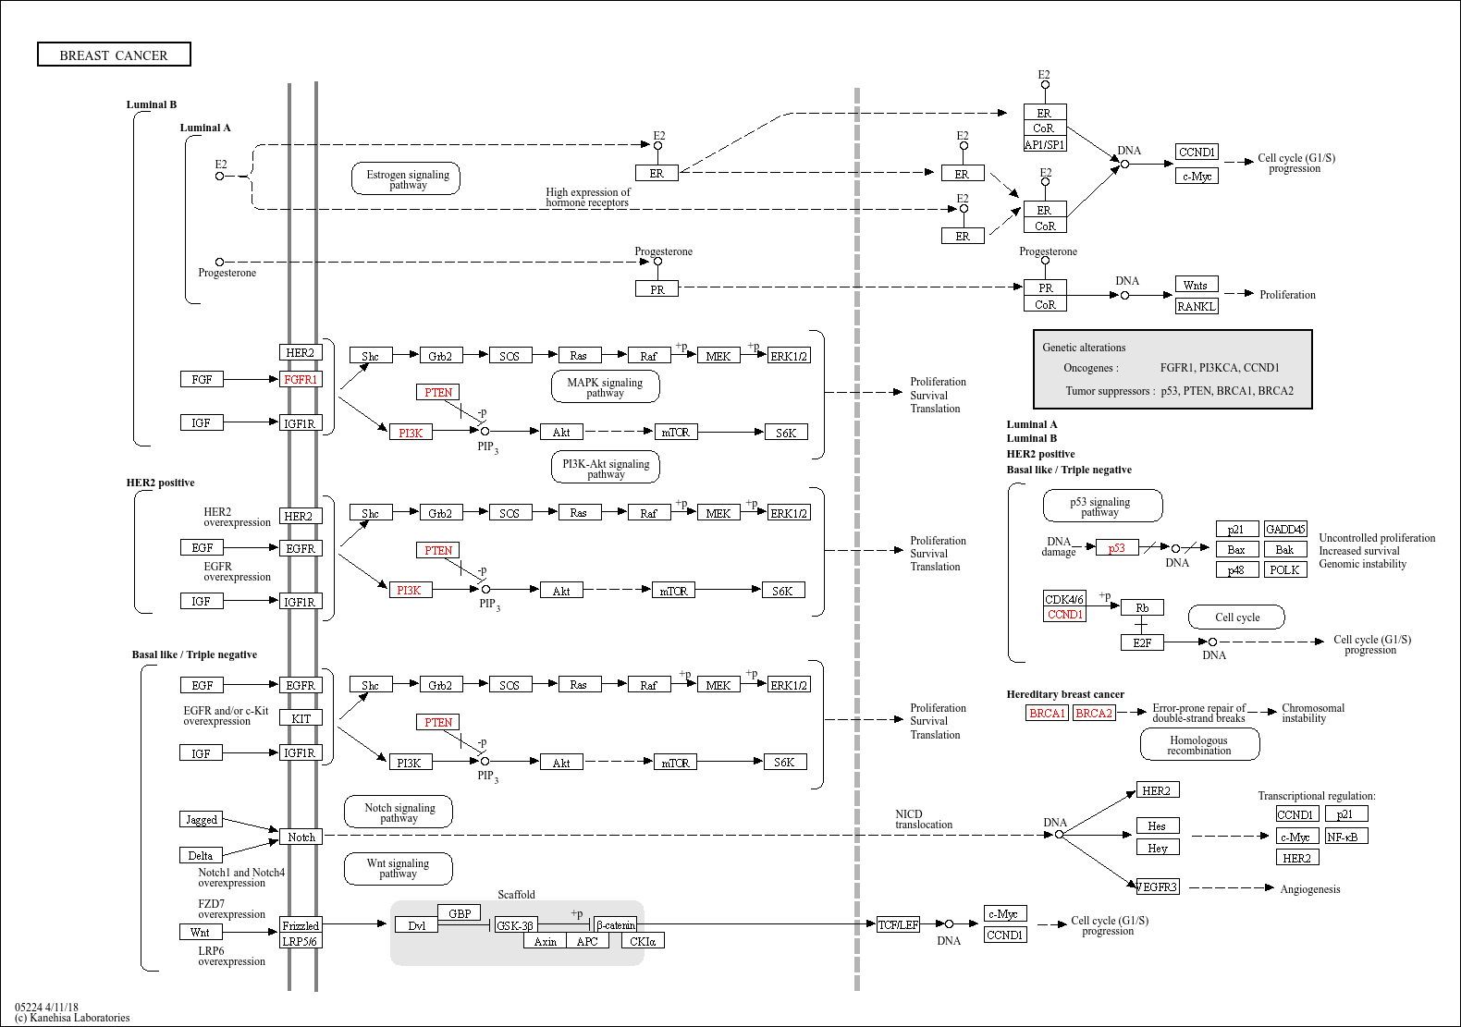

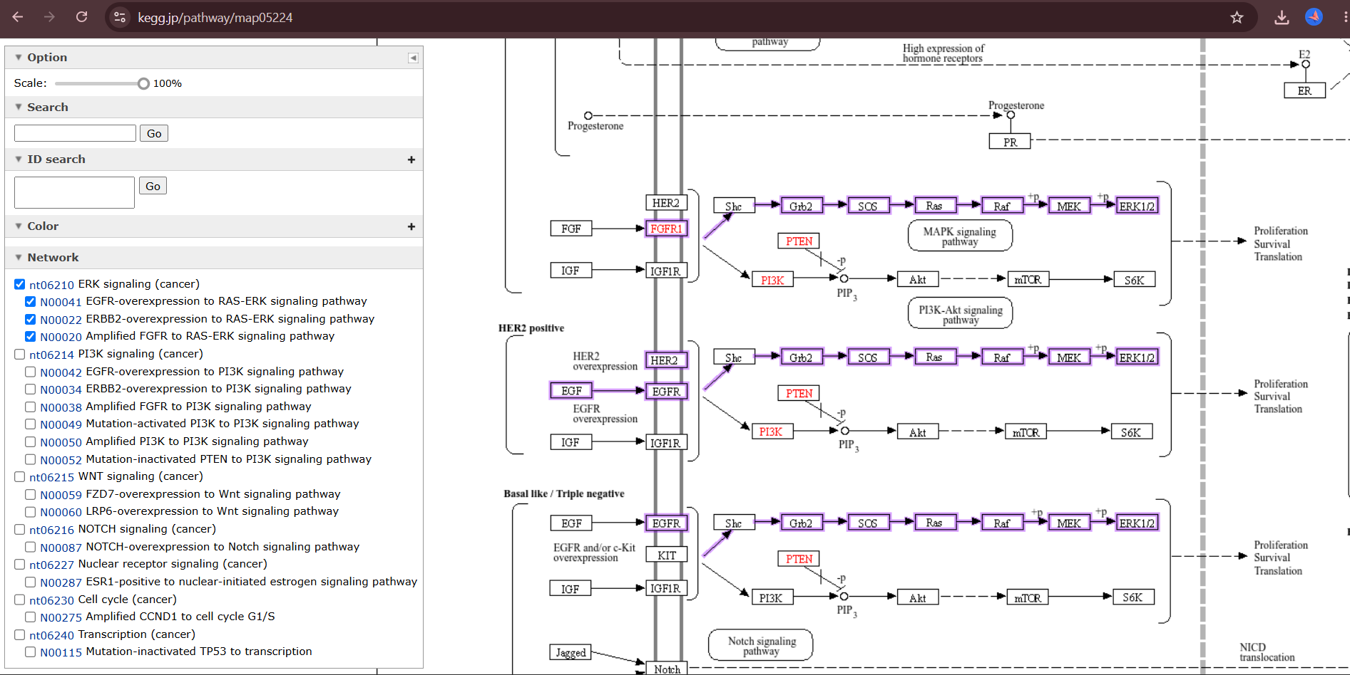

4.4 Therapeutic Target Analysis Using TTD
The Therapeutic Target Database (TTD) was used to validate the therapeutic relevance of the selected target. HER2 (ERBB2) was identified as a successful therapeutic target associated with breast cancer. Information including target name, gene symbol, organism, cellular location, biological function, signaling pathways, and approved drugs targeting HER2 was recorded.
Parameter | Information
Target Name | ErbB2 tyrosine kinase receptor (HER2)
Gene Symbol | ERBB2
Target Type | Successful Target
Organism | Homo sapiens
Associated Disease | Breast Cancer
Cellular Location | Cell membrane
Biological Function | Regulates cell proliferation, differentiation, and survival
Signaling Pathways | PI3K-AKT, MAPK, ErbB
Target ID | T14597
Former ID | TTDS00249
Source: Therapeutic Target Database (TTD).

4.5 Collection of Medicinal Phytochemicals
A total of 76 medicinal phytochemicals were collected from scientific literature and relevant databases. Information including compound name, PubChem CID, plant source, and SMILES was compiled in an Excel spreadsheet for further computational analysis. The complete list of compound dataset is provided in Appendix I.
4.6 Retrieval of Chemical Structures and SMILES
The PubChem database was used to retrieve chemical information for the selected compounds. Canonical or isomeric SMILES were obtained and recorded for each compound. These chemical structures were subsequently used for molecular property analysis and ligand preparation.
4.7 ADMET Screening
The selected phytochemicals were subjected to ADMET analysis to evaluate their drug-like and pharmacokinetic properties. Compounds were assessed using predefined criteria for relevant physicochemical and pharmacokinetic parameters. Compounds showing unfavorable ADMET characteristics were excluded, and the compounds with comparatively favorable profiles were shortlisted for toxicity assessment and molecular docking analysis.
PARAMETER | SELECTION CRITERION
MW | ≤ 500 Da
LogP | ≤ 5
HBA | ≤ 10
HBD | ≤ 5
TPSA | ≤ 140 Å²
GI Absorption | High
P-gp | No
Lipinski | 0
PAINS | 0
Brenk | 0
Bioavailability | ≥0.55

4.8 Toxicity Prediction Using ProTox
The shortlisted compounds were further evaluated using ProTox for in silico toxicity prediction. Relevant toxicity endpoints were examined, and compounds showing undesirable predicted toxicity profiles were excluded or deprioritized. The remaining compounds were selected for molecular docking against HER2.
4.9 HER2 Protein Retrieval and Preparation
The three-dimensional structure of the HER2 protein was retrieved from the Protein Data Bank (PDB). The selected HER2 structure was examined and prepared for molecular docking. The protein structure was then checked and prepared in a docking-compatible format for subsequent molecular docking analysis. For the present study, the PDB structure 3PP0 was used as the HER2 target structure. The required protein chain was retained and the unwanted chain was removed during protein preparation.
Table2. HER2 protein structure used for molecular docking
PARAMETER | INFORMATION
Target Protein | HER2
Gene | ERBB2
PDB ID | 3PP0
Organism | Homo sapiens
Chain Used | A Chain

4.10 Ligand Preparation
The 13 phytochemical compounds shortlisted after ADMET and toxicity screening were prepared for molecular docking. The corresponding three-dimensional structures were obtained from their chemical structures retrieved from PubChem and converted into a docking-compatible format. The ligand structures were checked for structural completeness and prepared for docking using the selected docking software. The prepared ligands were then imported into PyRx and converted to the required PDBQT format for molecular docking against the HER2 protein.
4.11 Binding Site and Grid Box Preparation
The binding site of the HER2 protein was defined based on the selected target region and the corresponding reference binding site. A grid box was generated around the selected binding region to restrict the docking search to the relevant area of the protein. The grid box dimensions and center coordinates were adjusted to adequately cover the binding pocket and allow the selected ligands to interact with the target region. The grid box parameters, including the X, Y, and Z center coordinates and X, Y, and Z dimensions, were recorded and kept constant for docking of all selected compounds.
Table 5. Grid box parameters used for HER2 molecular docking
PARAMETER | VALUE
Center X | 18.3224
Center Y | 18.7914
Center Z | 27.5998
Size X | 26.1274
Size Y | 25.3674
Size Z | 22.9796

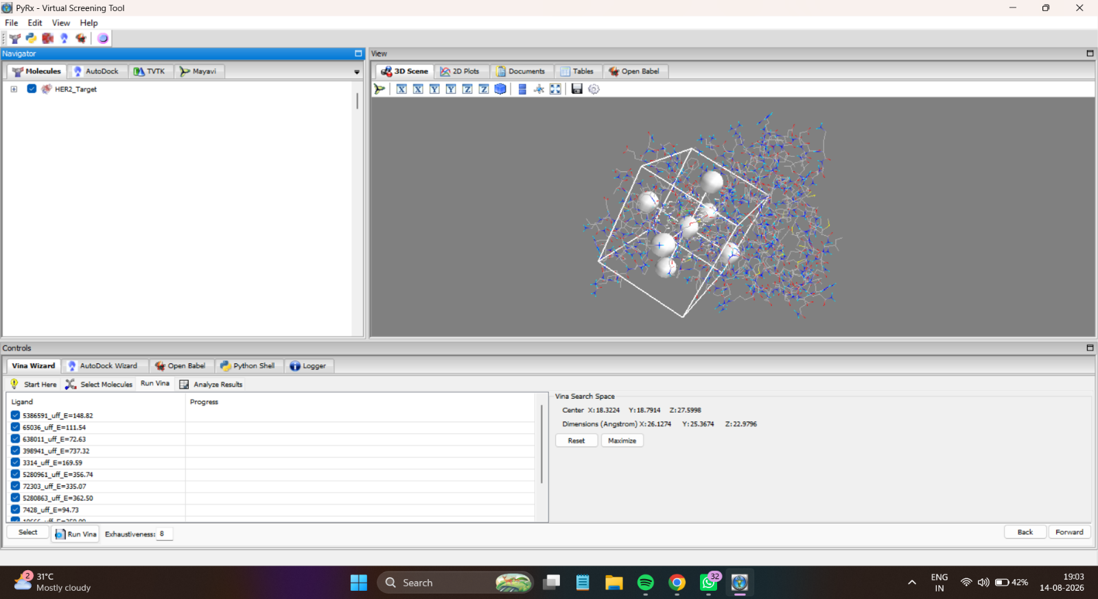
Figure 3. Grid box positioned around the selected HER2 binding site in PyRx.

4.12 Molecular Docking
Molecular docking was performed to evaluate the binding potential of the 13 shortlisted phytochemicals against the prepared HER2 protein. The prepared HER2 structure and ligand molecules were imported into PyRx, and docking was performed using the AutoDock Vina scoring algorithm. The predefined grid box was positioned around the selected HER2 binding site, and the same docking region was used for all compounds to ensure consistent comparison. For each ligand, the docking procedure generated possible binding poses and corresponding binding affinity scores (kcal/mol). The compounds were ranked according to their predicted binding affinities, with more negative values indicating stronger predicted binding under the docking scoring function. The best-ranked poses were selected for subsequent protein–ligand interaction analysis using PyMOL.
4.13 Protein–Ligand Interaction Analysis Using Discovery Studio
The selected docked protein–ligand complexes were analyzed using BIOVIA Discovery Studio Visualizer to investigate the interactions between the phytochemical compounds and the HER2 protein. The docked complexes were visualized in two- and three-dimensional representations, and the interacting amino acid residues were identified. Different types of non-covalent interactions, including conventional hydrogen bonds, carbon–hydrogen bonds, and hydrophobic interactions, were analyzed where applicable. The interacting residues, interaction types, and bond distances were recorded for the selected compounds. These interaction profiles were considered together with the molecular docking scores, ADMET properties, and toxicity predictions to support the identification of promising HER2-targeting phytochemicals.
5. RESULTS
5.1 KEGG Pathway Analysis
The KEGG database was used to investigate the molecular pathways associated with breast cancer. The analysis demonstrated that breast cancer involves multiple interconnected signaling pathways, including the ErbB, PI3K-AKT, MAPK, WNT, NOTCH, Cell Cycle, and Nuclear Receptor pathways. Several important genes, including ERBB2 (HER2), EGFR, PIK3CA, PTEN, ESR1, CCND1, and TP53, were identified as components of these pathways.
Among the identified targets, ERBB2 (HER2) was selected for further investigation because of its established role in breast cancer and its importance as a therapeutic target. The KEGG pathway image is presented in Section 4.3.

5.2 TTD Target Analysis
The Therapeutic Target Database (TTD) analysis confirmed HER2 (ERBB2) as a successful therapeutic target associated with breast cancer. HER2 is a cell membrane receptor involved in the regulation of cell proliferation, differentiation, and survival and is associated with the PI3K-AKT, MAPK, and ErbB signaling pathways. Based on its established therapeutic relevance, HER2 was selected as the target for subsequent molecular docking analysis. The detailed TTD target information is presented in Section 4.4.
5.3 Compound Screening Results
A total of 60 medicinal phytochemicals were initially collected from scientific literature and relevant databases. The compounds were compiled based on their chemical information, including compound name, PubChem CID, plant source, and SMILES. The collected compounds were subjected to ADMET screening to evaluate their drug-like and pharmacokinetic properties. Based on the predefined screening criteria, 35 compounds were retained for detailed ADMET evaluation. The complete compound screening result is provided in Appendix I
5.4 ADMET Screening Results
The selected medicinal phytochemicals were evaluated using in silico ADMET analysis to assess their drug-like and pharmacokinetic properties. The compounds were compared based on parameters including molecular weight, hydrogen bond acceptors, hydrogen bond donors, gastrointestinal absorption, bioavailability, and P-glycoprotein properties. Based on the predefined screening and scoring criteria, compounds with comparatively favorable ADMET profiles were prioritized for further analysis. Following the screening process, 13 compounds were shortlisted for subsequent toxicity prediction and molecular docking against the HER2 target. The complete ADMET results for the analyzed compounds are provided in Appendix II.
5.5 ProTox Toxicity Prediction Results
The 13 shortlisted phytochemicals were subjected to in silico toxicity prediction using ProTox to assess their potential toxicity profiles. The predicted toxicity results were examined for the selected compounds, and compounds with comparatively favorable toxicity profiles were prioritized for molecular docking against the HER2 target. The ProTox analysis, together with the ADMET results, was used to support the selection of compounds for subsequent docking analysis. The complete ProTox toxicity prediction results are provided in Appendix III.
5.6 Molecular Docking Results
Molecular docking was performed to evaluate the binding potential of the 13 shortlisted phytochemicals against the HER2 protein. The compounds were docked using PyRx with AutoDock Vina, and the resulting binding affinities were recorded and ranked. The docking scores were expressed in kcal/mol, with more negative values indicating stronger predicted binding affinity according to the docking scoring function. The 13 shortlisted compounds were selected for further protein–ligand interaction analysis. The complete docking results are provided in Appendix IV.
RANK | COMPOUND | BINDING AFFINITY (kcal/mol)
1 | Kaempferol | -6.5
2 | Methyl gallete | -6.2
3 | Eugenol | -6
4 | Citral | -5.6
5 | Ricinine | -5.4
6 | Sclareol | -5.4
7 | Genistein | -4.7
8 | Nigellone | -4.6
9 | Honokiol | -4.5
10 | Ajoene | -4.3
11 | Allicin | -4.2
12 | Theacrine | -4.2

Table 9. Molecular docking results of shortlisted phytochemicals against HER2
5.7 Protein–Ligand Interaction Analysis
The docked complexes of the 12 selected phytochemicals with HER2 were further analyzed using BIOVIA Discovery Studio Visualizer to examine their binding modes and identify the amino acid residues involved in ligand binding. The interaction analysis provided structural information that complemented the docking affinity results. The interaction patterns varied among the compounds, indicating differences in their binding orientations and interactions within the HER2 binding region. Compounds showing favorable docking scores together with multiple or relevant interactions with HER2-associated residues were considered comparatively promising candidates for further investigation. The detailed interaction profiles of the 12 docked complexes are provided in Appendix V, while representative interaction diagrams are presented in this section.
5.8 Final Compound Prioritization
The 12 compounds that progressed through molecular docking were comparatively evaluated based on their ADMET properties, predicted toxicity, docking affinity, and protein–ligand interaction profiles. These parameters were collectively considered to rank the compounds according to their overall computational performance. Among the evaluated compounds, the Rank 1 compound demonstrated the most favorable overall profile and was therefore selected as the final prioritized candidate for potential HER2-targeted drug discovery. The selection was based on the combined computational evidence rather than docking affinity alone.
6. DISCUSSION
6.1 Integrated Interpretation of Findings
The present study employed an integrated computational approach to identify potential medicinal phytochemicals targeting HER2 (ERBB2) in breast cancer. The sequential screening strategy enabled the progressive evaluation of the collected compounds based on their predicted drug-like properties, toxicity profiles, binding affinity, and interactions with the target protein.
The initial pathway and therapeutic-target analyses supported the selection of HER2 as a relevant molecular target in breast cancer. Subsequent ADMET and toxicity screening helped prioritize compounds with comparatively favorable predicted pharmacokinetic and safety characteristics. Molecular docking further provided an assessment of the potential binding of the shortlisted compounds to HER2.
The protein–ligand interaction analysis using Discovery Studio Visualizer provided additional structural information regarding the binding behavior of the selected compounds. The identification of hydrogen-bonding, carbon–hydrogen, and hydrophobic interactions helped support the interpretation of the docking results.
Among the 12 compounds evaluated by molecular docking, the compounds were ranked based on their overall computational performance. The Rank 1 compound showed the most favorable combined profile and was therefore selected as the final prioritized candidate for further investigation.
Overall, the study demonstrates the usefulness of an integrated CADD workflow for the preliminary identification and prioritization of phytochemical candidates against HER2. However, the findings are based on computational predictions and require experimental validation to confirm the actual biological activity and therapeutic potential of the identified candidate.

7. Conclusion
The present study employed an integrated computer-aided drug discovery (CADD) approach to identify potential medicinal phytochemicals targeting HER2 (ERBB2) in breast cancer. Breast cancer-associated pathways were investigated using KEGG, and HER2 was further validated as a therapeutic target using the Therapeutic Target Database (TTD).
A total of 76 medicinal phytochemicals were initially collected and subjected to computational screening. ADMET analysis was used to evaluate their drug-like and pharmacokinetic properties, followed by ProTox toxicity prediction. Based on the combined screening results, 12 compounds were selected for molecular docking against HER2.
Molecular docking and protein–ligand interaction analysis using Discovery Studio Visualizer provided information regarding the predicted binding affinity and interaction patterns of the selected compounds with HER2. The compounds were comparatively ranked using the combined computational findings, and the Rank 1 compound was identified as the final prioritized candidate.
Overall, the study demonstrates that an integrated computational workflow can be useful for the preliminary screening and prioritization of medicinal phytochemicals as potential HER2-targeting candidates. However, the findings are based on in silico predictions and require further in vitro and in vivo experimental validation to confirm their biological activity and therapeutic potential.
8. Limitations of the Study
- The study was primarily based on in silico computational predictions, and the predicted results may not always reflect actual biological behavior.
- ADMET and ProTox results are predictive and cannot replace experimental pharmacokinetic and toxicity studies.
- Molecular docking provides an estimate of ligand–protein binding affinity and possible binding modes but does not experimentally confirm binding or biological activity.
- The selected HER2 protein structure represents a specific structural state, and protein flexibility and dynamic changes may not be fully represented during docking.
- The study focused on a single molecular target, HER2, whereas breast cancer involves multiple interacting pathways and molecular targets.
- The final prioritized compound requires in vitro and in vivo validation to confirm its anticancer activity, HER2-targeting ability, safety, and therapeutic potential.

10. References
10.1 Research Articles
1. Breast Cancer Pathogenesis, Diagnosis and Treatment: A Comprehensive Review. PMID: 41971420
2. Cancer Hallmarks, Biomarkers and Breast Cancer Molecular Subtypes. PMID: 27390604
3. Potential Diagnostic and Prognostic Biomarkers for Breast Cancer: A Compiled Review. PMID: 37918101
4. Physical Exercise and the Hallmarks of Breast Cancer: A Narrative Review. PMID: 36612320
5. Global Cancer Statistics (GLOBOCAN/WHO) – Latest breast cancer incidence and mortality statistics.
6. https://doi.org/10.3390/cancers13246222
7. https://doi.org/10.3390/medicines7080047
8. https://doi.org/10.1111/jfbc.14387Digital Object Identifier (DOI)
9. https://doi.org/10.1155/2022/5886269
10. https://doi.org/10.2741/S544
11. https://doi.org/10.1080/10408398.2016.1203755
10.2 Database and Software References
- https://www.genome.jp/kegg/
- https://ttd.idrblab.cn/
- https://pubchem.ncbi.nlm.nih.gov/
- https://pubmed.ncbi.nlm.nih.gov/
- https://www.rcsb.org/
- https://www.swissadme.ch/
- https://tox.charite.de/protox3/
- https://sourceforge.net/projects/pyrx/
- https://www.3ds.com/products/biovia/discovery-studio/visualization

APPENDICES
APPENDIX I
Complete List of Medicinal Phytochemicals
APPENDIX II
Complete ADMET Screening Results

