Task 2: Banking Application
- Main Menu
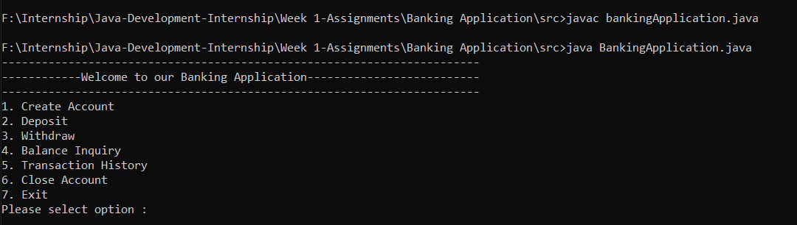
- Create Account/Add Account:
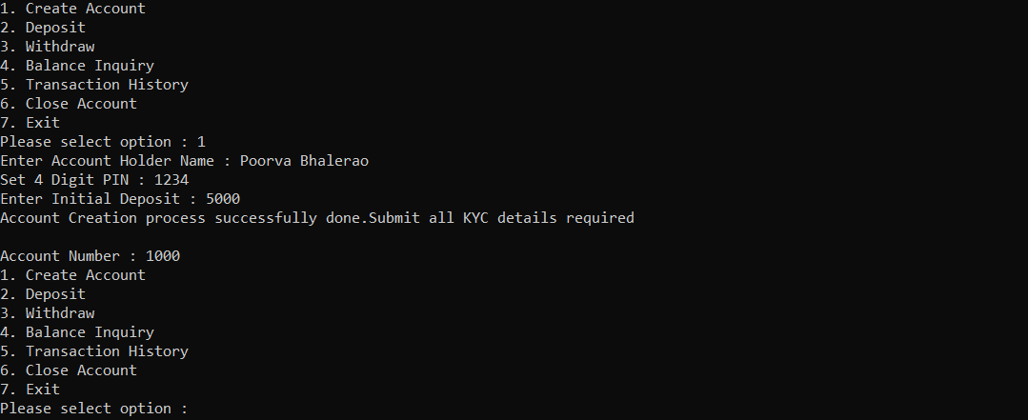
- Deposit(if right input entered as well as wrong input entered):
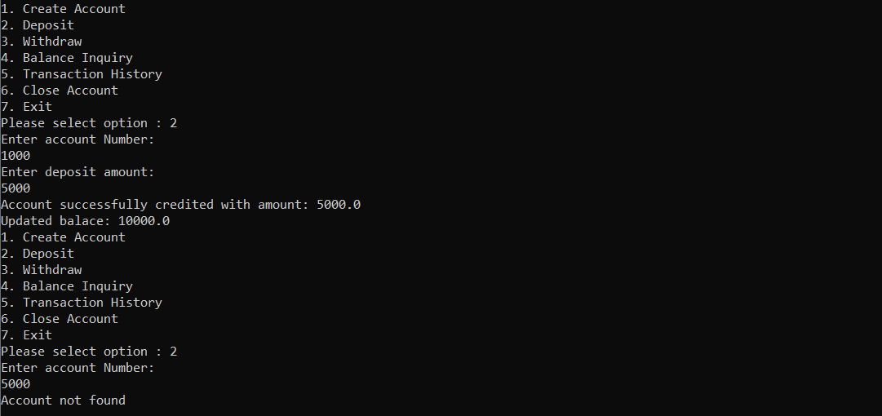
4.Withdrawl(if right input entered as well as wrong input entered):
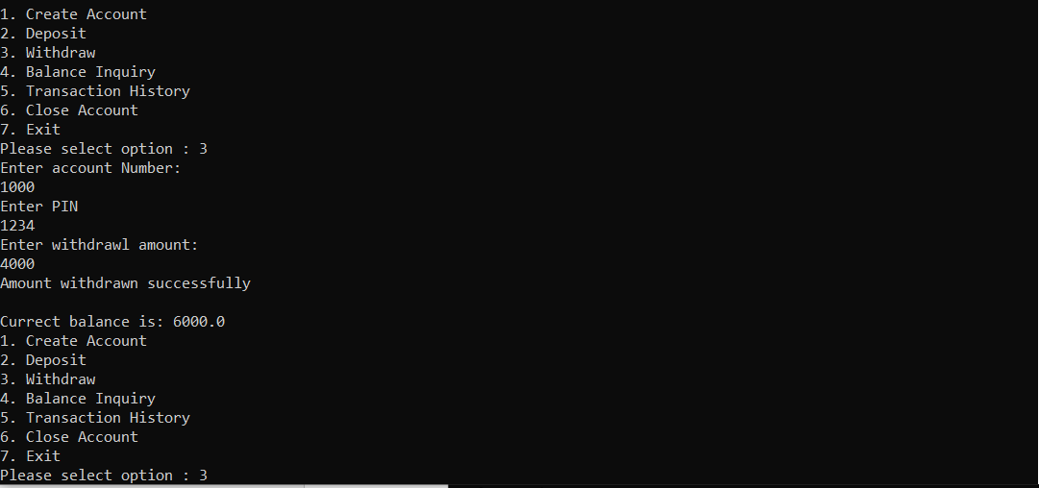
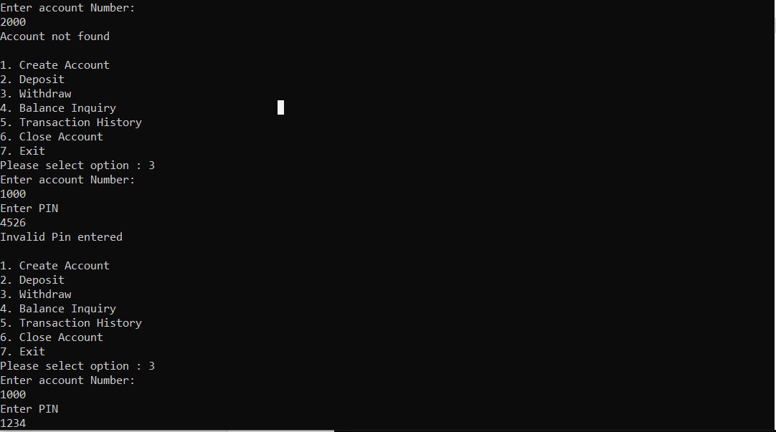
5.Balance Inquiry:
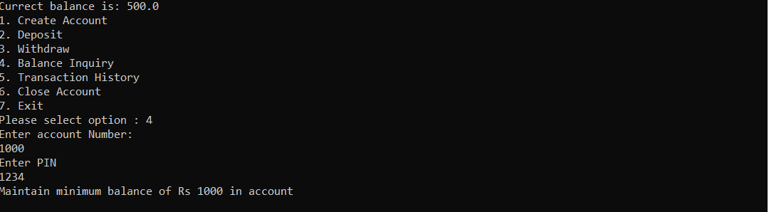
6.Transaction History:
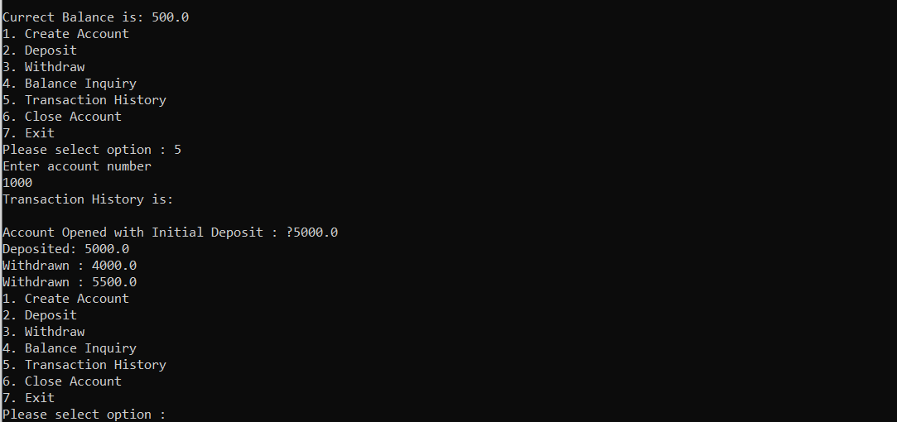
7.Close Account:
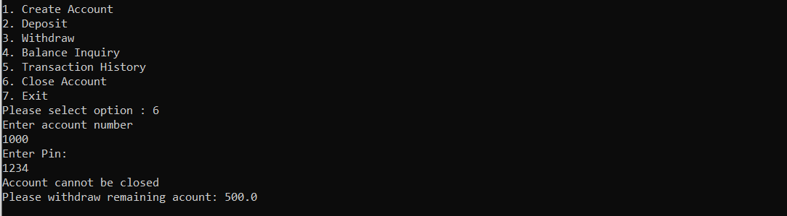
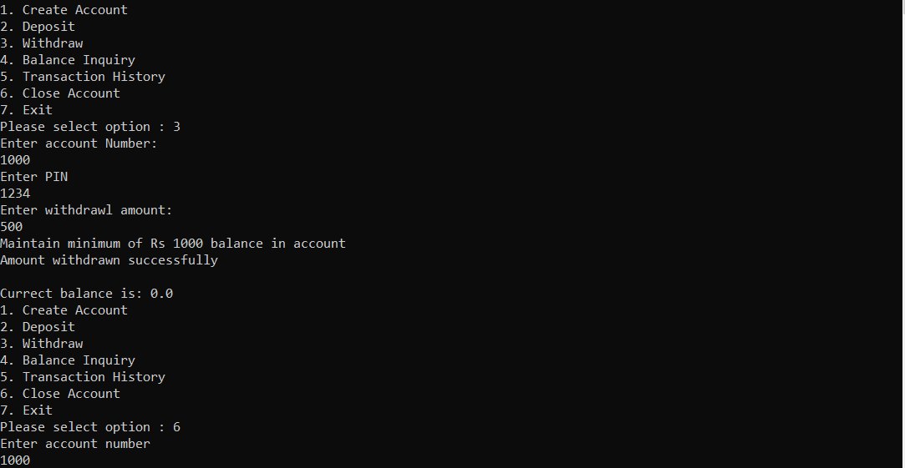
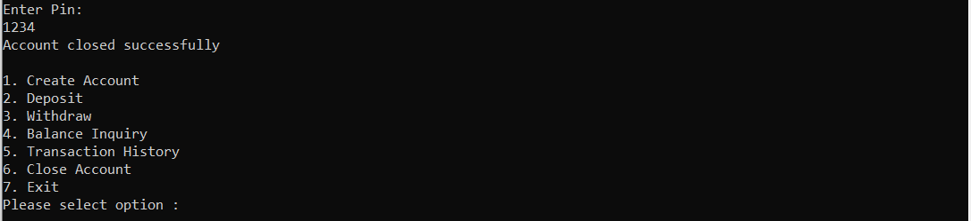
8. Exit the application:


