Game Design Document

Fill up the Following document

1. Write the title of your project.

My game.

1. What is the goal of the game?

The goal is to collect snows so you can dodge the fire and collect the most points.

1. Write a brief story of your game?

There is a person(snowman) who needs to go back to his home but he keeps getting caught from an object (fire ball). He needs help from the snowballs to get him home.

1. Which are the playing characters of this game?

* Playing characters are the ones which respond to the user based on the input from the user
* Cars, monkeys, dinos, wizards etc, are the playing characters in the game.

|  |  |  |
| --- | --- | --- |
| Number | Character Name | What can this character do? |
| 1 | Snowman | Jump, collects snows and throw snows at fire |
| 2 |  |  |
| 3 |  |  |
| 4 |  |  |
| 5 |  |  |
| 6 |  |  |
| 7 |  |  |
| 8 |  |  |

1. Which are the Non Playing Characters of this game?

* Non Playing characters are the ones which don't have an action or a behaviour when the user interacts with the game.
* Hurdles, stones, bananas, coins, etc are non playing characters in the game.

|  |  |  |
| --- | --- | --- |
| Number | Character Name | What can this character do? |
| 1 | Snowball | Fly from sky for the snowman to catch |
| 2 | Fire ball | Fly from sky to try and hit the snowman |
| 3 | Tree1,2,3 | 3 trees will be on the ground and snowman has to dodge them |
| 4 |  |  |
| 5 |  |  |
| 6 |  |  |
| 7 |  |  |
| 8 |  |  |

Draw your imagination of this game. What does this game look like?

* Draw the game either on your computer or on paper,
* Add images of scenes of the game to show each of the playing and non-playing characters at least once.

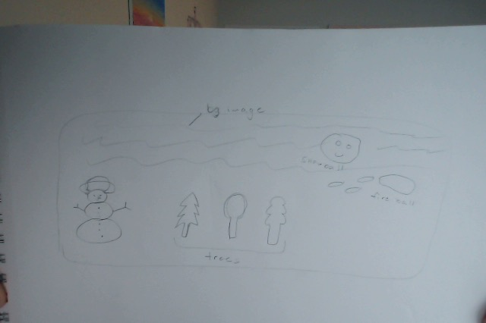

How do you plan to make your game engaging?

I will have interesting images and make the game challenging but not impossible so people will play my game.