GitHub Link - https://github.com/Poorvitha17/Tutedude_Assignments
Objective: Containerize a full-stack application — a Node.js/Express frontend and a Flask backend — using Docker and Docker Compose, then push the images to Docker Hub and the code to GitHub.

1. Frontend (Node.js with Express)
- Create a frontend using Express and Node.js.
- Include a form similar to the one from the Flask Assignment 2.
- Configure the form to send a request to the Flask backend.
2. Backend (Flask)
- Use the Flask backend to handle the form submission and process the data.
3. Folder Structure
- Organize the project with separate folders for the frontend and backend.
4. Docker Configuration
- Create a Dockerfile for both the frontend and backend.
- Write a .yaml file (Docker Compose) to connect both services in the same network.
- Upload both images to Docker Hub, and push your whole code to GitHub. Add node_modules and other non-required files (e.g., .vscode) to .gitignore.
Reference: https://github.com/Toto3107/flaskp

  - Step 1: Initialize Node.js project
Inside the frontend folder, I initialized the project:npm init -y
This created the package.json file.
Step 2: Install Express
I installed Express using:npm install express
I verified the installation using:npm list express
Step 3: Create Express server
I created:
frontend/server.js
The Express server runs on port 3000 and serves the frontend files from the public directory.
app.use(express.static(path.join(__dirname, "public")));

The application was started using:node server.js
and accessed from the browser using:localhost:3000
Step 4: Create the frontend form
I created:
frontend/public/index.html
The Student Form contains:
- Name
- Course
- Submit button
This frontend is designed to pass the submitted information to the Express server, which forwards the data to the Flask backend.

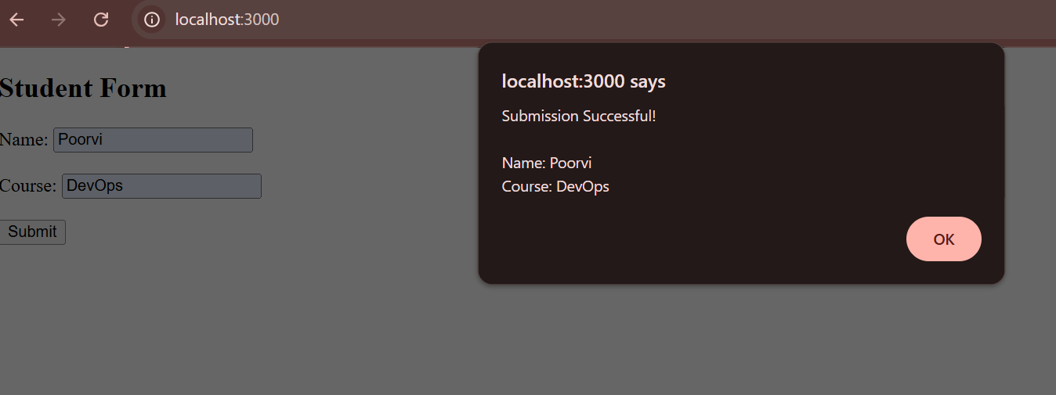

2) Step 1: Create Backend Folder
A separate backend folder was created inside the project:
docker_fullstack_assignment/
├── frontend/
└── backend/
Inside backend, I created:
backend/
├── app.py
└── requirements.txt
``
Step 2: Create Flask Application
In app.py, I created the Flask application:
from flask import Flask, request, jsonify

app = Flask(__name__)
Step 3: Create /submit API
A POST endpoint was created to receive the Name and Course values:
@app.route('/submit', methods=['POST'])
def submit():
data = request.get_json()

name = data.get('name', '').strip()
course = data.get('course', '').strip()

if not name or not course:
return jsonify({
"error": "Name and Course are required"
}), 400

return jsonify({
"message": "Data submitted successfully!",
"data": {
"name": name,
"course": course
}
}), 200
Step 4: Add Flask Dependency
The following dependency was added to requirements.txt:
Flask

Flask was installed using:pip install Flask
Step 5: Run the Backend
The Flask backend was started using:python app.py
The application runs on port:
5000
Step 6: Test the Backend
The backend was tested in the browser and successfully returned:

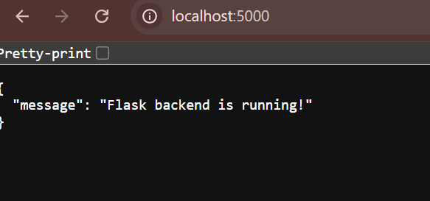

3) Frontend Folder
The frontend folder contains the Node.js and Express application:
- server.js → Express server
- public/index.html → Student form
- package.json → Node.js project configuration and dependencies
- package-lock.json → Dependency version information
- node_modules → Installed Node.js packages
Backend Folder
The backend folder contains the Flask application:
- app.py → Flask backend and /submit API
- requirements.txt → Python dependencies

4)
Step 1: Frontend Dockerfile
A Dockerfile was created inside the frontend folder.
FROM node:20-alpine
WORKDIR /app
COPY package*.json ./
RUN npm ci --omit=dev
COPY . .
EXPOSE 3000

CMD ["node", "server.js"]
The Node.js/Express frontend runs on port 3000.
Step 2: Backend Dockerfile
A second Dockerfile was created inside the backend folder.
FROM python:3.13-slim
WORKDIR /app
COPY requirements.txt .
RUN python -m pip install --no-cache-dir -r requirements.txt
COPY . .
EXPOSE 5000

CMD ["python", "app.py"]
The Flask backend runs on port 5000.
The requirements.txt file contains:Flask

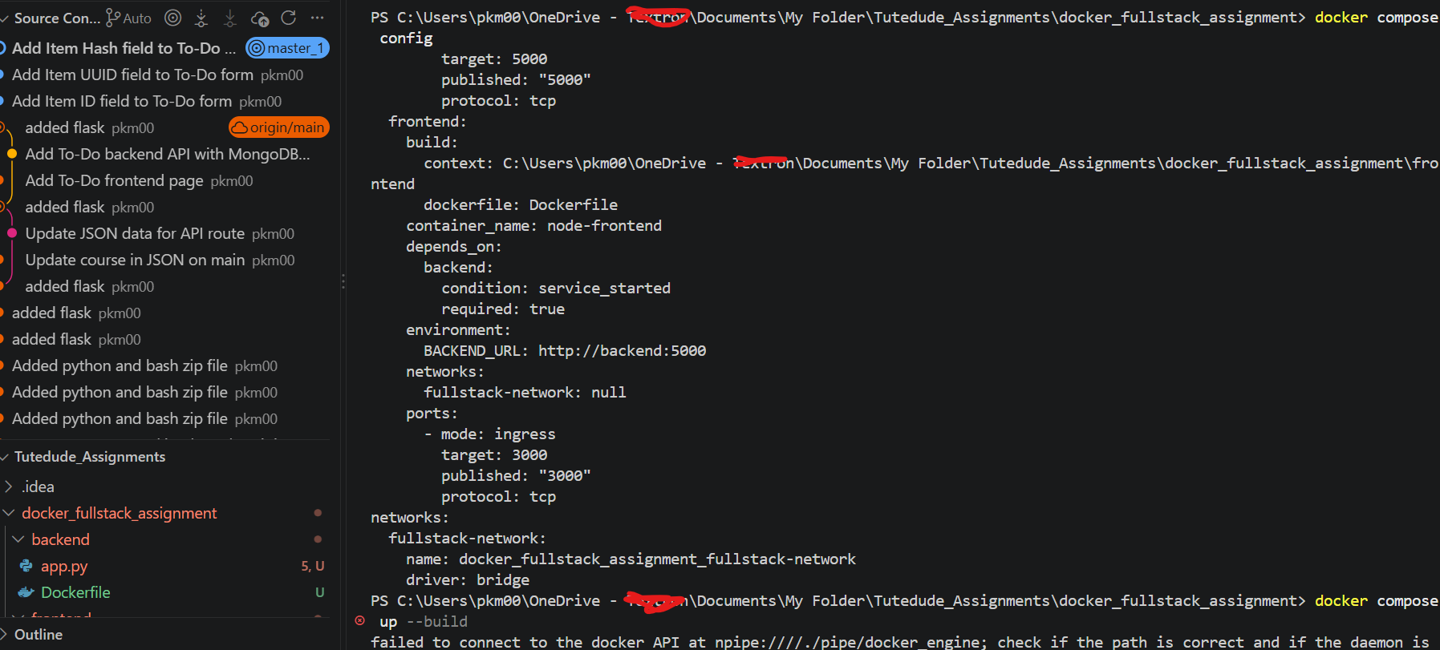

Step 3: Docker Compose
A docker-compose.yml file was created in the project root.
It defines two services:
frontend → port 3000
backend → port 5000
Both services are connected through the same Docker network.
The frontend communicates with Flask using:
http://backend:5000
Step 4: Build the Containers
The images and containers were built using:docker compose up --build
After resolving the missing Flask dependency, both services started successfully.
Step 5: Run and Verify Containers
The containers were started in detached mode:docker compose up -d
The running containers were verified using:docker compose ps

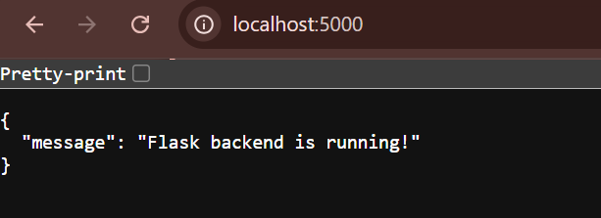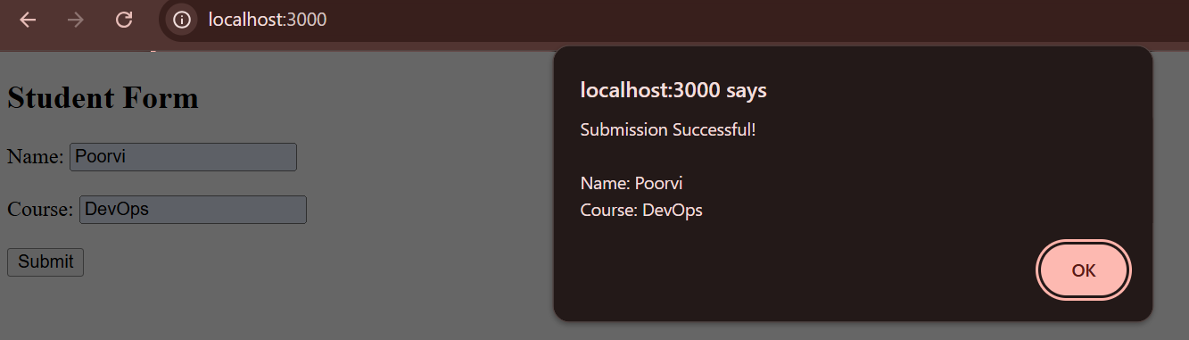

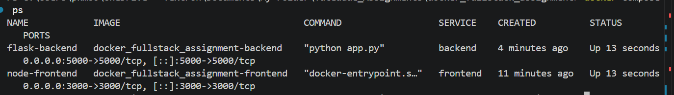

5. Docker Hub
Objective
The frontend and backend Docker images were uploaded to Docker Hub so they can be stored and shared through a container registry.

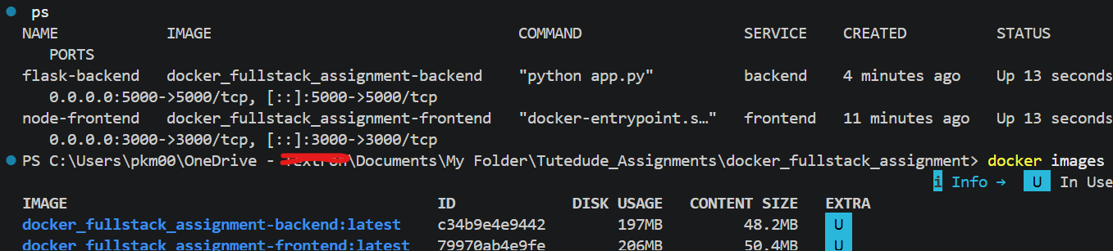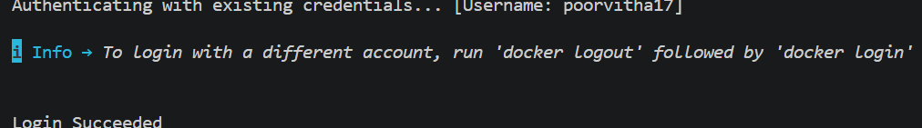
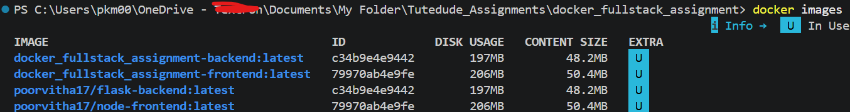

Step 1: Verify Docker Images
The locally created Docker images were checked using:docker images
Step 2: Login to Docker Hub
Docker Hub authentication was performed using:docker login
Step 3: Tag the Images
The frontend image was tagged with my Docker Hub username:docker tag docker_fullstack_assignment-frontend:latest poorvitha17/node-frontend:latest

The backend image was tagged using:docker tag docker_fullstack_assignment-backend:latest poorvitha17/flask-backend:latest

Step 4: Push Images
Frontend:docker push poorvitha17/node-frontend:latest
Backend:docker push poorvitha17/flask-backend:latest
Result
Both the Node.js frontend and Flask backend Docker images were successfully tagged and pushed to Docker Hub under the poorvitha17 Docker Hub account.
- docker images
- Successful Docker Hub login
- Successful frontend push
- Successful backend push
- Both repositories visible in Docker Hub
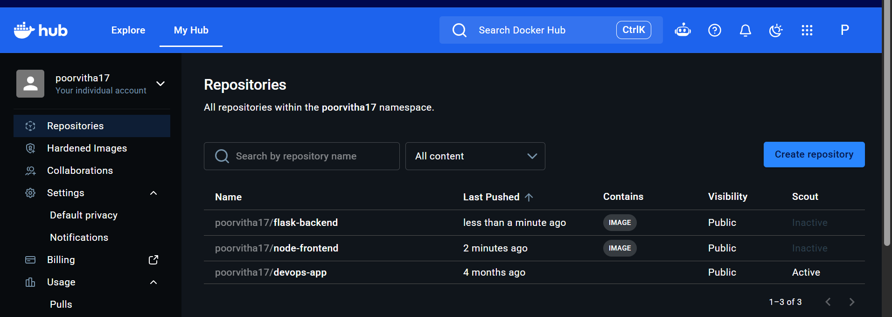

6. .gitignore and GitHub
Objective
A .gitignore file was added to prevent unnecessary generated files such as node_modules from being uploaded to GitHub.
Step 1: Create .gitignore
A .gitignore file was created in the project root.
.ignore
node_modules/
frontend/node_modules/
__pycache__/
*.pyc
*.pyo
venv/
.venv/
.env
.env.*
.vscode/
*.log
npm-debug.log*
Step 2: Verify ignored files
Git status was checked using:git status
The verification confirmed that node_modules was not listed for commit.
Step 3: Add and Commit
The .gitignore file was added:git add .gitignore
Then committed:git commit -m "Add gitignore for Docker assignment"
Step 4: Push to GitHub
The project uses the master_1 branch, so the changes were pushed using:git push origin master_1
Result
The .gitignore configuration was successfully added to exclude unnecessary files, and the changes were committed and pushed to the Git repository on the master_1 branch.
📸 Screenshots to include
- .gitignore in VS Code
- git status
- Successful git commit
- Successful git push origin master_1
- Final project files visible in GitHub
