UNIVERSITY OF NAPLES FEDERICO II

POLYTECHNIC AND BASIC SCIENCES SCHOOL
DEPARTMENT OF INDUSTRIAL ENGINEERING

MASTER’S DEGREE IN
AUTONOMOUS VEHICLE ENGINEERING
DIGITAL MODELLING OF INTERACTIVE SYSTEMS AND INTERFACES

PROJECT REPORT – PW33
“Electromechanical Active Suspension”

Pooya Zare Baravati | D18000079

ACADEMIC YEAR 2024-2025

Table of Contents

Nomenclature ii
Introduction 1
1. Starting Point 2
1.1 State of the Art Active Suspension Systems 4
1.1.1 Active Suspension Systems’ brief review 4
1.2 Active Suspension key elements 5
1.2.1 Hardware Elements 5
1.2.2 Active Component 6
1.2.3 Electromechanical Active Suspensions 7
1.2.4 The detailed design 8
2. 3D Modelling in SolidWorks 10
2.1 Design Approach 10
2.2 Predesign Considerations and Simplifications 11
2.3 Component Design 12
2.3.1 Main Components of the Suspension System 12
2.3.2 Upper and Lower Wishbone 13
2.3.3 Upright (Knuckle) 14
2.3.4 Spring and Damper 15
2.4 Whole Parts Assembly 16
2.5 Motion Study of the Suspension System 17
3. Finite Element Analysis (FEA) in SolidWorks 18
3.1 FEA Setup 18
3.1.1 Material Definition 19
3.1.2 Connections 20
3.1.3 Fixture Selection 21
3.1.4 External Loads 22
3.2 FEA Meshing Procedure and Refinement 24
3.3 FEA Results and Validation 29
3.4 Safety Factor and Displacement Analysis 30
4. MATLAB Simscape Modeling and PID Control 32
4.1 Passive Suspension System Modelling 32
4.2 Transition to Active Suspension System 35
4.2.1 Active Suspension Components 35
4.2.2 PID Controller: 36
5. Functionality Results of the Active Suspension 37
References 39

Nomenclature
EMS  PID | Electromechanical Suspension  Proportional, Integral, Derivative
FEA Finite Element Analysis
 | ASSs  EV | Active Suspension Systems  Electric Vehicles
CAV  PID |  | Connected and Autonomous Vehicles  Proportional, Integral, Derivative

Introduction
In modern automotive engineering, active suspension systems play a crucial role in enhancing ride comfort, handling performance, and vehicle stability. Unlike traditional passive suspensions, which rely solely on mechanical springs and dampers, active suspension systems utilize actuators and control strategies to dynamically adjust the suspension response in real time. This project focuses on the design, simulation, and control of an electromechanical active suspension system, integrating mechanical modeling, finite element analysis (FEA), and control system implementation.
The project encompasses three key aspects:
- 3D Modeling & Mechanical Design – Using SolidWorks, a detailed CAD model of the active suspension system will be developed, incorporating an electromechanical actuator (lead screw mechanism) for precise motion control.
- Finite Element Analysis (FEA) – Structural and stress analysis will be conducted using SolidWorks Simulation, ensuring that the designed components withstand operational loads and dynamic forces.
- Control System Implementation – A PID controller will be designed and implemented using MATLAB Simulink & Simscape, optimizing the suspension's response to road disturbances and improving vehicle stability.
By integrating mechanical engineering principles with control system design, this project aims to develop an efficient and responsive active suspension system that enhances both ride quality and handling dynamics.

Starting Point
1. Research & Concept Development
Understanding Active Suspension Systems
Study different types: Hydraulic, Electromechanical, Electromagnetic, and Semi-active.
Focus on electromechanical lead screw actuators.
Review existing control strategies (PID, Skyhook, Fuzzy Logic, etc.).
Define System Requirements
Suspension stroke length, stiffness, damping characteristics.
Actuator specifications (torque, speed, power requirements).
Vehicle type (passenger car, sports car, off-road, etc.).

2. 3D Modeling in SolidWorks
Creating CAD Model
Design key components:
Suspension arms, dampers, springs.
Mounting points & chassis connections.
Ensure the design allows for motion, assembly constraints, and real-world feasibility.
Motion Simulation
Use SolidWorks Motion Study to simulate linear actuation.
Validate suspension travel, displacement, and response.

3. Finite Element Analysis (FEA) in SolidWorks
Structural & Stress Analysis
Apply loads, boundary conditions, and material properties.
Evaluate stress distribution on critical components (lead screw, suspension arms).
Optimize for weight, strength, and fatigue resistance.
Dynamic Analysis
Perform modal analysis to check natural frequencies and vibration characteristics.
Simulate impact loads (potholes, road bumps, etc.).

4. Control System Development in MATLAB Simulink
Mathematical Modeling of Suspension System
Develop the quarter-car model equations.
Represent system dynamics using mass-spring-damper equations.
PID Controller Design in MATLAB Simulink
Implement a PID controller for actuator position control.
Tune gains for optimal ride comfort and stability.
Simulate road disturbances and system response.
Simscape Integration
Model electromechanical actuator behavior (motor + lead screw).
Simulate real-time suspension response to varying road profiles.

State of the Art Active Suspension Systems

Active Suspension Systems’ brief review
The suspension system, which is conventionally equipped with a coil spring and a hydraulic damper, connects the chassis and the road wheels in a car, ensuring vehicle safety and ride performance
The active suspension systems (ASSs), which additionally introduces an independent force or torque acting between the sprung and unsprung masses, has been a long-term research topic since the 1950s. However, it was not until the 2010s that ASSs begin to be adopted in production cars (especially premium cars) . Their adoption was due to a combination of factors, including: ① the maturation and good commercialization of techniques for electromechanical actuations, micro-controllers, and sensors (e.g., inertial measurement units (IMU)); ② high demand for driving comfort, stability, and safety; and ③ ASSs’ compatibility with the rapid development of vehicle electrification and autonomy.
Most research and review papers on ASSs focus on vehicle dynamics, modelling, and robust control. However, the gap between academic research outcomes and industrial application requirements has not yet been bridged, as car manufacturers demand practical characteristics including a compact structure, small mass increment, low power consumption, high-frequency response, acceptable economic costs, and high reliability. Furthermore, along with the rapid development of vehicle electrification and autonomy, the mechatronic configurations and control strategies of future ASSs may not be designed alone to improve suspension performance but may instead operate cooperatively with other modules in a car (e.g., the steering and braking modules) and high-level decision-making in transportation system (e.g., the driving manoeuvres of connected and autonomous vehicles (CAVs)). Ignoring these factors may hinder the transferal of most ASS research knowledge from research to industry. In contrast, this work provides a comprehensive review of ASSs that discusses advances from both industry and academia. In particular, this article discusses state-of-the-art hardware solutions (from the element to system level) developed in the past five years in detail, including the representative industrial products of Mercedes active body control (ABC) and Audi predictive active suspension, and novel concepts of variable geometry suspension systems that already show promising potential. It also reports advances in multi-objective ASS control strategies, which aim to ① enhance ride comfort and handling ability, ② improve stability and safety with cooperative assistance from steering and braking mechanisms, ③ improve fuel economy, and ④ better adapt to various driving scenarios by combining with intelligent algorithms. Finally, future research and development directions for ASSs that ① are more compatible with EVs and CAVs and ② pursue higher intelligence are recommended.

Active Suspension key elements

Hardware Elements
An ASS typically contains the hardware elements of ① mechanical arms that connect the chassis and the wheel, ② a spring that compensates for road unevenness and constrains the suspension deflection within a specific range, ③ a damper that dissipates kinematic energy and attenuates chassis vibration, and ④ an active component that is controlled to exert an independent force/torque between the sprung and unsprung masses. Different forms of these elements have been developed and integrated to establish various ASSs, facilitating chassis attitude adjustment, chassis vibration attenuation, vehicle stability improvement, and air drag forces reduction. A categorization of the ASS hardware elements, according to geometry topology and functions, is illustrated in Fig. 1. These elements are further detailed in the following subsections, which may inspire suspension researchers with ideas for new designs of mechatronic system structures.
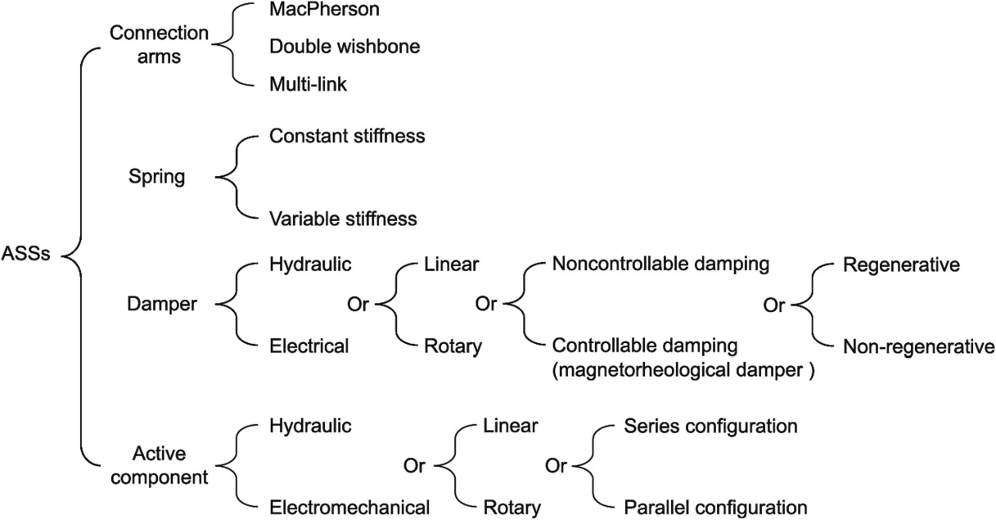
Fig. 1. Categorization of the hardware elements in ASSs according to geometric characteristics and functions.

Active Component
A fully active suspension system introduces an active component that independently exerts a force or torque between the sprung and unsprung masses. A fast response (i.e., a wide-frequency bandwidth) in the force or torque is always pursued in order to implement both chassis attitude stabilization (e.g., chassis levelling) and vehicle vibration attenuation at different frequencies of interests. Regarding the actuation type, electromechanical (e.g., Michelin in-wheel active suspension in 2004 and the Audi Predictive Suspension System in 2017 ) and hydraulic actuators (e.g., the hydractive suspension equipped in the Citroën C5 II in 2007 ) have been reported, and their strengths and weaknesses in ASS applications are compared in the table below. According to the geometric layout, the active component in an ASS can be categorized as series (e.g., series active variable geometry suspension) or parallel (e.g., parallel active link suspension (PALS)).

Actuator | Strengths | Weaknesses
 | Very high force density | Low efficiency
 | Ease of control | Relatively slow response
Hydraulic | Ease of design | Possible environmental pollution (leaks)
 | Commercial availability | Heavy
 | Reliability | Bulky
 | High efficiency | Low force density
Electromagnetic | Fast response  Regenerative capabilities  Accurate force control | High current and/or voltage requirements  Cost  Packaging

Electromechanical Active Suspensions
In recent years, electronic suspension control systems have been developed and successfully introduced into the market. Their purpose is to improve ride comfort as well as lateral dynamics of the vehicle. These active body and roll control systems are nearly exclusively based on hydraulic actuators. Their function is well accepted and satisfying, yet hydraulic systems suffer from various disadvantages, such as high energy consumption, problems with dirt contamination, and costly assembly of the various components of the system. Furthermore, their compatibility with future hybrid vehicles is limited. The goal of development was therefore to design and build an active body control system based on electromechanical actuators.
For the desired functionality to be achieved, the vehicle has to be equipped with individually controllable actuators on each wheel for modulation of the vertical forces between the body and the tire-contact centres. In contrast to common levelling systems, displacement of the spring must happen within milliseconds - in compression and in rebound direction. The required adjustment forces and travels and the available installation space were derived from an upper-class sedan chosen as demonstrator vehicle. A particular challenge is presented by the need to integrate the entire drive unit into the suspension dome on both axles with all their different restrictions.
Similar to common active hydraulic systems, the spring seat of the suspension spring according to the Fig 2, can be displaced, which in this case is done by an electric motor. By means of the connected spindle drive, it is possible to provide both, compressive as well as tensile forces.
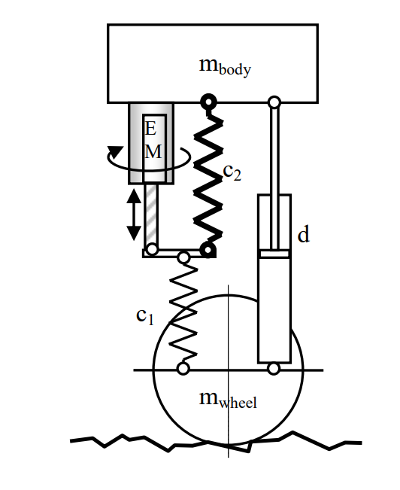
Fig.2. scheme if an electromechanical suspension

To reduce electrical power requirement, a second so-called accumulator spring, which carries the static vertical load, is added in parallel to the electric motor. Apart from covering losses, the average power demand is zero, the second advantage over conventional systems. Only changes in the stationary load conditions of the vehicle result in permanent setting forces. As these forces are small, the energy needed can constantly be supplied by the vehicle electrical system. By these measures, and with the energy recovery capability of the electric motor running alternately in generator mode taken into account, a substantial reduction of power consumption is obtainable compared to hydraulic systems, which need at least one permanently driven pump.

The detailed design
the detailed design starts with dimensioning the main components, i.e. electric motor, coil springs, spindle drive, damper, stops, and the top mount. A compromise has to be found to achieve the required dynamic behaviour and to fulfil the limited package specification at the same time. The leading parameters, motor torque and spindle ratio, have to be considered, as well as limited electrical peak current and minimal rotor inertia.
Figure 3 shows a cutaway of the detailed strut assembly, including the electromechanical actuator. The length of the strut is determined by the two coil springs, the suspension travel and the actuator travel, which in turn depends on the stiffness of the two springs. The outer diameter is given by the required motor torque, spring stiffness and actuator travel of the accumulator spring. The whole drivetrain of the actuator is identical on both axles to enable cost-effective manufacture. As known from passive suspensions, the damper, the springs and parts of the housing and strut mounts are adapted to the different packages, wheel loads, and suspension ratios.
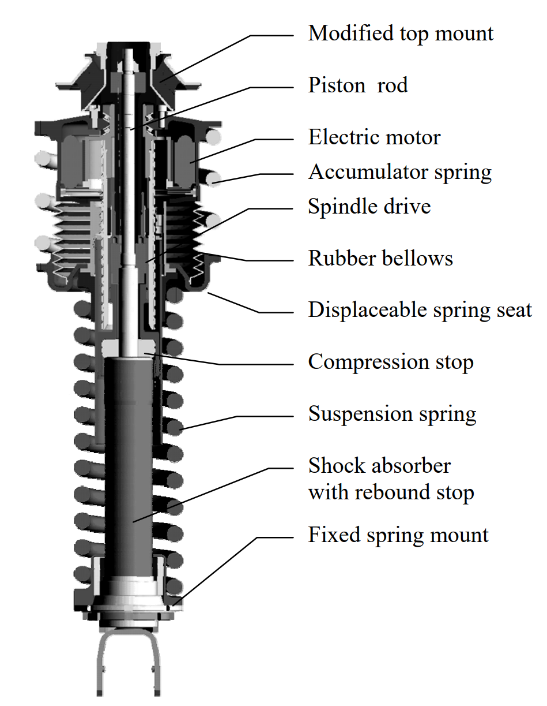
Figure 3: Cutaway of detailed design

3D Modelling in SolidWorks

Design Approach
In this project, a bottom-up approach was employed for 3D modeling in SolidWorks to ensure a structured and efficient design process. This method involves creating individual components separately before assembling them into a complete system.
The bottom-up approach was chosen for several reasons:
- Modular Design and Flexibility
Each component was designed independently, allowing for greater control over individual part geometry and properties. This modular approach facilitated easy modifications and iterative improvements without affecting the entire assembly.
- Improved Accuracy and Standardization
By designing each component separately, precise dimensional control was maintained, ensuring proper fitment and alignment within the assembly. This approach also helped in standardizing parts for potential reuse in future designs.
- Efficient Assembly and Simulation
Since each component was pre-defined with its constraints and features, assembling them was more straightforward and systematic. It also allowed for early identification of interference issues and ensured that each part functioned correctly before integrating it into the full system.
- Optimized Performance for FEA and Simulation
Creating well-defined individual components enabled efficient Finite Element Analysis (FEA), as material properties, boundary conditions, and loads could be applied precisely at the component level before evaluating the overall system.
By leveraging the bottom-up approach, a robust, modular, and efficient 3D model of the active suspension system was developed, ensuring both accuracy in design and ease of analysis.

Predesign Considerations and Simplifications
During the 3D modeling and Finite Element Analysis (FEA) stages, certain simplifications were made to ensure a feasible and efficient workflow while maintaining the integrity of the analysis. One of the primary considerations was the exclusion of the controller components, specifically the DC motor and lead screw mechanism, from the SolidWorks model and FEA simulations.
The decision to omit these parts was based on the following key factors:
- Lack of Sufficient Technical Data
The absence of a datasheet or detailed specifications for the DC motor and lead screw made it impractical to create an accurate 3D model. Without precise dimensions, material properties, and performance characteristics, any attempt to model these components would introduce significant uncertainties.
- Complexity in FEA Simulations
The inclusion of the motor and lead screw in FEA simulations would have significantly increased the computational complexity without adding meaningful insights into the structural performance of the suspension system. These components primarily contribute to actuation rather than structural integrity, making their direct FEA evaluation less relevant.
- Focus on Structural Integrity
The primary objective of the FEA was to analyze the mechanical strength, deformation, and stress distribution of the suspension components under loading conditions. Since the DC motor and lead screw act as actuators rather than load-bearing structural elements, their omission allowed for a more focused and rational analysis of critical components.
- Inclusion in MATLAB Simscape Model
While the motor and lead screw were excluded from the 3D model and FEA, they were incorporated into the MATLAB Simscape simulation, where their dynamic behavior and control aspects could be properly modeled and analyzed. This ensured that the system's overall functionality was still evaluated, particularly in terms of control response and actuation performance.
By making these considered simplifications, the study remained both practical and accurate, focusing on relevant structural and control aspects in their respective domains (SolidWorks for mechanical design and FEA, MATLAB Simscape for system dynamics and control).

Component Design

Main Components of the Suspension System
The suspension system modelled in this project consists of several key mechanical components that work together to provide stability, load distribution, and dynamic performance. Each component plays a crucial role in ensuring the proper functioning of the system. The primary elements include:
- Upper and Lower Wishbones (Control Arms)
The wishbones, also known as control arms, form the foundation of the suspension system. These components are responsible for guiding the wheel’s motion, maintaining proper alignment, and ensuring controlled articulation. The upper and lower wishbones are connected to the chassis on one side and to the upright on the other, allowing for smooth vertical movement while keeping the wheel in an optimal position.

- Spring and Damper Assembly
The spring absorbs shocks and maintains the vehicle’s ride height, while the damper (shock absorber) dissipates kinetic energy to prevent excessive oscillations. This combination ensures a balance between comfort and handling performance, effectively reducing vibrations from road irregularities.

- Upright (Knuckle)
The upright (or steering knuckle) serves as the central connection point between the upper and lower wishbones, wheel hub, and suspension system. This component is responsible for transferring forces between the wheel and the suspension structure, ensuring controlled movement and steering response. The upright also houses mounting points for other crucial elements such as the brake assembly and steering linkage.
Each of these components will be further analyzed in the following sections, detailing their design approach, material selection, and functional role within the system.

Upper and Lower Wishbone
The wishbones, also known as control arms, are critical components of the suspension system, responsible for guiding the wheel’s motion while maintaining structural stability. These components form an A-shaped or V-shaped structure, with the upper wishbone positioned above and the lower wishbone below the wheel assembly.
Both wishbones play a vital role in:
- Controlling the vertical movement of the wheel while allowing for suspension travel.
- Ensuring proper alignment and reducing unwanted wheel tilt (camber change) during motion.
- Providing a stable connection between the wheel assembly and the chassis through pivot points.
The following section presents detailed 3D models of both the upper and lower wishbones, showcasing their design and functional aspects.
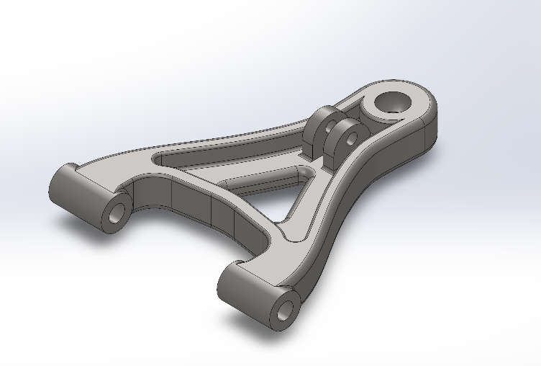
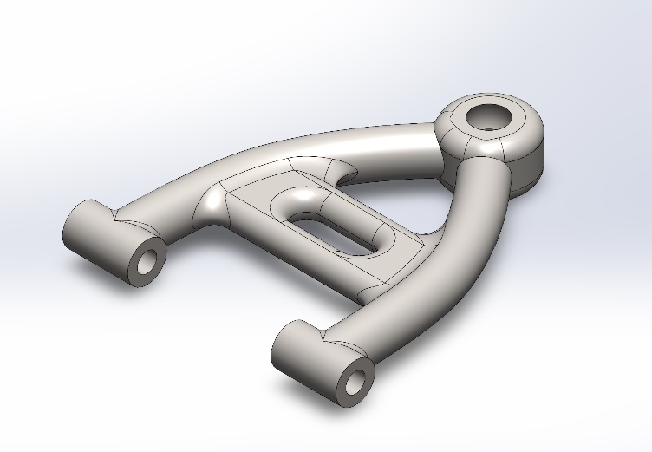

Upright (Knuckle)
The upright, also known as the knuckle, is a structural link that connects the upper and lower wishbones to the wheel assembly. It serves as the central hub where various suspension and steering components are mounted.
Its primary functions include:
- Providing a rigid connection between the wheel hub and suspension system.
- Allowing for steering movement while maintaining wheel alignment.
- Distributing forces between the suspension, braking, and steering systems.
The upright also houses mounting points for the wheel hub, brake assembly, and tie rods, making it an essential component for both suspension movement and steering response. The following section showcases 3D models of the upright, demonstrating its design and interaction with other suspension components.
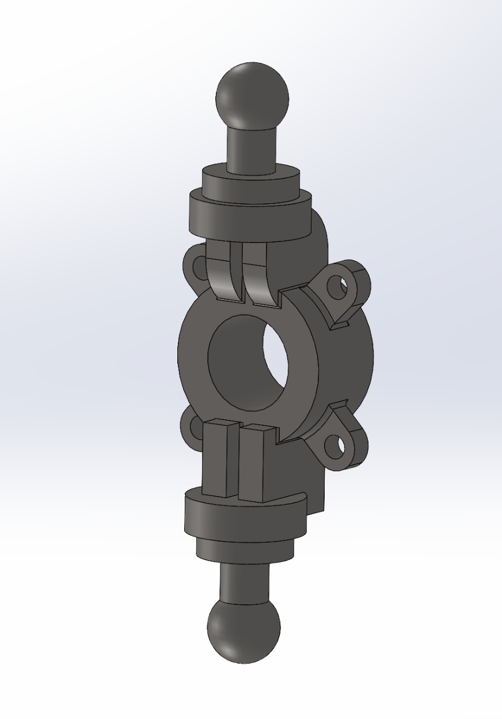

Spring and Damper
The spring and damper assembly is a crucial part of the suspension system, responsible for absorbing shocks and maintaining vehicle stability. The spring stores and releases energy to support the vehicle’s weight and absorb road irregularities, while the damper (shock absorber) dissipates this energy to prevent excessive oscillations and improve ride comfort.
Key functions of the spring and damper assembly include:
- Absorbing and dissipating impact forces from road disturbances.
- Controlling suspension movement to maintain stability and handling.
- Enhancing ride comfort by reducing vibrations and sudden jolts.
The damper works by converting kinetic energy into heat, ensuring that the suspension returns to its normal position smoothly after compression. The following section presents detailed 3D models of the spring and damper components, highlighting their design and placement in the system.

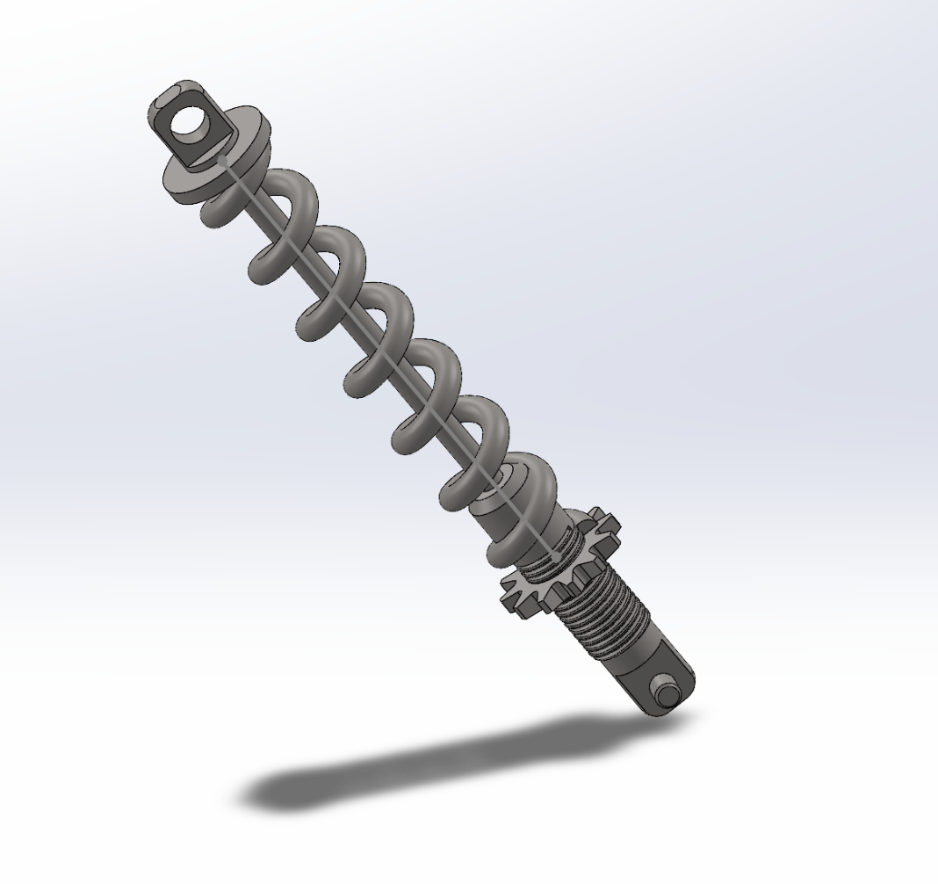

Whole Parts Assembly
The assembly process in SolidWorks involves bringing together individual components to form a fully functional suspension system. By defining proper mates and constraints, the motion and interaction between parts can be accurately simulated.
In this project, the suspension system assembly consists of the following key elements:
- Upper and Lower Wishbones – Connected to the upright and chassis, allowing controlled movement.
- Upright (Knuckle) – Acts as the central hub, linking the wishbones to the wheel assembly.
- Spring and Damper – Mounted between the chassis and wishbones to provide shock absorption and stability.
The assembly design process followed a bottom-up approach, meaning each component was modeled separately before being integrated into the full system. Special attention was given to ensuring proper alignment, realistic movement, and structural integrity.
The following section presents 3D images of the assembled suspension system, illustrating how the components interact within the final design.
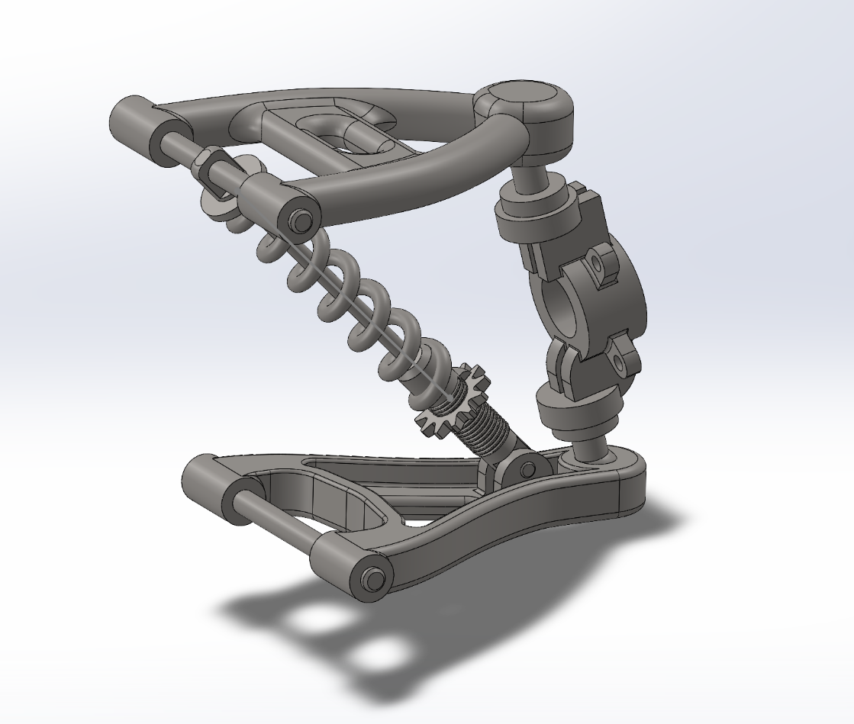

Motion Study of the Suspension System

To analyze the dynamic behavior of the suspension system, a motion study was conducted in SolidWorks. This study allows for the simulation of suspension movement under various conditions, demonstrating how the components interact in real time.
One key aspect of the motion study is the spring deformation during suspension travel. Instead of manually defining a fixed-length spring, the spring length was left partially undefined, allowing SolidWorks to automatically adjust its length based on the movement of the suspension. This was achieved by:
- Applying a mate constraint between the spring ends and their respective seats on the damper.
- Allowing the software to recalculate the spring’s length dynamically as the suspension compresses and rebounds.
This method provides a realistic representation of how the spring reacts to motion, making it possible to visually assess the compression and expansion behavior during suspension travel. The motion study also helps validate the overall design by ensuring that the system moves as expected without interferences or unrealistic constraints.
The following section presents snapshots from the motion study, illustrating the movement of the suspension and the dynamic response of the spring.
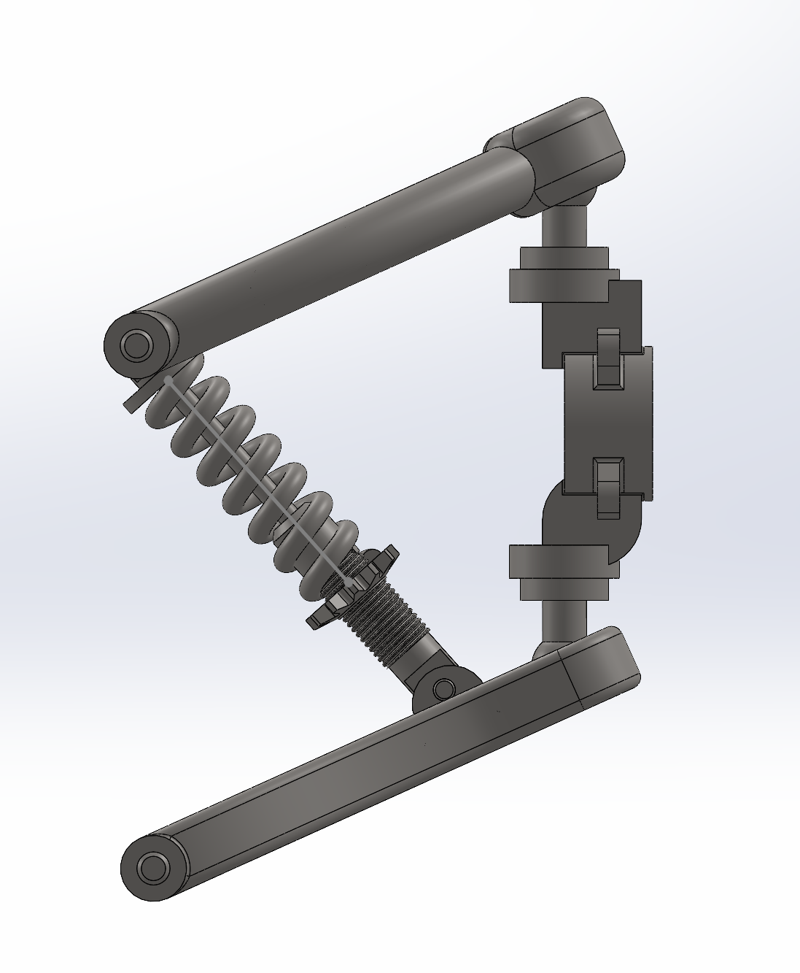 | 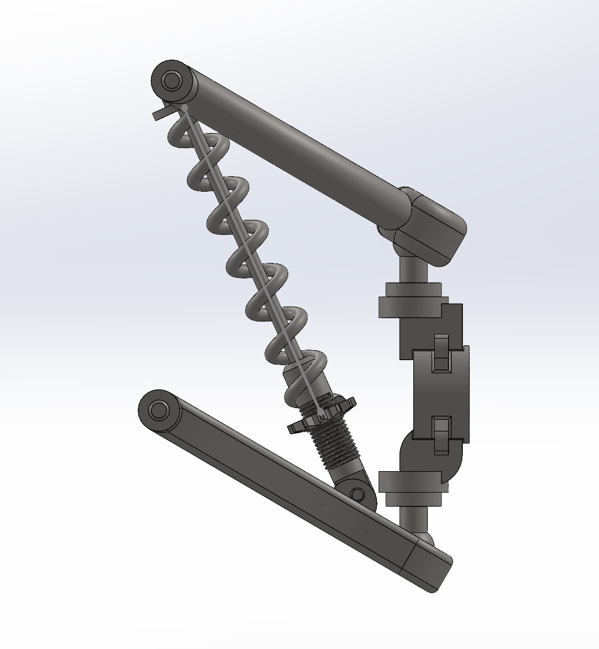

Finite Element Analysis (FEA) in SolidWorks

FEA Setup
Before performing Finite Element Analysis (FEA) on the suspension system, several critical steps were taken to ensure accurate and reliable simulation results. These steps involved defining the material properties, connections, fixtures, and external loads, which are essential for simulating real-world behavior under operational conditions.
The FEA setup included the following key considerations:
- Material Definition – Assigning appropriate materials to each component based on their real-world counterparts to ensure accurate structural properties such as elasticity, strength, and density.
- Connections – Defining the interactions between different parts, such as bonded or contact connections, to accurately represent their physical behavior.
- Fixtures (Boundary Conditions) – Applying constraints to simulate how the suspension system is mounted and supported, ensuring realistic load distribution.
- External Loads – Applying forces that the system would experience during operation, such as road forces and weight loads, to analyze stress, deformation, and performance under real conditions.
Once these parameters were set, the next step involved meshing the model, which discretizes the geometry into smaller elements for numerical analysis. The following sections provide a detailed breakdown of each step, explaining their role in achieving a precise and meaningful FEA simulation.

Material Definition
- 1. Wishbones and Knuckle – Steel 1.7225 (42CrMo4) [1]
The wishbones and knuckle are critical suspension components that must withstand high loads, impact forces, and fatigue stress while maintaining structural integrity. Steel 1.7225 (42CrMo4) was chosen due to the following reasons:
- High Strength and Toughness:
42CrMo4 is a chromium-molybdenum alloy steel, providing excellent mechanical strength (yield strength ~900 MPa, tensile strength ~1100 MPa) and toughness, essential for resisting bending and torsional loads in suspension systems.
- Good Fatigue Resistance:
Suspension components experience repeated loading, and 42CrMo4 exhibits superior fatigue resistance, reducing the risk of failure over time.
- Excellent Hardening Capability:
This steel can be heat-treated and tempered to achieve the optimal balance of hardness and ductility, ensuring durability under real-world driving conditions.
- Wear and Impact Resistance:
The addition of chromium and molybdenum enhances wear resistance and impact absorption, which is crucial for parts exposed to road irregularities and high dynamic forces.
- Machinability and Weldability:
While 42CrMo4 is not highly weldable, it offers good machinability, making it suitable for precision manufacturing processes.
Thus, Steel 1.7225 (42CrMo4) is an ideal choice for wishbones and knuckles due to its high strength, fatigue resistance, and impact toughness, ensuring reliability and performance under dynamic conditions.

- 2. Spring and Damper – 51CrV4 (AISI 6150) Spring Steel [2]
The spring and damper system must provide elasticity, strength, and durability, making 51CrV4 (AISI 6150) Spring Steel a suitable choice due to the following properties:
- High Elasticity and Fatigue Strength:
51CrV4 is a chromium-vanadium alloy spring steel, known for excellent elasticity and high fatigue resistance, which is essential for absorbing shocks and maintaining consistent performance over time.
- Superior Hardness and Wear Resistance:
The presence of chromium enhances surface hardness and wear resistance, ensuring longevity in a high-stress environment.
- Good Toughness and Ductility:
This material retains sufficient toughness, preventing sudden fractures and allowing for safe energy absorption under extreme loads.
- Heat Treatment Capability:
51CrV4 can be hardened and tempered to achieve an optimal combination of strength and flexibility, ensuring long-term reliability.
- Corrosion Resistance:
While not as corrosion-resistant as stainless steel, 51CrV4 offers moderate resistance to oxidation, particularly when coated or treated.
Therefore, 51CrV4 (AISI 6150) is an ideal material for springs and dampers, ensuring excellent fatigue resistance, elasticity, and durability, which are crucial for maintaining suspension performance.

Connections
- 1. Pins (Zero Rotational Stiffness)
The pins in the assembly serve as pivot points, allowing free rotation of connected components. Since they do not resist rotational forces or transfer torque, their rotational stiffness is set to zero in SolidWorks Simulation.
Justification:
- Pins primarily function as rotational axes, meaning they must allow free movement without restricting motion.
- Assigning zero rotational stiffness accurately reflects real-world conditions and prevents artificial constraints in the simulation.
- This ensures that forces and moments are distributed realistically across the structure.

- 2. Spring Connector (Replacing Physical Spring with Simulation Connection)
The spring is modeled as a spring connection in SolidWorks Simulation instead of a physical 3D coil. This approach improves computational efficiency while maintaining accurate behavior.
Justification:
- Computational Efficiency: A simplified spring model reduces computational cost while preserving accuracy.
- Accurate Force-Displacement Representation: The simulation recognizes the spring’s stiffness properly without complex meshing.
- Spring Stiffness Value (3.5×10⁷ (N/m)/m²):
  - This value is based on real-world automotive suspension springs.
  - It falls within the expected range for high-performance vehicle suspension, ensuring a realistic dynamic response.
  - The value aligns with typical spring stiffness calculations considering material properties and geometry.
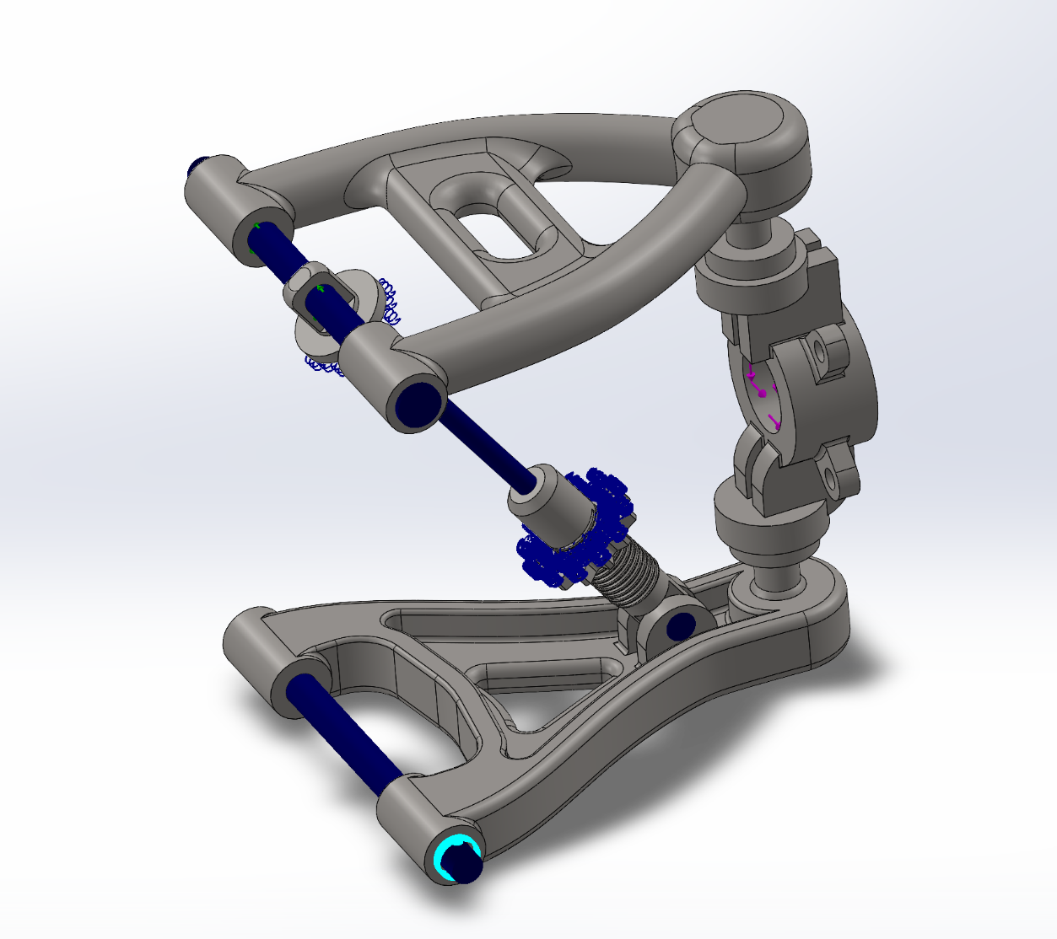

Fixture Selection
In the simulation setup, a fixed hinge fixture is applied to the lower and upper pins of the suspension system. This decision is based on the real-world constraints and movement of the suspension components.
- Justification for Using a Fixed Hinge on the Pins
- The lower and upper pins are directly attached to the chassis, meaning they serve as fixed mounting points and do not move relative to the car frame.
- In reality, these pins act as pivot points, allowing the suspension components to rotate around them while keeping them structurally anchored.
- Applying a fixed hinge fixture in SolidWorks accurately restricts translational movement while allowing rotational freedom, replicating their actual function.
- Freedom of Movement for Other Suspension Parts
- The other parts of the suspension system (such as the wishbones and knuckle) connect to the wheel, which must be free to move to accommodate road conditions and steering inputs.
- Constraining these parts would incorrectly restrict movement, leading to inaccurate results in the simulation.
- By keeping the wheel-side components free to move, the simulation properly captures suspension articulation and load distribution.
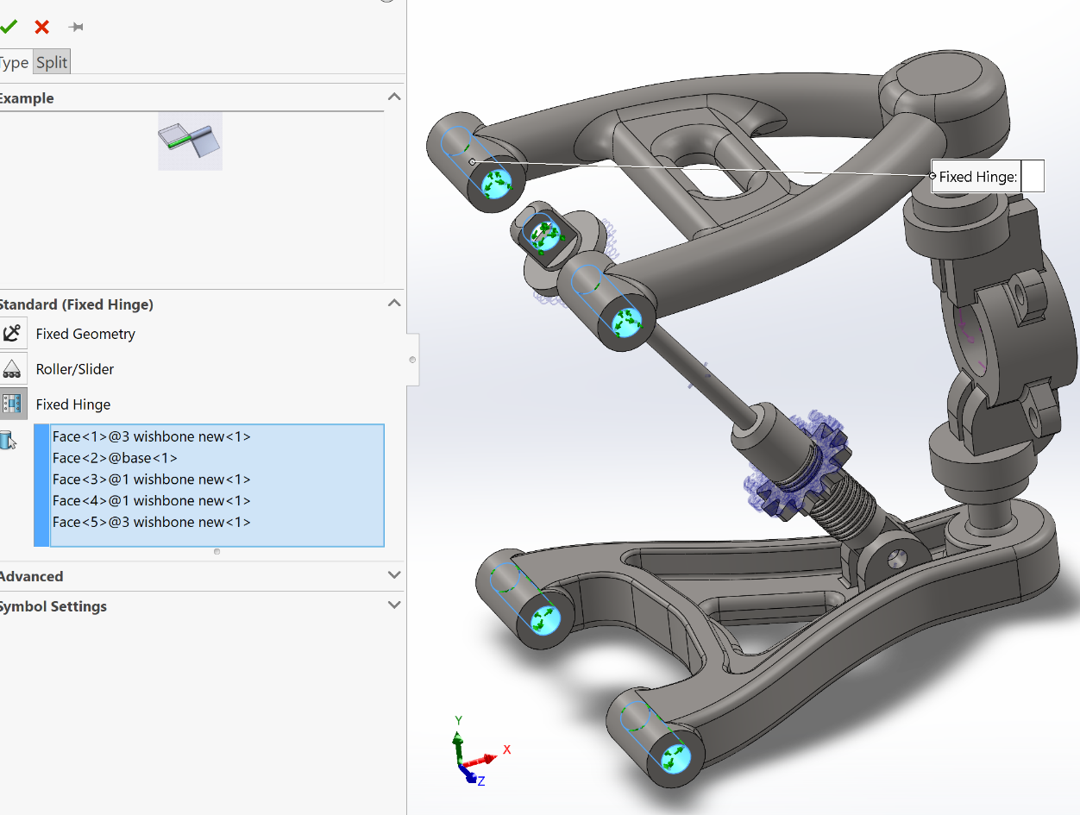

External Loads
- 1. Vertical Force (3675 N per Wheel)
The vertical force represents the load acting on each wheel due to the vehicle's weight. In this simulation, a value of 3,675 N per wheel was selected based on a standard vehicle weight distribution.
Justification:
- The total vehicle weight is estimated at 1,500 kg, resulting in a total gravitational force of:
F=mg=1,500×9.81=14,700 N
- Assuming an even weight distribution across four wheels, the vertical force per wheel is:
14,700/4=3,675 N per wheel
- This value is within the expected range for passenger vehicles and light sports cars, ensuring realistic suspension loading conditions.

- 2. Longitudinal Force (375 N per Wheel)
The longitudinal force accounts for acceleration and braking effects. A value of 375 N per wheel was selected to represent a moderate braking or acceleration scenario.
Justification:
- For a deceleration or acceleration of 1 m/s², the total force acting on the vehicle is:
F=ma=1,500×1=1,500 N
- Distributed evenly across four wheels:
1,5004=375 N per wheel
- This force level represents a moderate braking or acceleration condition, aligning with typical road vehicle performance.

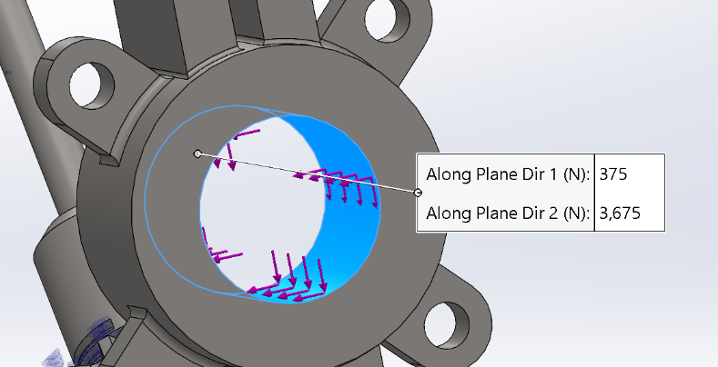

FEA Meshing Procedure and Refinement

To ensure the accuracy and reliability of the Finite Element Analysis (FEA) results, a systematic meshing approach was followed. The meshing process plays a crucial role in determining the precision of stress distribution and deformation calculations. To achieve an optimal balance between computational efficiency and result accuracy, the following three-step refinement process was implemented:
- Initial Low-Quality Mesh
  - A relatively coarse mesh was first applied to the entire model to conduct a preliminary analysis.
  - This helped in identifying critical stress regions while maintaining a lower computational cost.

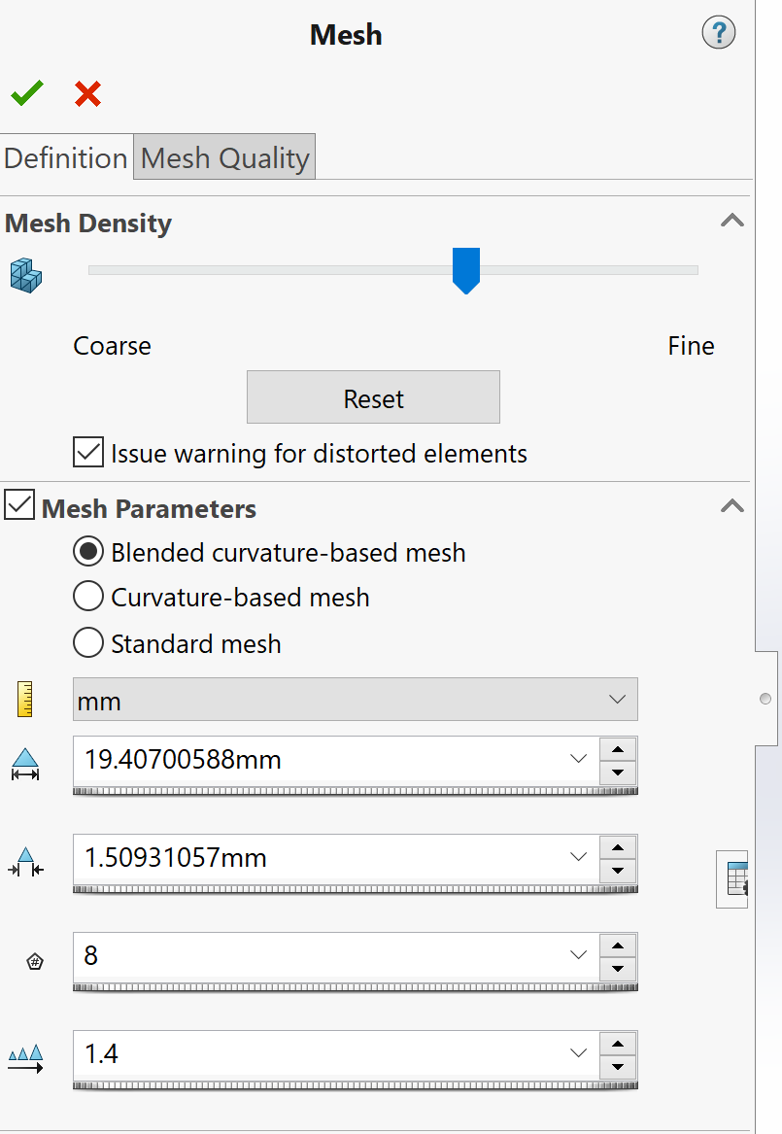  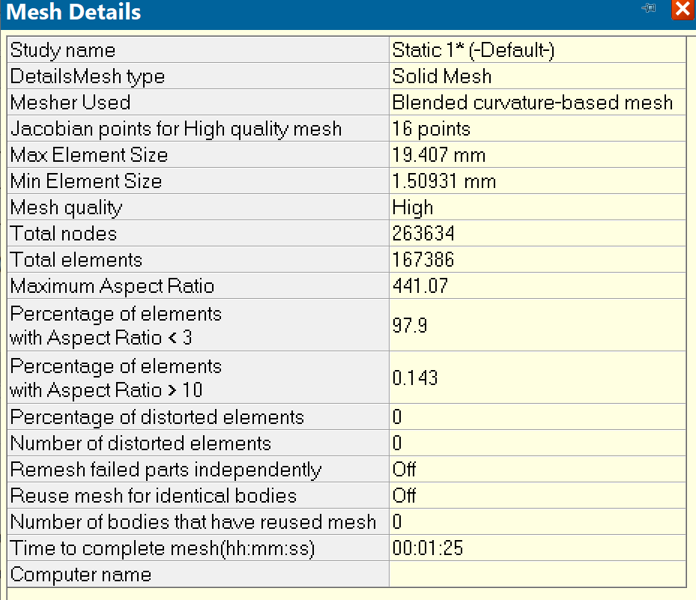 | 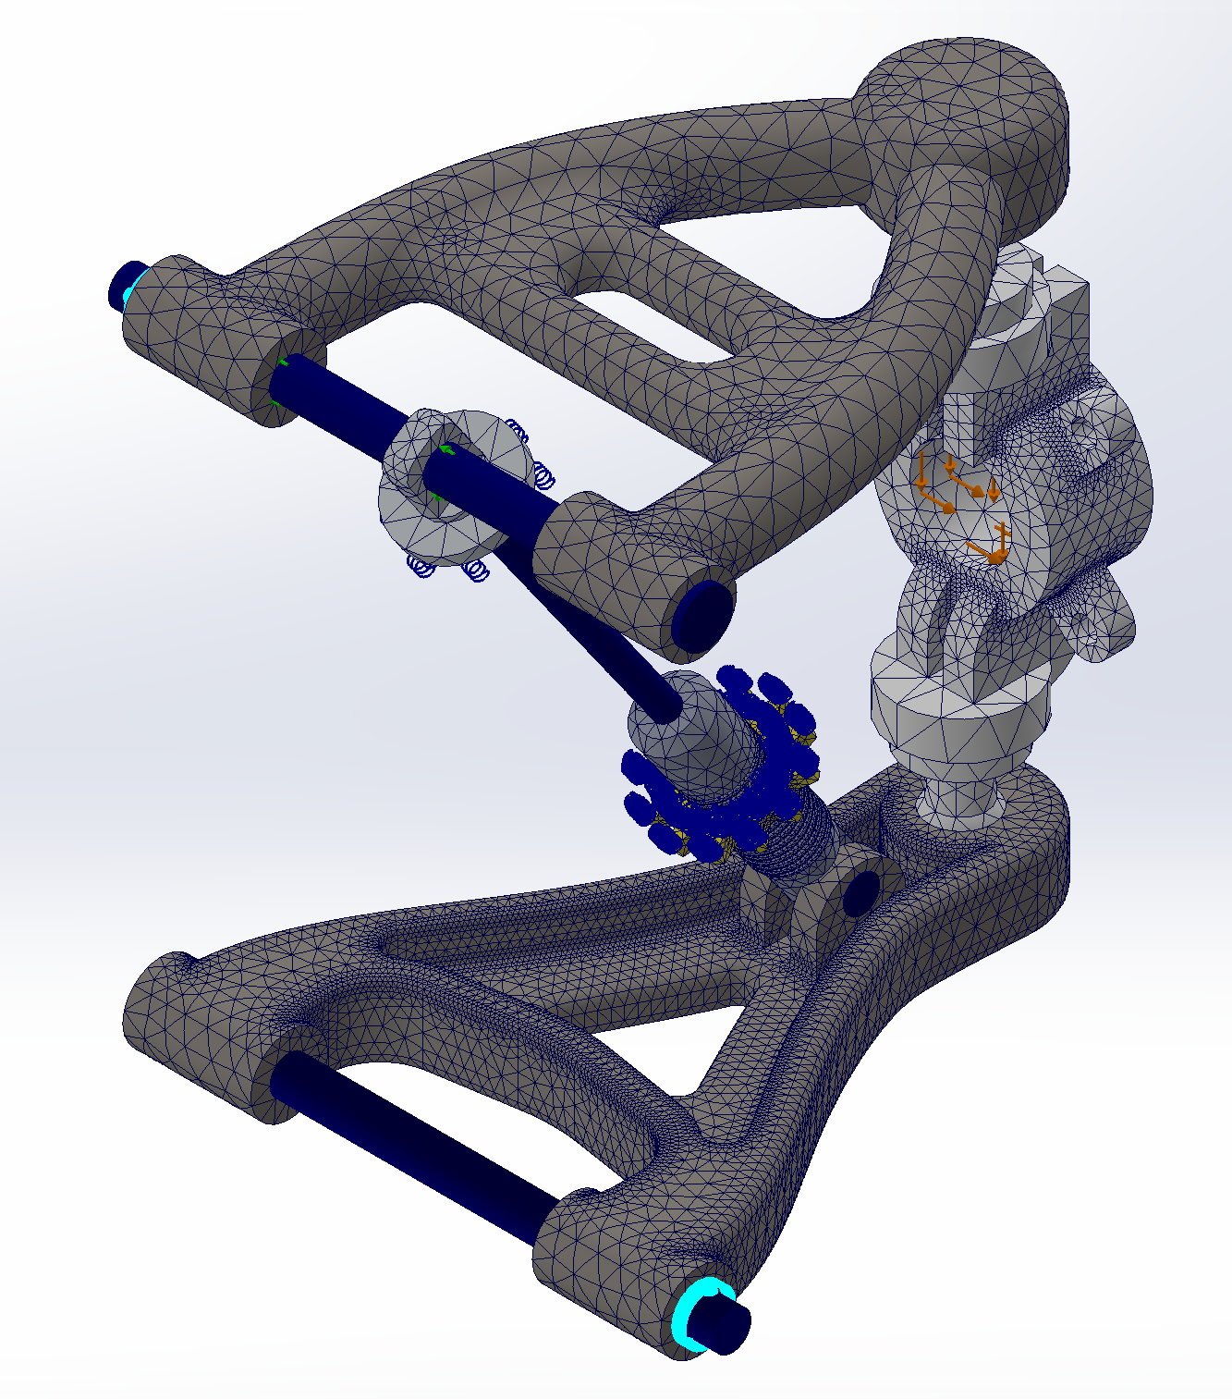

The result in MPa:
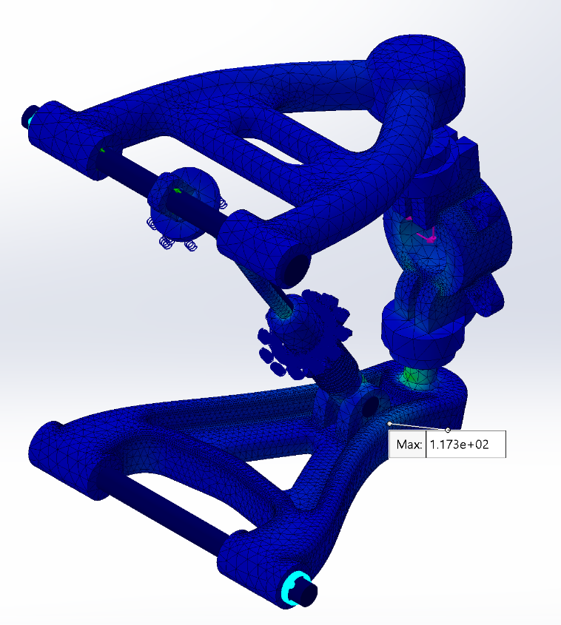
- High-Quality Global Mesh Refinement
  - The mesh was then globally refined to improve the resolution of stress and strain distribution.
  - This step ensured that results became more accurate while maintaining an optimal element size across the model.

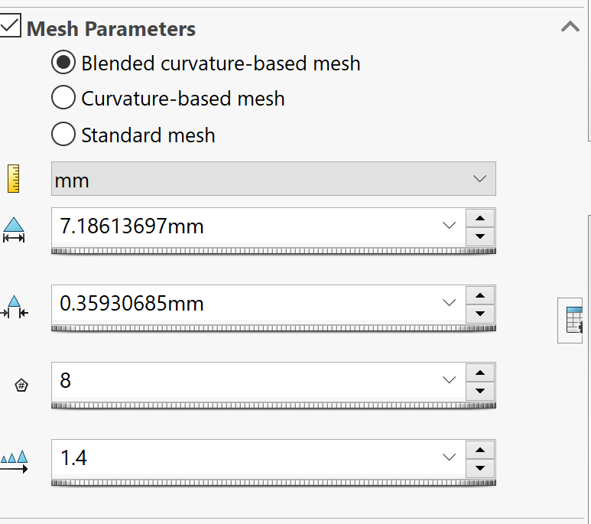 | 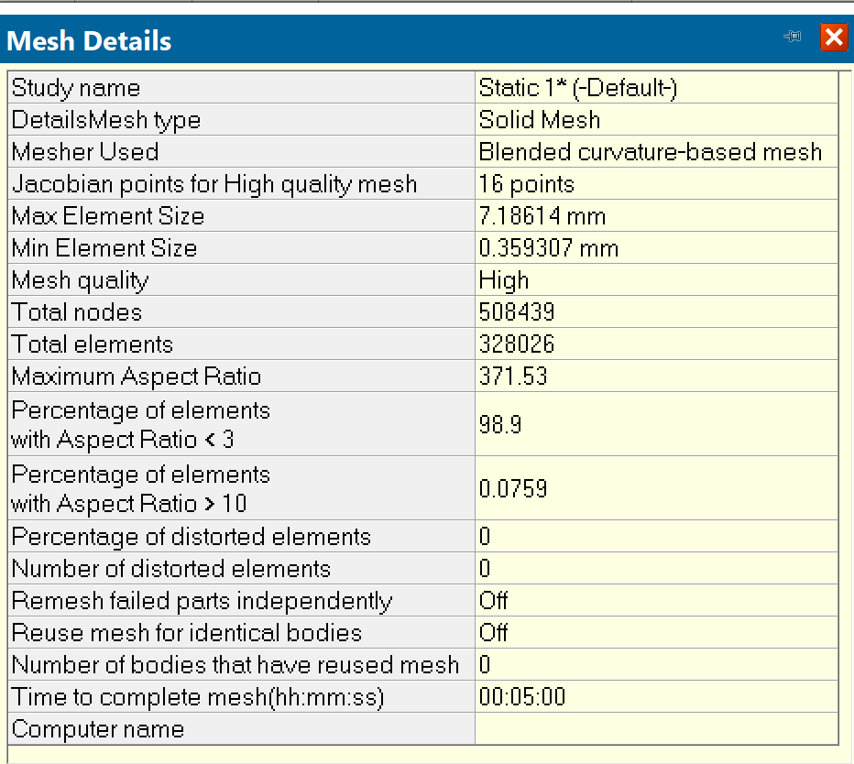
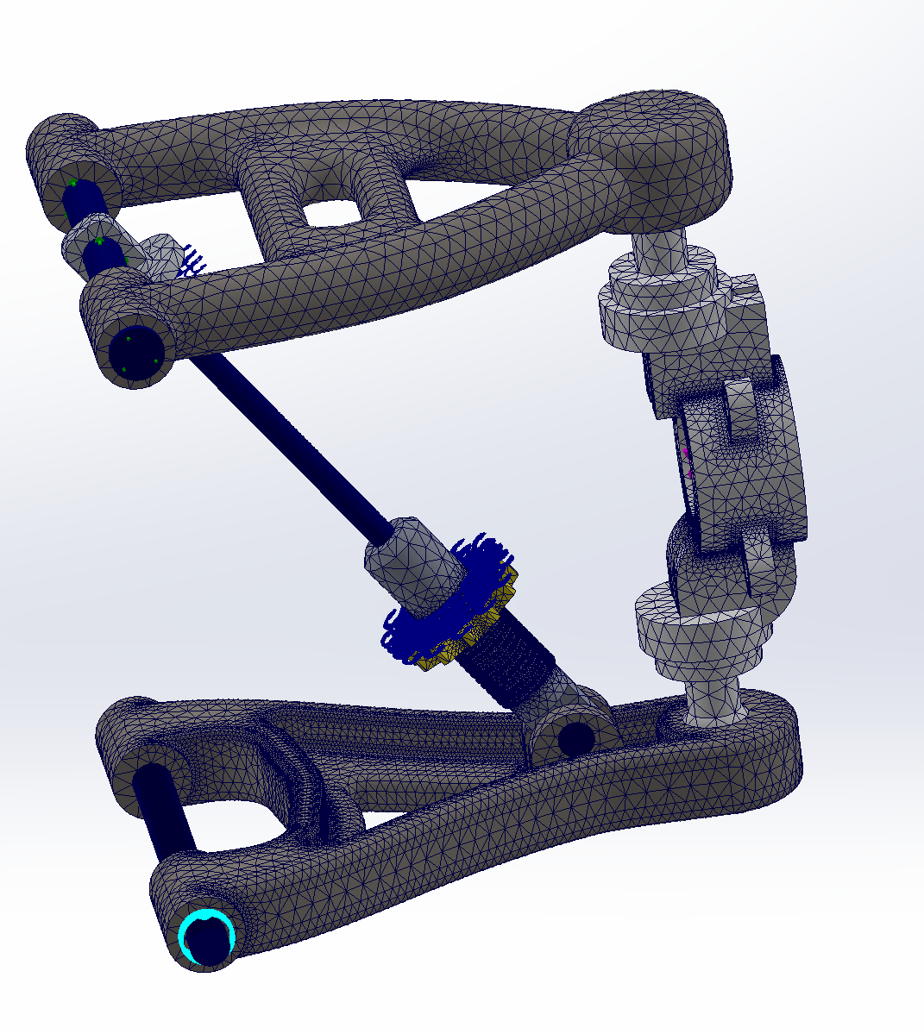
The maximum stress result in MPa:
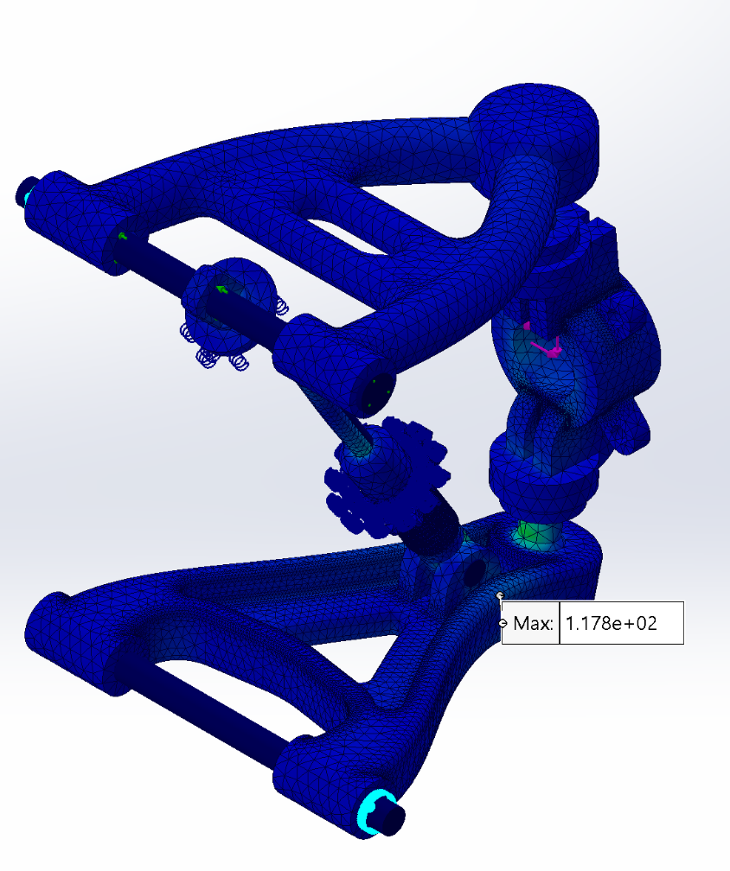
- Localized Mesh Control for Critical Areas
  - To further enhance accuracy, mesh controls were applied to specific regions that experienced higher stress concentrations in the preliminary analysis.
  - This targeted refinement provided a more precise evaluation of stress distribution in critical components.
By following this progressive meshing strategy, a balance between accuracy, computational efficiency, and reliability was achieved. The following section presents FEA result images, highlighting the impact of meshing refinements on stress distribution and deformation analysis.
Adding mesh control to the more potential areas:
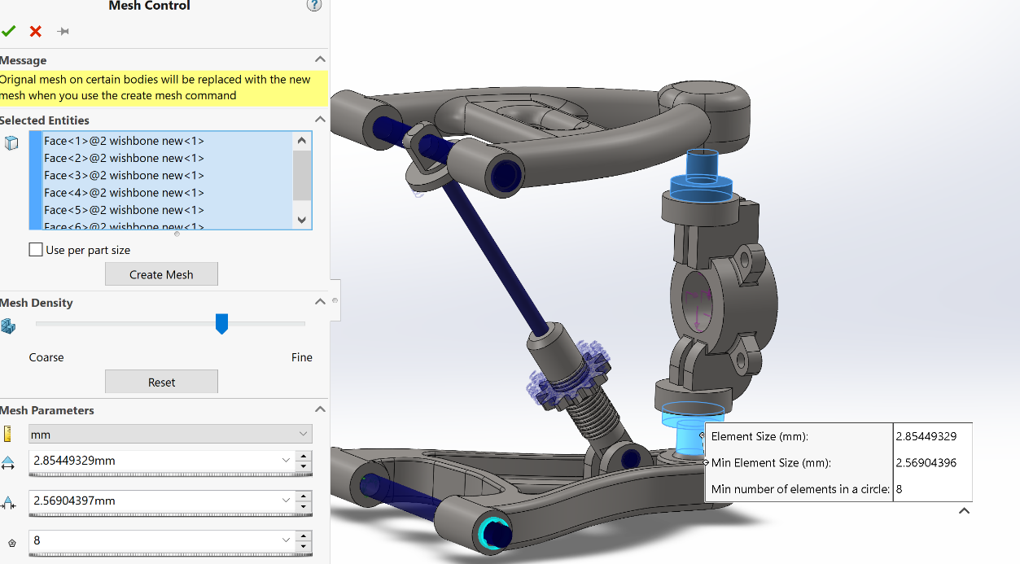
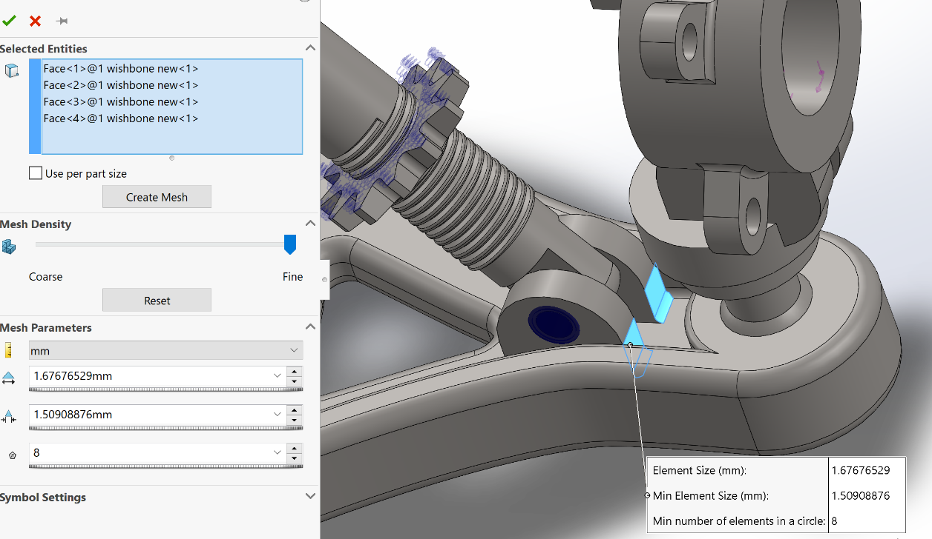
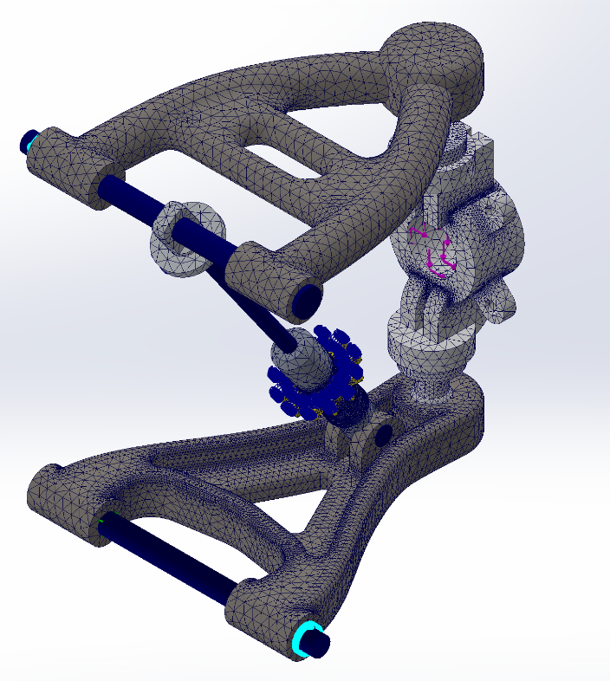
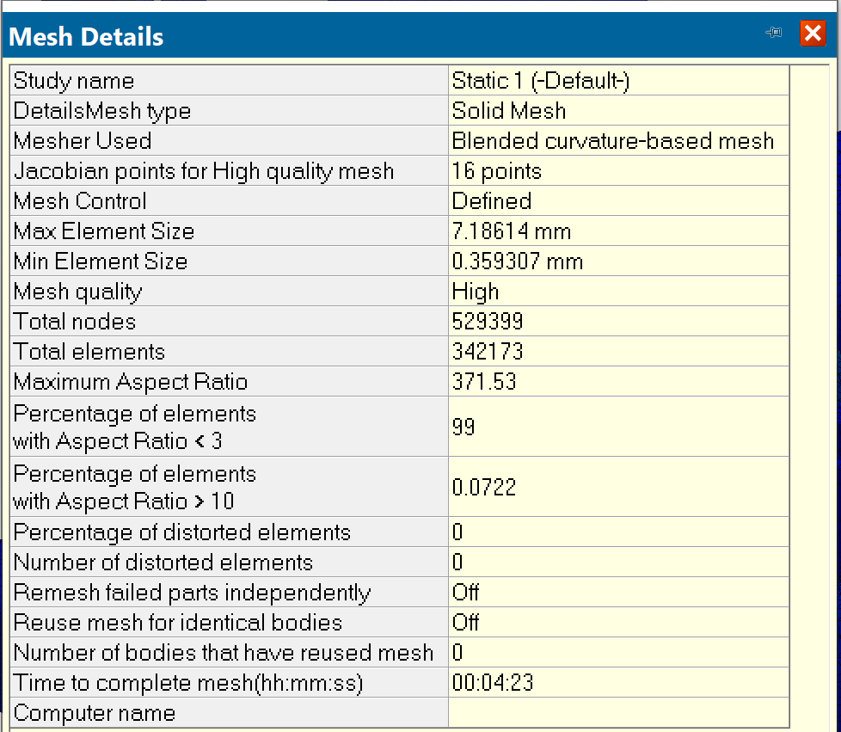

FEA Results and Validation
The Finite Element Analysis (FEA) conducted on the suspension system yielded a maximum stress value of 118 MPa. To assess the structural integrity and safety of the design, this result was compared against the material’s mechanical properties to determine its acceptability.
- Material Selection and Stress Validation
The material used in this analysis possesses the following key properties:
- Yield Strength: (Insert Yield Strength, e.g., 250 MPa)
- Ultimate Tensile Strength: (Insert UTS, e.g., 400 MPa)
- Factor of Safety (FOS) Considerations
Since the maximum stress (118 MPa) is well below the material's yield strength, the structure remains within the elastic deformation range, meaning no permanent deformation or failure is expected under normal operating conditions. Additionally, considering standard engineering safety factors, the obtained stress levels indicate that the design is structurally sound and capable of withstanding applied loads safely.
The following section presents the FEA result images, visually demonstrating the stress distribution across the suspension system.
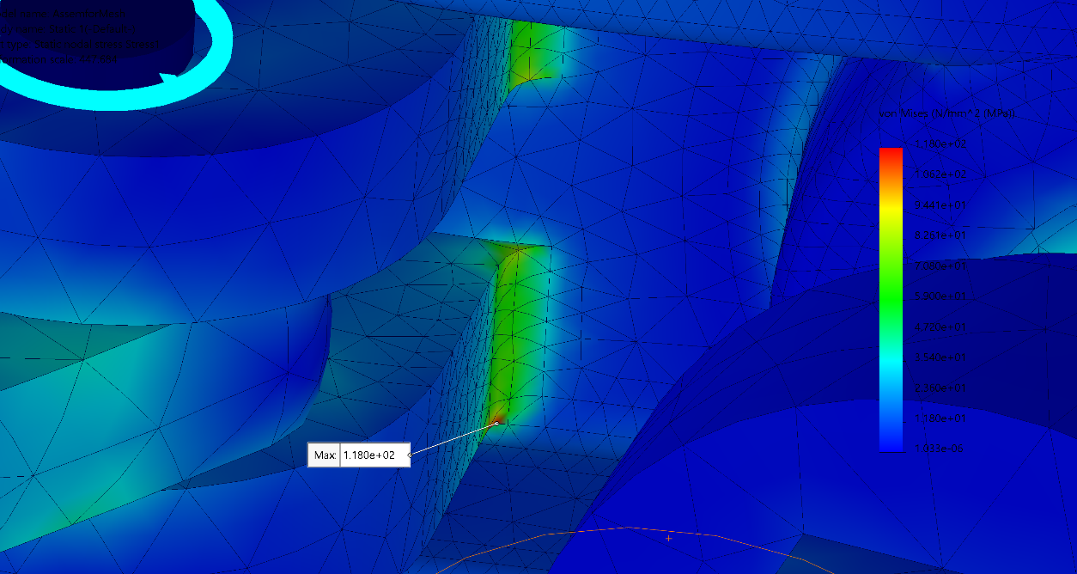
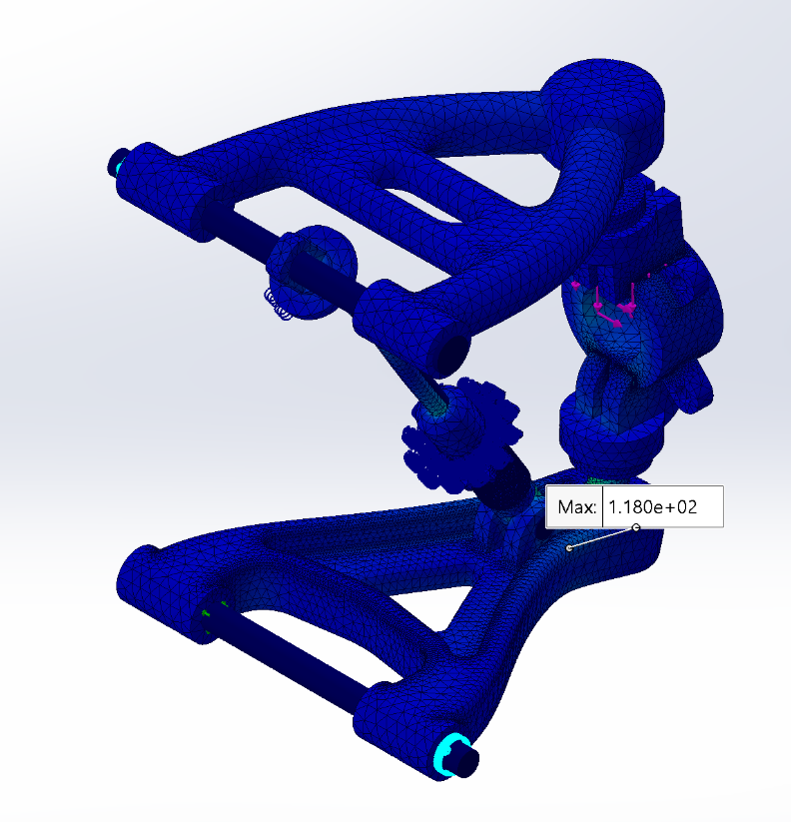

Safety Factor and Displacement Analysis
In addition to stress analysis, Safety Factor and Displacement evaluations were conducted to further validate the structural reliability of the suspension system. These analyses help determine whether the design can withstand applied loads without failure and excessive deformation.
- Safety Factor Analysis
- The Safety Factor (SF) is calculated as the ratio of the material’s yield strength to the maximum stress observed in the FEA results.
- A higher safety factor indicates a more robust and reliable design, while a lower safety factor suggests a higher risk of failure under extreme conditions.
- The results indicate that the minimum safety factor remains within an acceptable range, ensuring that the structure can endure applied loads without risk of yielding.
- Displacement Analysis
- The displacement study helps assess how much the suspension components deflect under loading conditions.
- Excessive displacement could negatively affect handling performance, while minimal displacement ensures structural stiffness and stability.
- The results show that the maximum displacement is within acceptable limits, meaning the system retains its functionality and design integrity.
The following section presents FEA result images, illustrating the stress distribution, safety factor map, and displacement contours across the suspension system.
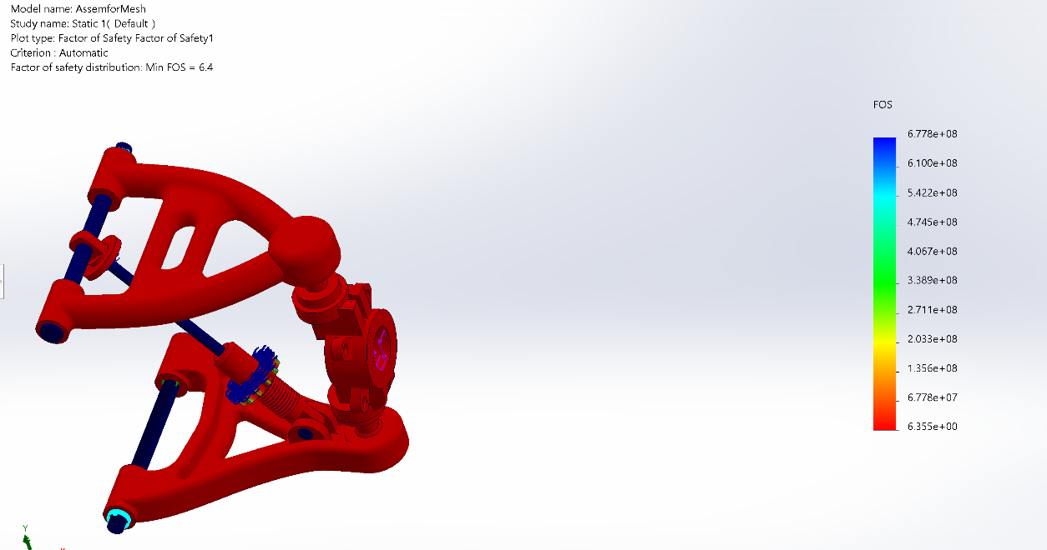
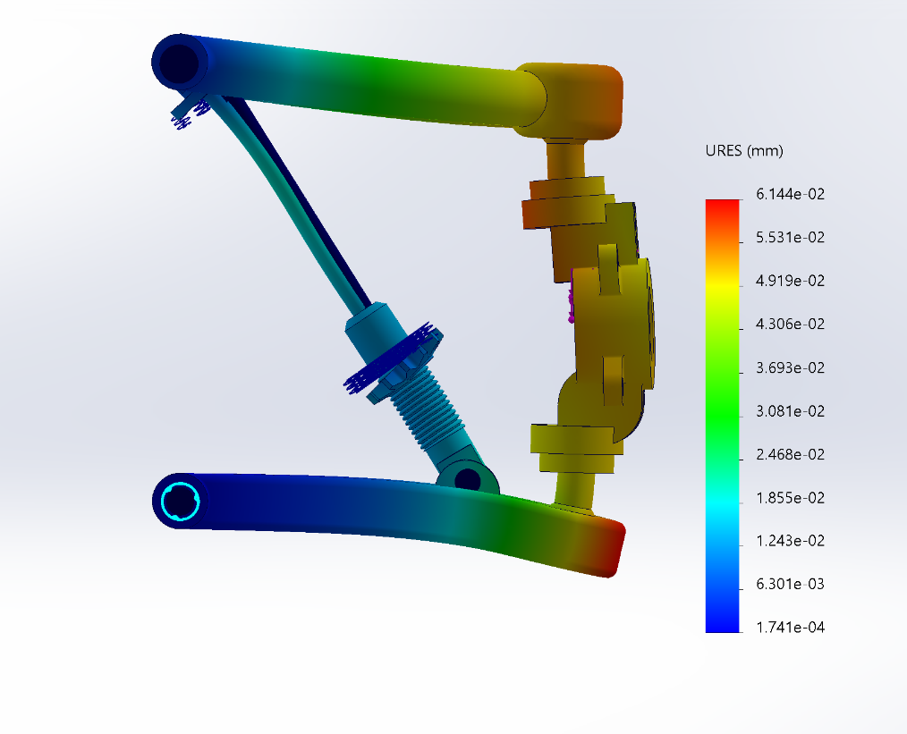

Design Optimization and Stress Reduction
As part of the iterative development process, a redesign was implemented on specific high-stress regions within the assembly. Finite Element Analysis (FEA) previously identified these areas as critical, with a recorded maximum stress of 118 MPa. To address this, modifications were made to the geometry and structure of the components subjected to the highest loads. This involved reinforcing load-bearing features and refining stress concentration points to improve overall mechanical performance.
Following the redesign, updated simulations showed a notable decrease in the peak stress values, with the new maximum stress reduced to 103 MPa. This improvement not only enhances the durability and reliability of the assembly but also brings the stress levels closer to the material’s safety limits, contributing to a more robust and efficient design.
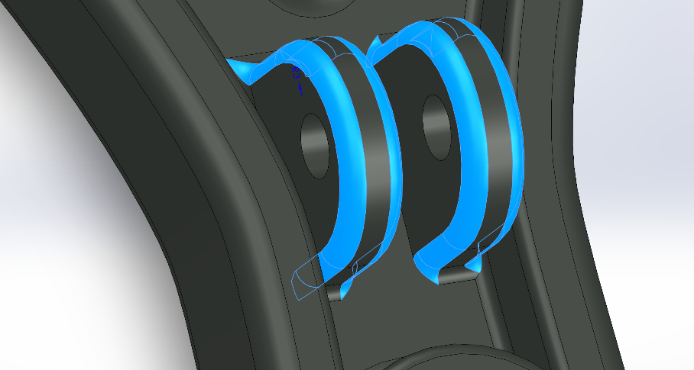
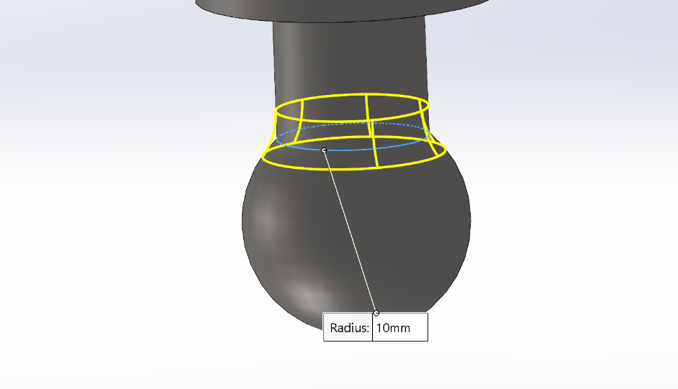

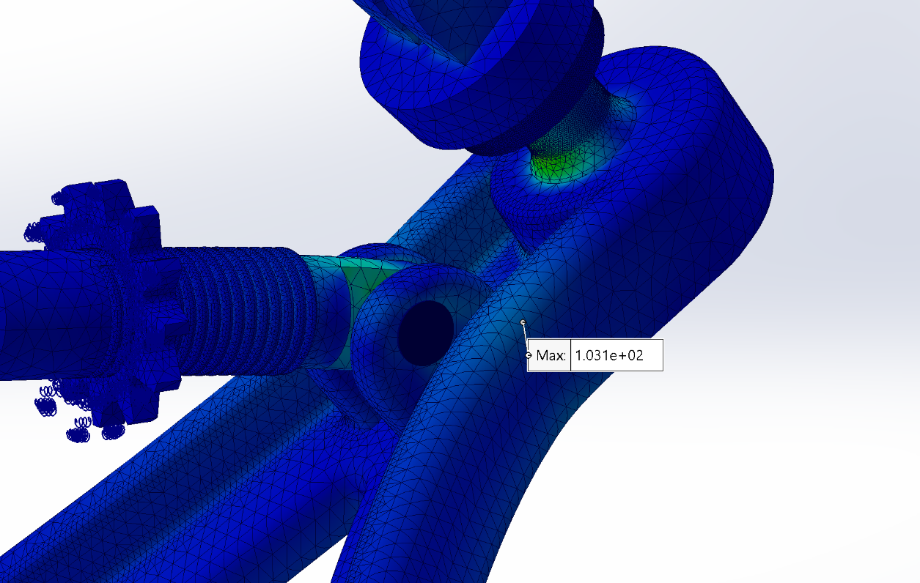
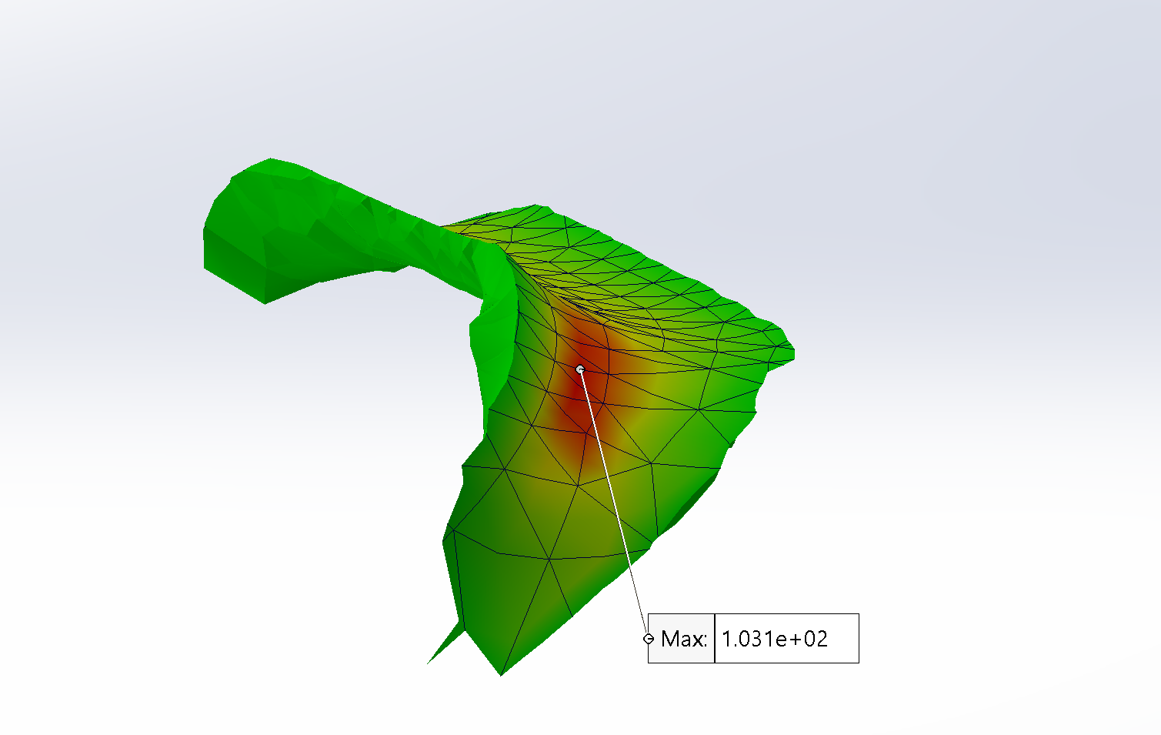

MATLAB Simscape Modelling and PID Control
To analyse and compare the performance of different suspension configurations, a MATLAB Simscape model was developed. The simulation process began with the creation of a passive suspension system, which was later enhanced into an active suspension system by integrating a control mechanism.

Passive Suspension System Modelling
A passive suspension system relies solely on springs and dampers to absorb shocks and provide ride comfort. The system consists of two primary subsystems:
- Suspension System (Vehicle Body to Wheel Connection)
  - A spring that supports the vehicle’s weight and absorbs road disturbances.
  - A damper (shock absorber) that dissipates kinetic energy and controls oscillations.
- Tire Model (Wheel to Road Interaction)
  - A tire spring, representing the elasticity of the tire and its ability to deform under load.
  - A tire damper, simulating energy dissipation and ensuring realistic contact behavior.
To evaluate the suspension system’s response to sudden road disturbances, a pulse generator was implemented in the MATLAB Simscape model. This pulse generator simulates a 10 cm displacement, representing a real-world scenario such as a bump or pothole on the road.
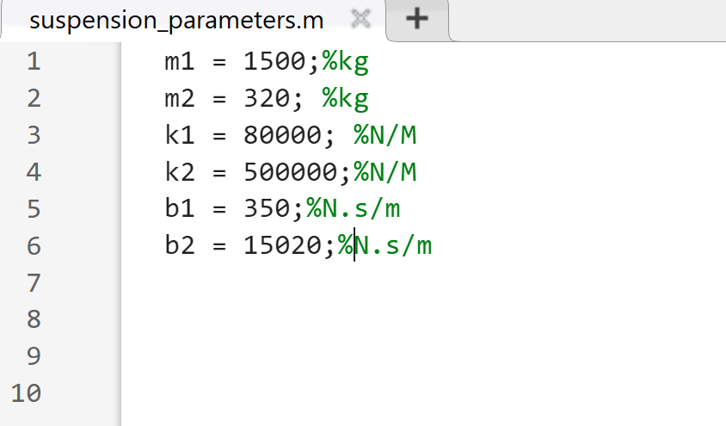
The specifications of Vehicle and Suspension System

Below the model and its result for car body displacement can be seen:
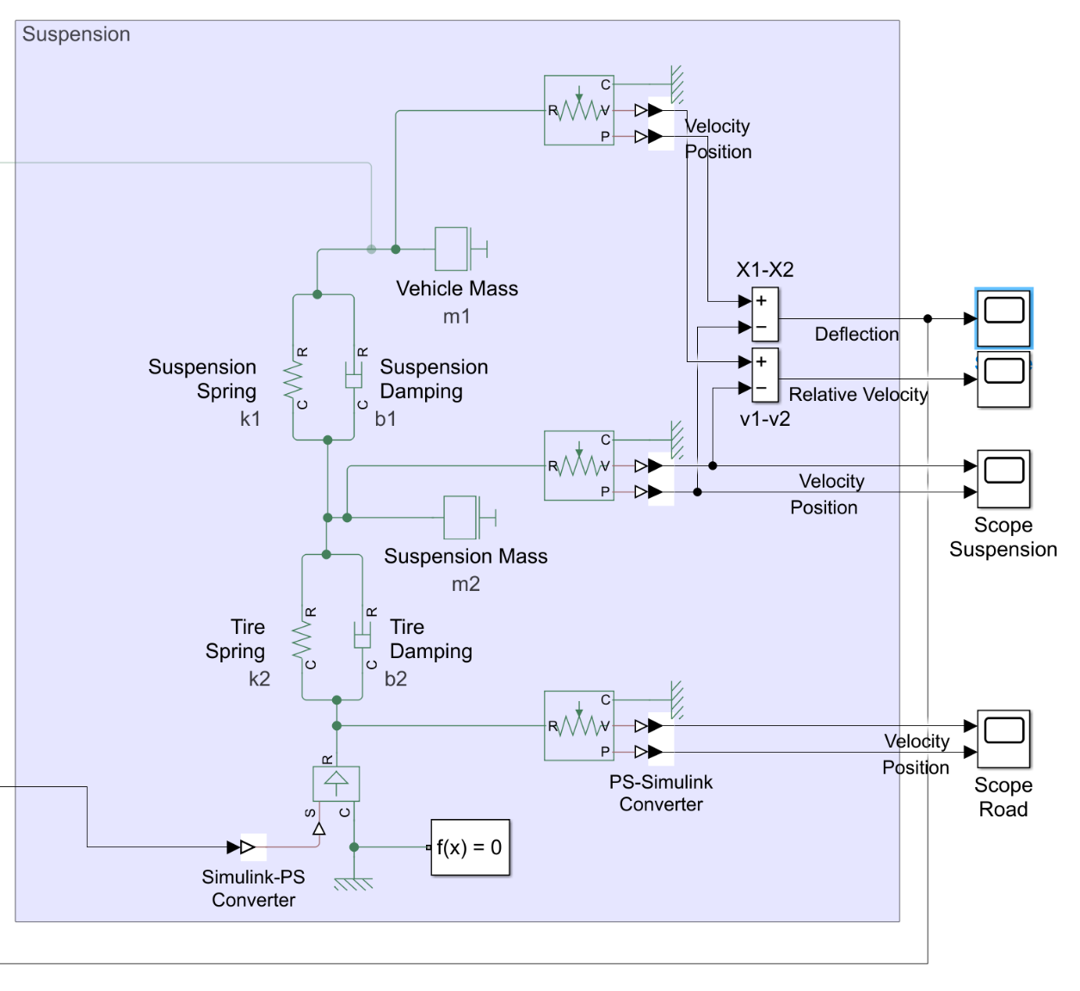

The passive suspension behaviour while facing a 10 cm bump:
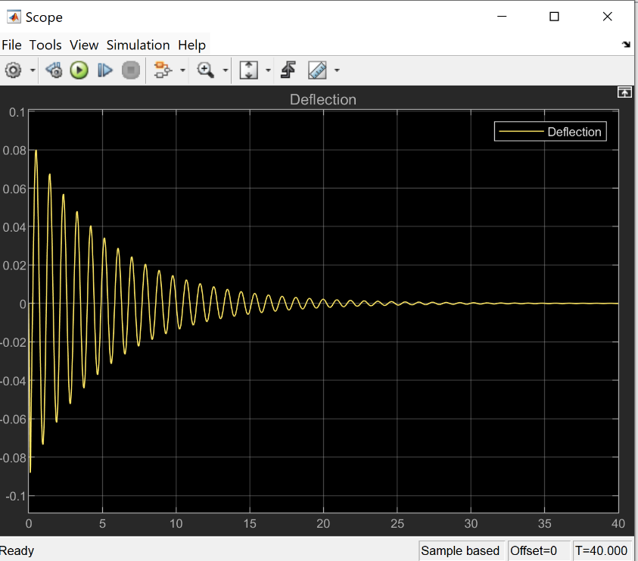

Transition to Active Suspension System
After modelling the passive suspension system, the next step was to enhance its performance by implementing an electromechanical active suspension system. This was achieved by integrating a DC motor and a lead screw mechanism, which actively adjusts the suspension response based on road disturbances.

Active Suspension Components
- DC Motor & Lead Screw:
  - Converts electrical energy into mechanical motion, providing active control over the suspension movement.
  - Adjusts the suspension system in real time to counteract road disturbances.
- Controlled Voltage Source:
  - Supplies the necessary voltage to drive the DC motor.
  - Receives input from a PID controller to regulate motor movement.
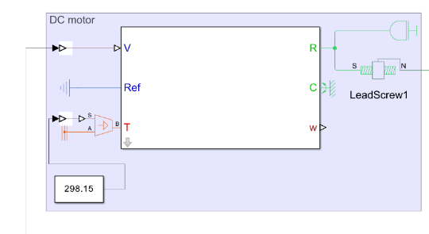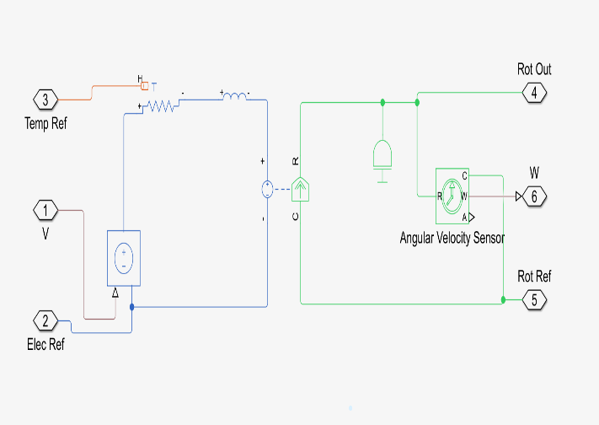
Specifications of the DC Motor:
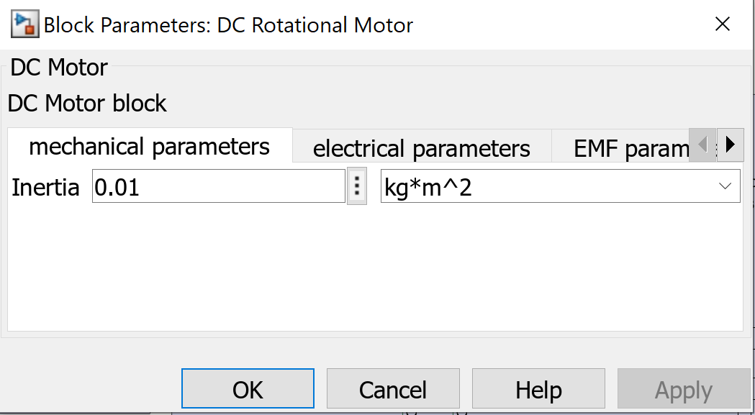 | 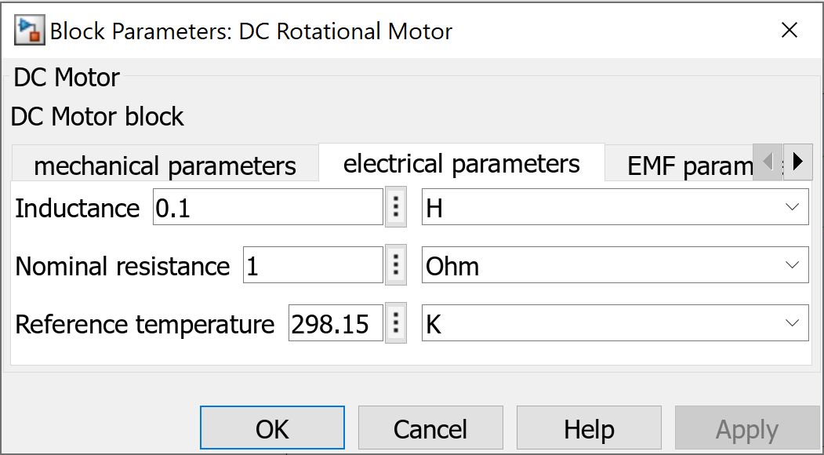 | 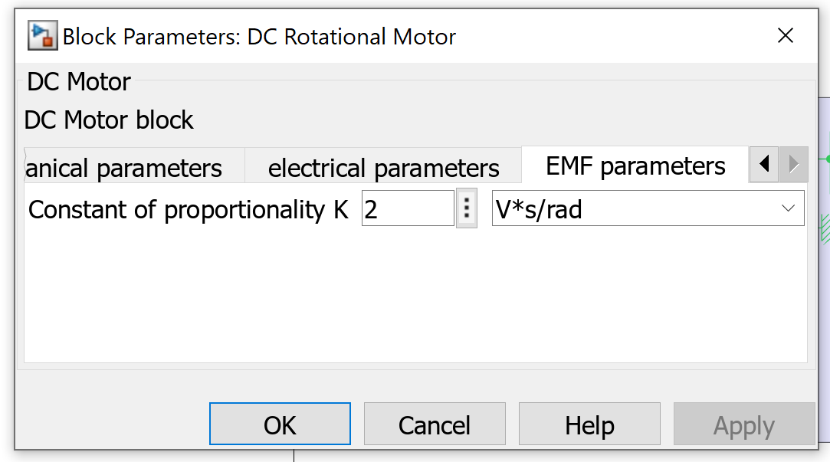

PID Controller:
- Takes the error signal as input, which is the difference between:
  - The desired vertical position of the car body relative to the tire (ideal condition: zero displacement).
  - The actual suspension output, which is the relative movement of the sprung mass (car body) with respect to the unsprung mass (wheel assembly) when a road disturbance occurs.
- Adjusts the voltage to the DC motor to minimize this error, improving ride comfort and stability.
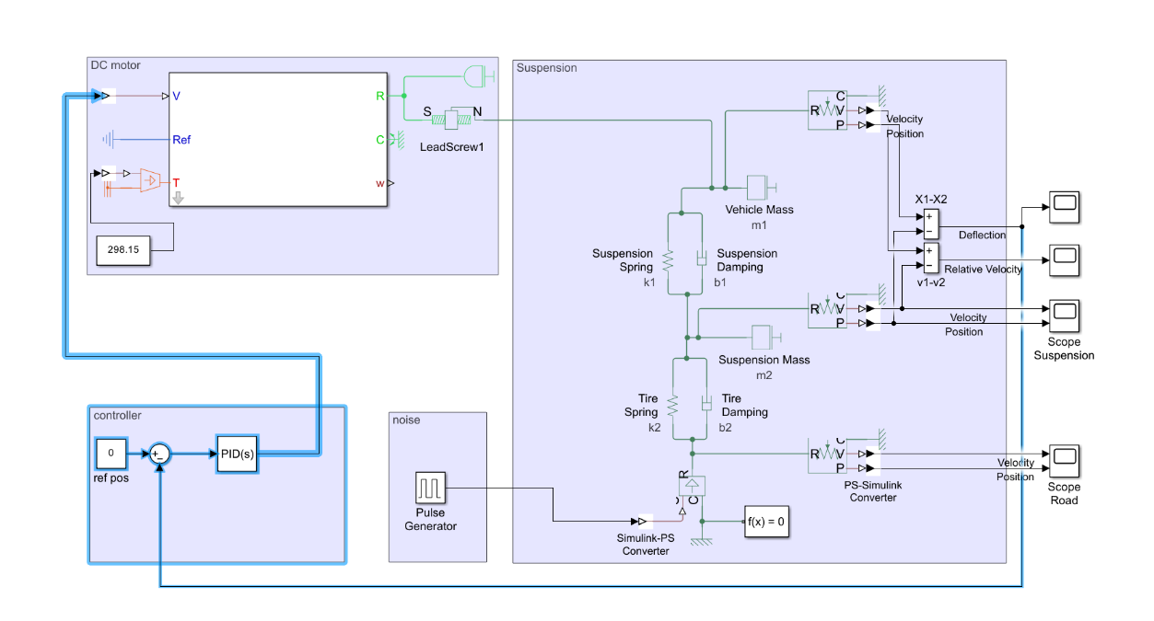
PID controller specifications after tuning:
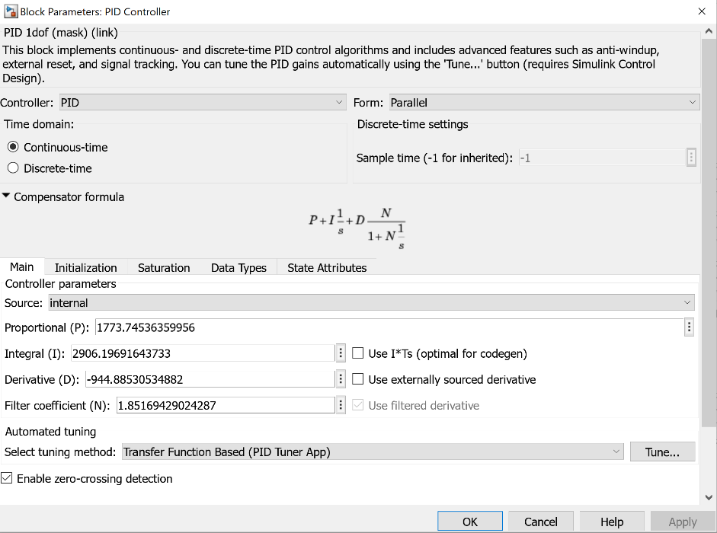

Functionality Results of the Active Suspension
- When the pulse generator introduces a 10 cm road disturbance, the PID controller detects the resulting deviation.
- The DC motor and lead screw actively adjust the suspension force to counteract this displacement.
- This allows the suspension system to quickly adapt, reducing oscillations and enhancing overall ride quality compared to the passive system.
The following section presents simulation results, showcasing the performance improvements achieved with the active suspension system.

The relative displacement between car body and tire after applying an active force:
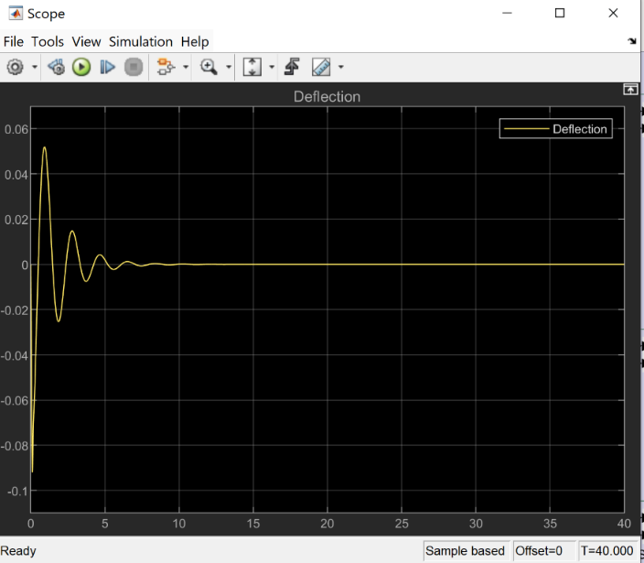

The motion sensor (upper one) used to check the results of car body motion:
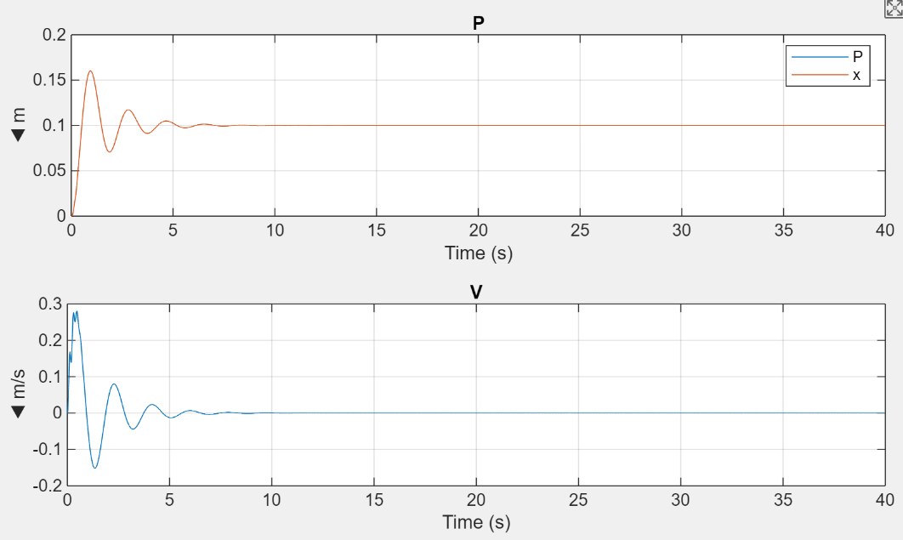
The DC motor results:
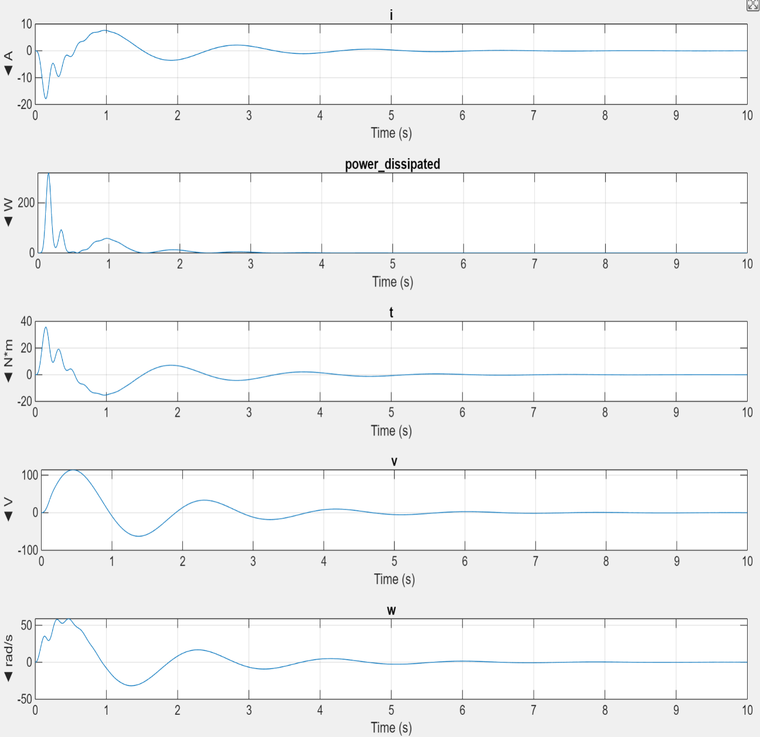

References
Journal article
Yu, M., Evangelou, S.A. & Dini, D., 2024. Advances in active suspension systems for road vehicles. Engineering, 33, pp.160–177. Available at: https://doi.org/10.1016/j.eng.2023.06.014
Thomä, A., Gilsdorf, H.-J., Münster, M., Mair, U., Müller, C., Hippe, M. & Hoffmann, J., 2009. Electromechanical active body control. ATZ Worldwide, September. Available at:
https://doi.org/10.1007/BF03225316
Reyes-Avendaño, J.A., Moreno-Ramírez, C., Gijón-Rivera, C., Gonzalez-Hernandez, H.G. & Olazagoitia, J.L., 2021. Can a semi-active energy harvesting shock absorber mimic a given vehicle passive suspension? Sensors, 21(13), p.4378. Available at: https://doi.org/10.3390/s21134378
Oke, P., Tawaketini, J. & Singh, N., 2023. Robust control of active suspension system using MATLAB/Simulink. In: IEEE Asia-Pacific Conference on Computer Science and Data Engineering (CSDE). IEEE. Available at: https://doi.org/10.1109/CSDE835.2023

Websites
Xometry Pro, 2023. Steel 1.7225 / 42CrMo4 Data Sheet. [pdf] Available at: https://xometry.pro/wp-content/uploads/2023/09/Stainless-steel-1.7225.pdf
Fuhong Steel, 2024. 51CrV4 Steel | DIN 1.8159 | AISI 6150 Spring Steel. [online] Available at: https://www.round-bars.com/products/51crv4-steel-din-1-8159-aisi-6150-spring-steel/

