DOCUMENTATION

ASSIGNMENT 3

STUDENT NAME: POP CĂTĂLIN GABRIEL FLAVIU
GROUP: 30422

CONTENTS

1. Assignment Objective 3
2. Problem Analysis, Modeling, Scenarios, Use Cases 3
3. Design 3
4. Implementation 3
5. Results 3
6. Conclusions 3
7. Bibliography 3

Assignment Objective
The main objective of the assignment is to design and implement an application for managing the clients, the products and the orders of a warehouse.
• Main objective
o Design and implement an application for managing the client orders for a warehouse
• Sub-objectives
o Analyze the problem and identify requirements
o Design the orders management application
o Implement the orders management application
o Test the orders management application

Problem Analysis, Modeling, Scenarios, Use Cases
• Functional requirements:
o The application should allow an employee to add a new client
o The application should allow an employee to add a new product
o The application should allow an employee to add a new order
o The application should allow an employee to edit a client
o The application should allow an employee to edit a product
o The application should allow an employee to delete a client
o The application should allow an employee to delete a product
• Non-Functional requirements:
o The application should be intuitive and easy to use by the user

Use Case: add product
Primary Actor: employee
Main Success Scenario:
1. The employee selects the option to add a new product
2. The application will display a form in which the product details should be inserted
3. The employee inserts the name of the product and current stock
4. The employee clicks on the “Add” button
5. The application stores the product data in the database and displays an acknowledge message
Alternative Sequence: Invalid values for the product’s data
- The user inserts a negative value for the stock of the product
- The application displays an error message and requests the user to insert a valid stock
- The scenario returns to step 3
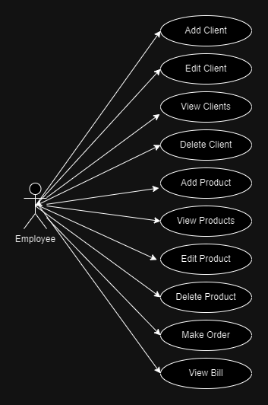
Figure 1 - Use Case Diagram

Design
The packages used implement a layer architecture. The Presentation package contains the classes which implement the Graphical User Interface, namely, the Controller class. Model package contains the classes which model the data from the Database, this being exactly the same as the tables from the Database: Client, Product and Order. BussinessLogic package contains the logic operations of the application, the validation of the SQL statements and the DAO classes. DataAccess is responsible for the SQL commands which are sent to the database

.
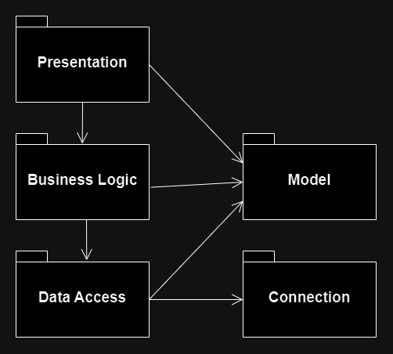
Figure 2 - Package Diagram

Implementation
The classes implemented are many, as they are varied. We have classes which contain the basic information from the Database, like Client, Product or Order. Classes like EmailValidator or Phone Validator are classes which implement the interface Validator, their purpose is to validate the data which is to be inserted into the Database.
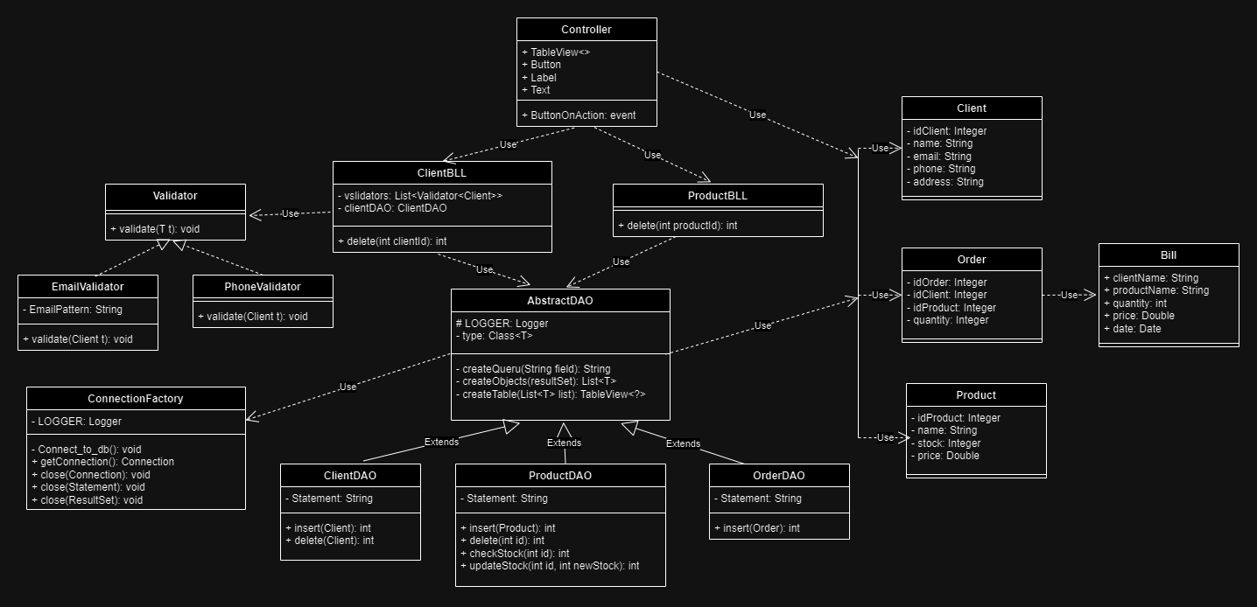
Figure 3 - Class Diagram
The main function of the application, the execution of the SQL queries is implemented by the DAO classes. ClientDAO, ProductDAO and OrderDAO extend class AbstractDAO. Their main methods are inserting, deleting or editing the data of the Database, this being implementing like in the following images:
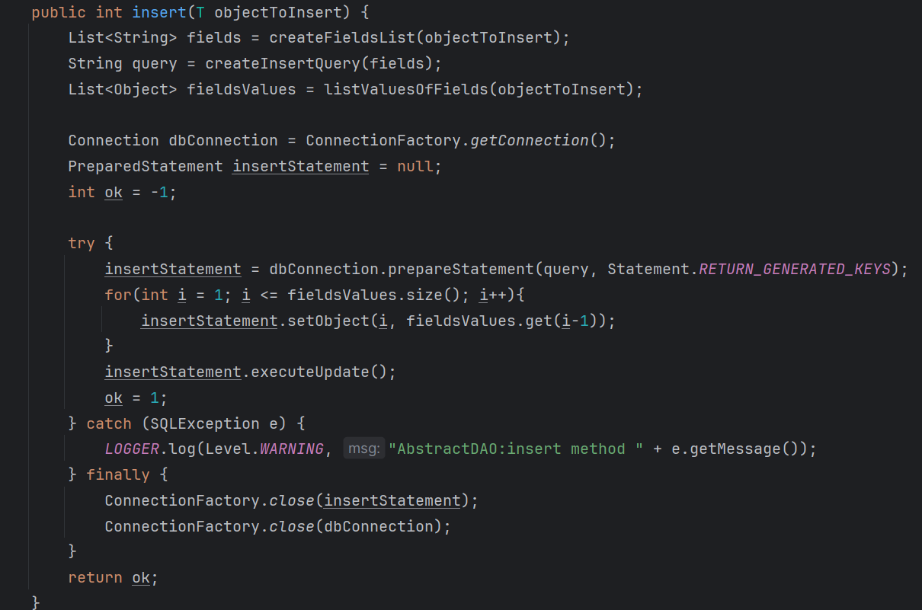
Figure 4 - Insert method
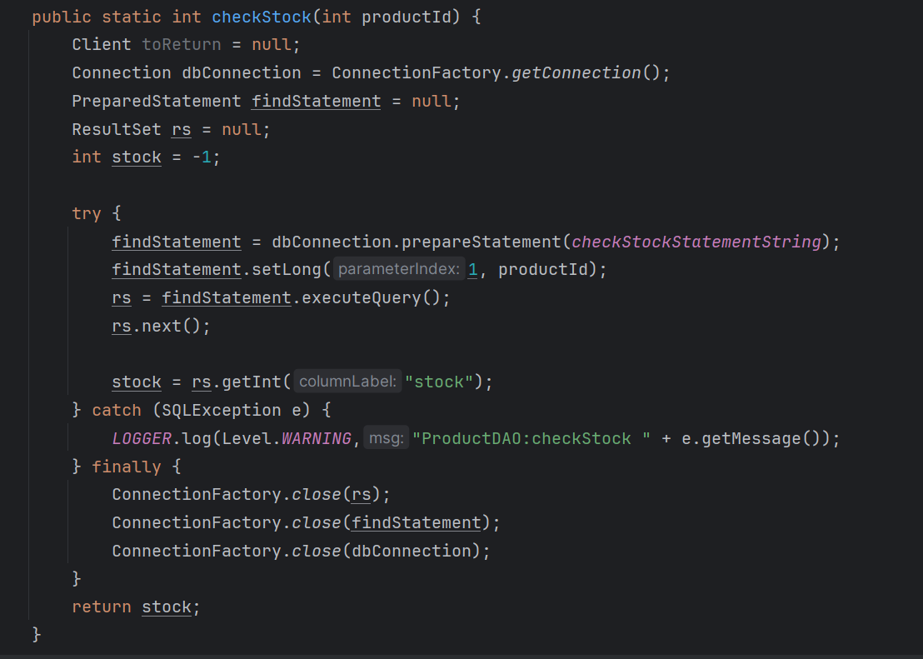
Figure 5 - Method checkStock of class Product

Results

The results of this assignment represent an application which is able to manage the data from a Database, to insert data, edit data, delete data. Also it implements the main purpose of the application, to generate Orders which are transmitted to the Database.
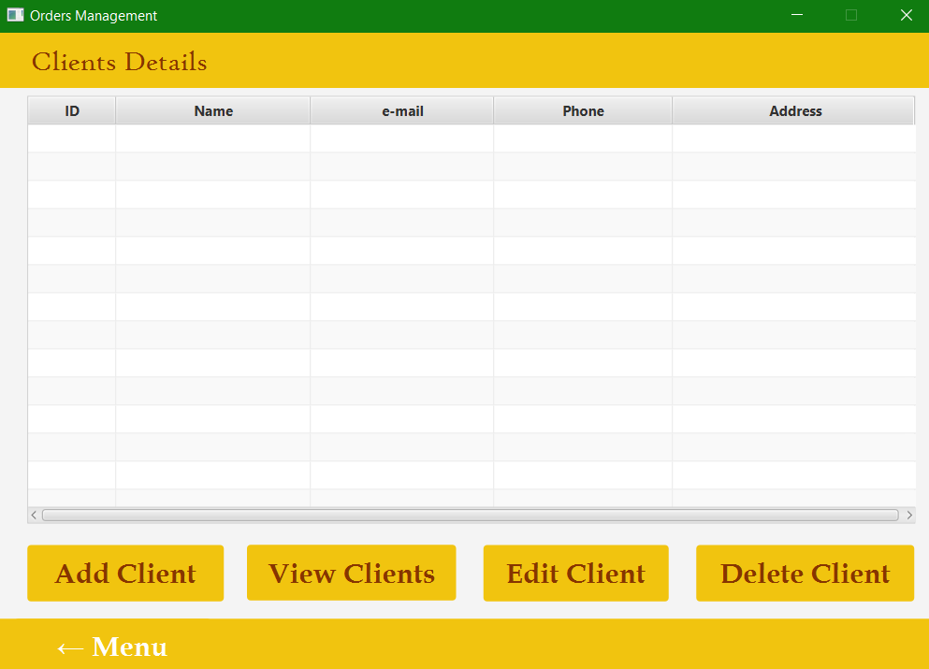
Figure 6 - Camption of the GUI
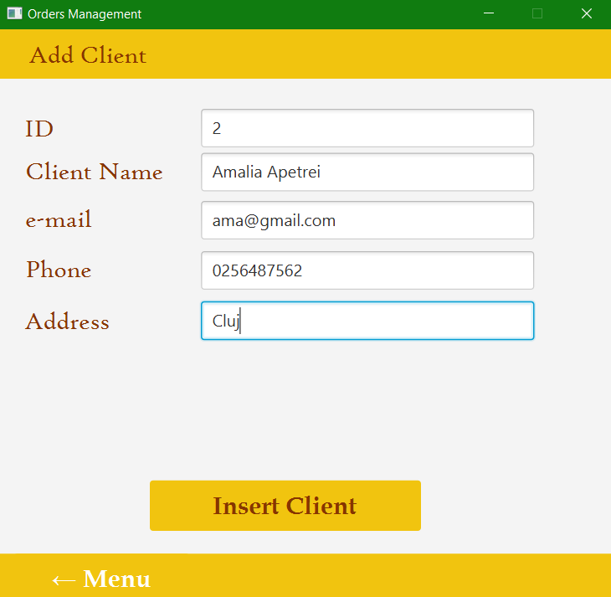
Figure 7 - Caption of the GUI

Conclusions
In conclusion, in this assignment, I have managed to learn about the use of generics in java, the use of reflection techniques, also using a database and managing the data inside it, using SQL dump files or tables of the Graphical User Interface.

Bibliography
- TableView and Table contruction - https://genotechies.medium.com/javafx-tableview-with-dynamically-filled-data-from-a-list-89ff6f8778e1
- SQL script and SQL dump file - https://www.youtube.com/watch?v=DCEi4IRFW_8
- Javadoc - https://www.baeldung.com/javadoc; https://www.youtube.com/watch?v=qLA7HhoajqM

