1)

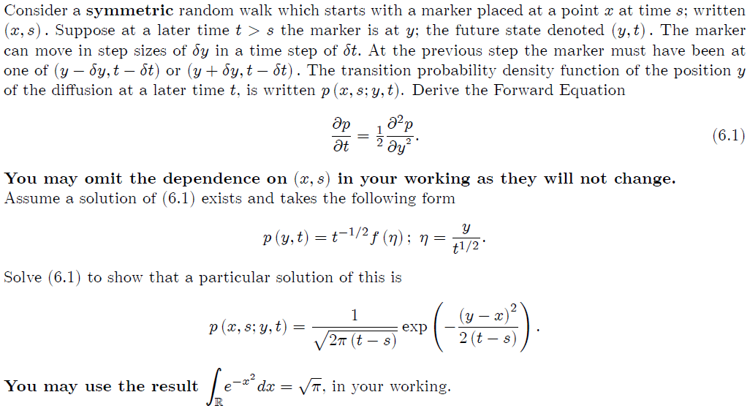

2)



10 days = 2.33 $\sqrt{10}$\* = 7.36% = 0.0736\*5M = 368000

3)

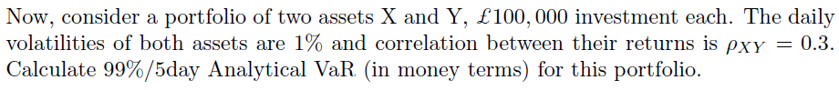

4) In the class, you computed VAR by using experimental data directly. Use the same data to find VAR and expected shortfall using an analytical model (normal distribution).