# Object Avoidance Robot

Student: Pop Alexandra

Design with Microprocessors

Technical University of Cluj-Napoca

February 20, 2025

Laboratory Professor: Ana Rednic

Course Professor: Radu Danescu

# Contents

1. **Introduction . . . . . . . . . . . . . . . . . . . . . . . . . . . . . . . . . . . . . . . . . . . . . . . . . . . . . . . . . . 1**
   1. Purpose and Motivation. . . . . . . . . . . . . . . . . . . . . . . . . . . . . . . . . . . . . . . . . . . . . . . . . 1
2. **Bibliographic Research (Comparison of Existing Solutions). . . . . . . . . . . . . . . . . . . . .1**
   1. Comparison Between My Project and the “Inspiration” Model?. . . . . . . . . . . . . . . . .1
   2. Key Differences and Justification. . . . . . . . . . . . . . . . . . . . . . . . . . . . . . . . . . . . . . . . . . 2
3. **Proposed Solution and Implementation. . . . . . . . . . . . . . . . . . . . . . . . . . . . . . . . . . . . 3**
   1. Overall Description. . . . . . . . . . . . . . . . . . . . . . . . . . . . . . . . . . . . . . . . . . . . . . . . . . . . . .3
   2. Implementation . . . . . . . . . . . . . . . . . . . . . . . . . . . . . . . . . . . . . . . . . . . . . . . . . . . . . . . .3
4. **Testing and Validation**. . . . . . . . . . . . . . . . . . . . . . . . . . . . . . . . . . . . . . . . . . . . . . . . . . . .**5**
5. **Conclusion**. . . . . . . . . . . . . . . . . . . . . . . . . . . . . . . . . . . . . . . . . . . . . . . . . . . . . . . . . . . . . .**5**

# Introduction

## 1.1 Purpose and Motivation

I chose this project because I find it a great starting point in Arduino and microcontroller programming while keeping it simple and fun. The primary motivation for this project was to develop an autonomous robot capable of navigating its environment while avoiding obstacles. The project integrates infrared (IR) sensors and an ultrasonic sensor to detect both small and large obstacles, ensuring smooth and efficient movement. The addition of a WS2812B LED strip enhances user interaction by providing visual feedback on the robot's movements.

**Scope of the Project**

This project aims to:

Implement an object avoidance system using IR and ultrasonic sensor

Control two DC motors via an L298N motor driver for movement

Integrate a WS2812B LED strip for indicating movement states

Ensure efficient navigation by handling both small and large obstacles

**Innovation & Uniqueness**

While object-avoiding robots are widely implemented, this project introduces a dual-sensor approach to improve obstacle detection. The IR sensors detect low-height objects, while the ultrasonic sensor ensures detection of larger obstacles at a distance. The LED strip adds an intuitive way to visualize the robot's movements, making it more interactive.

# Bibliographic Research

**2.1 Comparison Between My Project and the “Inspiration” Version**

I was inspired by the project described on <https://www.instructables.com/Line-Following-Robot-With-Obstacle-Avoidance/> : Line Following Robot With Obstacle Avoidance. This project also integrates IR sensors and an ultrasonic sensor to detect obstacles, similar to mine. However, there are some key differences between the two implementations.

|  |  |  |
| --- | --- | --- |
| Feature | My Project | Inspiration |
| Obstacle Detection | Uses IR sensors for small obstacles and an ultrasonic sensor for larger ones | Uses a similar combination of IR and ultrasonic sensors |
| Motor Control | Uses an L298N motor driver to manage two DC motors | Uses an L293D motor driver, which is slightly less efficient for high-power motors |
| LED Feedback | Integrates a WS2812B LED strip for real-time movement indication | No LED feedback system |
| Algorithm | Avoids obstacles by backing up slightly and turning, with specific LED indications | Follows a predefined line and avoids obstacles using turns |
| Power Source | Powered by a 9V battery | Uses a different battery configuration |

**2.2 Key Differences and Justification**

The main difference between my project and the one from <https://www.instructables.com/Line-Following-Robot-With-Obstacle-Avoidance/> is that is that my project also focuses entirely on obstacle avoidance rather than following a line, making it more versatile for general navigation. Additionally, I chose an L298N motor driver instead of an L293D, as it provides better power efficiency for my motors and also the addition of a WS2812B LED strip, which improves user interaction and visualization of movement states.

I find my approach more adaptable since it can navigate a variety of environments without requiring a predefined track. The LED indicators also provide an intuitive way to see how the robot is reacting to obstacles.

There are several existing object avoidance robots, mainly using:

* Only IR Sensors – Limited to detecting close-range objects.
* Only Ultrasonic Sensors – Struggles with small, low-height obstacles.
* Camera-based Systems – More advanced but require complex image processing.

|  |  |  |  |  |
| --- | --- | --- | --- | --- |
| Solution | Power Consumption | Difficulty to Implement | Obstacle Detection Quality | Cost |
| IR Sensors Only | Low | Easy | Poor (Small obstacles only) | Low |
| Ultrasonic | Medium | Moderate | Good (Large obstacles) | Low |

This project provides a balance of cost, efficiency, and detection capabilities, making it an ideal solution for small autonomous robots.

## Proposed Solution and Implementation

## 3.1 Overall Description

**The robot is equipped with:**

* Two **IR sensors** to detect small obstacles.
* **An HC-SR04 ultrasonic sensor** to detect larger obstacles.
* **Two DC motors** controlled via an **L298N motor driver**.
* **A WS2812B LED strip** to indicate movement states.
* **A 9V battery** to power the system.

**Theoretical Description of Algorithm**

* The robot follows a decision-based algorithm:
* **Move Forward** → If no obstacles are detected.
* **Turn Right** → If the left IR sensor detects an obstacle.
* **Turn Left** → If the right IR sensor detects an obstacle.
* **Move Back Slightly Left** → If both IR sensors detect an obstacle.
* **Move Back Slightly Right** → If the ultrasonic sensor detects an obstacle within 10cm.
* **Stop and Blink LEDs** → When reversing or stopping.

**3.2 Implementation**

**Hardware Implementation**: The circuit was designed using Fritzing:

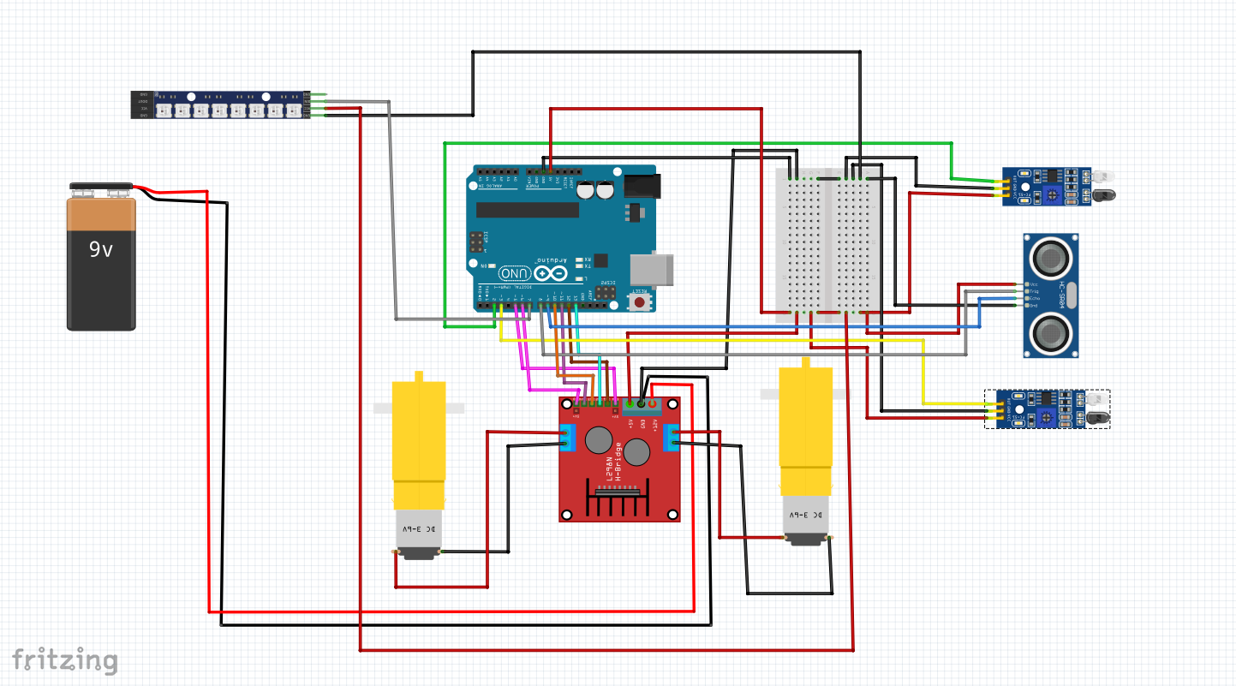

**Software Implementation**: Key functions in the Arduino code include:

The Arduino program is designed to control the robot’s movement based on sensor readings and provide real-time visual feedback through the WS2812B LED strip. The core functionalities are structured into several key functions, ensuring smooth operation and precise obstacle avoidance.

Key Functions in the Arduino Code

* Movement Functions

The robot’s movement is controlled through dedicated motor functions that respond dynamically to sensor inputs. The L298N motor driver allows precise control over the two DC motors, adjusting both direction and speed based on real-time obstacle detection.

1. Forward Movement: Both motors receive a forward signal when no obstacles are detected.
2. Turning Left or Right: When one IR sensor detects an object, the opposite motor continues moving while the other stops, allowing the robot to turn in place.
3. Reversing with a Slight Turn: If both IR sensors detect an obstacle or the ultrasonic sensor detects an object within 10 cm, the robot moves backward while slightly adjusting its angle to ensure effective avoidance.
4. Stopping: If the robot encounters an unavoidable obstacle or reaches the end of a path, the motors are completely turned off.

* LED Feedback System (**setAllLeds()**, **blinkLeftIndicator()**, **blinkRightIndicator()**)

The WS2812B LED strip serves as a real-time status indicator for the robot’s movement, making its actions more intuitive and visually informative. Three functions manage LED behavior:

1. setAllLeds(): This function sets all LEDs to a uniform color based on the robot’s current movement state.
2. Green when moving forward.
3. Red when stopping or reversing.
4. blinkLeftIndicator(): When the robot turns left, the leftmost LED blinks yellow, while the others remain red to indicate movement.
5. blinkRightIndicator(): When the robot turns right, the rightmost LED blinks yellow, while the others remain red.

These functions ensure that movement states are clearly visible and aid in debugging by providing real-time visual feedback.

* Decision Logic (**loop()**) & **Debugging**

The loop() function forms the core of the decision-making process, continuously evaluating IR sensor values and ultrasonic distance measurements. Based on this data, the function determines the appropriate movement response and updates the LED feedback accordingly. Debugging played a crucial role in optimizing this logic:

1. Sensor Calibration: Ensuring the IR sensors were correctly detecting obstacles at the appropriate range.
2. Timing Adjustments: Fine-tuning delays and movement execution times to prevent erratic behavior.
3. LED Synchronization: Aligning LED color changes with movement to reflect the robot’s real-time status.

**Testing and Validation**

Challenges Faced

* IR sensor placement: Adjusted positions for better detection.
* Ultrasonic sensor placement on the ultrasonic because it keeps falling when the robot hits the small obstacles
* Power management: The 9V battery was draining quickly, leading to motor power issues (I used 4 only in testing)
* LED responsiveness: Ensured LED indicators correctly synced with robot movements.
* Direction of moving the wheels (one wheel was moving forward and one backward)

I am sure that this robot is not working 100% correct with the delays, the wheels moving at the same time and the bending of sensors while hitting the objects.

Final State vs Initial State

* Initially, the robot only had basic movement logic.
* Later, IR and ultrasonic integration improved obstacle detection.
* LED behavior was optimized to provide better user interaction.

# Conclusion

Project Success & Adaptability

The object avoidance robot successfully navigates environments, avoiding both small and large obstacles. The dual-sensor approach enhances detection accuracy, while the LED strip provides real-time feedback.

Future Improvements

* Optimize power consumption by using a more efficient power source.
* Increase maneuverability by fine-tuning motor speed during turns.
* Add Bluetooth/WiFi control for manual navigation.

Practical Applications

* This project serves as a foundation for autonomous mobile robots, useful in:
* Home automation (vacuum robots, smart assistants).
* Industrial automation (warehousing robots).