**Installing R and RStudio: A Step-By-Step Guide**

R is a programming language primarily used for statistical analysis and visualizing data. RStudio is an integrated development environment (IDE) for R with useful features ranging from basics, like syntax highlighting, to more advanced features useful in package development.

Let’s start installing both of these by going to the RStudio website:  
<https://posit.co/download/rstudio-desktop/>

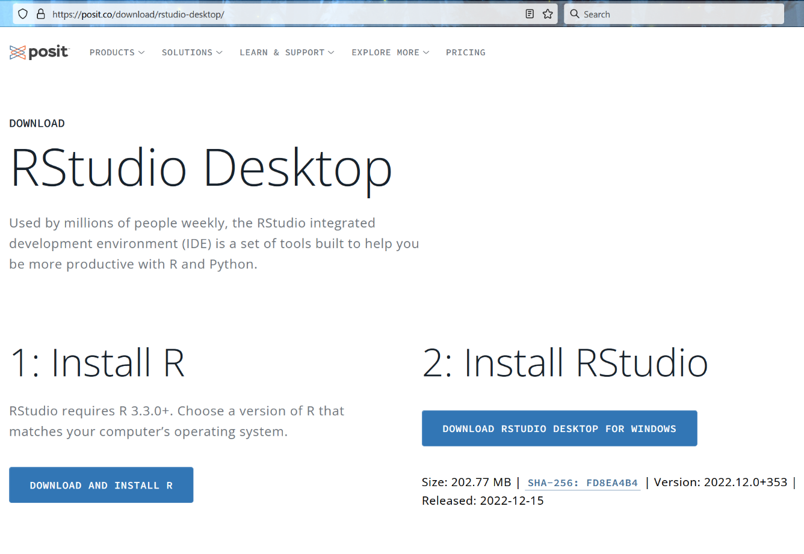

Clicking on the “Download and Install R” button will bring you to this page:  
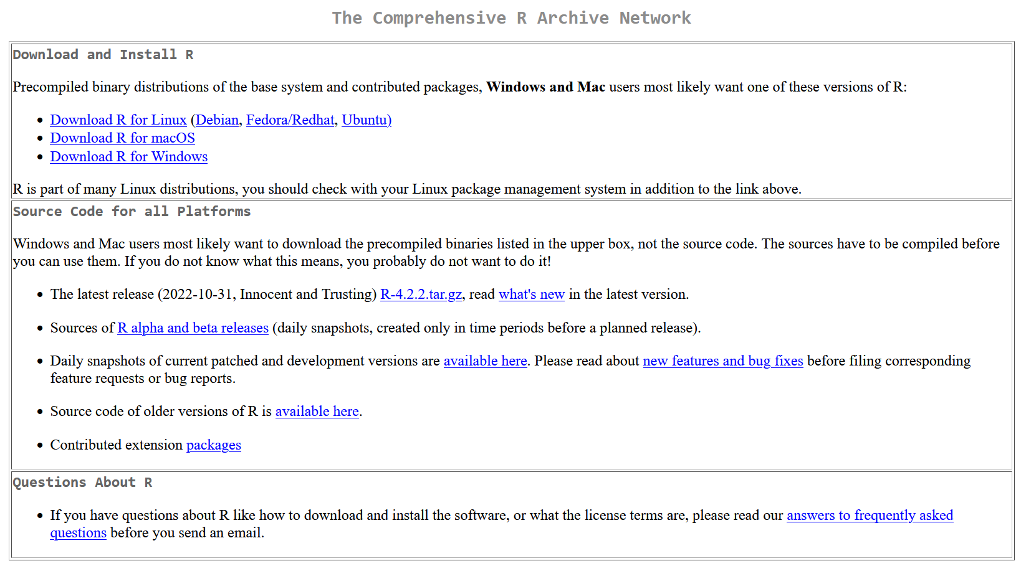

Toward the top of that page, you can see the section titled “Download and Install R”. Here, you can get the latest installer for your operating system (Windows, Mac, or Linux). Click the one that’s appropriate for your OS and download the installer. At least for the Windows installer, you’ll need to navigate through another page after the above where you need to select “Install R for the first time” and then, finally, click “Download R-4.2.2 for Windows” to download it. The version number may not match exactly depending on how long its been since this guide was created.

Different operating systems will have different install procedures (you’re probably familiar with this process from other software you’ve installed). For Windows, you just need to double-click the executable installer you downloaded to start the install process (‘R-4.2.2-win.exe’ in this screencap):

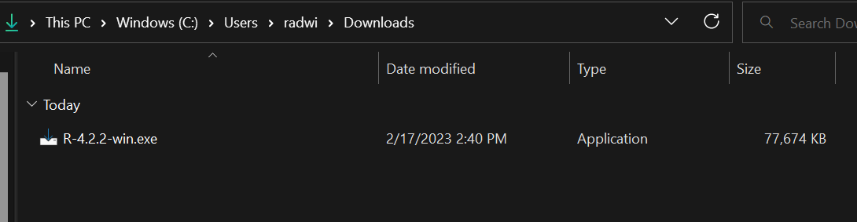

For our purposes, there’s no reason to change any of the defaults (unless you *really* want to), so just click ‘next’ on the installer until it fully installed. Finally, click ‘Finish’ to close the installer. R is now installed, but we still need to install R Studio, so let’s go back to RStudio install page:  
<https://posit.co/download/rstudio-desktop/>

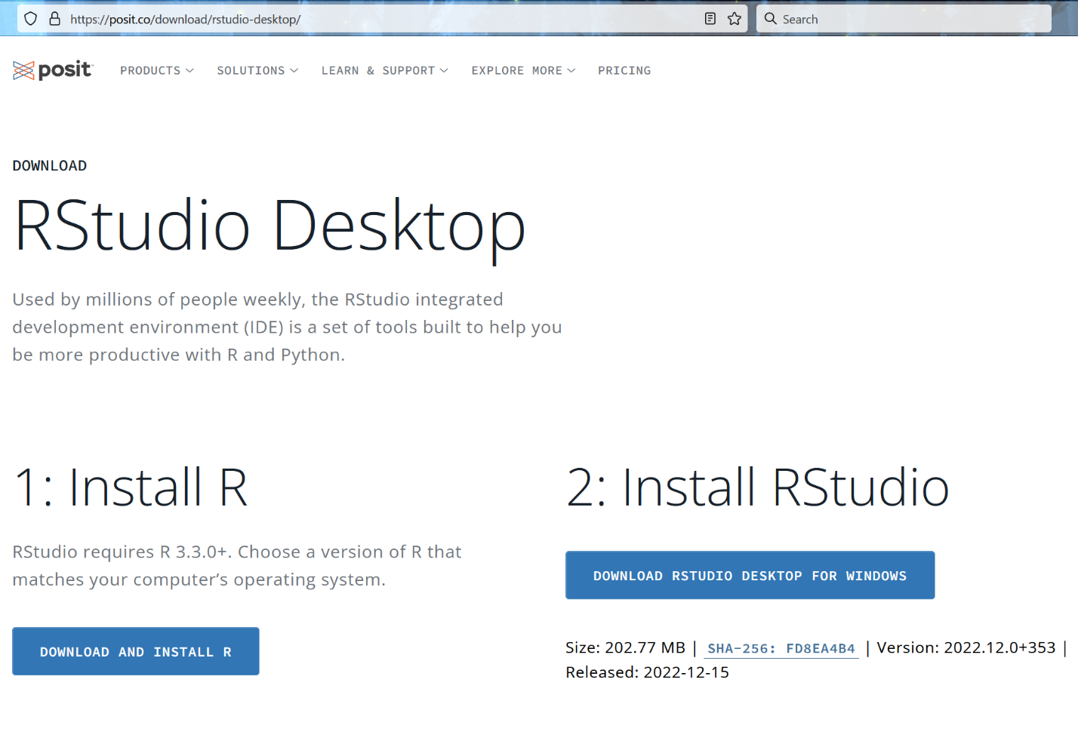

Now, click the “Download RStudio Desktop for [Your OS]” button. If for some reason it doesn’t show the correct operating system, you can scroll down on this page and select the appropriate installer for your OS. Once you’ve downloaded that, go through the same install process as before. For Windows, again, you can start the install by simply double-clicking the installer you downloaded:  
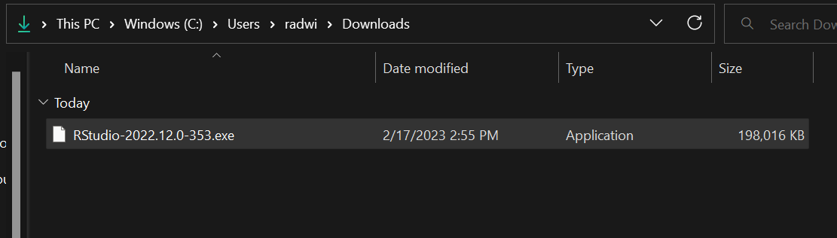

Click ‘Next’ until the installer finishes, and then click ‘Finish’. You should now have working versions of R and RStudio installed! Try launching RStudio just to make sure. When you launch RStudio, you might be asked which version of R to use. The default should be to use “machine’s default 64-bit version” and that’s what you want, so no need to change anything.

In the below screencap, you can see the default window for RStudio. Notice that I’ve run two functions in the ‘console’ panel to just test things out. The first function, getwd(), returns the current working directory. The second function, citation(), returns how to cite R. We’ll talk more about functions in the main portion of the workshop.

