Procedurally Generated Maps in FPS games
Adam Bari

BSc (Hons) Computer Games Applications Development, 2020

School of Design and Informatics
Abertay University

Table of Contents

Table of Figures 2
Table of Tables 3
Acknowledgements 4
Abstract 5
Abbreviations, Symbols and Notation 7
Introduction 1
What is Procedural Content Generation 1
Procedural Content Generation in FPS Games 2
Aim 4
Research Question 4
Research Question - Critical Analysis 4
Objectives 4
Literature Review 5
Procedural Content Generation Techniques 5
Search Based PCG 5
Evolutionary Algorithm 6
Interactive Genetic Algorithm 6
Human Based Genetic Algorithm 7
Direct Fitness Function 7
Simulation Based Fitness Function 8
Competitive FPS Games 8
The History of Competitive FPS Games 8
Methodology 9
Overview 9
Application 10
Application Design 10
Tilemap Generation Implementation 11
Tilemap Generation: Room Generation 11
Tilemap Generation: Objectives 12
Tilemap Generation: Corridor Generation 12
Tilemap Generation: Cover Placement 13
Fitness Function Implementation 14
Fitness Function: Distance to Bombs 14
Fitness Function: Bomb Distance 15
Fitness Function: Spawn-Bomb Line of Sights 15
Fitness Function: Line of Sights 16
Fitness Function: Navigation 16
User Testing 17
Results 18
Questionnaire Data 19
Playtest Data 20
Playtest Player Data 20
Playtest Session Data 21
Discussion 23
Playtest Session 23
Playtest Questionnaire Data Analysis 23
Playtest Session Data Analysis 26
Playtest Player Data Analysis 27
Project Findings 28
Summary 28
Research Question 28
Project Critical Evaluation 29
Development Evaluation 29
Playtest Evaluation 32
Conclusion 32
Main Conclusion 32
Implications 34
Future Work 34
Appendices 35
List of References 38

Table of Figures
Figure 1: Top down view of the playtest session. 14
Figure 2: Distribution of Player Skill 17
Figure 3: Average Player KD Ratio vs Player Skill 17
Figure 4: Tilemap output on the command prompt 24
Figure 5: Tilemap output to an SFML window with interactive pathfinding being displayed 25

Table of Tables
Table 1: Questionnaire Questions 15
Table 2: Questionnaire Results (No Comments) 15
Table 3: Compiled Player Performance Data 16
Table 4: Playtest Session Data 18
Table 5: Level Results vs Fitness Score 18

Acknowledgements

I would like to thank my supervisors Christopher Acornley and Grant Clarke for all the guidance you have provided me throughout the year. I would also like to thank my roommate Kajsa Adler for your continued support and assistance with writing the dissertation. Additionally, I would like to thank all the staff at Abertay who have provided support and put together the module in the manner it has been.

Abstract
Context: Procedural content generation (PCG) is used in a variety of game genres, one genre which has not seen much use of this is the competitive first-person shooter (FPS) genre. This project presents a different approach to level design in such games.

Aim: This project aims to evaluate how PCG could fit into the competitive FPS formula, how a system could be implemented to generate balanced levels and how it might help during the development cycle.

Method: A prototype was developed using selected procedural generation techniques. The system takes input parameters which set the specifics of how a map should be generated. This was then evaluated by examining if the areas defined by the key constants were functioning as they should and if the maps generated held a level of consistency.

Results: The results obtained address the effectiveness of the implemented methodology and show how real players respond to the results of the system in a test environment. The areas of focus were the competitive balance of generated levels and the player satisfaction after playing the content. The results of this research demonstrated how procedurally generated content could have potential in the competitive FPS genre. However, further work is needed for such a system to be deployed directly within a games context.

Conclusion: This project assists in determining whether procedural generation is an appropriate manner of level design in competitive FPS shooters, what PCG techniques are most suitable for doing so and whether procedural generation is a good alternative for developers looking to save time on level design and development costs.

Abbreviations, Symbols and Notation

Direct Fitness Function – DFF

First-Person Shooter – FPS

Graphical User Interface - GUI

Human-Based Genetic Algorithm - HBGA

Interactive Genetic Algorithm – IGA

Lines of Sight - LOS

Procedural Content Generation – PCG

Search-Based Procedural Content Generation - SBPCG

Simulation Based Fitness Function - SBFF

Introduction

What is Procedural Content Generation
PCG is the process of algorithmically creating content at run-time using a pre-defined process created by a programmer. This lends itself as a useful solution to saving time on content creation within a game’s development cycle. PCG has been used in many styles of games since appearing in the gaming world during the late 70s. One of the earliest examples of PCG in games is Rouge (Glenn Wichman et al., 1980), which have the player navigate through procedurally generated dungeon floors. This was very effective as it took advantage of the low memory capacity available on computers at the time and gave an expansive amount of content, which would otherwise be impossible to store on systems during this period. Changing the scenario each time a new game begins significantly improves replay value and alters the skillset required to become good at the game.

With the rapid expansion of the video games industry over the past few decades, more content is constantly needed to meet the high expectations of modern gamers. Content creation is usually a costly process as a variety of highly trained skillsets are required over a long period of time. Grand Theft Auto V (Rockstar Games, 2013) cost over $137 million dollars in development costs alone (Sinclair, 2013). The use of PCG can significantly decrease the amount of time required to produce content in a variety of ways. It can be used to produce templates for designers to work on during production or it can be used to create completely new content for the player each time they play. While having many benefits, choosing to include PCG in a project still runs the risk of becoming more difficult than creating content by hand. It can be a very difficult process to get right and take a lot of time to be ready and reliable for use in a game (Ludwig, 2020).

Procedural Content Generation in FPS Games
With modern computers not having the same restrictions as older hardware, PCG has developed a variety of different uses and implementations over time. It is typically used in large open world games to generate the world and content around the player. Take Minecraft (Mojang, 2009), since its release it has gone on to sell more copies worldwide across all platforms than any other game in history (Dent, 2019). The game uses PCG to create a vast world of perceivably infinite size, which is made up of blocks that the player can interact with and explore. Part of success Minecraft has achieved can be credited to the creative freedom it gives to players using PCG, “It's a system for fitting pieces together to create something — sometimes amazing somethings — from nothing.” (Gilbert, 2018). There have been many titles since that have taken this concept and expanded upon it. No Man’s Sky (Hello Games, 2016) and Astroneer (System Era Softworks, 2019) are examples of titles which have taken PCG above and beyond previous standards by using PCG to generate explorable planets, eco-systems (including wildlife) and even entire galaxies.
A genre which has not seen much attention in the field of procedural generation is the competitive first-person shooter (FPS) genre. Typical features of FPS games include the in-game camera position being from the point of view of the players eyes and the ability to shoot in the direction which the camera is pointing towards. While there have been instances of PCG in shooters such as the weapons and loot system in Borderlands 3 (Gearbox Software 2019), level creation has not seen much attention in competitive shooters. Designing and creating competitively balanced maps for such games is a lengthy and difficult process which requires a high level of skill and experience. This is because there are a considerable number of factors to take into consideration when creating this type of content and if one of these elements is not considered, the balance of an entire level could be compromised. Competitive FPS titles are also often released with a limited number of maps. Call of Duty: Modern Warfare (Infinity Ward, 2019) released with 23 maps in total (James and Hurley, 2019). While seeming like a sizeable number, these maps are split across multiple game modes where there are between 2 – 10 maps available on each game type. The automation of this process either entirely or partially could save a lot of time during development. It will give the player more content to experience whilst saving money and resources for the developer.

Aim
This project aims to develop a prototype system which can procedurally generate balanced levels for use in a competitive FPS game and analyse how effective this method of content creation is.

Research Question
How can competitively balanced first-person shooter maps be effectively procedurally generated?

Research Question - Critical Analysis
Procedurally generating competitively balanced maps for an FPS game is a feature which is yet to be seen in mainstream gaming. The consistency of the generation is extremely important in a competitive environment as maps must maintain competitive balance for players to be able to play the game and compete as intended. Thus, there is a wide variety of difficulties when implementing a procedural system to effectively generate competitively balanced maps.

The proposed question intends to address the issue of whether it is possible to generate partially or finished maps which maintain a competitive balance. Partially finished maps which are competitively balanced could also be an invaluable tool for developers looking to save time on the production of a title.

Objectives
The primary objectives of this project are:
- To review existing levels in current competitive shooters as well as other games and assess what constants makes them balanced, interesting and fun for the player.
- To prototype a procedural generation system which can create balanced levels for use in a competitive FPS environment.
- Identify if PCG can create suitable levels for a competitive FPS game.
- Obtain data regarding player performance in the generated levels. Analyse and review this data to identify strengths and weaknesses of the system.
- Make recommendations on how this system could be used in the development of a competitive FPS game.

Literature Review
In order for this project to be successfully carried out, research was conducted into various techniques revolving around the map generation process as well as the history and current state of the competitive FPS genre. The following section reviews the existing relevant literature relating to the research project.

Procedural Content Generation Techniques

Search Based PCG
SBPCG is the process of generating content and testing it using a selected AI technique. Instead of giving generated content either a pass or a fail, the chosen AI algorithm will return a score representing the effectiveness of the generated solution (Zafar et al., 2020). This score is commonly known as a fitness score. Hence, the name of this evaluation process is often referred to as a fitness function. While other methods of PCG exist, SBPCG methods are currently the most common implementations being used as there are a variety of forms which are suitable for a wide array of tasks and goals. As of recent times, SBPCG is largely up and coming with the full potential of this process still being explored (Togelius et al., 2011). Having to create a reliable and efficient fitness function is one of the technical challenges when using this approach to PCG. Togelius et al. (2010) outlines the issues which can arise during this process; the representation of game content within the fitness function, and the testing method can vary drastically on a case-to-case basis. However, with appropriate solutions to these challenges the results can be significantly prolific.

Evolutionary Algorithm
The most popular form of Search Based PCG are evolutionary algorithms (Togelius et al., 2011) due to their established effectiveness. A population of solutions are created in the initialisation process, which are then stored and evaluated by the respective fitness function. Solutions with low scores are discarded and replaced with higher scoring solutions which have been mutated (randomly modified). Mutated solutions are also evaluated and discarded if fitness is lower than the initial solution. The entire process is then repeated several times with the intent to find a higher fitness score, with each repeat being referred to as a generation.

Interactive Genetic Algorithm
This process is a form of evolutionary algorithm which uses human interactivity to grade an array of solutions during the fitness function process (Bhojan and Wong, 2014). This type of evaluation can be necessary when the form of a fitness function is unknown or difficult to define through algorithmic means. While direct human feedback can be very valuable when seeking a specific evaluation for the fitness computation of a solution, Interactive Fitness Functions are limited by a variety of factors. The process can cost a considerable amount of time and money when being compared to computing a Direct Fitness Function. User fatigue can also be an ongoing issue, affecting results and time taken during this process. It is impossible to avoid human preference falling into the evaluation process (Takagi, 2001). This can cause results to vary across different test subjects.

Human Based Genetic Algorithm
A HBGA falls under the category of an Evolutionary Algorithm. Deriving from Interactive Genetic Algorithms, HBGAs allows human input as part of the evolutionary process while utilising computed agents to assist in the evaluation process (Kruse and Connor, 2015). The human works alongside a computed agent to carry out the selection process of the genetic algorithm. Recombination is then carried out by an agent. A mix of human selection and agent selection can also be utilised in order to help with user fatigue during this process (Kruse et al., 2016). HBGAs derive from Interactive Genetic Algorithms whilst addressing some core issues which are present in IGAs, such as user fatigue. Whilst consuming less time than an IGA, a HBGA can still take a considerable amount of time in respect to content generation and lend itself as more of a tool to assist in the development process of a project as opposed to generating whole content at runtime.

Direct Fitness Function
A Direct Fitness Function is typically the least computationally heavy method of evaluating content in the PCG process. A list of features is defined in order to judge the respective content (Togelius et al., 2010). Values are returned based on if the features are met. The combination of these values can then be further evaluated to compute overall fitness. This method is specifically efficient at run-time as it involves no simulation of content. It simply requires a list of design principles being represented in algorithmic form to evaluate the effectiveness of a solution. The negative aspects of this method are rooted in the applied design principles. It can be the case that it is not possible or incredibly difficult to define what is required of a good solution before the generation process takes place. In these cases, a DFF could be more trouble than it is worth to implement.

Simulation Based Fitness Function
Agents play through generated content in order to evaluate the solution. This method involves simulating the game to test content. This is a beneficial method of testing as it can closely represent how players might interact with a certain level or attempt to solve a puzzle (Bhojan and Wong, 2014). This lends itself to be a useful evaluation method when used by developers during the creation of content in the studio, potentially preventing fatigue and saving on costs in instances where constant play sessions are needed to test content. However, this means that this method’s limitations lie in the capability of the simulated agents. The simulated agents may not accurately represent how real players might interact with an environment and could provide misleading data and gameplay statistics on content. It can also be computationally expensive to run, particularly when being deployed on an array of solutions across the whole process of an evolutionary algorithm. Thus, it can take relatively long periods of time to compute (Cardamone et al., 2011).

Competitive FPS Games

The History of Competitive FPS Games
Competitive FPS games are a relatively modern genre in the history of video games. Most modern editions of such games take their influences from notable pioneers including Quake (id Software, 1996) and Counter Strike (Valve, 2000). The term FPS derives from the phrase First Person Shooter. It is used to describe any shooter game played from the viewpoint of the character. Competitive FPS games are a product of the FPS genre which has its roots spanning all the way back to the 1970s. The earliest known examples being Maze War (Greg Thompson, 1973) and Spasim (Jim Bowery, 1974).

It was not until much later in the 1990s when FPS games (not to be confused with competitive FPS) began to find their place in the mainstream, with the title Wolfenstein 3D (id Software, 1992). Wolfenstein 3D has been accredited to the invention of the modern FPS genre (Cifaldi, 2006). The game surpassed expectations, selling over 100,000 copies between May 1992 the end of 1993 (Antoniades, 2009).

Moving into the late 90s, the release of Quake could be considered the beginning of Competitive FPS games as we see them today. The popular game mode “deathmatch” has players fight against each other and had been seen previously in Doom (id Software, 1993). However, Quake featured network compatibility which allowed players to play with and against each other over a network. This helped to revolutionise the way that Competitive FPS games could be played. Counter Strike (Valve Corporation, 2000), which was originally created as a mod for Half-Life also introduced further game modes to the competitive shooter scene with the introduction of networked objective-based gameplay. The most popular of these game types include “Bomb Defusal” and “Hostage Rescue” where one team defend bomb sites or a hostage whilst the other team must attack and attempt to carry out their objective or eliminate the opposing team (Blog.counter-strike.net, n.d.).

Level Design in Competitive FPS Games
Level design is a complex area and even more so in the area of competitive games. “Every game is different. Mechanics will vary between games, as well as what players are able to do within the bounds of the game.” (Gaunt, 2020). As highlighted, different games utilise a variety of different principles in their level design due to the varying nature in gameplay. As a result of this, there is not a strict set of principles which can be applied to every game when designing levels.

There are however, some general principles which are commonly applied to levels in Competitive FPS games today. The following list highlights these principles:
- Navigability - This is an important element as players need an appropriate number of options when moving around the map, attempting to attack or defend areas.

- Choke Points - The points at which players must cross over to enter key objective areas are known as “choke points”. If there are too many choke points, there can be imbalance where defending teams become overwhelmed by being exposed to too many lines of sight at once (Gaunt, 2020).

- Lines of Sight – The LOS present within a level are highly impactful on the gameplay. “Having too little or awkwardly placed sightlines in-between structures/obstacles can create confusion” (Cicala, 2020). As stated, having too many LOS can give players too much to worry about at one time, therefore having an appropriate number of well-placed LOS, can give players the opportunity to progress through environments without having to overexpose themselves to danger. This encourages team coordination, where team-mates can work together to simultaneously cover lines of sight which are overlapping.

- Cover and Occlusion – Placing cover on a map serves the key purpose of blocking off sight lines. Having the right amount of cover in an area means that there are enough options for players needing to defend themselves. This allows for more dynamic situations to occur within spaces which would otherwise be open and empty (IronEqual, 2020). At the same time, if there is too much cover in an area, additional unintended sight lines can be created, causing further imbalance towards the aggressor.

Methodology

Overview
In order to investigate the research question, this project required a prototype application that can generate balanced levels for an FPS game. The primary purpose of the application is to generate, test and identify balanced maps. The system utilises the SFML library to display generated content giving a top down view of the maps. Maps are output in a generalised format which can be taken as an input by any system to reconstruct a 3D scene of the map. Generated maps were then deployed to obtain real player statistics and feedback on the generated levels, by using a networked FPS prototype game with the generated levels loaded in.

Application

Application Design
The PCG within the application was designed around a tilemap system using an X and Y coordinate to represent the position of each tile on a 2D grid. The applied method is based upon previous work carried out by Bhojan and Wong (2014) where SBPCG was utilised to generate and test tilemaps. Each grid tile contained specific information representing what it was in the game world. The use of this method allowed for tilemaps to be output to a text file and still retain all the information required to reconstruct a representation of the map. The form of the output map data is abstract and can be easily read by any system to create a 2D array of data. This method also allows for a good level of control over the system because rules can be defined and applied to the tile set. The tiles provide a relatively simple quantisation of game level content which can be easily understood and readable from a top down point of view.

The system utilises a SBPCG process where content is generated, tested and graded using a DFF as the evaluation method. The use of a DFF allows for the algorithm to be computationally light and thus allows the system to generate a multitude of maps and evaluate them all within a reasonable time frame. The DFF was executed by applying a variety of design features to the tilemap which contribute to the competitive balance of a map. A score was assigned to each criteria based on how close the input tilemap is to fulfilling the ideal criteria. An average of the scores was then used to represent the final grade returned by the Fitness Function.

Tilemap Generation Implementation
When beginning work on the system, an infrastructure to carry out the content generation within the tilemap system was required. The first step of building the application was to design and create a tilemap manager which stores tileset information and is able to carry out various functionality within the tilemap. The tilemap manager class was designed to contain information and basic tilemap operations whilst not including the procedural generation process within itself. A separate tilemap generator class was utilised to carry out the content generation within the tilemap. The steps carried out within the generation are as follows: Initialise the blank tilemap; populate the tilemap with a defined number of rooms; connect each room in sequence to guarantee connectivity throughout the whole map; and add spawn points and bomb points. For each room, corridors are generated to adjacent rooms based on defined rules.

Tilemap Generation: Room Generation
The number of large and medium rooms to be part of the tilemap is set before the generation process begins with the bounds of each room being given a minimum and a maximum possible value. The tilemap manager generates an array of tiles with a size x*y. Each tile is initially set to be a wall. A set of large and medium rooms are generated with random size within defined values. In order to add a room to the tilemap, a set of tiles within the map must be iterated over and set to be a corresponding tile from the room being added. For the number of rooms specified, a random x and y coordinate are generated, and the room is added to the tile set with its origin at the generated coordinates. If the room overlaps with another room the process is cancelled and repeated with new coordinates being generated. If the process fails a number of times over a threshold the current tile set is discarded, and rooms are re-generated and placed again from the beginning of the process.

Tilemap Generation: Objectives
Once rooms are added to the tile set, spawn points are the next component to be added. Spawn points are added to the two rooms in the tilemap which are furthest away from each other. This is implemented by using a nested for loop. The loop iterates through all rooms in the tile set and then takes the distance between them. If the distance between any two rooms is greater than the current greatest distance, both rooms are saved to be spawn rooms.

After spawn points are added to the tile set, bomb site locations are added. The bomb sites must be placed relative to the attacker and defender spawns. In order to find the most suitable points to add the bomb sites, firstly the distances from each spawn to each room are saved into a vector. To identify which site is more suited to be the defender spawn, 1/3 of the distance between spawn rooms is set as the ideal distance to look for. Iterating through all the distances in the vector, the distance which is closest to the ideal distance is used to set the defender spawn and bomb site. Since the defender spawn is now set, it is possible to find the next closest distance to the ideal distance from the defender spawn and set this room to contain the second bomb site.

Tilemap Generation: Corridor Generation
After rooms and objectives have been placed on the tile set, the rooms must be connected to allow players to navigate the map appropriately. A function which can connect any two rooms in the tile set was implemented. This function takes two rooms as an input and was implemented using the following method: The bounding tiles of the rooms are found and saved. The side of the room to generate corridors from is identified by taking the distances between each side of each room, where the shortest distance between two sides is used to identify which sides to connect. Once tiles on the sides of both rooms are identified, rooms are generated with the correct length and random width. The rooms generated are an X corridor and a Y corridor which are connected in an L shape to link the rooms.

The first step in the corridor generation process is to connect all the closest rooms in sequence. This is done to ensure that the map has full connectivity and to avoid any floating or unconnected rooms. A for loop iterates through each room in the tile set and finds the closest room which is not currently connected to any other room. This room is then connected to the room in the current iteration of the for loop.

Next, rules are applied to the corridor generation process to decide how many corridors should be generated from each room. Rooms are connected by getting the closest rooms to the current room and connecting them, with options to skip the first and second closest rooms. For regular rooms which do not contain a bomb or a spawn, the second and third closest rooms are found and connected. The first closest room is never considered in this phase as it will be connected from the first phase of corridor generation. For rooms which contain a spawn point, similar logic is applied but only 1 room is found and connected to after the first and second closest rooms. For rooms containing bomb sites, one room is connected after the first closest room.

Tilemap Generation: Cover Placement
Cover is utilised in the map generation process to break up long lines of sight and to add strategic points in large open spaces. The implemented method to add cover to the tile set is as follows:
- The tile set is iterated through, if the tile is a floor tile the process begins.
- Adjacent tiles are saved and the number of adjacent tiles which are walls is tracked.
- The length of the line of sight in each direction from the tile is calculated and saved.
- If any of these lengths exceed a maximum defined value, checks are made to see if the tile is suitable to become a cover tile.
- To become cover, a tile must have at least 1 adjacent wall and greater than 6 adjacent floor tiles. This is to prevent creating dead ends and completely blocking off paths with cover.
- Spawn and bomb tiles also prevent tiles from becoming cover.

Fitness Function Implementation
Once maps were generated, a Fitness Function was required to be able to evaluate the maps and grade them in a suitable manner. The Fitness Function was contained within its own class and contains data and functionality which allow reading in tile sets and evaluating their competitive balance. This is done by applying design patterns to the tile set regarding competitive balance, then scoring each design principle individually. Once each fitness parameter has a score, an average score is weighed up between them all to determine the overall fitness score of the tile set. If any fitness parameter returns below a threshold value the overall fitness score will be returned as 0. This is to remove flawed tile sets from the population.

Fitness Function: Distance to Bombs
Based upon work carried out by Bhojan and Wong (2014), one of the devised methods to calculate competitive balance of the map was to take the distance from spawns to objective sites and grade fitness based on how close these distances were to an ideal distance. The defending team should always spawn closer to the bomb site than the attacking team. The functionality of this fitness parameter was implemented as follows: Firstly, a max distance is defined by taking the overall distance between the 2 spawn sites on the map. Next, the path from each spawn to each bomb is found for the defending team. The closer the path distance is to 1/3 of the max distance the higher the fitness score will be graded. For the attacking team, the closer the path distance is to 1/7 of the max distance the higher the fitness score. These distances are predefined and based on examples of the typical distances found in maps designed for the bomb game mode in Counter Strike: Global Offensive (Valve, 2012). If a defender’s path to a bomb site is greater than an attacker’s path, the function will return 0.

Fitness Function: Bomb Distance
Another method used to compute final fitness was to grade a fitness score based on the distance between each bomb site. If bomb sites are too close to each other, competitive balance can be compromised as the defending team would have to focus on defending only one area of the map. This would subsequently force the attacking team to have to apply pressure to one area of the map and thus their actions can be much more easily read by the defending team. To prevent this occurring in generated maps, an ideal minimum distance between bomb sites is set. Fitness is graded by taking the difference between the bomb sites distance and the ideal distance. If the distance is less than the ideal distance a fitness score is assigned based on how close the distance is to the ideal distance. If the distance between bomb sites is greater than the ideal distance, a maximum fitness score is returned.

Fitness Function: Spawn-Bomb Line of Sights
This fitness function parameter was designed around the basis of the previous method. If there is a line of sight between any two bomb sites or the attacker spawn to a bomb site, the competitive balance of a map can be negatively impacted. If there is a line of sight from one bomb site to another then it is possible for a defending player to guard both sites from the same location. To calculate this parameter, the lines of sight were taken for each of the following cases: Each bomb site to attacker spawn, bomb to bomb and spawn to spawn. Lines of sight are calculated using an implementation of the Bresenham’s line algorithm. This algorithm will return a straight line of grid tiles between a start and an end point in the tile set. If there are no walls found between any input tiles, the function will return a fitness score of 0. Otherwise the function will return max fitness for this parameter.

Fitness Function: Line of Sights
This fitness function parameter is intended to identify how many long lines of sight there are in a map and give a lower score to maps with too many long lines of sight. The implementation of this method is as follows: For each tile in the tile set, first, check if the tile is a floor tile and then check if there is an adjacent wall tile. If both of these parameters are true, then get the distance until a wall is found, for each direction (straight lines and diagonals). For each distance which is under the threshold to be considered a long line of sight, add to the fitness score. This function is not intended to weed out maps which contain long lines of sight but to ensure there are not too many long lines of sight within maps.

Fitness Function: Navigation
This fitness function parameter was intended to evaluate if the attacking team has a suitable number of options when navigating towards bomb sites. As the defenders must hold the bomb sites, they naturally have the advantage unless the attacking team has a variety of strategies and routes to push and catch the defenders off-guard. The implemented method involved making paths from the attacker spawn to each bomb site. For each successful path, every tile in that respective path becomes unnavigable for future paths. This process is then repeated until there are no more possible paths to a bomb site. The average distance between points in the identified paths are then compared. If there is a great enough distance between points in the paths, then it can be considered that the two paths navigate through different routes within the generated level. The total number of navigable routes to each bomb site is saved and used to compute the final fitness value of this function. It should be noted that the pathfinding algorithm utilised in this project was an external path finder and A* solver called “Micropather” (Thomason, 2012).

User Testing
To address the research question, user testing was utilised to gather both quantitative and qualitative data in the form of game statistics and a structured questionnaire. The user testing process involved having a group of participants play on a set of generated maps in a networked prototype FPS game. The utilised FPS prototype was developed using Unreal Engine 4.19. The prototype utilises networking to create an environment similar to that found in a typical competitive FPS. Players are able to shoot each other and interact with the objectives to plant and defuse bombs based on their respective team. The game type bomb was implemented for the prototype, one team’s objective was to defend the bomb sites whilst the others is to attack bomb sites and plant the bomb. If the bomb was planted the attacking team would win in 20 seconds unless the defending team was able to disarm the bomb. It was also possible to win a round via eliminating all of the opposing team. If the attackers planted the bomb, then the defenders could only win the round if they successfully defused the bomb within 20 seconds.

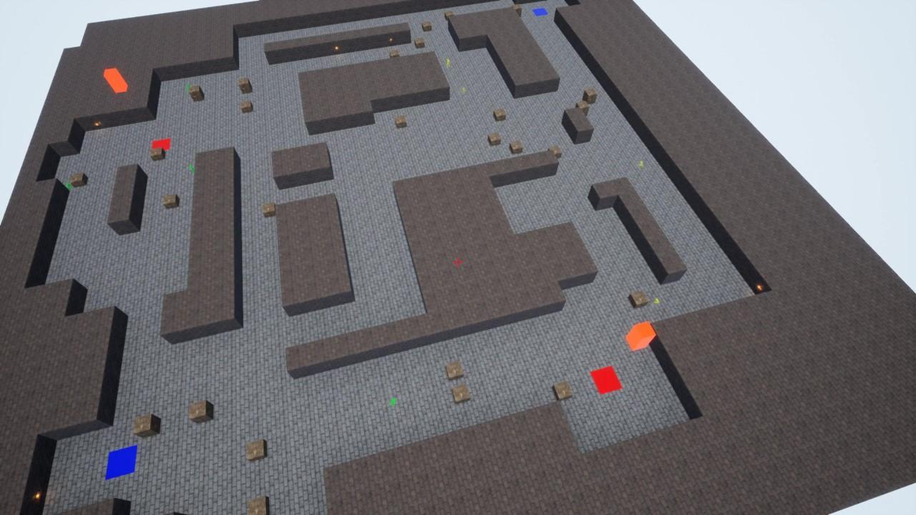
Figure 1: Top down view of the playtest session.

Participants gave themselves an anonymous player tag which would be used to record the statistics of each player throughout the session anonymously. After the play session, participants were also asked to fill out a questionnaire. Statistics from the play session were also saved for further breakdown of how generated levels’ fitness scores correlate to competitive balance. Evaluating competitive balance can be severely affected by a large discrepancy in the skill of users. Using information from the questionnaire combined with gameplay statistics for each user, helped to identify if competitive balance issues were apparent because of the format of generated maps or because of a difference in player skill-level. The mixture of quantitative and qualitative data will allow for correlations to be drawn from performance data on generated levels and opinion on how the map felt from the user perspective.

Results
Data was gathered on participant’s gameplay performance as well as the outcomes of each round during the playtest session. Participants also answered a structured questionnaire after the playtest where they were able to give their own view on how balanced they thought the levels were through answering a series of multiple-choice questions with the option for additional comments. Other questions asked players to describe their skill-level in FPS games. The feedback on generated levels along with information on player skill-level was used to assist in the breakdown of gameplay statistics. Below are the results from the questionnaire and the playtest sessions.

Questionnaire Data
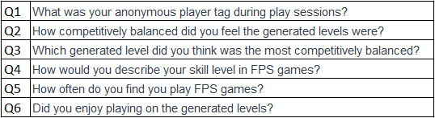
Table 1: Questionnaire Questions
Questions asked as part of the questionnaire were intended to be used to gather player feedback on the playtest sessions as well assisting in the breakdown of player performance statistics.
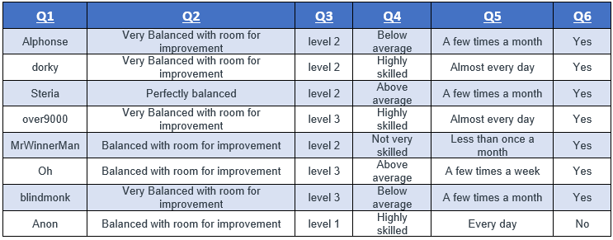
Table 2: Questionnaire Results (No Comments)

At a first glance the player feedback would suggest that the levels felt balanced from the players’ perspective as there were no negative responses to question 2. The skill-level and average play time of participants varied between not very experienced and very experienced with distribution lying more towards players being above average and beyond. Having players of varying experience was useful as it provided feedback from a varying level of player skill. Table 2 does not include the comments which were optional as part of answers to questions two and six See appendix A for the version of this table which includes these comments.

Playtest Data
Data was gathered during the playtest which was relevant to two areas. The first set of data was player specific to track player performance on the generated levels. The second set of data was session specific, which tracked the results and win conditions of each round on each level.

Playtest Player Data
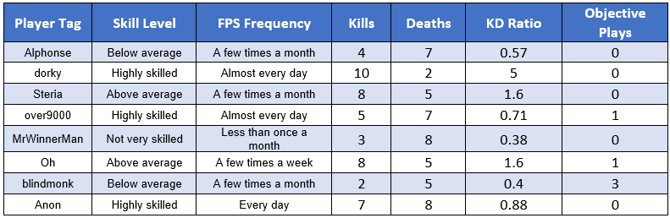
Table 3: Compiled Player Performance Data
The gathered player data shows the self-declared skill-level of players, the frequency of which they play FPS titles, Kill to Death (KD) ratio as well as the number of objective plays that the player made. This set of data is useful as it is can be used to make correlations between a player’s supposed skill-level and their actual performance during the session.

The below tables break down the data gathered relevant to player performance during the playtest session. This shows more clearly the correlation between the self-declared skill-level of players and how they performed during the playtest.

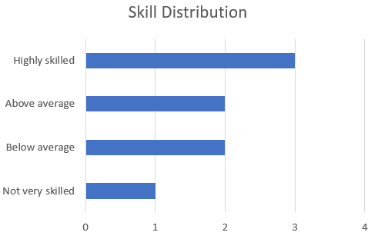
Self-Declared Skill level

Number of Players

Figure 2: Distribution of Player Skill
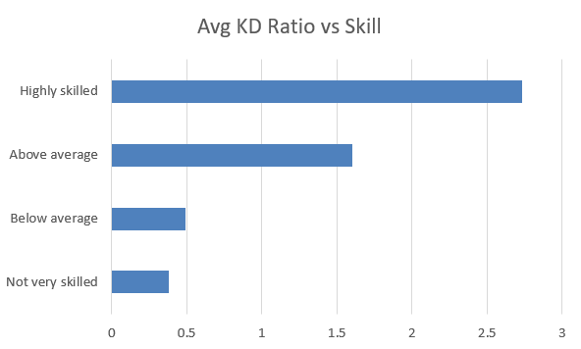
Self-Declared Skill level

KD Ratio

Figure 3: Average Player KD Ratio vs Player Skill

Playtest Session Data
In this section the results of each round on each level are displayed along with the win condition and whether or not the bomb had been planted (objective has been played).

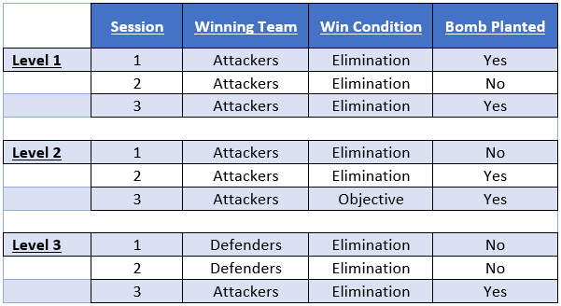
Table 4: Playtest Session Data

The attacking team dominated with a 78%-win rate leaving the defenders with a 22%-win rate. Rounds ended due to eliminations in 89% of occurrences leaving wins due to the bomb only having an 11% occurrence. Whilst the wins due to objective were very low, the bomb was planted in 56% of the rounds suggesting that some of the wins due to elimination were still affected by the objective’s presence.

The table below shows the results on each level compared to the fitness score. This is useful as it shows how the fitness score of a level can correspond to the balance.

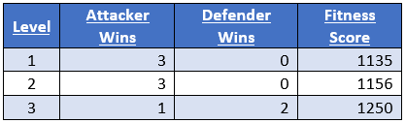
Table 5: Level Results vs Fitness Score

Discussion
This section will discuss and analyse the overall development of the project along with the results of the playtest session. Discussion will be centred around how well the project and gathered data were able to answer the proposed research question and if the results suggest that procedurally generated levels have the potential to be used in the competitive FPS genre.

Playtest Session
The playtest session contributed towards answering the research question significantly and showed that the generated levels are capable of being played as intended and within the intended environment (in an FPS game over a network). The intention of the session was to simulate a competitive FPS environment using real players playing each other over a network to get as close to a 1:1 experience possible.

Playtest Questionnaire Data Analysis
The answers to question two in the questionnaire were very positive with no negative answers received. Whilst a positive player opinion on the balance of the map doesn’t necessarily mean the maps were balanced, a general positive response does suggest that the maps were not immediately or obviously unbalanced. It also suggests that player frustration due to map imbalance was low which is an important factor when considering a system which would be deployed in a real competitive title.

Comment responses to the second question highlighted multiple areas of the system which players thought were good and bad. One comment stated that “there was a good variation of both long and short ranges”, this implies that the implemented line of sights fitness function algorithm helped to balance the maps as it was intended. Another comment mentioned that some areas of the map were slightly too open. This was an issue that was notable throughout the development of the project from the developer’s perspective. In a lot of map generations, placed corridors would overlap and create large open spaces, potentially turning adjacent rooms into one large room. Many actions were taken to reduce the chances of this occurring. This included lowering the number of corridors generated as well as constantly making adjustments to the corridor placement algorithm to discourage overlapping corridors. The results of these changes assisted with lowering the chances of creating too many open spaces, however, there is still room for improvement.

Answers to question three showed that players generally thought levels two and three were the more balanced levels, with level one only being chosen as an answer by a single participant. Examining table five does show that level one received the lowest average fitness score opposed to levels two and three. Level three scored the highest fitness value but was chosen as the most balanced level by fewer participants than level two. Overall, this would advocate for the fact that the fitness value does correlate to some aspects of the final competitive balance of maps. Nonetheless the system could be further refined to show a more consistent relation between the fitness score given and the level of competitive balance, which is felt by players on the generated level. The small sample size of levels played negatively affects both, the data gathered, and the analysis of this data. It makes it harder to draw any certain conclusions from the data and make any reliable correlations during data analysis. Using real players instead of an AI system to test levels meant that there were more constraints in terms of time and participant numbers when gathering playtest data. This along with the timing of the coronavirus pandemic occurring resulted in a smaller sample size than initially intended.

Questions 4 and 5 pertain to player specific data and will be discussed further in the playtest player data analysis section.

Question 6 gave participants the opportunity to express whether they enjoyed playing on the generated levels and what any of their additional thoughts on the generated levels were. This question was intended to gauge if the generated levels were fun or not to play on. This is an important aspect for the system to be able to fulfil. This is because if the generated levels are solely competitively balanced but not fun to play then procedurally generating levels would not serve any purpose in the gaming industry. Feedback received was overwhelmingly positive with 7 out of 8 participants responding yes. The comments left by participants highlighted a variety of areas which were felt to be positive aspects of the system. One comment stated “Lots of replayability.”, which is a very important aspect for the system to create. It is a good sign that the developed system appears to have this feature, as replayability is often one of the main purposes of PGC. A comment left by one of the highly skilled participants states that they thought the generated levels were “very competitive” and that they found themselves using their “FPS skills rather than struggling to understand the game”. Another comment which highlighted multiple positive aspects states “The lines of sight were there and cover was there as well, there wasn't a level where a team was exposed and didn't have cover”. This comment indicates that the cover placement and various line of sights algorithms implemented work together to encourage map balancing in the aspects which they were intended to do. This is a general indication that the system shows promise and is capable of balancing levels.

In summary, feedback left in the questionnaire was very positive and assisted in indicating the overall effectiveness of the system. The fact that feedback was strongly on the positive side does suggest that procedurally generating competitive levels is possible and that the methods utilised were effective in achieving this goal. Of course, the feedback in this section is orientated around the players opinion on the system and whilst player satisfaction is important, it is not enough on its own to confirm the overall level competitive balance encouraged by the system. This is why further data was gathered on the results of the session.

Playtest Session Data Analysis
The round results of the session highlighted a varying number of aspects that the system got right as well as any apparent issues in the system. The session results data (table. 4) suggests that the generated maps were highly imbalanced in favour of the attacking team. Whilst this could be the case, the distribution of player skill (figure. 1) could have had a large effect on the outcome of rounds as there was no balancing implemented into the team matching. This means that it is possible that all the highly skilled players could be in the same team, causing a severe imbalance in skill-level. A larger sample size would assist in a further breakdown of these results and what they suggest. Sadly, due to the coronavirus pandemic occurring, gathering participants for testing was more challenging than would have been in normal circumstances. A more positive assumption which can be made from this data is that the maps which are considered most balanced by the system (level 3) appeared to be the most balanced in terms of results.

Another positive aspect to note is that the objectives appeared to be functioning as intended. The objectives were intended to define the flow of the rounds, giving the players more tactical choices to make. With the bomb being planted in 5 out of 9 rounds it would suggest that the generated objectives were placed in suitable locations on the maps.

Playtest Player Data Analysis
The gathered player data was not enough on its own to make any clear statements on the effectiveness of the system. However, it was found to be very useful when correlated with the data gathered from the session results to reinforce any assumptions being made. Giving participants the opportunity to declare their own skill-level was not a secure way to fully evaluate the skill-level of players and make assumptions from this data. Combining the declared skill-level with the KD ratio of players did however show whether the players skill-level was relevant to their actual performance and assisted in breaking down the results shown in Table 4. On average, players with a greater skill-level performed better, while not explicitly being tied to level balance. This was a good sign that generated levels did not have any major flaws and played out similar to levels that experienced players would be used to.

The distribution of players who had made objective plays was not very spread out and at a first glance seemed underwhelming. However, when considering that there was a total of nine rounds played, five objective plays were completed within these rounds. This still suggests that the objective plays were not underwhelming in terms of gameplay importance, even if the distribution of players playing the objectives was unbalanced. It can also be considered that the gathered data for objective plays only considered successful actions. This means that if players were killed while planting or defusing the bomb or forced to move out of danger it wouldn’t have been recorded.

The distribution of player skill proved to be a hurdle when analysing certain aspects of the session data. If there had been more players of a similar skill-level in the session the overall results would have been much more affected by just the map balancing. Due to the high distribution of player skill and small sample size it was difficult to fully assume whether the results were caused by map balancing or a discrepancy in player skill.

Project Findings

Summary
The overall findings of the project were very positive. The prototype system showed that there is potential in procedurally generating competitively balanced levels for FPS games even if the results did not prove the system to be an outright success. The implemented methods were proven to be suitable methods for generating balanced levels and the various algorithms that were implemented showed their strengths and weaknesses. The overwhelmingly positive player feedback showed that it is also possible for the system to provide a good level of player satisfaction. If the system was to be developed further, it could continue to improve on the level generation process, further refining the current methods used and adding new methods, which would help improve competitive balance in many aspects.

Research Question
The research question that this project set out to answer was: “How can competitively balanced first-person shooter maps be effectively procedurally generated?”. The results have shown that it is indeed possible to generate competitively balanced levels and the applied methodology stands as an example of a way that this type of system can be implemented. By bringing together a system which can procedurally generate tilemaps and a system which can evaluate generated tilemaps, it has been shown that generated levels can not only maintain a healthy level of competitiveness but also be enjoyable to play.

Project Critical Evaluation

Development Evaluation
The project seen many changes and iterations throughout its development as different problems arose. The foundations which the generation system was built upon had some flaws which were not addressed early on. This led to much more time being spent revising code which had been written in the past, causing more time being lost. An example of this was the functionality for rooms being placed within the tilemap. Rooms were placed in the tilemap using an iterative method to find the correct tiles for rooms to be placed on. Optimisation became an issue as this process begun to take up more than 90% of the time spent in the generation process. The solution to this problem was identified and fixed later in the project but had there been more consideration for this function to begin with, much time could have been saved.

The first iteration of the system which was considered fully functional, output the tilemaps to the windows command prompt as seen in Figure 4.
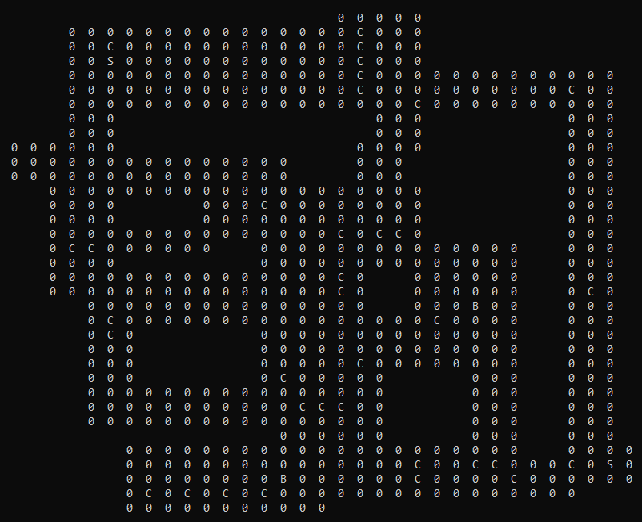
Figure 4: Tilemap output on the command prompt
Whilst this method was quick and efficient to implement, it became more of a problem as the project’s development progressed. Without being able to display any information other than the tile values and with no means to interact with the generated tilemaps, it became challenging to debug many aspects of the system. To get around this, it had been decided that the SFML library would be utilised to provide a GUI, which would allow for much more information to be displayed and also a much higher level of interactivity. As seen below in figure 5, the implemented SFML system for displaying tilemaps was a much more suitable means of viewing them. It proved particularly useful when developing the fitness function aspect of the system as debugging the pathfinding was particularly challenging.
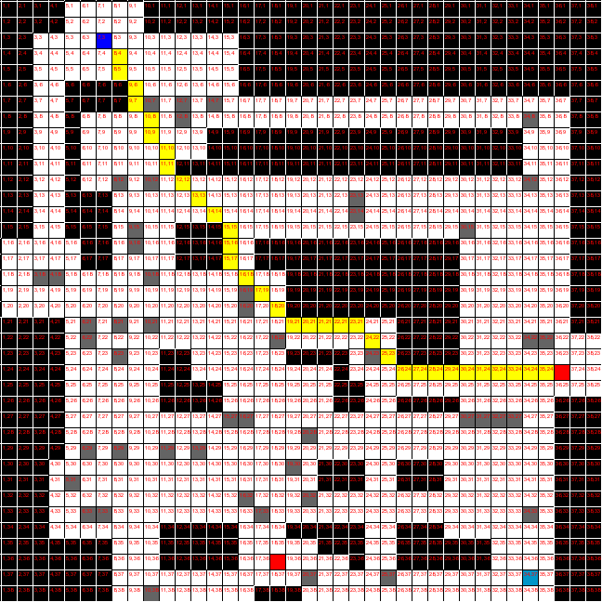
Figure 5: Tilemap output to an SFML window with interactive pathfinding being displayed

The overall efficiency of the system could be improved in many areas. The time taken for the generation process varies drastically, often taking more than a minute to generate a level which fits all the specified parameters. This occurs even though the system can generate a full level within 10 seconds or less whilst running on an AMD Ryzen 5 2600x CPU. Further developing the system to include a genetic algorithm could help to narrow the randomness in the generation process. Additionally, it has the potential to vastly improve the quality of generated levels. Improvements could also be made to the various algorithms which make up the generation process to be more consistent when addressing level balancing parameters.

The prototype FPS game used for playtesting was initially going to be a ready-made networked FPS game known as “FPS Sample” provided by Unity. It had been decided that taking this project and adding some features to handle the bomb sites, game loop and data gathering would not take up much time and was mostly considered an afterthought. However, due to my unfamiliarity with the Unity game engine, implementing additional functionality on top of this already sophisticated project very quickly became a struggle and a time sink. After a week of development and many hurdles being hit, with no solutions being found, it was decided that implementing a more bare bones networked FPS game in Unreal Engine would be quicker and more predictable in terms of the time needed to have it ready for playtesting. Once the switch was made, another week was spent preparing the networked FPS game and progress was steady throughout. The initial train of thought was to take an almost complete project which is made for a game engine which was less familiar in order to learn more about said game engine. In practice, it was quickly shown that considering the amount of aspects and time constraints with this project it would have been much better to go with the framework which I have experience with even if there wasn’t a readymade project for it.

The reliability of the system left a lot to be desired in the areas where it could be improved. While the implemented methods were functioning as intended, there were still many aspects of level creation not addressed by the system. Because of this, the generation process can still put out maps which would not be suitable for gameplay. One feature which would improve the reliability of the system significantly would be to implement an algorithm which can identify dead ends in generations and either remove them or connect them to a suitable area.

Playtest Evaluation
A larger sample size of participants would have helped to make more certain conclusions from the data gathered. Due to the coronavirus pandemic, it became difficult to find more participants who were willing to take part in the study. The participants were diverse in their level of skill. Whilst this might be a benefit in terms of the feedback received being from a broader audience, it did not help when breaking down whether the results of the session were due to the map balance or a discrepancy in player skill-level. Having a group of participants with a much lower distribution of player skill could have made it possible to draw more conclusions from the gathered data.

A larger sample of generated levels being tested also would have greatly benefited the project. Due to the inclusion of participants as opposed to simulating bots on the generated levels, time constraints were a much more apparent issue during the data gathering phase. Thus, it was an issue trying to fit more generated levels into the playtesting session with the time that was available. The choice of using real participants had its pros and cons, if there had been more preparations put in place earlier on in the project’s development, more of these negatives could have been avoided. The implications of this are that the sample size may not represent the population of interest accurately, which means that the correlations that have been made require further data to confirm the current results.

Conclusion

Main Conclusion
This project initially set out to determine how competitively balanced maps can be procedurally generated. Based on progress made through the development of the system and the results of the playtest, it can be concluded that it is most likely possible to generate competitively balanced maps for FPS games. The applied methods within the tilemap Generation process and the Direct Fitness Function are a feasible way to achieve this. The system was able to generate maps with consideration put towards the competitive balance of levels. The generated levels can be applied in an FPS environment where players are able to play against one another over a network.

The feedback received shows that this method of content creation provides players with an entertaining experience and the competitive balance of a level can certainly be addressed in the process of a Search Based PCG algorithm. Whilst the system was able to create balanced levels to a high enough standard which provided players with a positive experience, when compared with the level of polish achieved by designing a level by hand, there are still a lot of questions left to be answered in the area of PCG.

The primary use of the project in its current form would be to produce partially finished levels. From this point it would be in the hands of the developer to further polish the generated content. The time in which the system can generate levels shows promise in the area of producing complete content ready for the player, but a lot more work is needed on the system for it to be reliable enough for deployment in this manner.

Creating a reliable system in the area of procedural content creation is a challenging task. When done right it can provide endless amounts of content for players and add a lot of replay value to a game and have the possibility to save valuable time and costs for developers. While the developed system is certainly not the most reliable or perfect solution to adding a greater amount of content to FPS games, the work carried out shows that it is a feasible method of content creation in this area and that the unpredictable nature of PCG can provide a lot of entertainment for the players.

Implications
The work carried out stands as an example for any future efforts made in the field of procedurally generating competitively balanced content. The applied methodology demonstrates how competitively balanced content can be generated and paves the way for any future work to continue making progress in this area. It confirms that generating competitively balanced content for FPS games is an area with potential and that with more research put into this field, it could definitely become a more common feature to be found in the genre.

Future Work
There are many aspects of the system that could be improved upon or even implemented using a different methodology. Based on the derived conclusions the following highlights areas where the system could be improved upon:

- Further refinement of the Direct Fitness Function could allow for more parameters being tested, resulting in maps which are balanced in more aspects. An example would be adding a fitness function parameter which can test whole map navigation. The intention here would be to adjust areas of generated levels which are unlikely to see much activity from players due to dead ends etc.

- The map generation process could be improved to include more rules based on design principles such as how rooms can be placed or more methods to create corridors between rooms. Improving on this area could greatly increase the consistency of the system, making it more reliable and decreasing the time taken to generate an appropriate level.

- A more complex object placement algorithm for creating environments within the generated rooms could be added. This would improve the competitive balance of levels by placing objects in locations which would break up lines of sight. It would also add to the aesthetic value of levels which is an area which was not touched upon by the system.

Different methods of PCG could also be applied in the area of generating competitively balanced content to see if similar or better results can be achieved. This would help to highlight the strengths and weaknesses of applying different methodologies to this area.

Appendices
Appendix A – Raw Questionnaire Results
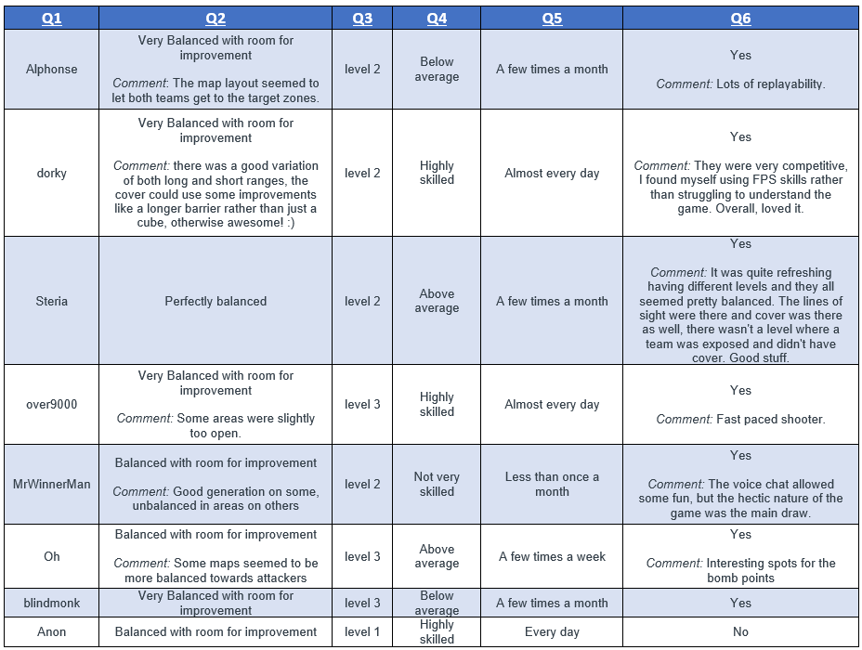

Appendix B – Data Collection Consent Statements

Participants had to agree to the following statements in order to take part in the study.
- I understand that my participation is voluntary and that I am free to withdraw at any time without giving any reason, without any of my rights being affected.

- I Understand that data collected during the study may be looked at by individuals aiding or evaluating the research, where it is relevant to my participation. I give permission to these individuals to have access to my records.

- I understand that the information collected about me will be used to support other research in the future and may be shared anonymously with other researchers

- I understand the data collected about me will only include my gameplay statistics, my anonymous opinion on the game and how frequently I play games.

- I understand that once my data has been collected it will be used alongside others to produce a written evaluation on the project, I also understand that I can still withdraw my data at this point.

- I understand at the end of the game, after I have completed the questionnaire that I am free to disregard all of my data by not sending it to the researcher.

- I understand that my data will be held securely on an external hard drive with only the researcher having access.

- I agree to take part in this study.
Appendix C – GDPR Data Protection Form



List of References
Antoniades, A. (2009). The Game Developer Archives: 'Monsters From the Id: The Making of Doom '. [online] Gamasutra.com. Available at: https://www.gamasutra.com/php-bin/news_index.php?story=21405 [Accessed 10 Feb. 2020].

Bhojan, A. and Wong, H. (2014). ARENA -Dynamic Run-time Map Generation for Multiplayer Shooters. [online] Link.springer.com. Available at: https://link.springer.com/content/pdf/10.1007%2F978-3-662-45212-7_19.pdf [Accessed 3 Feb. 2020].

Blog.counter-strike.net. (n.d.). About CS:GO. [online] Available at: https://blog.counter-strike.net/index.php/about/ [Accessed 10 Feb. 2020].

Cardamone, L., Yannakakis, G., Togelius, J. and Lanzi, P. (2011). Evolving Interesting Maps for a First Person Shooter. [online] SpringerLink. Available at: https://www.researchgate.net/publication/220867335_Evolving _Interesting_Maps_for_a_First_Person_Shooter [Accessed 8 Oct. 2019].

Cicala, A., 2020. Importance Of Small Scale FPS Level Design - Mainstream Development - Black Shell Media. [online] Black Shell Media. Available at: <https://blackshellmedia.com/2017/01/17/importance-small-scale-fps-level-design-mainstream-development/> [Accessed 19 April 2020].

Cifaldi, F. (2006). The Gamasutra Quantum Leap Awards: First-Person Shooters. [online] Gamasutra.com. Available at: https://www.gamasutra.com/view/feature/1832/the_gamasutra_quantum_leap_awards_.php [Accessed 10 Feb. 2020].

David, M. (2016). Tile-based Method for Procedural Content Generation. [online] Available at: https://etd.ohiolink.edu/pg_10?0::NO:10:P10_ACCESSION_N UM:osu1461077485 [Accessed 8 Oct. 2019].

Dent, S. (2019). 'Minecraft' has sold 176 million copies worldwide. [online] Engadget. Available at: https://www.engadget.com/2019/05/17/minecraft-has-sold-176- million-copies-worldwide [Accessed 8 Oct. 2019].

Game Development Envato Tuts+. (2019). Create a Procedurally Generated Dungeon Cave System. [online] Available at: https://gamedevelopment.tutsplus.com/tutorials/create-a-procedurally-generated-dungeon-cave-system--gamedev-10099 [Accessed 8 Oct. 2019].

Gaunt, C., 2020. Analyzing Level Layouts To Improve Level Design In Competitive FPS. [online] Gamasutra.com. Available at: <https://www.gamasutra.com/blogs/CurtisGaunt/20170405/295251/Analyzing_Level_Layouts_to_Improve_Level_Design_in_Competitive_FPS.php> [Accessed 19 April 2020].

Hullet, K. and Whitehead, J. (2010). Design Patterns in FPS Levels. [online] Games.soe.ucsc.edu. Available at: https://games.soe.ucsc.edu/sites/default/files/khullett-fdg-camer a-ready.pdf [Accessed 8 Oct. 2019].

James, F. and Hurley, L. (2019). Modern Warfare maps: The complete list of maps in Call of Duty this year. [online] gamesradar. Available at: https://www.gamesradar.com/uk/call-of-duty-modern-warfare-maps/ [Accessed 29 Jan. 2020].

Kruse, J. and Connor, A. (2015). Multi-agent evolutionary systems for the generation of complex virtual worlds. EAI Endorsed Transactions on Creative Technologies, 2(5), p.150099.

Kruse, J., Sosa, R. and Connor, A. (2016). Procedural urban environments for FPS games. Proceedings of the Australasian Computer Science Week Multiconference on - ACSW '16.

Ludwig, J. (2020). Procedural content is hard. [online] Programmerjoe.com. Available at: http://programmerjoe.com/2007/02/11/procedural-content-is-hard/ [Accessed 27 Jan. 2020].

Mapviewer.codewing.de. (n.d.). CS:GO - MapViewer //codewing.de. [online] Available at: https://mapviewer.codewing.de/ [Accessed 8 Oct. 2019]. Statista. (2019). CS:GO peak players on Steam 2019 | Statista. [online] Available at: https://www.statista.com/statistics/808630/csgo-number-players -steam/ [Accessed 8 Oct. 2019].

Medium. 2020. PRACTICAL GUIDE ON FIRST PERSON LEVEL DESIGN - IronEqual. [online] Available at: <https://medium.com/ironequal/practical-guide-on-first-person-level-design-e187e45c744c> [Accessed 20 April 2020].

Sinclair, B. (2013). GTA V dev costs over $137 million, says analyst. [online] GamesIndustry.biz. Available at: https://www.gamesindustry.biz/articles/2013-02-01-gta-v-dev-costs-over-USD137-million-says-analyst [Accessed 29 Jan. 2020].

Takagi, H. (2001). Interactive evolutionary computation: fusion of the capabilities of EC optimization and human evaluation. Proceedings of the IEEE, 89(9), pp.1275-1296.

Thomason, L., 2012. Micropather. [online] Grinninglizard.com. Available at: <http://www.grinninglizard.com/MicroPather/> [Accessed 1 May 2020].

Togelius, J., Yannakakis, G., Stanley, K. and Browne, C. (2010). Search-based Procedural Content Generation. [online] Eplex.cs.ucf.edu. Available at: http://eplex.cs.ucf.edu/papers/togelius_evogames10.pdf [Accessed 3 Feb. 2020].

Togelius, J., Yannakakis, G., Stanley, K. and Browne, C. (2011). Search-based Procedural Content Generation. [online] Julian.togelius.com. Available at: http://julian.togelius.com/Togelius2011Searchbased.pdf [Accessed 1 Feb. 2020].

Togelius, J., Kastbjerg, E., Schedl, D. and Yannakakis, G., 2011. What is procedural content generation?. Proceedings of the 2nd International Workshop on Procedural Content Generation in Games - PCGames '11, p.2.

Unity. (2020). FPS Sample - A multiplayer shooter game project | Unity. [online] Available at: https://unity.com/fps-sample [Accessed 22 Feb. 2020].

Zafar, A., Mujtaba, H. and Beg, M. (2020). Search-based procedural content generation for GVG-LG. Applied Soft Computing, 86, p.105909.

