Section 1

Networking basics — LAN, WAN, routers, switches

Networking: Networking is the process of connecting computers, devices, or people so they can communicate and share information or resources (Data).

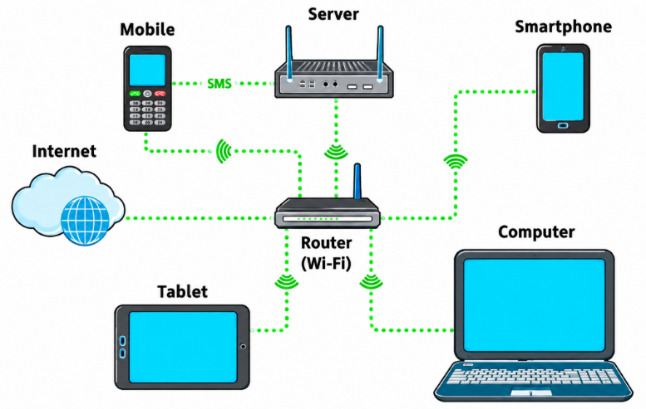
Why we use Network
- Share info or data
- Share Hardware and Software
- Emails or message
- Audio and Video calls
- Share printers
- Share Hard drives
Switch: is hardware that connects devices (like computers, printers, and gaming consoles) within a Local Area Network (LAN)

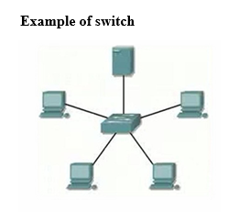

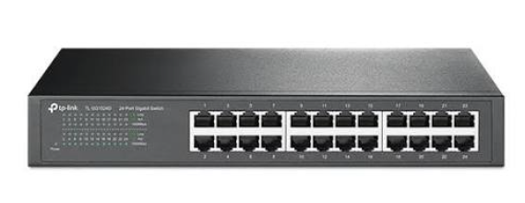

Switch talks to a different devices across your local area network. Sends your request to a relevant network device.
Wireless Access Point (WAP) : used to connect wireless devices.
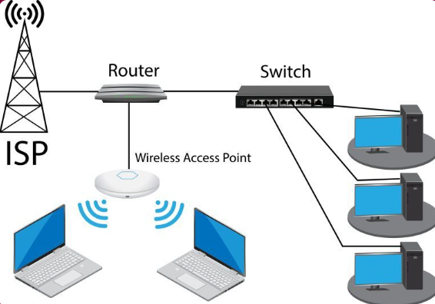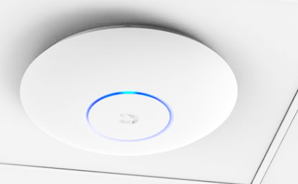

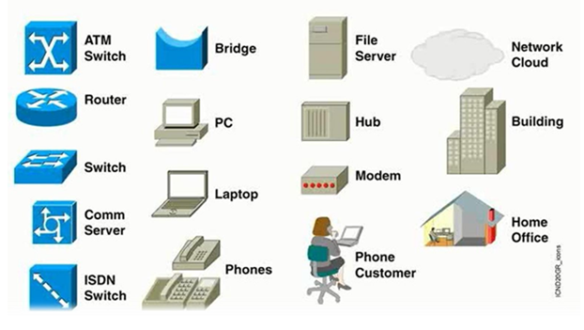
- Hub: Connects group of hosts
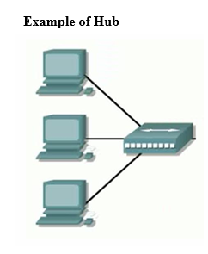

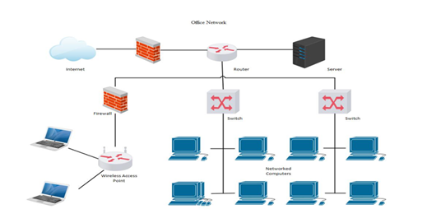

- Router: connects different networks or distance networks
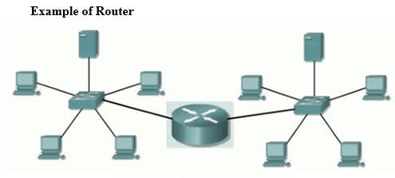

Local Area Networks (LANs) -> Operate within a limited geographic area such as office or Home
Metropolitan-area Networks (MANs) ->
Wide-area Networks (WANs) -> Operate over a large geographical area or connect LANs.

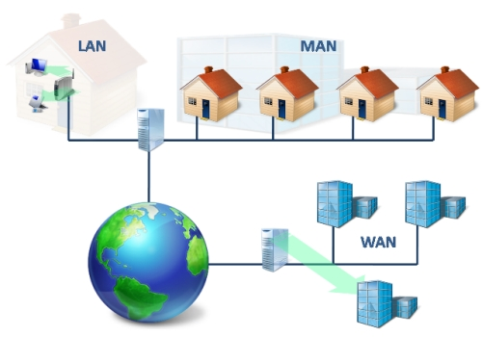
Bandwidth:
Speed of internet is called Bandwidth.

Firewall

Firewall has DMZ (Demilitarized Zone ad-hock or direct connection will be reported to DMZ) and Port FWD (identifies port for our local introduced (subnet) devices).

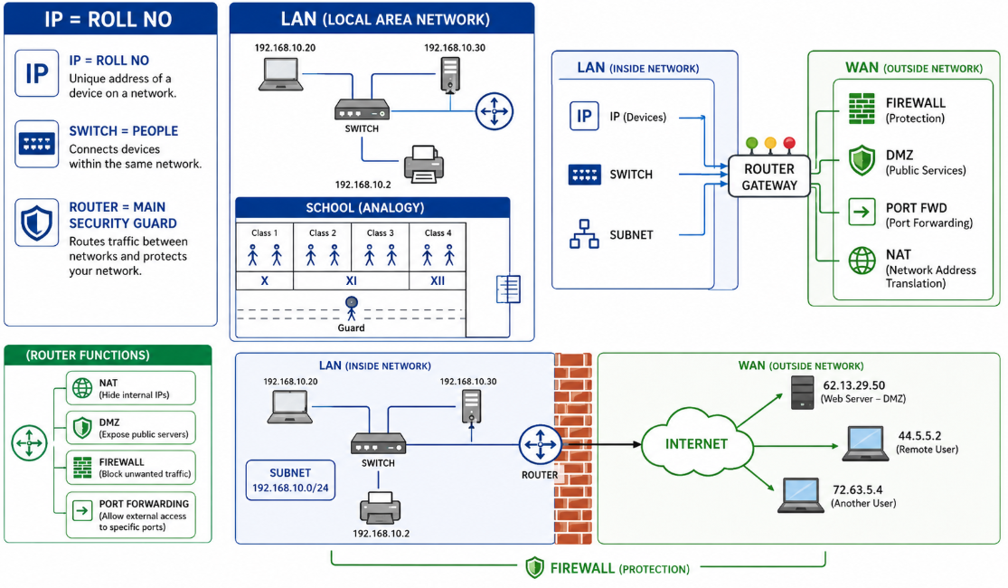

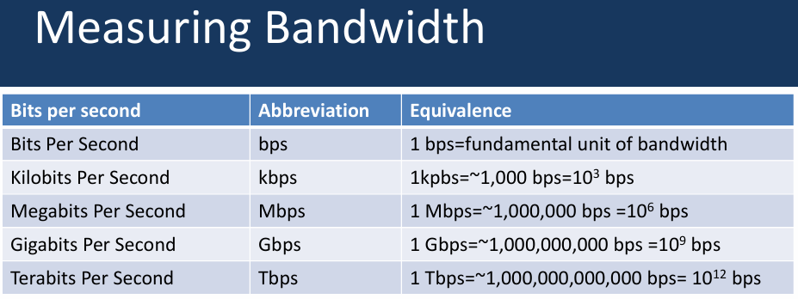

Topologies (Shape of Possible Networks):
Structure in network is called topology.
Mainly used are star and tree

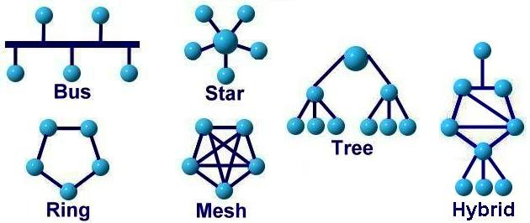

Cable Types
Cat 5 (Category 5) and Cat 5e (Category 5 enhanced) are Ethernet cables that use twisted pairs of copper
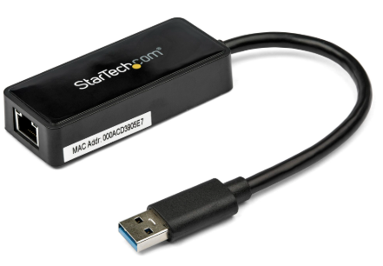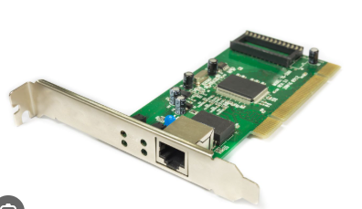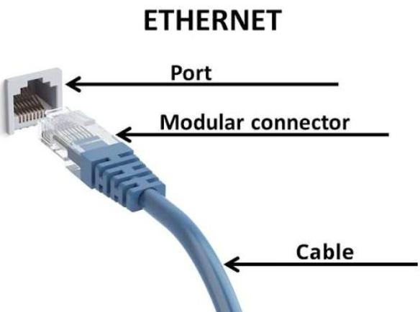
NIC card
- Straight through: connects two different type of devices such as computer to switch, Router to switch. A straight-through cable has the same wiring standard on both ends. (RJ45 connector)
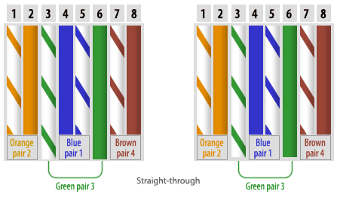
- Cross over : connects two like network devices
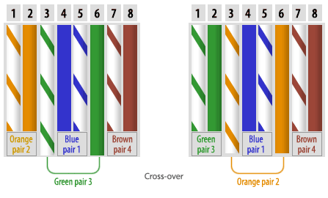
Rollover cable (Console cable)
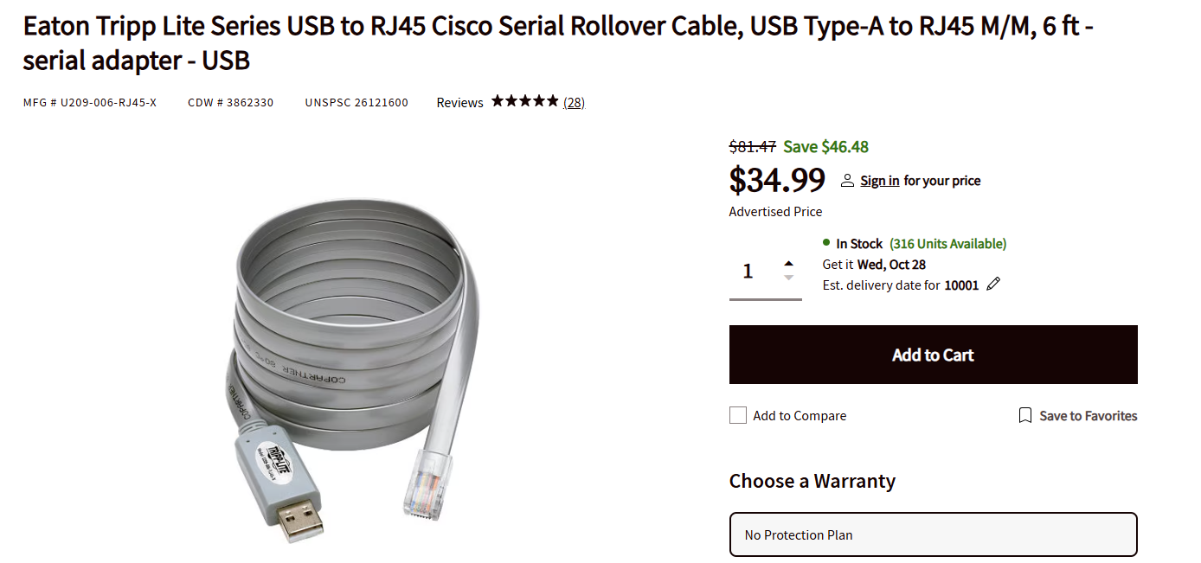
Generally this cable is used for the configuration of router and switch. Which dosent need ip address

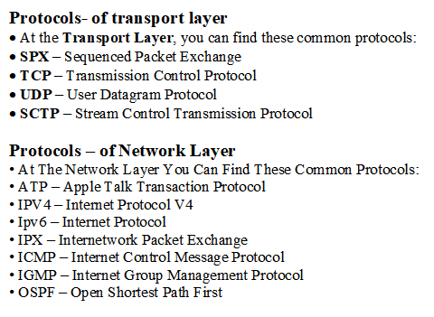

IP addressing — IPv4, IPv6, Subneting
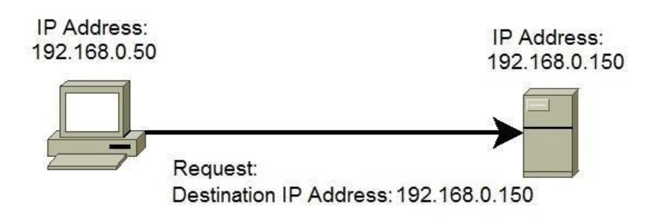
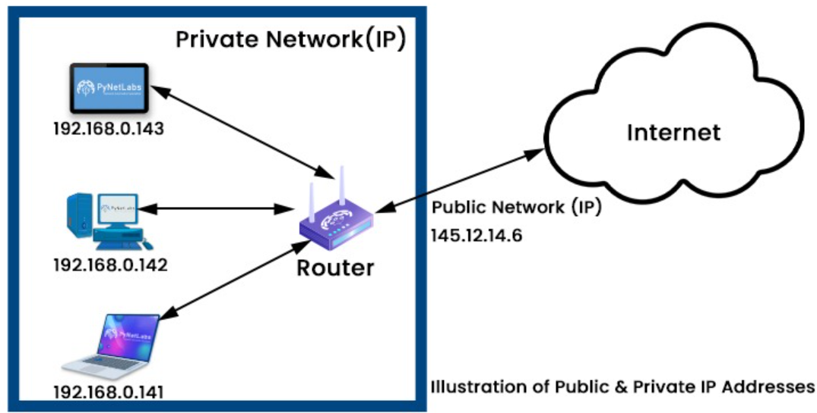

Any network needs 3 things IP, Subnet and Gateway (IP address of Router is called gateway)
LAN Card has two addresses as below
✓ IP Address
✓ MAC Address
IP (internet protocol) Address:
MAC (Media access control) Address
A changeable logical address assigned to acms computer or device to identify it and communicate with other devices on a network.
✓ once cabling id done, we must assign IP address for all the network computers. After that the network computers can communicate, share, apply policy, and sending message etc. to others.
CMD = > getmac to get current device mac address (ipconfig)
The TCP/IP suite defined five blocks of addresses, called IP address classes, for specific network uses and sizes.

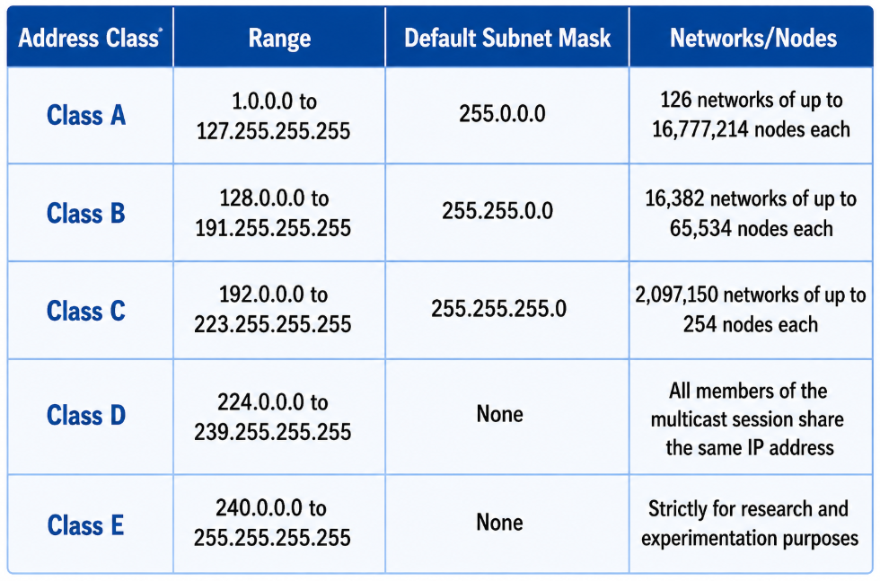
Ex: IP 192.168.1.0
Ex: Sub netmask 255.255.255.0

Means we have 3 octet of Networks and 1 Host. So N.N.N.H so we can’t change Networks but we can change Host and also we can do sub-netting.

If you want assign new IP address:
Control Panel, Network and Internet – Network and Sharing Center- Properties – TCP/ip4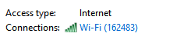
IPv4 has totally 32 – bit logical address
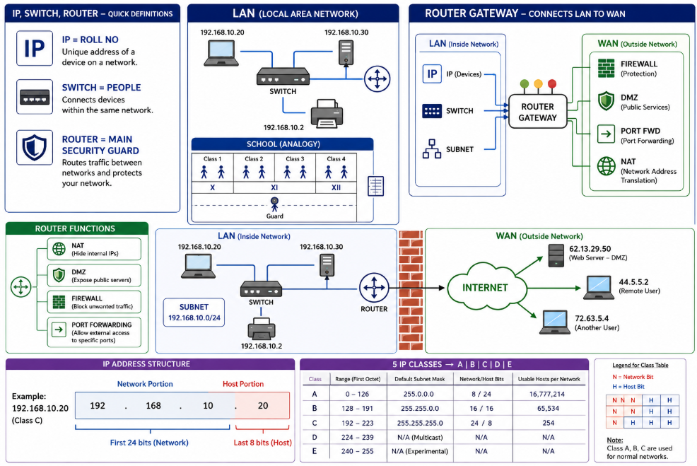
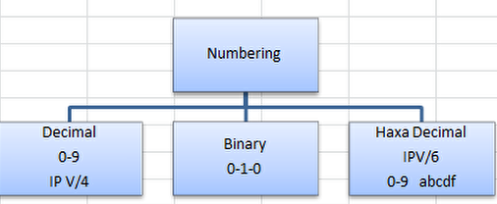
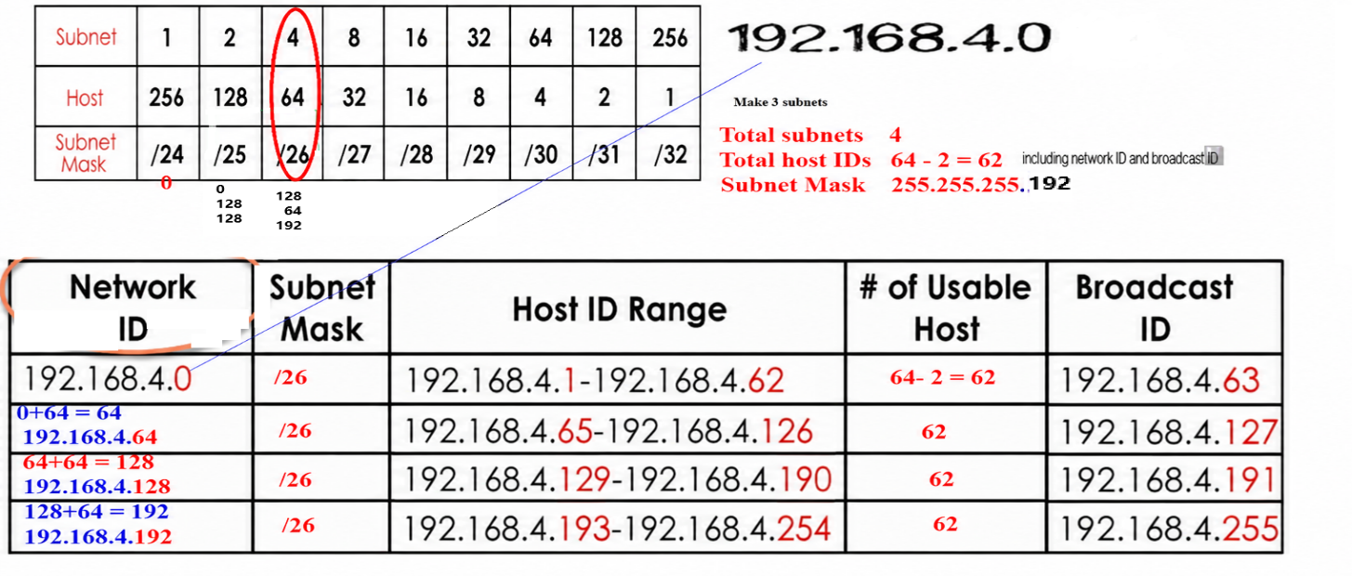
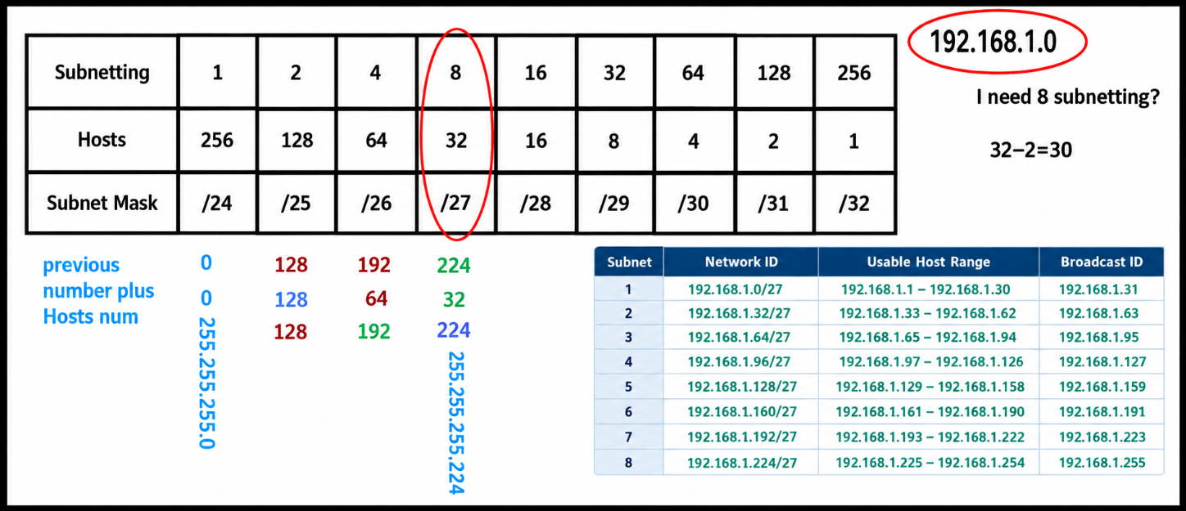
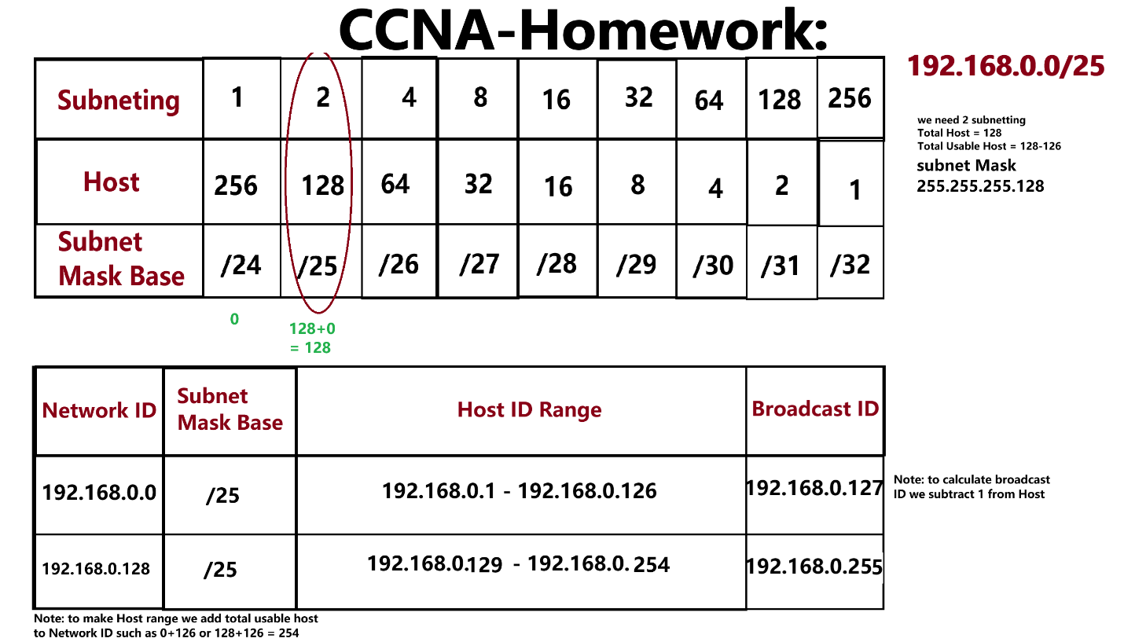

Subnet defines your local area network Range. Subletting are private IP address that defines some one’s computer.
All classes are divided into two Parts Private IPs and Public IPs
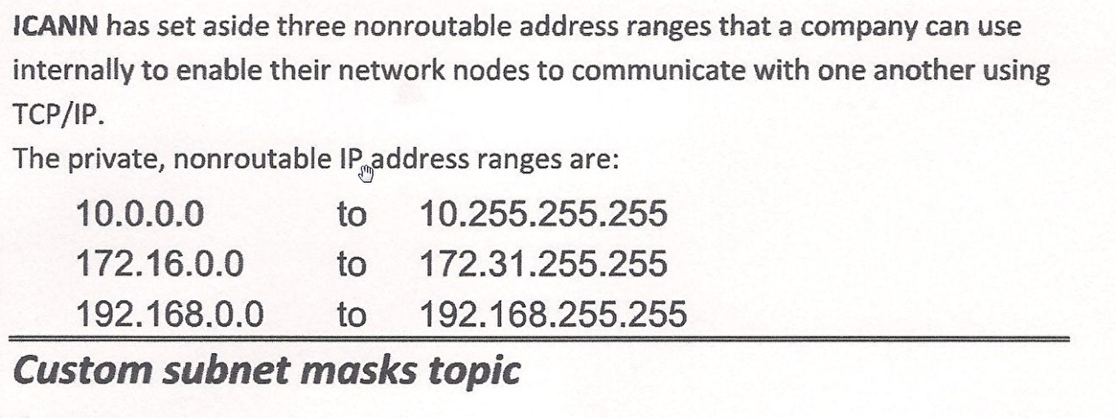
Public and Private IPs
We can make 15 networks in B class
222.0.0.1 This public IP other than the range of Private IP.
SUBNET 192.168.0.2 - 192.168.0.254

Cisco
Cisco Systems was founded in 1984 by married couple Leonard Bosack and Sandy Lerner, who worked at Stanford University. The first thing they created was gateway server to communicate. They helped develop networking technology that allowed computers on different networks and departments to communicate, which led to the creation of Cisco routers. The company was named Cisco, derived from San Francisco, California. Cisco Packet Tracer: is a virtual networking lab used to practice Cisco networking and CCNA skills.

Ex: 8 bits C class IP subnetting 192.168.4.0
192 sub netting

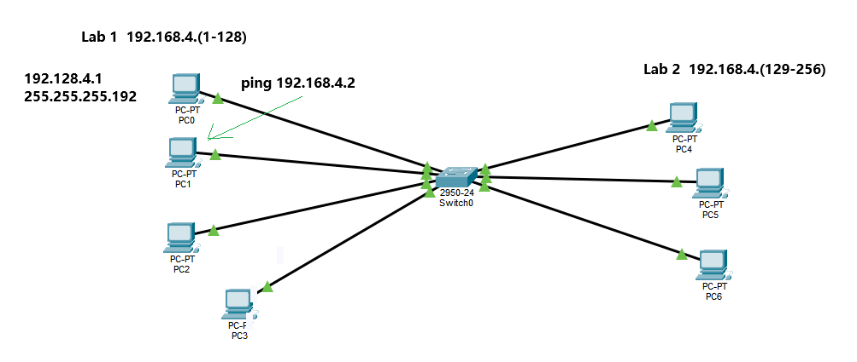

Switch + Access Point Setup

LAN wireless + line
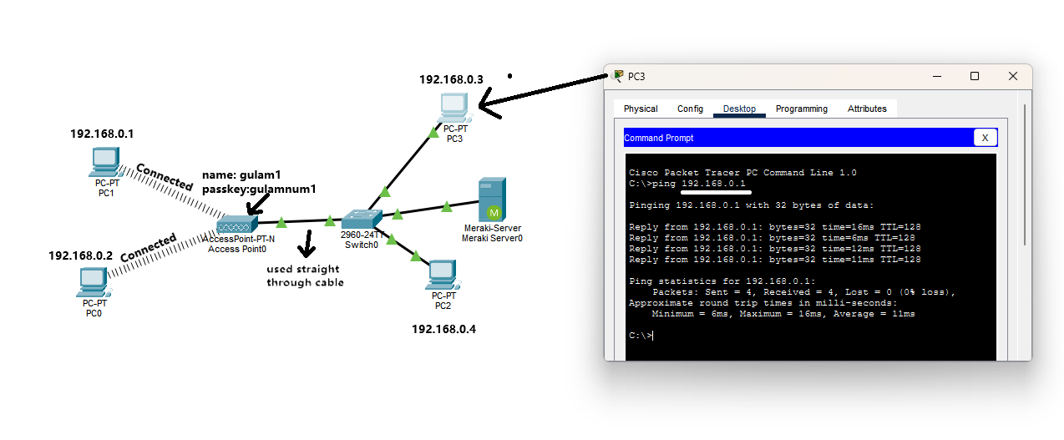

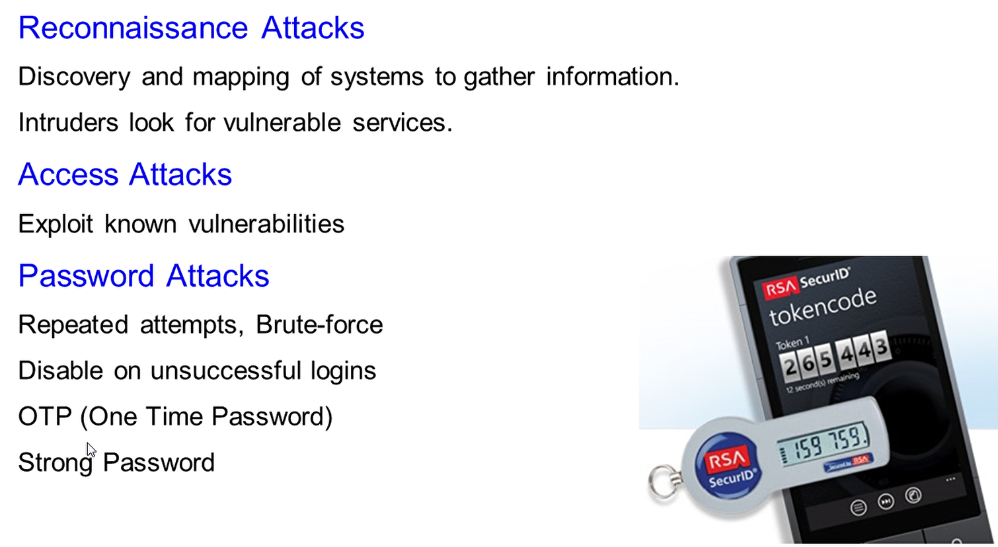

Section 2
Client and Server
Server: is the computer that controls clients.
DNS Server: converts name.com to IP and IP to name.com
Active Directory
Set of rules used to create users, and rules for the clients.

Characteristics of Network
- Speed: How fast data transmitted over the network.
- Cost: General cost of components, installation, and maintenance.
- Security: How secure the network?
- ([Number of minutes in a year-downtime]/[Number of minutes in a year])*100=Percentage availability
- 15 minutes downtime =99.997
- Scalability and Reliability: How well your network can accommodate more users and MTBF (Mean time between failures)

Need for Network Security
- 60 to 80 percent of network misuse comes from inside
- Open and close Network
- Closed Network does not allow a connection to public networks
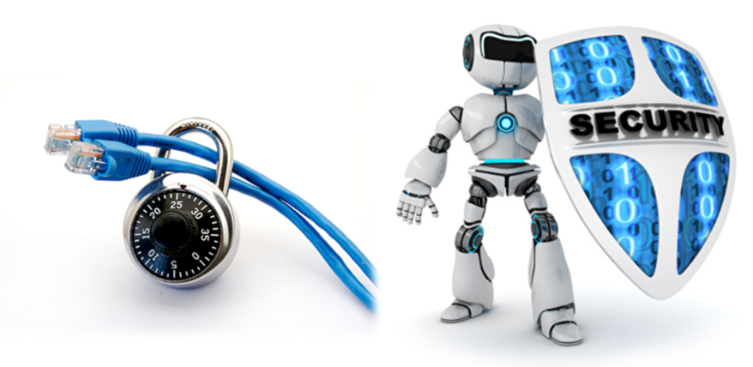

Classes of Attack
- Passive: Traffic analysis, monitoring communication
- Active: Attempts to circumvent or break protection features i.e. DOS
- Close-in: Attempting to go close physical proximity to networks, systems, or facilities
- Insider: Malicious insiders intentionally eavesdrop, steal, or damage information
- Distributed: Malicious modification of hardware or software during distribution with back door installed

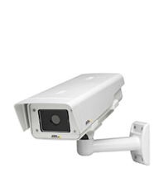

Mitigating Common Threats
Physical Installations
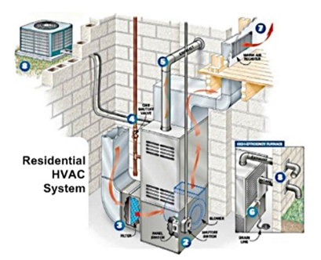
✓ Room Look
✓ No access from ceiling
✓ Electronic access control (Biometric)
✓ CCTV (Closed-circuit television)
✓ Temperature and humidity control systems (HVAC) (Heating,ventilation,and air conditioning)
✓ Electrostatic and magnetic interference
✓ UPS and backup generator

Note: Lock is not the Preventive control

Network Layers OSI (Open Systems Interconnection)
7 — Application Layer
✓ Message format, Human-Machine Interfaces
6 — Presentation Layer
✓ Coding into 1s and 0s; encryption, compression
5 — Session Layer
✓ Authentication, permissions, session restoration
4 — Transport Layer
✓ End-to-end error control
3 — Network Layer
✓ Network addressing; routing or switching
2 — Data Link Layer
✓ Error detection, flow control on physical link
1 — Physical Layer
✓ Bit stream: physical medium, method of representing bits
UPPER LAYERS: 7, 6, 5
TRANSPORT SERVICE: 4, 3, 2, 1
Letter | Name | Notes
A | NDREW | company owner speaks Japnies
P | ARVEEN | Translate, Encrypt
S | EEMA | appointment
T | ANVEER | make it down to pieces, packs, sigma
N | NAVEED | two way address, send and receive
D | AVID | seal it
P | EON | physically deliver, send as signal

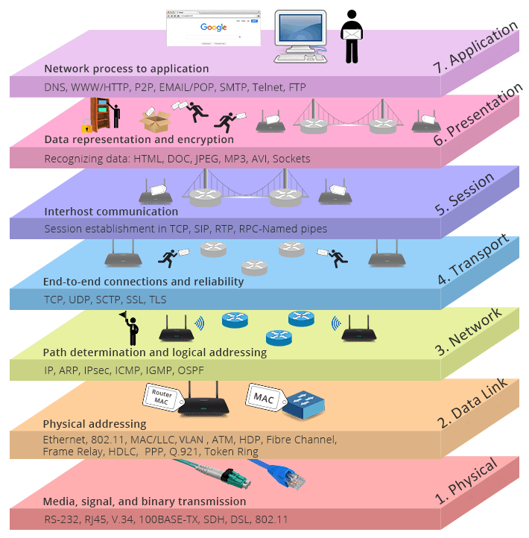

Switching — VLANs, trunking, STP

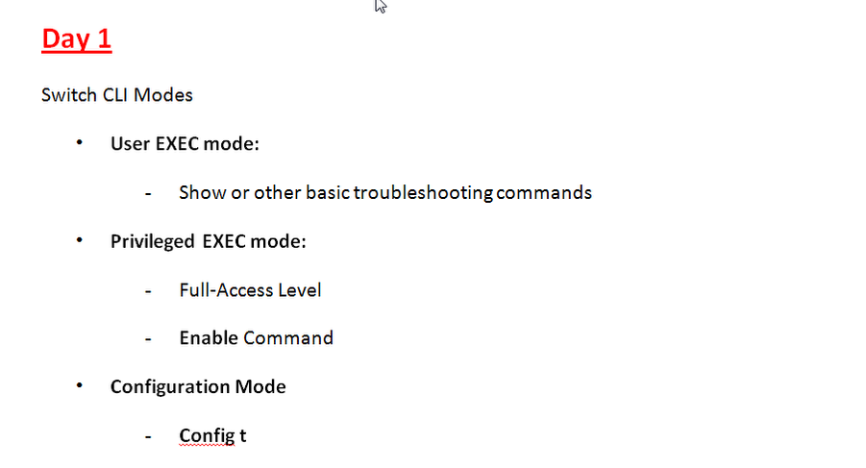

Switch configuration using console cable we connect SP of computer the switch console port.
Now we enter from our PC – Desktop – Terminal –
This exec Mode if we want to switch to privilege Mode then we write en
Or if we want to change Mode to configuration then we write configure t
Day 2

Changing Switch Name and password
- Enable en
- Configure terminal confi t
- Hostname KDR
- Enable password khan
- exit
- exit
- en
- password khan
if we want to remove security or password from switch then we write (no enable password) in config mode.
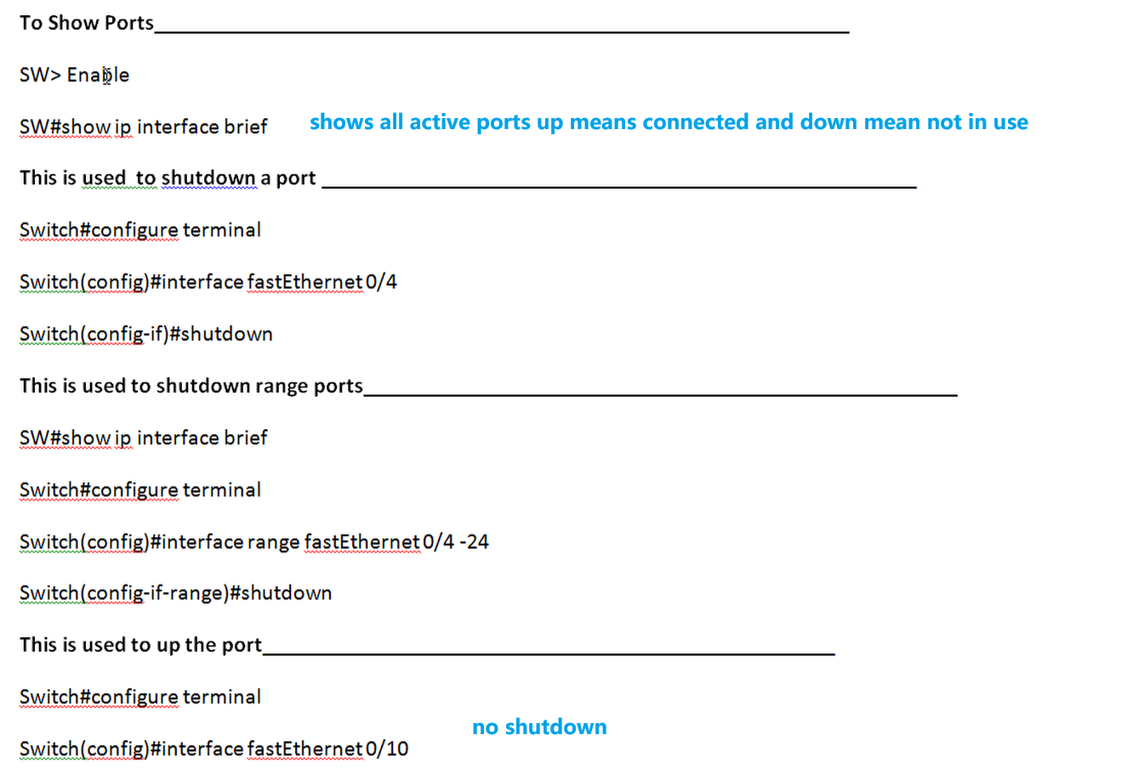

Routing — static routes and OSPF
Router setup with Wireless Network

Routers have DHCP servers inside which assigns by default IP addresses when it is enabled. And when we make it Disabled then we can assign Static IP means manually entering IPs.
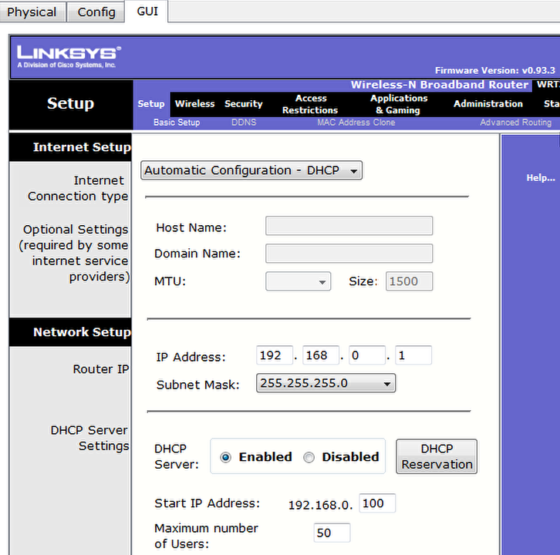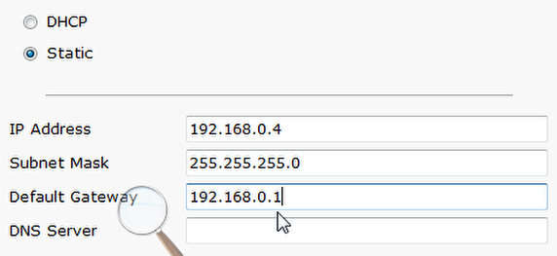
How to change Network Name
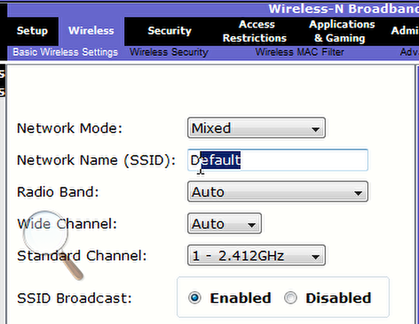
In Administer tab we can change router admin password
In wirless security we can allow or block mac address
How to find mac address cmd – ipconfig/all the physical address is your mac address.

How to configure router from a client browser
Step 1:
Make a wireless connect setup
Step 2:
Click on a laptop/computer/pc you made
Step 3:
Click on desktop then on web browser
Step 4:
Enter your gateway IP
Step 5:
Then ender admin admin
Step 6:
Go to wireless then click wireless security then give it a passphrase
Step 7:
Then connect the computer and you’re done

Wireless networking

Network security

NAT, DHCP, DNS

Network automation and programmability



https://www.coursera.org/google-career-certificates
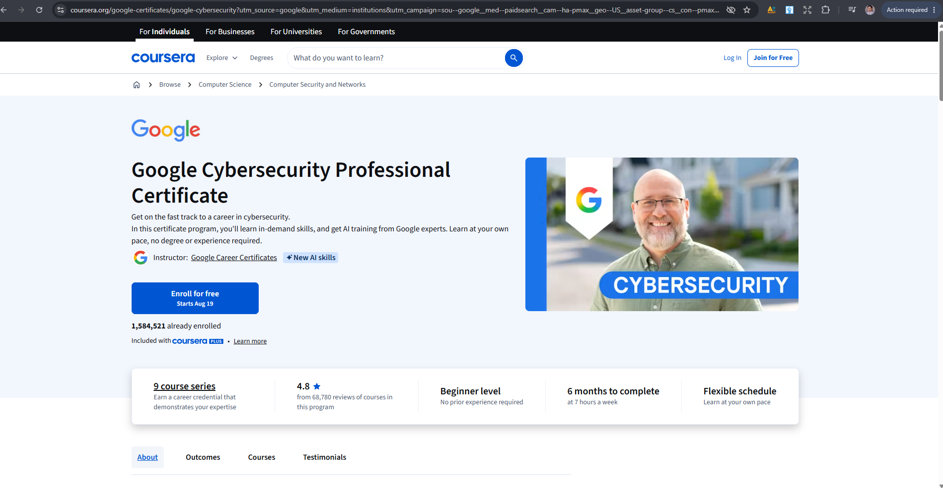

https://www.coursera.org/google-certificates/google-cybersecurity?utm_source=google&utm_medium=institutions&utm_campaign=sou--google__med--paidsearch__cam--ha-pmax__geo--US__asset-group--cs__con--pmax__LP--DR__ter--null&gwg_campaign_id=20906443665&gwg_exp=null&gwg_ad_id=GCLID--CjwKCAjwqJXUBhBNEiwA8BgG7vYxmpYotdUV-juPKqYwcXDwTAiRCuJm-j6g_oQjXUZ1ESUE0fEDPBoCGpkQAvD_BwE&_gl=1*1nbigtr*_gcl_aw*R0NMLjE3ODcxNzE5MzUuQ2p3S0NBandxSlhVQmhCTkVpd0E4QmdHN3ZZeG1wWW90ZFVWLWp1UEtxWXdjWER3VEFpUkN1Sm0tajZnX29RalhVWjFFU1VFMGZFRFBCb0NHcGtRQXZEX0J3RQ..*_gcl_au*MjA1NTMyMjQyNC4xNzg3MTcxOTM1

