CS412 – Individual Lab 1 Report
Nguyen Thanh Tung
1751119 - 17CTT2

Problem
1. Load an image by reading it from a file

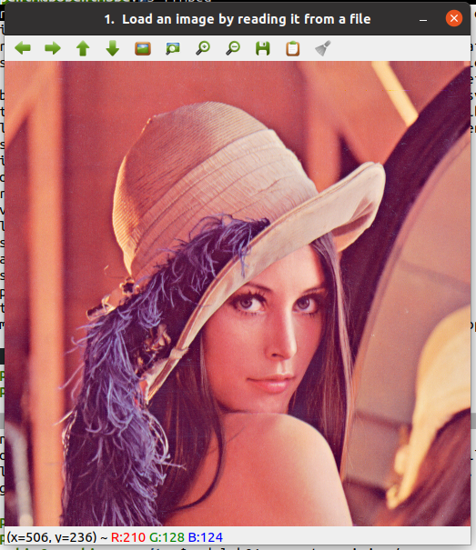

2. Convert a color image into a gray-scale image

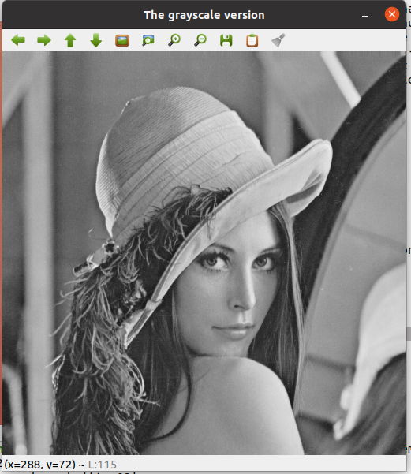

3. Change the brightness of the color image

4. Change the contrast of the color image

5. Filter a color image/ a gray-scale image using average filter operator

6. Filter a color image/ a gray-scale image usingGaussian filter operator

How I code

For brightness/contrast problem I used saturate_cast()
For average/Gaussian filter I used
blur() and GaussianBlur()

Kernel for average filter:
[[1 1 1]
[1 1 1]
[1 1 1]]

Kernel for Gaussian filter:
[[1 2 1]
[2 4 2]
[1 2 1]]

