Website Development Plan
  - Mount Elgon Ecosystem Conservation Trust (MEECT)

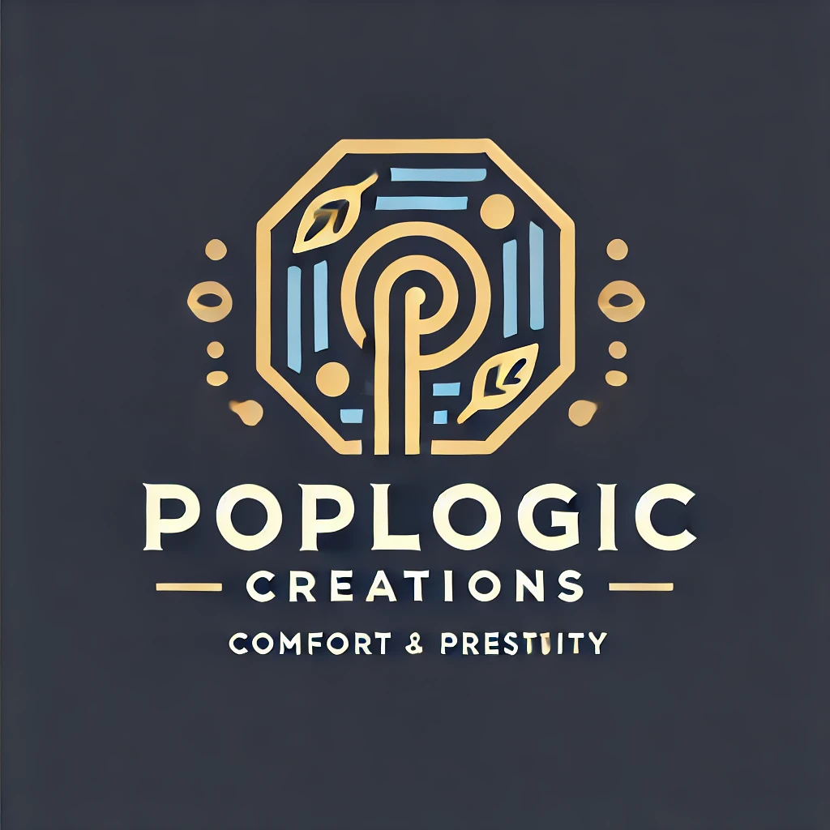

Prepared by: Robert Kimutai
Email: workwithkorir@gmail.com / tadzworld007@gmail.com
Phone: 0713626045 / 0722774212
Organization: Poplogic Creations

1. Overview
This plan outlines the step-by-step process for designing, developing, testing, and deploying a professional, responsive, and interactive website for the Mount Elgon Ecosystem Conservation Trust (MEECT). The project aligns with MEECT’s vision of promoting conservation awareness, transparency, and stakeholder engagement through a digital platform.

2. Project Objectives
• Develop a modern and SEO-optimized website that enhances MEECT’s visibility and credibility.
• Showcase MEECT’s programs, partnerships, and community impact.
• Provide a hub for knowledge sharing and stakeholder engagement.
• Enable donations, volunteer sign-ups, and partner collaborations.
• Train MEECT staff to independently manage and update the website.

3. Project Approach and Methodology
The project will follow a five-phase structured approach covering inception, design, development, testing, and training & handover. Each phase will deliver measurable outputs ensuring quality and timely completion.

4. Website Structure and Content Outline
The website will include Home, About Us, Programs & Projects, Our Impact, Resources, News & Events, Get Involved, Contact Us, and Donate pages.

5. Technical Specifications
Platform: Django CMS
Frontend: HTML5, CSS3, JavaScript; Framework (Vite+React)
Hosting: Secure VPS with SSL
Database: MySQL
SEO Tools: Google Analytics, Yoast SEO
Donation Integration: PayPal or M-Pesa API
Security: SSL, CAPTCHA, Backups

6. Design Style and Branding
Theme: Modern and natural
Colors: Green and grey tones
Typography: Clean sans-serif fonts
Tone: Trustworthy, community-driven, and eco-conscious

7. Quality Assurance
Testing will include usability, accessibility (WCAG 2.1), responsiveness, and load speed optimization. SEO and content validation will also be conducted before launch.

8. Capacity Building & Support
MEECT staff will receive training on CMS usage, basic troubleshooting, and content management. A user manual and three-month support plan will be provided.

9. Risk Management
Potential risks include delayed content submission, scope creep, or downtime. Mitigation involves early planning, adherence to scope, and scheduled deployments.

10. Project Team and Roles
Robert Kimutai (Lead Developer & Project Manager)
UI/UX Designer
Alvin Waliaula (Backend Developer & QA Tester)
Content Officer (MEECT)
Trainer

11. Timeline Summary
Week 1: Inception & Planning
Week 2: Design Prototype
Weeks 3–4: Development & Testing
Week 5: Training & Handover

12. Sustainability and Maintenance
MEECT staff will manage updates internally, with optional quarterly technical reviews for backups, security, and SEO performance improvements.

13. GANNT CHART
