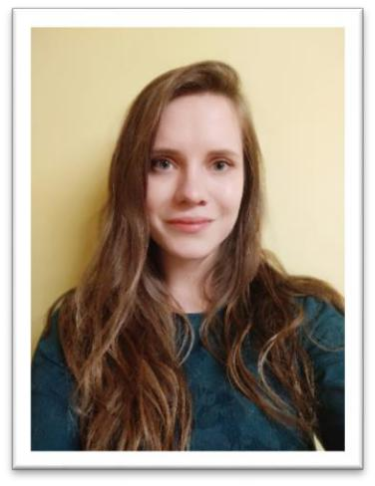**Ivana Brkić**

**Student of Computing and Control Engineering / Elective courses in Applied Computer Science and Informatics (Currently 3rd year)**

PERSONAL INFO

*Phone:* +381 (65)-27-54-579

*Email*: ivanabrkic192@gmail.com

*LinkedIn:* [ivanabrkic](http://linkedin.com/in/ivanabrkicc)

EDUCATION

**2016 - present**

**Student in Computer Sciences and Computer engineering**

*Faculty of Technical Sciences, University of Novi Sad, Republic of Serbia*

SKILLS

***Programming languages:*** Java, C/C++, C#, Assembly

***Web programming:*** HTML, CSS

***Databases:*** SQL

***Version control:*** SVN

***Tools:*** Eclipse IDE, Microsoft Visual Studio, SQL Developer, Matlab, CodeBlocks

***Languages:*** English–upper intermediate speaking/writing skills

PROJECTS

*Java Swing - Fundamentals of Information Systems and Software Engineering project C - Database project*

COURSES

**2015 - 2016**

*Center for Young Talents, Novi Sad, Republic of Serbia,* programming and mathematics courses

INTERESTS

Darts, gaming, movies, music, travelling, languages, art