**Performance Task**

1. Screenshot the message on the console of the page.

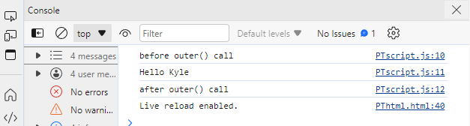

1. Write the debugger statement in the console.log block in the PTscript.js file. Place it before calling the function outer. Save the file.

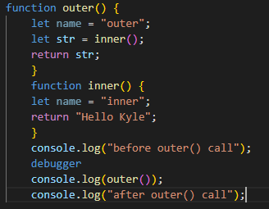

1. Refresh the browser and screenshot the console. Explain how the console displayed such output.

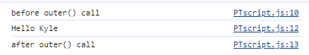

1. Look at the console and explain why the console displayed such output.

**-When I click the resume button it shows the output in the number 3 because the console is waiting for the developers instruction to run the code.**

1. With the breakpoint on the 15th line, click the Resume button again.



1. What happens to the JavaScript code in the Developer Tools when the Step Over button is pressed?

* **When I click the line 12 and click the step over button the select of line 12 goes to line 13.**

1. What happens to the console if the Step Over button is pressed two (2) additional times?

* **When I click the step over button 2 additional times the line number 12 goes to line 15**

1. Now, click the Step Into button (next to the Step Over button) and list the highlighted words each time the button is clicked.

* **When I click the step into button the highlight goes to** 

1. Repeat the instruction above, but this time, click the Step Into button six (6) times and provide the screenshot of the Developer Tools.

* **When I click the step into button six times it highlights the code in the javascript file.**

**1.** 

**2.** 

**3.** 

**4.** 

**5.** 

6. 