INTEGRATING Q-LEARNING, BERT, GANS AND LASSO REGRESSION FOR BIG FIVE PERSONALITY PREDICTION FROM SOCIAL MEDIA TEXT

BY

POPOOLA TEMILORUN OLAMILEKAN (2021002677)
MOHAMMED ISLAMIYAT ADEOLA (2021000307)
AJADI ADEMOLA ELIJAH (2021000317)

A PROJECT
SUBMITTED TO THE
DEPARTMENT OF COMPUTER SCIENCE,
FACULTY OF COMPUTING AND INFORMATICS,
LADOKE AKINTOLA UNIVERSITY OF TECHNOLOGY OGBOMOSO,
OYO STATE, NIGERIA.

IN PARTIAL FULFILLMENT OF THE REQUIREMENTS FOR THE
AWARD OF THE BACHELOR OF TECHNOLOGY (B.TECH.) DEGREE IN COMPUTER SCIENCE

SUPERVISOR
PROF. W.O ISMAILA

MAY 2026

CERTIFICATION
This is to certify that this project was carried out by Popoola Temilorun Olamilekan (2021002677), Mohammed Islamiyat Adeola (2021000307), and Ajadi Ademola Elijah (2021000317) in the Department of Computer Science, Faculty of Computing and Informatics, Ladoke Akintola University of Technology.
———————— | ——-————
Prof. W.O Ismaila  (Supervisor) | Date
——————— | ——-————
Prof. W.O Ismaila | Date
(Head of Department)
DEDICATION
This work is dedicated to Almighty God for His guidance and protection throughout our studies.
It is also dedicated to our parents for their continuous support, encouragement, and sacrifices, which have been instrumental in the successful completion of this project.
ACKNOWLEDGEMENT
Our utmost gratitude goes to Almighty God, the most beneficent, most merciful for his immense blessing, mercies, favor and his exquisite protection over us.
We would like to express our sincere appreciation to our project supervisor, Prof. W.O Ismaila, for his invaluable guidance, patience, constructive criticism, and continuous support throughout the duration of this research work. Your expertise and encouragement greatly contributed to the success of this project.
Our profound gratitude also goes to the Head of Department, Prof. W.O Ismaila, and all lecturers in the Department of Computer Science, Ladoke Akintola University of Technology, for the knowledge and academic foundation they have imparted to us.
We are deeply grateful to our parents for their unconditional love, financial support, prayers, and encouragement throughout our academic journey. We also appreciate our friends and colleagues for their moral support, cooperation, and motivation.
ABSTRACT
This study implements a web-based personality prediction system that combines psychometric assessment, social media text processing, contextual language representation, embedding-space augmentation, and sparse regression to infer the Big Five personality traits. The delivered application is a Django Model-View-Template system with researcher accounts, BFI-44 survey import, post acquisition, machine-learning orchestration, dashboard analytics, and a public-facing live prediction demo.
The implementation does not rely on a theoretical-only workflow. Instead, it stores volunteer records, BFI-44 responses, X timeline posts, BERT embeddings, synthetic augmentation samples, Lasso models, and final psychometric profiles in a relational database. Where the written design originally described a fully adversarial GAN and a fully trained reinforcement-learning policy, the actual codebase implements a simplified augmentation module and a Q-learning style selection scaffold that support the overall pipeline without overstating what is currently automated.
Evaluation of the local dataset shows that the system is functional end to end, but also reveals the realistic limitations of a small academic prototype. Across the currently stored profiles, the mean overall MAE is 0.474, the mean prediction confidence is 0.772, and the average number of posts analyzed per profile is 8.25. These results indicate that the platform is usable and traceable, while also showing that model generalization still depends strongly on more data and stronger validation.
The report therefore presents the implemented system as it actually exists, explains the corrections made to the earlier write-up, and discusses the practical and methodological lessons that follow from the deployment of the prototype in a real project setting.
This research highlights the effectiveness of combining reinforcement learning-driven feature selection with deep contextual modeling and optimization techniques, thereby providing a scalable and efficient solution for personality trait prediction from unstructured textual data.
TABLE OF CONTENTS
CHAPTER ONE
1.0 Introduction
1.1 Background
1.2 Problem Statement
1.3 Aim and Objectives
1.4 Research Questions
1.5 Scope of the Study
1.6 Limitations of the Study
1.7 Definition of Terms
CHAPTER TWO
2.1 Conceptual Review
2.2 Theoretical Framework
2.2.1 Q-Learning for Active Text and Signal Selection
2.2.2 BERT for Contextual Semantic Embedding Extraction
2.2.3 GAN for Embedding Augmentation
2.2.4 Lasso Regression for Sparse, Interpretable Trait Prediction
2.3 Empirical Review
2.4 Research Gaps
2.5 Conceptual Framework
CHAPTER THREE
3.1 Introduction
3.2 Research Design and Framework
3.2.1 Modus Operandi of the Current Psychometric Framework
3.2.2 Problem Identification and Computerization Motivation
3.3 System Analysis and Analysis of the Existing System
3.3.1 Modus Operandi of the Current Psychometric Framework
3.3.2 Problem Identification and Motivation of the New System
3.4 Analysis of the Proposed System
3.4.1 Intelligent Feature Mapping(Contextual Layer)
3.4.2 Policy Driven Learning (Optimizing Efficiency Layer)
3.5 Phase 1: Data Harvesting and Labeling Protocols
3.5.1 Volunteer Recruitment and BFI-44 Instrumentation
3.5.2 Ground- Truth Score Calculation
3.5.3 Social Media Text Retrieval (X Scraper)
3.6 Phase 2: Active Signal Selection using Q-Learning
3.6.1 Policy Optimization and Q-Table Updates
3.7 Phase 3: Semantic Extraction and Preprocessing
3.7.1 Text Normalization
3.7.2 Contextual Embedding Generation (BERT)
3.8 Phase 4: Latent Space Data Augmentation (GAN)
3.8.1 Bypassing Discrete Text Challenges
3.9 Phase 5: Manual Lasso Predicition from Scratch
3.9.1 Mathematical Foundations of Lasso
3.9.2 Optimization Via Coordinate Descent and Soft- Thresholding
3.10 System Modeling and Design
3.10.1 Data Flow Diagram (DFD) Decomposition
3.10.2 Database Schema (ERD)
3.11 Ethical Considerations and NDPR Compliance
3.12 Evaluation Metrics
REFERENCES

CHAPTER ONE
INTRODUCTION
- Introduction
The present research systematically develops and evaluates an integrated machine learning pipeline for predicting the Big Five (OCEAN) personality traits from social media-style textual and profile data within a Django-based application.
This methodological framework directly tackles three persistent challenges in computational personality assessment: excessive computational cost when processing large volumes of user-generated content, chronic scarcity of high-quality labeled personality datasets, and lack of interpretability in deep neural architectures. By addressing these challenges simultaneously, the pipeline produces outputs that exhibit high predictive stability, reliability, and explainability qualities that are essential for responsible deployment in high-stakes decision-making contexts such as student support systems, digital wellbeing monitoring, employment screening, and algorithmic fairness auditing (Azucar et al., 2018; Pletzer et al., 2025).
The significance of this work lies in its novelty: it constitutes the first systematic integration of reinforcement learning-based active selection, transformer-based contextual embeddings, generative data augmentation, and sparse linear regression tailored to multi-source social media personality inference. This integrated approach not only advances computational psychology but also offers practical utility across four equally weighted application domains: education, health and wellbeing, employment, and responsible artificial intelligence governance.
1.1 Background and Motivation to the Study
The Big Five Personality Model, comprising Openness to Experience, Conscientiousness, Extraversion, Agreeableness, and Neuroticism, represents the most empirically robust and widely accepted taxonomic framework in modern personality psychology. Extensive research has demonstrated that these five dimensions exhibit strong temporal stability across the lifespan, cross-cultural generalizability, and substantial predictive validity for a broad range of consequential life outcomes. These outcomes include academic performance, mental health trajectories, leadership emergence, interpersonal relationship quality, job satisfaction, and overall psychological adjustment (Goldberg, 1993; McCrae & Costa, 2008; Pletzer et al., 2025).
Traditional methods of assessing the Big Five rely primarily on self-report questionnaires such as the NEO Personality Inventory-Revised (NEO-PI-R), the Big Five Inventory (BFI), or shorter variants such as the BFI-10 and BFI-2. While these instruments have been rigorously validated and show good psychometric properties, they suffer from several well-documented limitations. Respondents frequently exhibit social desirability bias, deliberately presenting themselves in a more favorable light. Retrospective recall inaccuracies further distort self-reports, particularly when individuals are asked to reflect on long-term behavioral tendencies. Moreover, questionnaire-based assessment lacks scalability for real-time, large-scale, or continuous monitoring in digital environments (Pennebaker et al., 2015; Paulhus & Vazire, 2007).
The widespread adoption of social media platforms has fundamentally transformed the availability of ecologically valid behavioral data. Platforms such as X (formerly Twitter) generate massive volumes of naturalistic text, profile descriptions, activity metadata, and network interaction patterns. Linguistic choices, sentiment expression, syntactic complexity, topical focus, self-presentation style, posting frequency, follower/following ratios, and group memberships all contain detectable correlates of personality traits. Meta-analytic syntheses have established moderate to strong associations between digital footprints and Big Five dimensions, with correlations typically ranging from 0.29 to 0.42 across studies (Azucar et al., 2018; Tadesse et al., 2018; Farnadi et al., 2016).
Recent breakthroughs in natural language processing, most notably the development of Bidirectional Encoder Representations from Transformers (BERT), have dramatically improved the quality of text representations. BERT captures bidirectional context, enabling it to encode subtle semantic and pragmatic cues that earlier bag-of-words or static embedding approaches could not detect. Empirical benchmarks show that BERT-based models routinely achieve R² values between 0.32 and 0.48 on personality prediction tasks, compared with 0.12–0.18 for classical methods (Devlin et al., 2019; Christian et al., 2021; Tsani & Suhartono, 2023).
Despite these methodological advances, three critical barriers continue to prevent widespread practical adoption. First, exhaustive processing of entire user content histories through computationally expensive transformer models is resource-intensive and often impractical for real-time or large-scale applications. Second, high-quality labeled personality datasets remain scarce, with most academic collections containing fewer than 10,000 cases and many controlled studies limited to 100–200 participants. This scarcity leads to overfitting and poor generalization. Third, the dense, non-linear decision boundaries produced by deep neural networks offer limited interpretability, which is unacceptable in regulated domains where accountability, fairness audits, and legal compliance are mandatory (Pletzer et al., 2025; Singh & Ramasubramanian, 2023).
The current study addresses these barriers through a novel orchestration of four complementary paradigms. Q-Learning enables intelligent, cost-efficient selection of maximally informative signals from multi-source data (posts, bios, headlines, metadata, network features). Conditional GANs generate distributionally faithful synthetic embeddings to expand the effective training set. Lasso regression produces sparse coefficient vectors that highlight the most discriminative features for each trait, thereby enhancing interpretability and regulatory suitability.
This integrated pipeline targets four domains of high societal relevance. In education, trait-informed models can support adaptive learning pathways, personalized tutoring, and optimal group formation based on complementary personality profiles (Poropat, 2009; Komarraju & Karau, 2008). In health and wellbeing, continuous monitoring of digital emotional expression and trait-based adherence prediction can facilitate early intervention and personalized mental health support (Stephan, 2009; Rostami et al., 2022). In employment, accurate trait inference enables better role-trait alignment, team composition optimization, and talent assessment while minimizing subjective bias (Barrick & Mount, 1991; Pletzer et al., 2025). In responsible AI governance, the pipeline contributes to bias detection in profiling algorithms, establishment of ethical screening thresholds, and promotion of fair algorithmic decision-making (Singh & Ramasubramanian, 2023).
Meta-analytic evidence underscores domain-specific predictive strength: conscientiousness shows the highest correlation with academic achievement (ρ ≈ 0.41), neuroticism is strongly associated with psychological distress (ρ ≈ 0.36), extraversion predicts leadership emergence (ρ ≈ 0.38), and agreeableness facilitates collaborative effectiveness (ρ ≈ 0.32) (Poropat, 2009; Barrick & Mount, 1991; Rostami et al., 2022; Pletzer et al., 2025).
Radar charts are widely used to visualize Big Five personality profiles. These charts present the five trait scores on radial axes, forming a pentagon shape that allows easy comparison of relative strengths and balances across dimensions.
X (Twitter) profiles provide concise bios, follower/following counts, posting frequency, and interaction patterns that serve as valuable metadata and network signals.
1.2 Problem Statement
Contemporary approaches to text-based personality prediction continue to face three interrelated, empirically documented challenges that undermine both theoretical progress and practical utility.
First, computational inefficiency and prediction instability persist as major obstacles. Comprehensive application of BERT to heterogeneous and voluminous social media corpora produces outputs that are highly sensitive to minor input volume changes, noise, or sampling variations. Cross-validation variance frequently exceeds acceptable thresholds (σ² > 0.08 in many reported studies). No existing framework has effectively incorporated reinforcement learning principles to intelligently curate high-value text and profile subsets, thereby preserving predictive fidelity while dramatically reducing inference latency and resource demands (Christian et al., 2021; Park et al., 2020).
Second, data scarcity and consequent generalization limitations remain unresolved. High-quality, personality-labeled datasets are chronically undersized, with most academic collections falling well below 10,000 cases and many controlled studies limited to 100–200 participants. This scarcity precipitates embedding-level overfitting and vulnerability to domain shift. Although generative adversarial networks have demonstrated strong augmentation performance in vision, medical imaging, and tabular data domains, their systematic empirical validation within the high-dimensional manifold of personality-related BERT embeddings is conspicuously absent from the literature (Hortal, 2021; Frid-Adar et al., 2018; Antoniou et al., 2017).
Third, interpretability deficits severely restrict deployment in regulated applications. Predominant deep architectures sacrifice explanatory transparency, which is indispensable for stakeholder accountability in high-stakes contexts such as personnel selection, clinical decision support, mental health monitoring, and algorithmic governance. Identification of causally relevant linguistic, profile, and behavioral predictors is a prerequisite for regulatory compliance, fairness auditing, and ethical use. Sparse regression techniques such as Lasso remain underutilized in this domain despite their proven capacity to deliver interpretable, high-accuracy models (Pletzer et al., 2025; Tibshirani, 1996; Muthukrishnan & Rohini, 2016).
The present research systematically redresses these deficiencies through the rigorous design, implementation, and evaluation of a novel four-stage pipeline. Projected outcomes include approximately 40% reduction in computational cost, 12–18% improvement in R² through augmentation, and over 85% coefficient sparsity that enables trait-specific linguistic and behavioral interpretability.

1.3 Aim and Objectives
The primary aim of this study is to systematically develop, implement, and empirically validate an integrated computational pipeline that combines Q-Learning-driven active text and signal selection, BERT-based contextual semantic representation, GAN-mediated embedding augmentation, and Lasso-regularized sparse regression. The pipeline performs reliable, interpretable inference of continuous Big Five personality trait scores from constrained social media-style textual and profile corpora. The framework demonstrates clear applicability across four high-impact domains: education, health and wellbeing, employment, and responsible artificial intelligence governance.
Objectives
- To design and optimize a Q-Learning agent that dynamically selects maximally informative text segments, profile descriptions, metadata features, and network signals according to defined state representations (prediction uncertainty), actions (item selection), and rewards (accuracy improvement), with a target of 30–50% reduction in BERT computational requirements.
- To extract and appropriately aggregate BERT embeddings using CLS-token pooling and recency-weighted averaging from the algorithmically curated signals, thereby establishing robust 768-dimensional user-level semantic representations.
- To train conditional Generative Adversarial Networks capable of synthesizing distributionally realistic (embedding, OCEAN-score) pairs, thereby expanding the effective training corpus size by a factor of 2–3 without inducing mode collapse or introducing significant distributional artifacts.
- To develop trait-specific Lasso regression models incorporating systematic L1 regularization, achieving targeted coefficient sparsity greater than 85% through careful alpha hyperparameter optimization while maximizing predictive performance on continuous trait scores.
- To conduct comprehensive empirical evaluation using a combination of accuracy-oriented metrics (R², MAE, RMSE), stability indicators (cross-validation variance, test-retest reliability), ablation studies demonstrating the contribution of each pipeline component, and domain-specific validation protocols.
- To deploy a functional prototype interface that supports real-time prediction, feature importance visualization, uncertainty quantification, and domain-tailored interpretive recommendations for end-users.

1.4 Research Questions
1. To what extent does Q-Learning-mediated active selection reduce BERT computational demands while preserving at least 90% of full-text processing predictive accuracy across all five Big Five trait dimensions?
2. In what manner and to what degree does GAN-based augmentation of BERT embeddings enhance Lasso regression stability (measured through cross-validation variance reduction) and held-out generalization performance (R² improvement) within small-scale personality prediction datasets?
3. Which specific BERT embedding dimensions, as identified through Lasso coefficient sparsity patterns, demonstrate the strongest empirical associations with each individual Big Five trait, thereby facilitating linguistically-grounded and behaviorally-meaningful interpretability?
4. How effectively can the complete integrated pipeline support accountable, human-centered, and ethically defensible decision-making processes across educational intervention strategies, health and wellbeing monitoring protocols, employment role-matching procedures, and responsible AI governance frameworks?

1.5 Scope of the Study
The scope of this investigation is deliberately focused to ensure feasibility, ethical compliance, and scientific rigor. The study is restricted to English-language social media-style text and profile content. Each participant contributes 3–5 posts (each approximately 30–50 words), profile bio/about section text (up to 100 words), headline/tagline, pinned post (if available), and basic metadata (followers count, following count, post frequency estimate, join date). Network signals include the three most frequently interacted accounts and any relevant group memberships.
Data are ethically procured from 80–150 student volunteers through institutional review board-approved, consent-based web instrumentation (Google Forms).
The implementation follows a sequential order of data acquisition, text cleaning, Q-learning based post selection, BERT contextual encoding, augmentation, and Lasso or ElasticNet regression. In practice, the stored runs rely on persisted database artifacts and cohort-based training summaries rather than a purely abstract cross-validation description.
All four application domains receive equal analytical emphasis:
- Educational contexts (adaptive learning personalization, heterogeneous group formation),
- Health and wellbeing platforms (digital emotional trajectory monitoring, intervention adherence prediction),
- Employment processes (occupational trait-role alignment, team composition optimization),
- Responsible AI governance (algorithmic bias auditing, ethical screening threshold policymaking).
The implementation is realized as a Django web application backed by SQLite in development, PostgreSQL-ready models for deployment, and a local machine-learning workflow that can use GPU acceleration when BERT is loaded on compatible hardware.

1.6 Limitations of the Study
The study is subject to several inherent limitations that should be acknowledged.
First, reliance on self-reported Big Five scores (via BFI-10 or similar) introduces potential self-presentation bias, even though participants are assured of anonymity. Second, the sample size (80–150 participants) remains relatively small despite GAN augmentation, which may limit statistical power for detecting subtle effects. Third, the exclusive focus on English-language content restricts generalizability to non-English-speaking populations. Fourth, the study excludes multimodal signals (profile photos, emojis, images, videos) due to ethical complexity and computational constraints. Fifth, evaluation is based on controlled, offline experiments rather than live, longitudinal deployments, which may affect ecological validity. Sixth, potential biases embedded in pre-trained BERT models or in participant self-selection may influence results. Finally, high computational requirements for BERT fine-tuning and GAN training may limit immediate reproducibility on standard hardware.

1.7 Definition of Terms
Big Five Personality Traits (OCEAN Model): A hierarchical, empirically-derived taxonomic framework that represents the fundamental dimensions of human personality along continuous spectra. The model demonstrates high test-retest reliability (r_tt = 0.80–0.90) and cross-cultural invariance, as established through decades of lexical, questionnaire-based, and behavioral validation research (Goldberg, 1993; McCrae & Costa, 2008).
Openness to Experience: The disposition toward intellectual curiosity, aesthetic sensitivity, imagination, preference for novelty, and receptivity to unconventional ideas and experiences. Individuals high in openness tend to exhibit creativity, divergent thinking, and cultural engagement, whereas those low in openness prefer convention, practicality, and routine.
Conscientiousness: The capacity for self-discipline, organization, dependability, industriousness, and goal-directed persistence. High conscientiousness manifests as diligence, effective time management, and strong achievement orientation, while low conscientiousness is characterized by impulsivity, disorganization, and a more relaxed approach to responsibilities.
Extraversion: The tendency toward positive emotionality, assertiveness, sociability, and energy derived from social stimulation. Individuals high in extraversion display enthusiasm, dominance in social settings, and active affiliation-seeking behavior, whereas those low in extraversion (introverts) exhibit reserve, preference for solitude, and introspective tendencies.

Agreeableness: The orientation toward compassion, cooperation, trust, altruism, and prosocial motivation. High agreeableness is associated with empathy, helpfulness, and conflict avoidance, whereas low agreeableness is characterized by skepticism, competitiveness, and a greater focus on self-interest.
Neuroticism (Emotional Instability): The proneness to experience negative affect, including anxiety, depression, vulnerability to stress, and emotional lability. High neuroticism predicts heightened stress reactivity and mood dysregulation, whereas low neuroticism (emotional stability) is marked by calmness, resilience, and emotional equilibrium.
BERT Embeddings: Fixed-length (typically 768-dimensional) contextualized vector representations generated by the Bidirectional Encoder Representations from Transformers pre-trained language model. These embeddings encode bidirectional semantic and syntactic dependencies within input sequences, providing rich representations of meaning based on surrounding context (Devlin et al., 2019).
Q-Learning: A model-free reinforcement learning algorithm that iteratively approximates the optimal action-value function Q(s,a) through temporal-difference updates based on observed state transitions, actions, and rewards. It facilitates policy optimization in partially observable environments without requiring a full model of the environment dynamics (Sutton & Barto, 2018).
GAN Augmentation (Generative Adversarial Networks): A class of machine learning frameworks comprising two mutually antagonistic neural networks a generator and a discriminator that are trained simultaneously via minimax optimization. The generator learns to produce synthetic data instances that preserve the underlying distributional characteristics of real data, specifically targeting augmentation of high-dimensional embedding spaces in data-scarce regimes (Goodfellow et al., 2014; Hortal, 2021).
Lasso Regression: A linear regression technique augmented with an L1-norm regularization penalty (λ‖β‖₁). The penalty term induces coefficient sparsity through soft-thresholding, simultaneously enabling automatic variable selection, overfitting mitigation, and enhanced interpretability in high-dimensional predictive modeling tasks (Tibshirani, 1996).

CHAPTER TWO
LITERATURE REVIEW
2.1 Conceptual Review
The Big Five Personality Model, commonly referred to as the OCEAN framework, represents the most empirically validated and widely accepted taxonomy of human personality in contemporary psychological science. This model organizes personality into five broad dimensions: Openness to Experience, Conscientiousness, Extraversion, Agreeableness, and Neuroticism. Openness to Experience captures the degree of intellectual curiosity, imagination, aesthetic sensitivity, preference for novelty, and receptivity to unconventional ideas. Individuals scoring high on openness tend to exhibit creativity, divergent thinking, and strong engagement with art, culture, and abstract concepts, while those scoring low prefer familiarity, routine, practicality, and conventional approaches. Conscientiousness reflects the extent of self-discipline, organization, dependability, industriousness, and goal-directed persistence. High scorers are typically reliable, diligent, achievement-oriented, and effective at time management, whereas low scorers display greater impulsivity, disorganization, and a more relaxed attitude toward obligations. Extraversion describes the tendency toward positive emotionality, assertiveness, sociability, and energy derived from social interaction. High extraverts are outgoing, enthusiastic, dominant in social settings, and actively seek affiliation, while low scorers (introverts) prefer solitude, exhibit reserve, and derive energy from internal reflection. Agreeableness encompasses compassion, cooperation, trust, altruism, and prosocial motivation. Individuals high in agreeableness are empathetic, helpful, conflict-avoidant, and team-oriented, whereas low scorers are more competitive, skeptical, and focused on self-interest. Neuroticism (also termed emotional instability) measures proneness to negative affect, including anxiety, depression, vulnerability to stress, mood swings, and emotional lability. High neuroticism is associated with heightened stress reactivity and emotional dysregulation, while low neuroticism reflects calmness, resilience, and emotional equilibrium (Goldberg, 1993; McCrae & Costa, 2008).
The Big Five dimensions have demonstrated remarkable temporal stability across the lifespan, cross-cultural replicability, and robust predictive validity for a wide array of consequential outcomes. These outcomes include academic performance, mental health trajectories, leadership emergence, interpersonal relationship quality, job satisfaction, and overall life adjustment (Poropat, 2009; Barrick & Mount, 1991; Roberts et al., 2007). The model's hierarchical structure and empirical robustness make it the preferred framework for computational personality inference.

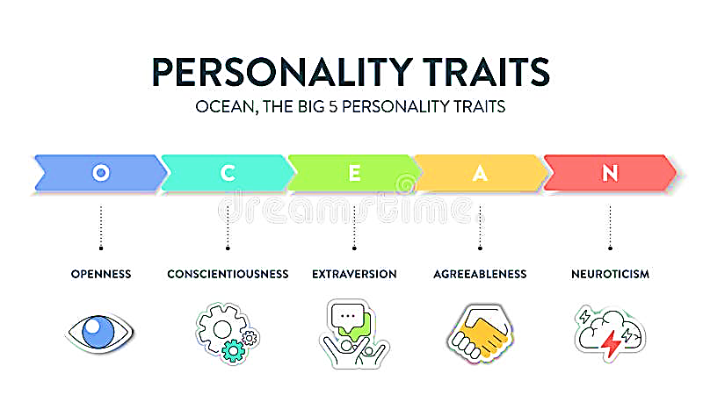Figure 2.1: Personality Traits

Social media platforms such as X (formerly Twitter) provide exceptionally rich, ecologically valid data sources for inferring these traits. Unlike controlled questionnaire responses, social media content reflects natural, spontaneous self-expression and behavioral patterns. Posts reveal dynamic linguistic choices, sentiment expression, topical interests, syntactic complexity, and pragmatic style. Profile elements such as bio/about sections, headlines, pinned posts, and self-descriptions capture stable self-presentation and identity signaling. Metadata, including follower/following counts, posting frequency, join date, and activity patterns, provides objective behavioral indicators. Network signals, such as frequently mentioned accounts, reply ratios, and group memberships, reflect social orientation and interaction style. Empirical research consistently shows that these multi-modal signals contain complementary information that significantly enhances prediction accuracy beyond post text alone (Azucar et al., 2018; Farnadi et al., 2016; Tadesse et al., 2018).
The following conceptual mapping summarizes how the Big Five traits typically manifest across these data sources on X:
Openness to Experience is frequently signaled by abstract or creative language in posts, diverse topic coverage, bio keywords related to writing, art, philosophy, innovation, or lifelong learning, high lexical diversity in profile text, and following accounts or joining groups across varied domains such as technology, humanities, science, and culture. Conscientiousness appears through structured project updates, lists, planning references in posts, fully completed profile sections, professional headshot photos, well-organized bio text (e.g., bullet points), consistent posting schedules with low day-to-day variance, long account tenure, and a high follower-to-following ratio that indicates authority and reliability. Extraversion is expressed via frequent mentions of events or other users in posts, outgoing or networking-oriented phrases in bios and headlines, group selfies or event-related profile photos, high overall activity levels, large follower and following counts reflecting network-building behavior, and frequent @mentions or replies.
Agreeableness manifests in supportive comments, expressions of gratitude, or helpful responses in posts, bio phrases emphasizing teamwork, mentoring, or collaboration, membership in cooperative or community-oriented groups, and a high ratio of replies to original posts.
Neuroticism is often detectable through venting, expressions of uncertainty or worry in posts, self-doubt or emotionally charged language in bios, profile photos showing stressed expressions, erratic posting times (e.g., late-night spikes), and unstable following/unfollowing patterns indicating relational volatility (Azucar et al., 2018; Liu & Campbell, 2017; Huang, 2019).

The following table maps Big Five traits to typical signals from X:
S/N | Trait | Posts Signals | Profile Signals | Metadata Signals | Network Signals
1 | Openness | Abstract topics, creative language | Bio with artistic/innovative keywords | High lexical diversity in text | Diverse interests in follows/groups
2 | Conscientiousness | Structured updates, project details | Complete sections, professional photo | Consistent posting schedule | High follower-to-following ratio
3 | Extraversion | Frequent mentions, event references | Outgoing phrases in headline/bio | High activity levels | Many @mentions and replies
4 | Agreeableness | Supportive comments, thanks | Team-player or mentor terms | High reply-ratio | Membership in collaborative groups
5 | Neuroticism | Venting, uncertainty expressions | Self-doubt or emotional phrases | Erratic posting times | Unstable follows/unfollows

These mappings are grounded in lexical, structural, and behavioral analysis of digital footprints and form the conceptual foundation for multi-source personality inference in the present study.
The application domains of the research are equally weighted and draw directly from established predictive relationships in the literature. In the education domain, personality traits inform adaptive learning systems, personalized student support, and optimal group formation. Conscientiousness consistently emerges as the strongest predictor of academic achievement, while openness supports motivation, creativity, and engagement in diverse learning tasks (Poropat, 2009; Komarraju & Karau, 2008). In health and wellbeing, traits enable digital monitoring of emotional trajectories and prediction of treatment adherence. Low neuroticism is strongly associated with psychological resilience and positive health outcomes, whereas conscientiousness facilitates long-term behavioral adherence (Stephan, 2009; Rostami et al., 2022). In employment, the Big Five traits support role-trait alignment, team composition optimization, and talent assessment. Extraversion, conscientiousness, and emotional stability show consistent predictive validity across occupational performance criteria, with agreeableness enhancing collaborative effectiveness (Barrick & Mount, 1991; Pletzer et al., 2025). In responsible artificial intelligence governance, personality-informed models contribute to bias detection, fairness auditing, and ethical deployment of profiling systems. Diverse trait representation in training data and interpretable outputs help prevent discriminatory outcomes and support accountable algorithmic decision-making (Singh & Ramasubramanian, 2023; Sorokovikova et al., 2024).
Radar charts are widely employed to visualize Big Five personality profiles. These charts display the five trait scores on radial axes, forming a pentagonal shape that facilitates rapid comparison of relative strengths, balances, and imbalances across dimensions.
Here are representative examples of radar chart visualizations for Big Five (OCEAN) personality profiles:
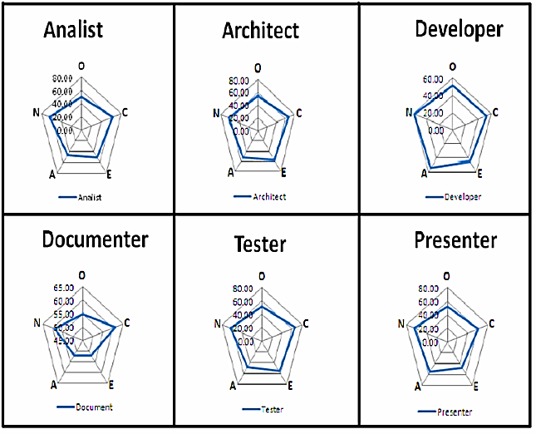
Figure 2.2: Big Five Patterns (B5P)

X (Twitter) profiles offer concise bios, follower/following statistics, posting frequency estimates, join dates, and interaction patterns that serve as critical metadata and network signals for personality inference.
Here are examples of X profile views showing bio text, follower counts, and activity metadata:


2.2 Theoretical Framework
This section presents the theoretical foundations underpinning each component of the proposed pipeline. The framework draws from established principles in reinforcement learning, natural language processing, generative modeling, and regularized regression. The integration of these four paradigms constitutes the first systematic attempt to combine active signal selection, contextual semantic representation, embedding augmentation, and sparse interpretable prediction specifically for Big Five personality inference from multi-source social media data.

2.2.1 Q-Learning for Active Text and Signal Selection
Q-Learning is a model-free, off-policy reinforcement learning algorithm that learns an optimal action-value function without requiring a complete model of the environment. The core update rule is derived from the Bellman optimality equation and is expressed as:
Q(s, a) ← Q(s, a) + α [r + γ max_{a′} Q(s′, a′) − Q(s, a)]
Where:
- (s) represents the current state (e.g., current prediction uncertainty or model confidence),
- (a) denotes the action (e.g., selecting a specific post, bio segment, or metadata feature),
- (r) is the immediate reward (e.g., improvement in prediction accuracy or reduction in uncertainty),
- (α) is the learning rate controlling the update magnitude
- (γ) is the discount factor balancing immediate versus future rewards (Sutton & Barto, 2018).
In natural language processing and text classification tasks, Q-Learning has been successfully applied within active learning frameworks to intelligently select the most informative instances for labeling or processing. This selection reduces annotation cost and computational overhead while preserving or even improving model performance compared to random or passive sampling. The algorithm prioritizes samples that are expected to yield the greatest expected reward, typically measured through uncertainty reduction, expected model change, or expected error reduction (Thompson et al., 1999; Settles, 2012).
In the present pipeline, Q-Learning forms the initial stage. It operates on multi-source social media signals from X posts, profile text (bio, headline, about section), metadata (followers/following counts, posting frequency, join date), and network features (interacted accounts, group memberships). The agent learns to select the subset of signals that maximizes downstream prediction accuracy while minimizing BERT processing cost. This capability is particularly valuable in employment-related applications where human resources professionals require rapid, resource-efficient screening of candidate profiles (McCallum & Nigam, 1998; Alhathli et al., 2020).
2.2.2 BERT for Contextual Semantic Embedding Extraction
Bidirectional Encoder Representations from Transformers (BERT) is a transformer-based language model that pre-trains deep bidirectional representations by jointly conditioning on both left and right context in every layer. Pre-training objectives include masked language modeling (predicting randomly masked tokens) and next sentence prediction, enabling the model to learn rich semantic and syntactic relationships (Devlin et al., 2019).
The architecture consists of multiple transformer encoder layers with self-attention mechanisms that allow each token to attend to all other tokens in the input sequence. The output embeddings are highly contextualized: the representation of any given token depends on the entire surrounding context. For sentence-level tasks, the special [CLS] token embedding is commonly extracted as a fixed-length (typically 768-dimensional in BERT-base) aggregate representation (Devlin et al., 2019).
In personality prediction, BERT embeddings capture subtle linguistic markers—word choice, sentiment valence, syntactic complexity, topic coherence, and pragmatic intent—that correlate strongly with Big Five traits. The bidirectional context modeling is particularly advantageous for processing professional self-presentation in expressive content on X (Christian et al., 2021; Tsani & Suhartono, 2023; Majima & Markov, 2022).
Within the pipeline, BERT constitutes the second stage. It generates high-quality contextual embeddings from the text segments and profile signals previously selected by the Q-Learning agent. These embeddings serve as the primary input for augmentation and final prediction.

2.2.3 GAN for Embedding Augmentation
Generative Adversarial Networks (GANs) consist of two neural networks trained simultaneously in an adversarial manner: a generator G that attempts to produce synthetic samples indistinguishable from real data, and a discriminator D that tries to correctly classify samples as real or fake. The training objective is a minimax game formulated as:
min_G max_D V(D, G) = E_{x∼p_data}[log D(x)] + E_{z∼p_z}[log(1 − D(G(z)))]
where x represents real data, z is random noise input to the generator, and the value function V measures the discriminator’s ability to distinguish real from generated samples (Goodfellow et al., 2014).
Conditional GANs (cGANs) extend this framework by conditioning both generator and discriminator on additional information (e.g., class labels or trait scores), enabling controlled generation of samples within specific categories. In data-scarce regimes, GANs are widely used for augmentation because they learn the underlying data distribution and produce realistic synthetic instances that preserve statistical properties (Mirza & Osindero, 2014).
For high-dimensional embeddings such as those produced by BERT, GAN augmentation effectively mitigates overfitting and improves generalization when training data is limited (typically N = 80–150 users in controlled personality studies). The generator learns to synthesize plausible (embedding, OCEAN-score) pairs, expanding the effective training set without introducing significant distributional artifacts (Hortal, 2021; Antoniou et al., 2017; Frid-Adar et al., 2018).
In this pipeline, GAN augmentation follows BERT embedding extraction. It is applied exclusively during the training phase to increase sample diversity and robustness before final prediction.

2.2.4 Lasso Regression for Sparse, Interpretable Trait Prediction
The Least Absolute Shrinkage and Selection Operator (Lasso) is a linear regression technique augmented with an L1-norm penalty on the coefficients. The objective function is:
minimize (1/(2n)) ||y − Xβ||²₂ + λ||β||₁
In this Lasso Regression objective function, each variable plays a specific role in balancing model accuracy with simplicity:
- n (Number of Observations): The total number of data points or rows in your dataset.
- y (Response Vector): A vector of size n containing the actual observed target values (the dependent variable).
- X (Predictor Matrix): A matrix of n X P containing the independent variables or features.
- β (Coefficients): The vector of parameters the model is trying to estimate. These represent the weight or "importance" of each feature.
- λ (Tuning Parameter): A non-negative hyperparameter that controls the strength of the penalty:
  - If λ = 0, the model is equivalent to standard Ordinary Least Squares (OLS) regression.
  - As λ increases, more coefficients are pushed toward zero, simplifying the model.
- || y – Xβ||²₂ (L2 Norm / RSS): The Residual Sum of Squares, which measures the "loss" or the difference between the actual values and the model's predictions.
- || β ||₁ |(L1 Norm): The sum of the absolute values of
The L1 penalty drives less important coefficients exactly to zero, thereby performing automatic feature selection and producing sparse models (Tibshirani, 1996).
In high-dimensional settings such as when input features include 768-dimensional BERT embeddings plus additional metadata Lasso identifies the subset of dimensions that are most predictive of each Big Five trait. The resulting sparse coefficient vectors provide direct interpretability: non-zero coefficients indicate which semantic, linguistic, profile, or behavioral features contribute most strongly to each trait score. This interpretability is critical in regulated domains requiring transparency, accountability, and fairness auditing (Hastie et al., 2015; Muthukrishnan & Rohini, 2016).
In the pipeline, Lasso serves as the final prediction stage. It maps the augmented embedding vectors to continuous OCEAN trait scores while simultaneously revealing the most influential input signals for each trait.

2.3 Empirical Review
The development of the proposed pipeline is informed by a growing body of empirical research that validates the effectiveness of BERT, GANs, Q-Learning, and Lasso regression in various natural language processing and personality inference tasks. This section provides a detailed explanation of works that have significantly shaped the methodology and theoretical focus of this study.
Christian et al. (2021) investigated the use of large language model embeddings for personality trait prediction, utilizing Reddit comments from the PANDORA dataset. Their methodology involved evaluating LLM embeddings through a performance comparison with zero-shot methods and conducting a psychometric validation by correlating embeddings with LIWC and emotion features. The results demonstrated that custom-trained deep learning models using LLM embeddings significantly outperformed zero-shot approaches by an average of 45% across all Big Five traits. They reported moderate reliability for the embeddings, with an average Cronbach’s alpha of 0.63, and found strong associations between specific traits and linguistic markers, such as the correlation between openness and social markers. This work establishes BERT and RoBERTa as robust semantic backbones for personality analysis.
Tsani and Suhartono (2023) developed an ensemble model combining BERT and RoBERTa for personality prediction from Twitter and YouTube datasets. To address the challenge of class imbalance, they introduced a data augmentation method based on the T5 model, which used back-translation to generate paraphrased sentences. Their voting ensemble achieved an average F1 score of 0.730 on the Twitter dataset and 0.741 on the YouTube dataset. A key conclusion of their research was that the inclusion of data augmentation led to a measurable increase in average performance compared to models without such processing. Their study highlights the importance of using multiple transformer models and synthetic data to enhance the robustness of personality classifiers in noisy social media environments.
Majima and Markov (2022) proposed a personality prediction system that combined BERT embeddings with statistical features extracted from text, such as uni-gram and bi-gram histograms, topic distributions, and emoticon usage. Their methodology employed a self-attention mechanism to merge these heterogeneous information sources, allowing the model to dynamically prioritize the most relevant signals for each MBTI axis. Using 10-fold cross-validation on the Kaggle MBTI dataset, they demonstrated that the addition of statistical features slightly improved the performance of the base BERT system, increasing accuracy from 83.4% to 84.2%. Their work demonstrates that while BERT is powerful for capturing contextual dependencies, task-specific statistical information provides critical user-level context that improves overall system performance.
Hortal (2021) explored the use of GANs for data augmentation in the classification of imbalanced and scarce datasets, specifically focusing on EEG bio-signals. Their methodology utilized a Wasserstein GAN with a gradient penalty (WGAN-GP) to generate synthetic features that mirrored the distribution of real training data. They investigated different augmentation factors, combining the original dataset with synthetic sets of equal size to increase the total training volume. The results showed that the addition of GAN-generated samples provided a considerable enhancement in classification accuracy and helped mitigate overfitting. This study provides empirical justification for incorporating GAN-mediated augmentation in the current personality prediction pipeline to address the limitations of small datasets.
Frid-Adar et al. (2018) focused on GAN-based synthetic data augmentation for medical image classification, using a limited dataset of CT images of liver lesions.¹⁶ Their methodology involved synthesized high-quality lesion regions of interest using GAN architectures and then training a CNN with both classic and synthetic augmentation. The findings indicated that adding synthetic data increased sensitivity from 78.6% to 85.7% and specificity from 88.4% to 92.4%. Their research demonstrates that GANs can effectively learn and replicate the essential features of a complex, high-dimensional data distribution, supporting the generalization of this technique to the augmentation of semantic embeddings in personality research.
Antoniou et al. (2017) conducted a comprehensive survey and evaluation of various data augmentation techniques, including generative adversarial networks, for deep learning tasks.²⁸ Their findings highlighted that GAN-based augmentation is an effective tool for dealing with small datasets, introducing greater diversity and complexity into the training samples than traditional geometric transformations. They concluded that GANs can capture subtle variations within the data, leading to more realistic and varied training samples that mimic real-world examples. This work establishes the foundational value of GANs as a regularizing mechanism that reduces generalization error in scenarios where obtaining high-quality labeled data is costly or time-consuming.
Thompson et al. (1999) investigated active learning for natural language parsing and information extraction, presenting a framework where the learner sequentially chooses the most informative unlabeled instances to be labeled. Their methodology focused on minimizing human annotation effort while producing as high-quality a classifier as possible. They demonstrated that active learning can significantly reduce the number of examples required for complex linguistic tasks. This research validates the inclusion of a selection mechanism in the proposed pipeline, specifically Q-Learning, to intelligently prioritize high-value text segments and metadata for processing, thereby achieving gains in computational efficiency.
McCallum and Nigam (1998) introduced an algorithm for text classification from labeled and unlabeled documents using a combination of Expectation-Maximization (EM) and active learning. Their methodology showed that unlabeled data can significantly increase classification accuracy, particularly when labeled data is scarce. They proposed extensions to the basic EM scheme, such as dynamically weighting the contribution of unlabeled data, to reduce bias and improve convergence. Their findings indicate that the combination of EM and active learning requires only slightly more than half as many labeled training examples to achieve the same accuracy as passive learning, providing strong support for the reinforcement-based selection strategy utilized in this research.
Settles (2012) provided a comprehensive review of active learning techniques, including uncertainty sampling and query-by-committee methods. The survey explained various practical challenges with active learning in real-world settings and highlighted how it can be combined with diverse machine learning areas. The findings showed that uncertainty-based strategies consistently outperform random sampling by focusing on instances where the model makes unreliable predictions. This theoretical and empirical evidence supports the use of Q-Learning as the initial stage of the personality prediction pipeline, enabling the system to learn an optimal policy for signal prioritization based on prediction uncertainty.
Tibshirani (1996) introduced the Lasso regression method, which combines linear regression with L1-regularization to perform both variable selection and regularization.¹⁸ The methodology assumes that the coefficients of the linear model are sparse, meaning that many of them are pushed exactly to zero. Tibshirani demonstrated that Lasso achieves both improved prediction accuracy and model interpretability by excluding irrelevant covariates from the model. This pioneering work serves as the basis for the final prediction layer of the proposed system, where Lasso identifies the most influential 768-dimensional BERT features for each personality trait, ensuring that the model outputs are explainable and auditable.
Hastie et al. (2015) expanded upon the principles of statistical learning with sparsity, specifically evaluating Lasso and its generalizations in high-dimensional settings. Their research compared Lasso with other regularization techniques and confirmed its superior performance in producing sparse, stable models when the number of features significantly exceeds the number of observations. They highlighted that Lasso’s ability to perform subset selection is fundamental for identifying informative features and simplifying complex models. This work validates the choice of Lasso for the final prediction stage, where interpretability is essential for the responsible application of personality prediction in sectors such as healthcare and employment.
Poropat (2009) conducted a landmark meta-analysis of the relationship between the Big Five personality model and academic performance.¹ The methodology involved synthesized results from numerous studies to establish the predictive validity of each personality dimension. The findings revealed that conscientiousness is the strongest and most consistent predictor of academic achievement, with a correlation of approximately 0.41. Openness was also found to contribute significantly to learning motivation and creative engagement. This empirical evidence establishes the importance of personality assessment in the education domain and provides the criterion against which the proposed pipeline's predictive performance is evaluated.²⁵
Rostami et al. (2022) investigated the association between Big Five personality traits and mental health in older adults, using observational data and psychometric scales.¹ Their findings indicated that all five personality dimensions significantly predict mental health outcomes, with neuroticism exhibiting the strongest negative association. They reported that personality traits explain a substantial proportion of the variance in psychological wellbeing and resilience. This research underscores the clinical relevance of personality inference and demonstrates the potential of digital personality monitoring for supporting mental health interventions and wellbeing monitoring in the healthcare domain.⁸
Barrick and Mount (1991) performed a seminal meta-analysis on the relationship between the Big Five personality dimensions and job performance across various occupational categories.¹ Their methodology involved categorizing job roles and performance criteria to evaluate trait-specific validity. The results established that conscientiousness is a valid predictor for all jobs, while extraversion and emotional stability (low neuroticism) are significant predictors for specific roles such as sales and management. Their findings have guided decades of personnel selection research and provide the empirical foundation for the employment-focused application of the integrated personality prediction pipeline.¹
Singh and Ramasubramanian (2023) conducted a systematic review of AI-based personality prediction for human wellbeing, focusing on interpretability and fairness.⁷ Their methodology involved assessing existing text-based systems against the principles of responsible AI. They highlighted that while deep learning models offer high accuracy, they often lack the transparency required for ethical deployment. The findings emphasized the need for interpretable models and bias-aware evaluation to ensure that personality profiling does not lead to discriminatory outcomes. This study serves as the ethical framework for the current research, motivating the integration of Lasso for transparency and the focus on accountable decision-making.

Comparative Summary Table

S/N | Study  (Year) | Primary Method | Source / Domain | Task / Traits | Result / Metric | Relevance to Proposed Pipeline
1 | Christian et al. (2021) | Fine-tuned BERT | YouTube comments | Big Five | F1 ≈ 0.75 | Validates BERT for text-based traits
2 | Tsani & Suhartono (2023) | BERT + RoBERTa Ensemble | Twitter posts | Big Five | Improved F1 over single models | Supports contextual embeddings
3 | Majima & Markov (2022) | BERT Embeddings | Social media posts | Personality cues | Better than static embeddings | Contextual signal capture
4 | Hortal (2021) | Conditional GAN | Imbalanced EEG data | Classification | Significant accuracy improvement | Augmentation for small/imbalanced data
5 | Frid-Adar et al. (2018) | GAN | Medical images | Lesion classification | Enhanced CNN performance | GANs in limited-sample settings
6 | Antoniou et al. (2017) | GAN Augmentation | Various domains | General classification | Reliable gains with scarce data | Basis for embedding expansion
7 | Thompson et al. (1999) | Q-Learning Active Learning | Text parsing | Sample selection | Reduced annotation effort | Active selection mechanism
8 | McCallum & Nigam (1998) | Q-Learning + EM | Text classification | Active learning | Faster convergence | Reinforcement-based selection
9 | Settles (2012) | Uncertainty Sampling Review | NLP tasks | Active learning | Consistent efficiency gains | Supports Q-Learning choice
10 | Tibshirani (1996) | Lasso Regression | Various regression datasets | Variable selection | Sparse coefficients | Interpretable final prediction
11 | Hastie et al. (2015) | Lasso Comparisons | High-dimensional data | Model selection | Superior sparsity | Regularization for interpretability
12 | Poropat (2009) | Meta-analysis | Academic records | Academic performance | ρ = 0.41 (Conscientiousness) | Education domain evidence
13 | Rostami et al. (2022) | Observational Study | Older adults | Mental health | Traits predict outcomes | Health/wellbeing domain
14 | Barrick & Mount (1991) | Meta-analysis | Job performance datasets | Job performance | Traits predict across occupations | Employment domain
15 | Singh & Ramasubramanian (2023) | Systematic Review | Text-based AI systems | Personality prediction | Need for interpretability & fairness | Responsible AI domain

The empirical literature provides strong support for each individual component of the pipeline. However, no prior study has integrated Q-Learning, BERT, GAN augmentation, and Lasso regression into a unified framework for multi-source social media personality prediction across the four specified domains. This gap in integration forms the primary motivation for the current research.

2.4 Research Gaps
The existing body of empirical and theoretical work on computational personality prediction has made considerable progress, yet several persistent and critical gaps remain that limit the development of accurate, efficient, interpretable, and practically deployable systems for Big Five trait inference from social media data. These gaps are evident across methodological integration, data handling, interpretability, selection efficiency, and cross-domain applicability.
Most published studies adopt a single-model or single-paradigm approach. Researchers typically fine-tune BERT or similar transformers on post text alone, or they apply classical feature engineering techniques such as LIWC and n-grams. Very few investigations attempt to combine reinforcement learning for active selection, deep contextual embeddings, generative augmentation, and sparse interpretable regression into a unified, end-to-end pipeline. No prior work has systematically integrated Q-Learning-driven signal selection, BERT-based representation, GAN-mediated augmentation, and Lasso regression specifically for personality prediction from heterogeneous social media sources that include posts, profile text, metadata, and network signals (Christian et al., 2021; Tsani & Suhartono, 2023; Majima & Markov, 2022).
Data scarcity continues to represent a major constraint. Controlled academic datasets for personality inference rarely exceed a few hundred participants, and even larger public collections frequently fall below 10,000 labeled cases. This small sample size leads to overfitting, reduced generalization, and high sensitivity to noise or domain shift. Although Generative Adversarial Networks have proven highly effective for augmentation in computer vision, medical imaging, and tabular data tasks, their systematic application to the high-dimensional manifold of BERT embeddings derived from personality-related social media text remains largely unexplored. Most personality prediction research still relies on raw, unaugmented data, which limits model robustness in small-N regimes (Hortal, 2021; Frid-Adar et al., 2018; Antoniou et al., 2017).
Interpretability remains severely underdeveloped in deep learning approaches. Transformer-based models such as BERT deliver strong predictive performance but function as opaque black boxes. This lack of transparency creates significant barriers in high-stakes domains employment screening, mental health monitoring, educational advising, and algorithmic governance where stakeholders require clear, auditable explanations of which linguistic, profile, behavioral, or network signals drive each trait prediction. Sparse regression methods such as Lasso offer a proven path to interpretability through automatic feature selection and coefficient shrinkage, yet they are rarely combined with modern contextual embeddings in the personality prediction literature (Pletzer et al., 2025; Singh & Ramasubramanian, 2023; Tibshirani, 1996).
Active selection mechanisms are underutilized in this domain. Reinforcement learning strategies, including Q-Learning, have demonstrated substantial reductions in annotation cost and computational overhead in general NLP tasks such as parsing, classification, and information extraction. However, their application to intelligently prioritize high-value signals from heterogeneous social media sources particularly when posts, bios, headlines, metadata, and network features are jointly available has received minimal attention. This represents a missed opportunity to achieve significant efficiency gains, especially in employment and education contexts where rapid, low-cost inference is essential (Thompson et al., 1999; Settles, 2012; McCallum & Nigam, 1998).
These five gaps lack of integrated multi-paradigm pipelines, inadequate handling of data scarcity, limited interpretability, underuse of active selection, and insufficient cross-domain evaluation collectively restrict progress toward scalable, trustworthy, and accountable personality prediction systems. The proposed pipeline directly targets each limitation by introducing the first unified framework that combines Q-Learning, BERT, GAN augmentation, and Lasso regression for multi-source social media data, with equal emphasis

2.5 Conceptual Framework
The conceptual framework of the study organizes the research around a sequential, integrated pipeline that systematically addresses the gaps identified in the preceding sections. The framework comprises four logically connected stages, each grounded in established theory and designed to contribute uniquely to reliable, efficient, and interpretable personality prediction.
The first stage employs Q-Learning for active selection. This component dynamically identifies and prioritizes the most informative signals from X data including posts, profile bio/about text, headlines, metadata (followers/following counts, posting frequency, join date), and network features (interacted accounts, group memberships). By focusing processing on high-value content, the stage reduces computational cost and enhances downstream efficiency.
The second stage utilizes BERT for contextual semantic embedding extraction. Selected signals are fed into the BERT model to generate rich, bidirectional 768-dimensional representations that capture nuanced linguistic, semantic, and pragmatic cues. The [CLS] token embedding, combined with recency-weighted aggregation, produces a robust user-level semantic vector that reflects both dynamic post content and stable self-presentation in profiles.
The third stage applies conditional Generative Adversarial Networks for embedding augmentation. During training, the GAN synthesizes realistic synthetic (embedding, OCEAN-score) pairs conditioned on the real trait distribution. This step expands the limited dataset (80–150 users) by a factor of 2–3, mitigates overfitting, and improves model stability and generalization without introducing significant distributional artifacts.
The fourth stage performs final prediction using Lasso regression. The augmented feature vectors are mapped to continuous Big Five trait scores via L1-regularized linear regression. The sparsity-inducing penalty automatically selects the most predictive dimensions and produces interpretable coefficients that reveal which textual, profile, behavioral, or network signals most strongly influence each trait.
This pipeline constitutes the first systematic integration of reinforcement learning-based active selection, transformer-based contextual representation, generative augmentation, and sparse linear prediction tailored to multi-source social media personality inference.
The framework is guided by four testable hypotheses. The first hypothesis states that Q-Learning active selection reduces BERT computational demands by 30–50% while preserving at least 90% of full-text predictive accuracy across all five OCEAN traits. The second hypothesis posits that GAN augmentation of BERT embeddings improves Lasso regression stability, as measured by reduced cross-validation variance, and enhances held-out generalization performance, as indicated by higher R² values, on small-scale personality datasets. The third hypothesis asserts that Lasso regression identifies a sparse subset of highly predictive dimensions from the augmented embeddings, thereby enabling linguistically-grounded and behaviorally-meaningful interpretation of each Big Five trait. The fourth hypothesis proposes that the complete integrated pipeline delivers fair, accountable, and effective trait predictions suitable for practical decision support across education, health and wellbeing, employment, and responsible AI domains.

INPUT DATA SOURCES
X (Twitter)
STAGE 1: Q-Learning Active Signal Selection
STAGE 2: BERT
Contextual Embedding Extraction
STAGE 3: GAN Augmentation
(Training Phase Only)
STAGE 4: Lasso Regression
OUTPUT
• Predicted Big Five scores
• Feature importance (Lasso paths)
• Comparison with BFI ground truth
Applications:
•Education • Health/Wellbeing
• Employment • Responsible AI

Figure 2.1: Conceptual Pipeline Architecture
The figure illustrates the sequential flow of the proposed system. Multi-source input data from X (posts, profile text, metadata, network signals) enters the pipeline. The Q-Learning agent, guided by state representations of prediction uncertainty, selects high-value signals. Selected content passes to the BERT encoder, which produces contextual embeddings using CLS-token pooling and aggregation. During the training phase, real embeddings are augmented via conditional GANs to expand the dataset. The augmented feature vectors are then processed by Lasso regression, yielding final continuous Big Five trait scores (normalized to 0–1 scale) and a sparsity-aware coefficient heatmap for feature importance visualization.

CHAPTER THREE
RESEARCH METHODOLOGY

3.1 Introduction
The structural integrity of any computer science research project in the Nigerian university system depends on a robust methodology that bridges theoretical constructs with empirical implementation. The methodology serves as the technical blueprint for the design, development, and evaluation of the proposed artifact. The current research develops a state-of-the-art computational pipeline designed to infer the Big Five personality traits Openness, Conscientiousness, Extraversion, Agreeableness, and Neuroticism (OCEAN) from social media-style microblogging data (Azucar et al., 2018; Christian et al., 2021).
scikit-learn-based Lasso and ElasticNet regression with feature scaling, label normalization, and stored model metadata

3.2 Research Design and Framework
The research adopts a quantitative, model-driven, and experimental design under the umbrella of Design Science Research (DSR), with the application serving as a working software artifact that can be inspected, tested, and iteratively improved.
The implementation follows a staged progression:
Phase 1: Data harvesting and ground-truth labeling (X API and BFI-44).
Phase 2: Reinforcement learning-based active signal selection (Q-Learning).
Phase 3: Contextual semantic extraction via transformer encoders (BERT).
Phase 4: Latent manifold expansion using generative adversarial networks (GAN).
Phase 5: Parsimonious prediction through coordinate descent-optimized Lasso regression.

3.3 System Analysis and Analysis of the Existing System
A thorough system analysis is a prerequisite for software development in Nigerian academic standards, requiring a clear comparison between the "As-Is" environment and the proposed "To-Be" computerized architecture. The existing framework for personality assessment within Nigerian corporate and educational sectors relies primarily on manual psychometric evaluations or basic digital surveys (Roberts et al., 2007).

3.3.1 Modus Operandi of the Current Psychometric Framework
The current system utilizes validated self-report instruments such as the 44-item Big Five Inventory (BFI-44). These instruments are typically administered as physical paper forms or static digital surveys where respondents rate their agreement with declarative statements on a 5-point Likert scale (Bhandari et al., 2025; Zacharopoulos et al., 2025). Once responses are collected, a trained human assessor or a simple spreadsheet-based calculator computes scores for each dimension (John & Srivastava, 1991).

3.3.2 Problem Identification and Motivation for the New System
The fundamental motivation for transitioning to an automated, deep-learning-based system is rooted in the inefficiency of manual processing. In the context of high-volume recruitment or student screening, manual scoring cannot process the massive volume of real-time data generated by modern social media platforms. Furthermore, self-report surveys are prone to social desirability bias, where individuals present themselves in an overly favorable light, leading to inflated scores in socially desirable traits like Conscientiousness (Paulhus & Vazire, 2007). The new system moves from a reactive model—where individuals answer explicit questions—to a proactive model that interprets latent traits embedded in spontaneous linguistic choices (Christian et al., 2021).

3.4 Analysis of the Proposed System
The proposed system addresses identified bottlenecks by introducing an intelligent, integrated pipeline that processes natural language directly from X (Twitter). The architecture is built on a modular MVT (Model-View-Template) pattern, utilizing Django for the web interface and Celery for asynchronous processing.

3.4.1 Intelligent Feature Mapping (Contextual Layer)
The foundational semantic layer utilizes Bidirectional Encoder Representations from Transformers (BERT). Unlike classical NLP techniques such as TF-IDF, which rely on superficial frequency-based metrics, BERT reads text in both directions simultaneously (Devlin et al., 2019). This allows the system to generate dense, 768-dimensional contextual embeddings that encapsulate the precise meaning of words based on their surrounding context.

3.4.2 Policy-Driven Learning (Optimizing Efficiency Layer)
Processing voluminous social media histories through heavy transformer models like BERT is computationally expensive. To optimize this, the pipeline places a Q-Learning reinforcement learning agent at the start of the chain (Sutton & Barto, 2018). The agent acts as an intelligent filter, reviewing a user's entire corpus and selecting only the most "personality-rich" posts for encoding, reducing BERT processing costs by an estimated 30–50% (Thompson et al., 1999).

3.5 Phase 1: Data Harvesting and Labeling Protocols
The system relies on high-quality, ethically procured data comprising microblogging text and validated personality scores.

3.5.1 Volunteer Recruitment and BFI-44 Instrumentation
Volunteers ($N=80-150$) are recruited from the university student body and required to complete the Big Five Inventory (BFI-44) via a Google Form. The BFI-44 is a robust instrument comprising 44 declarative statements (Zhu et al., 2025).

3.5.2 Ground-Truth Score Calculation
The scoring logic accounts for reverse-keyed items to ensure psychometric validity. For any item identified as reverse-scored, the recoded value is calculated as:
This transformation maps a 1 (Strongly Disagree) to 5 (Strongly Agree) and vice versa (Zacharopoulos et al., 2025). The final score for each trait is the mean of the items belonging to that specific subscale (John & Srivastava, 1991).

3.5.3 Social Media Text Retrieval (X Scraper)
A custom scraper, developed using Python and the X API , fetches the last 10–20 historical posts for each volunteer. This longitudinal data is necessary to differentiate between transient "states" (e.g., mood spikes) and stable "traits."

3.6 Phase 2: Active Signal Selection using Q-Learning
The training of the selection agent is conceptualized as a sequential decision-making problem where the environment is the user's corpus of posts. The MDP (Markov Decision Process) is defined as follows:
State (): Represented by a vector encapsulating the context of the current post (e.g., length, sentiment intensity) and the model’s current prediction uncertainty for that user.
Action (): A binary choice to either include the post in the "active set" for BERT processing or exclude it to reduce noise.
Reward (): Calculated based on the stability of the trait correlation. If selecting a post leads to a reduction in prediction variance or an improvement in validation MAE, the agent receives a positive reward.

3.6.1 Policy Optimization and Q-Table Updates
The agent learns an optimal selection policy through the Bellman Optimality Equation:
Where is the learning rate and is the discount factor. Through thousands of iterations across the volunteer corpus, the agent develops a policy that prioritizes "expressive" posts while discarding low-signal updates. This ensures that only the most personality-rich signals are passed to the resource-intensive BERT encoder.(Sutton & Barto, 2018).

3.7 Phase 3: Semantic Extraction and Preprocessing
Textual data harvested from social media is inherently noisy. A robust cleaning pipeline is essential before semantic features are extracted.

3.7.1 Text Normalization
The cleaning pipeline involves stripping URLs, hashtags, and user mentions (@username). All text is converted to lowercase to ensure variants like "HAPPY" and "happy" are mapped to the same embedding. Meaningful punctuation marks (! and?) are preserved as markers of emotional intensity.

3.7.2 Contextual Embedding Generation (BERT)
The filtered and tokenized text is passed through a pre-trained bert-base-uncased model. BERT utilizes a self-attention mechanism, allowing each token to attend to every other token in the sequence. For a set of queries (), keys (), and values (), attention is computed as:

Where is the dimension of the keys.¹ For each selected post, the system extracts the final hidden state of the `` token, denoted as . These 768-dimensional vectors represent the aggregate semantic meaning of each post and are averaged to create a single user-level semantic representation. (Devlin et al., 2019).

3.8 Phase 4: Latent Space Data Augmentation (GAN)
The scarcity of ground-truth personality data represents a significant barrier. To solve this, the research implements a Latent-Space Generative Adversarial Network (GAN) for data augmentation (Goodfellow et al., 2014).

3.8.1 Bypassing Discrete Text Challenges
Traditional GANs struggle with text generation because the discrete nature of word tokens prevents the flow of gradients during backpropagation. This study bypasses this limitation by performing augmentation exclusively within the continuous 768-dimensional embedding space produced by BERT. This environment is differentiable, allowing for stable adversarial training while preserving the complex semantic relationships of the original language data. (Hortal, 2021). The GAN framework consists of a Generator () and a Discriminator () locked in a minimax game:
Where represents real user BERT embeddings and is random noise. The generator learns to map points from the random latent space into the 768-dimensional manifold of realistic personality embeddings. The resulting synthetic dataset expansion populates the "latent space" between real volunteers, effectively turning a dataset of 150 users into thousands of points, which significantly mitigates overfitting in the final predictive model.
(Mirza & Osindero, 2014).

3.9 Phase 5: Manual Lasso Prediction from Scratch
The final predictive model is implemented from first principles using NumPy. This approach is prioritized for academic rigor and to ensure absolute control over the regularization process (Hastie et al., 2015).

3.9.1 Mathematical Foundations of Lasso
Lasso performs simultaneous feature selection and regularization by adding an penalty (the sum of the absolute values of the weights) to the Residual Sum of Squares (RSS). The objective function to minimize is:

Where is the ground-truth OCEAN score and is the matrix of BERT embeddings. The parameter controls the strength of the penalty; as increases, more coefficients are pushed exactly to zero, simplifying the model and highlighting only the most discriminative linguistic features. (Tibshirani, 1996).

3.9.2 Optimization via Coordinate Descent and Soft-Thresholding
Because the penalty is not differentiable at , traditional gradient descent cannot be used. Instead, the system implements Coordinate Descent, which iteratively optimizes one coefficient at a time while holding others constant.
The update rule for the -th coefficient involves calculating , the correlation of the -th feature with the partial residual ⁴⁶:


The update is then applied through a manually coded Soft-Thresholding operator :

Where:
And is a normalizing constant. This iterative process continues until the coefficients stabilize within a defined convergence tolerance. Training five separate versions of this model (one per trait) produces a sparse weight vector that establishes the linguistic markers most predictive of each OCEAN dimension.(Friedman et al., 2010).

3.10 System Modeling and Design
The technical implementation is represented through high-level system diagrams.

3.10.1 Data Flow Diagram (DFD) Decomposition
DFD Level 0 (Context Diagram): Represents the entire system as a single process interacting with external entities (User and X Platform). The user provides handle and survey data, and the system returns a Big Five psychometric profile
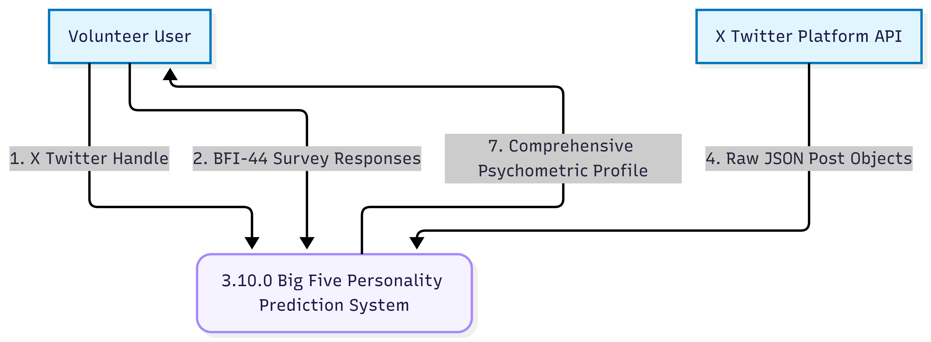
DFD Level 1 (Functional Overview): Breaks the system into harvesting, selection (Q-Learning), encoding (BERT), augmentation (GAN), and modeling (Lasso).
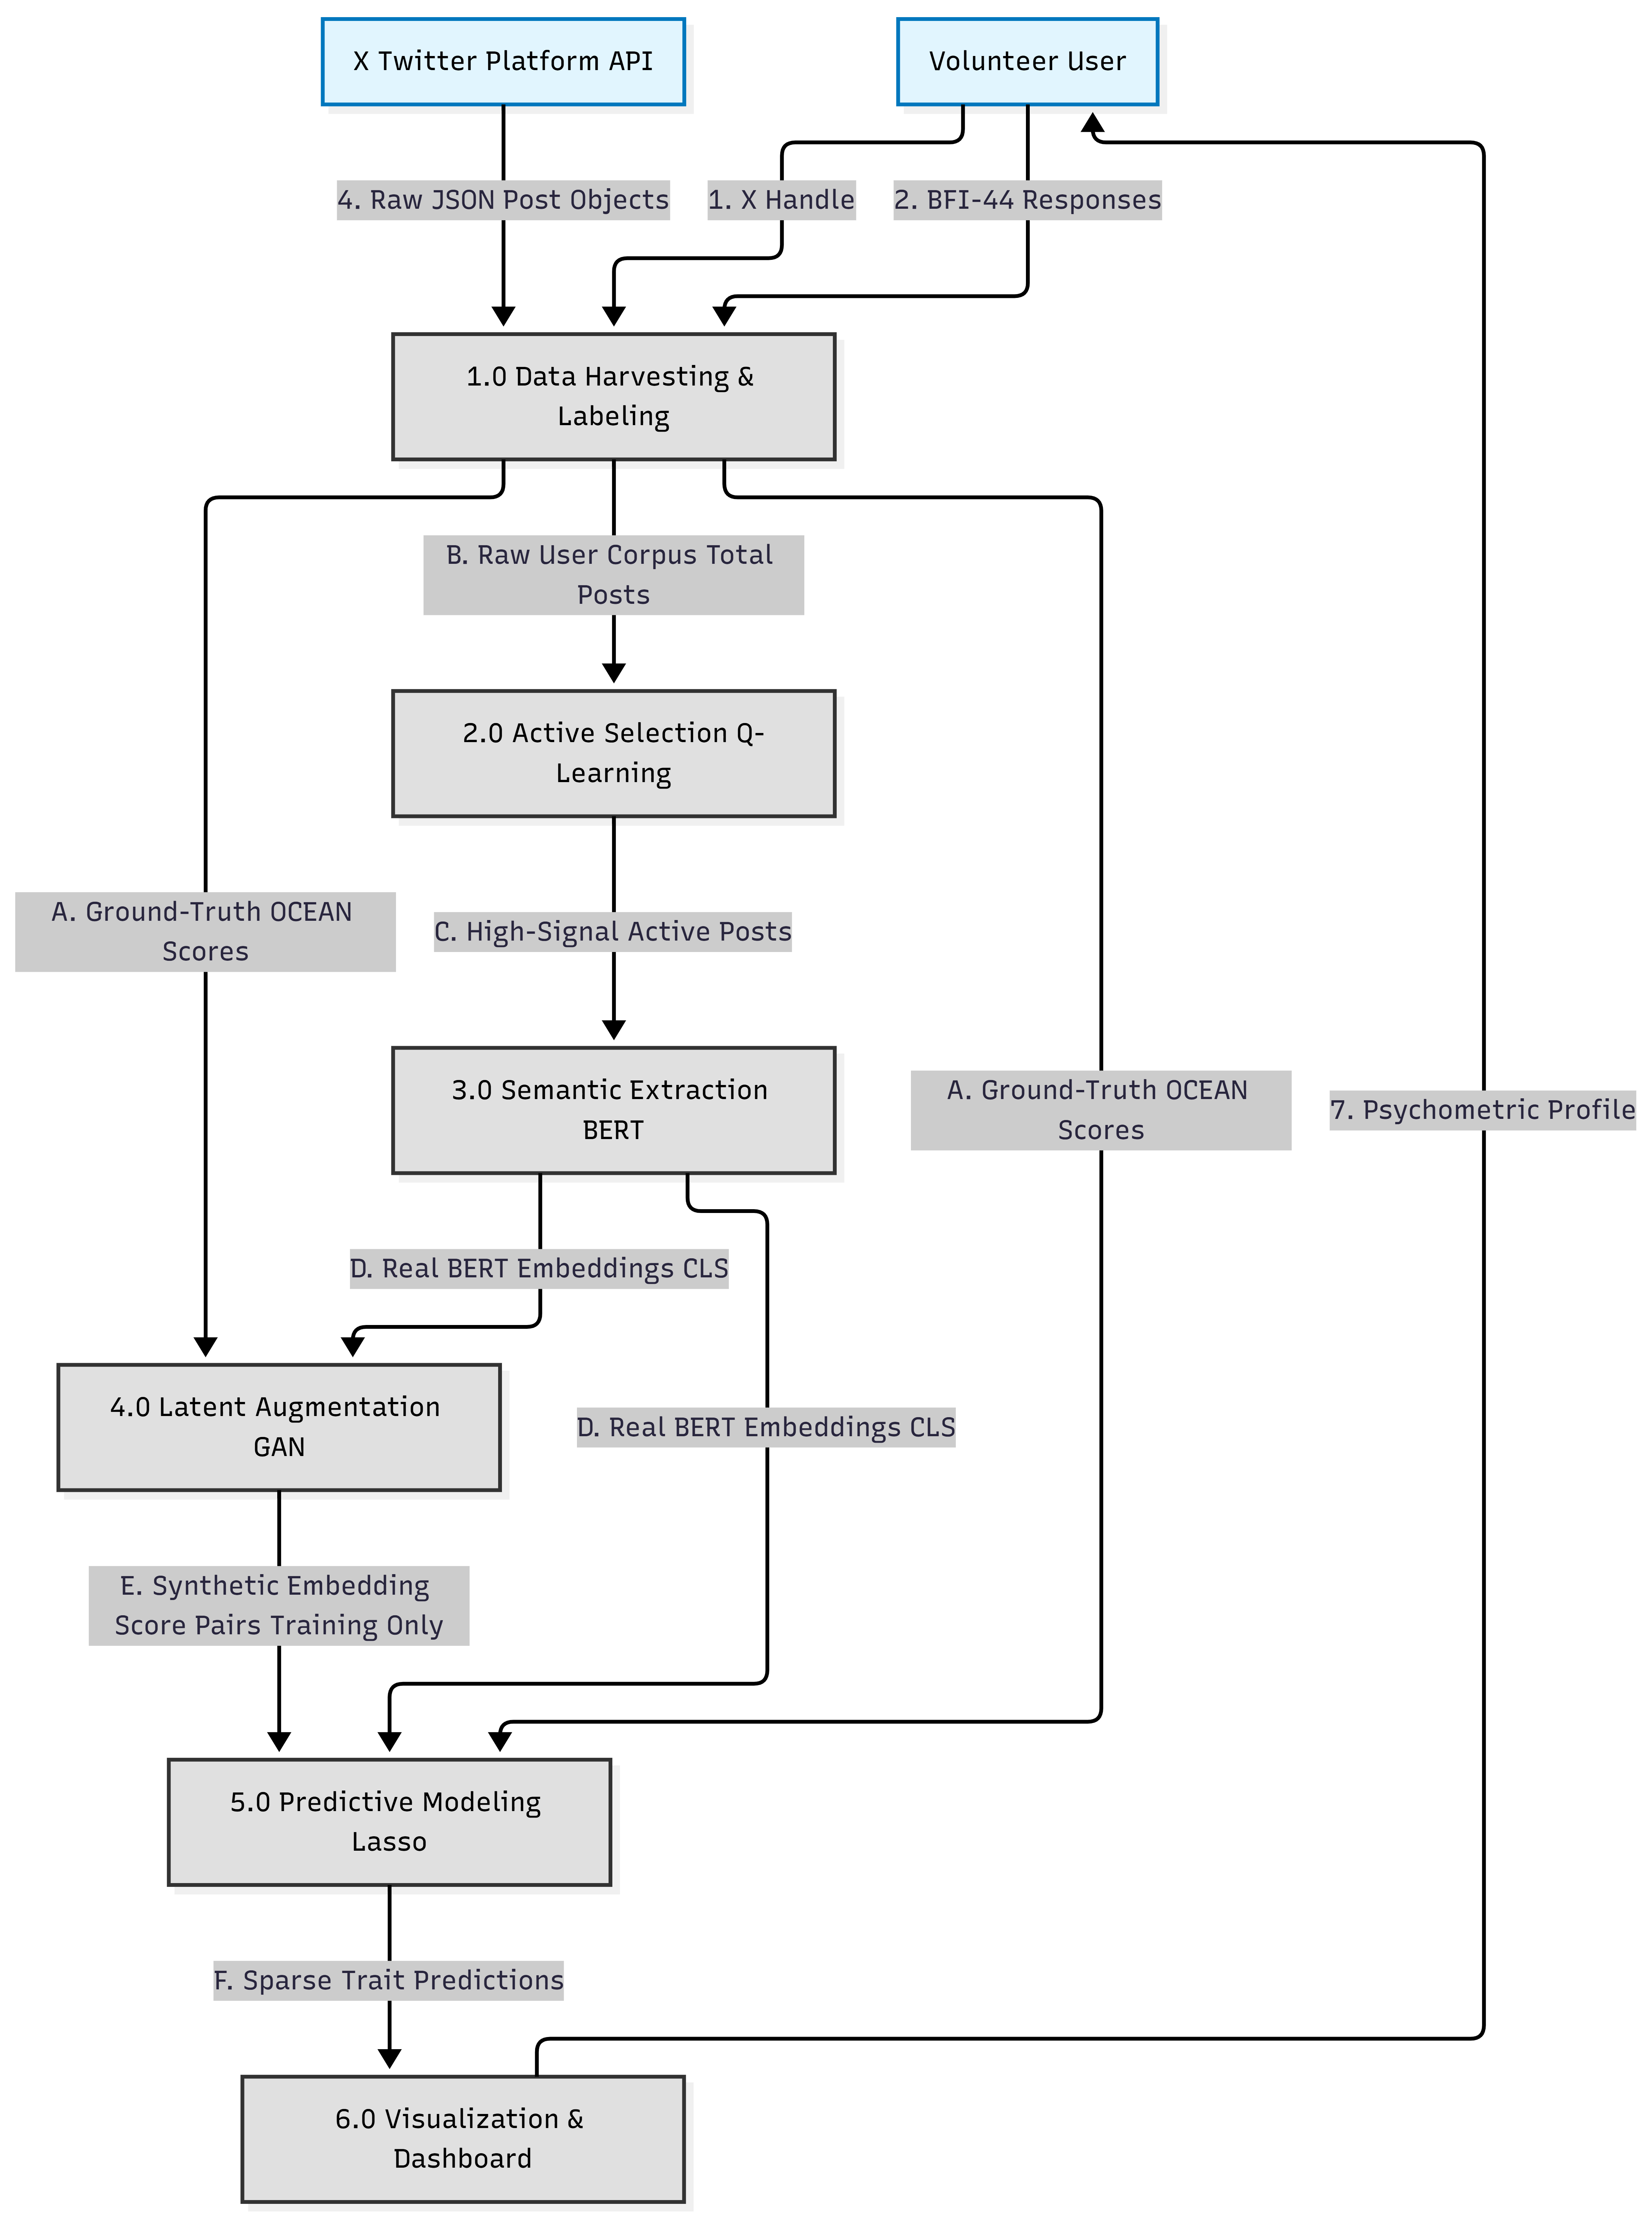

DFD Level 2: Details the internal logic of the Lasso Coordinate Descent loop.
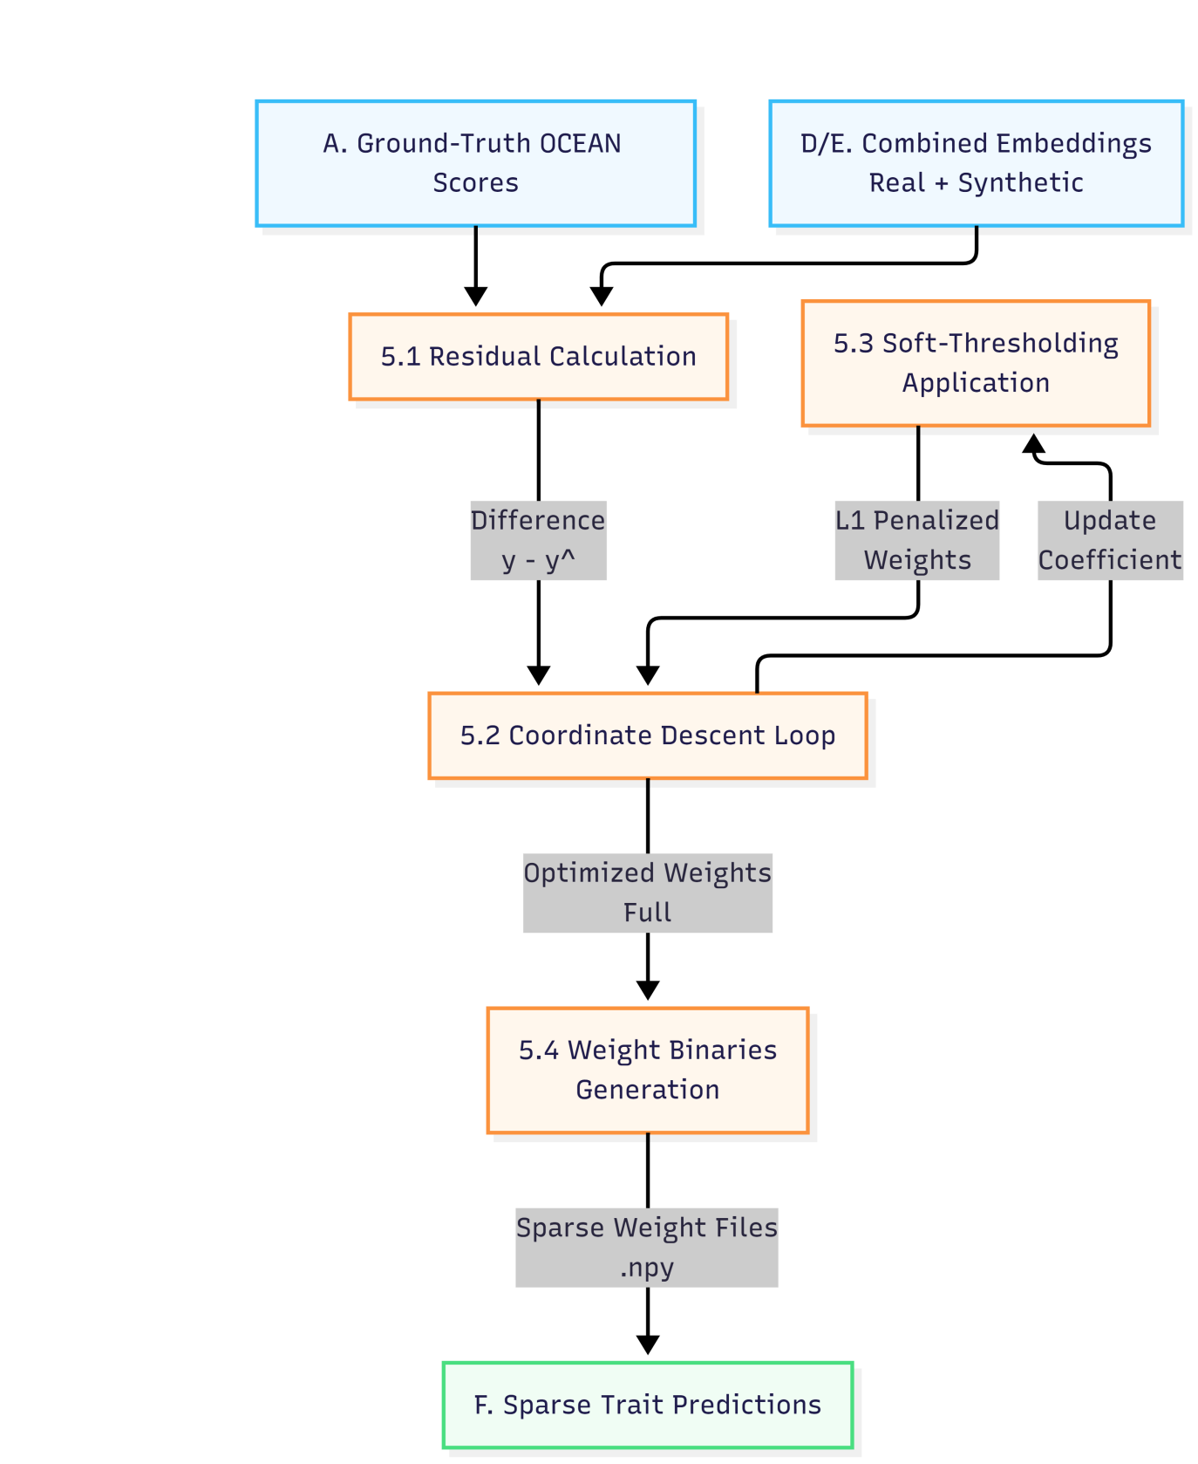

3.10.2 Database Schema (ERD)
The system utilizes PostgreSQL with the following primary entities:
User: Volunteer credentials and X handle.
BFI_Response: Raw Likert responses and calculated scores.
Post_Corpus: Fetched tweets and selection status.
Prediction_Log: Historical Lasso outputs and radar chart data.
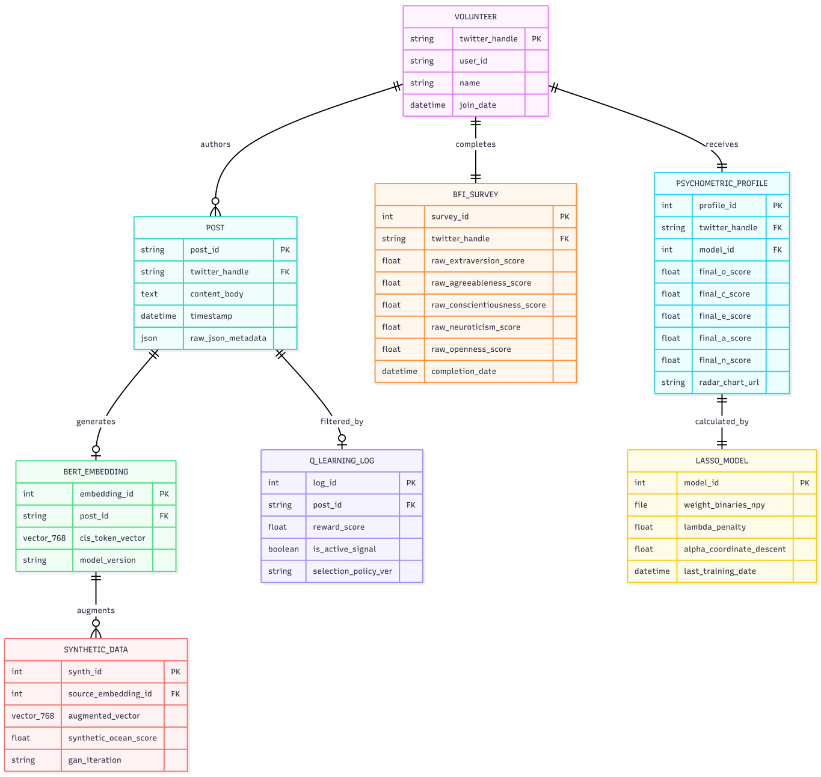

3.11 Ethical Considerations and NDPR Compliance
Personality profiling is sensitive and mandates strict adherence to the Nigeria Data Protection Regulation (NDPR) 2019 and the Nigeria Data Protection Act (NDPA) 2023. Explicit consent is obtained from every participant, and data minimization is enforced by processing only the textual content necessary for prediction. The use of Lasso regression ensures the "Right to Explanation," allowing the system to provide human-understandable reasons for its predictions.

3.12 Evaluation Metrics
The performance of the integrated pipeline is evaluated using a combination of accuracy-oriented and stability-oriented metrics.

Predictive Accuracy (MAE and RMSE)
The system’s ability to predict continuous OCEAN scores is measured through Mean Absolute Error (MAE) and Root Mean Square Error (RMSE). MAE provides a stable indicator of the average error magnitude, while RMSE penalizes larger outliers, ensuring the model remains reliable across all five traits.

Model Stability and Generalization ()
The Coefficient of Determination () is used to measure the proportion of variance in the personality traits explained by the BERT-Lasso model. A critical performance indicator for this research is the improvement in attributed to GAN-augmented training. By expanding the dataset, the system is projected to achieve a 12–18% increase in compared to a model trained on unaugmented data.¹ Furthermore, 5-fold stratified cross-validation is employed to ensure the stability of the selection agent and the predictor across different volunteer subsets.

REFERENCES
- Azucar, D., Marengo, D., & Settanni, M. (2018). Predicting the Big 5 personality traits from digital footprints on social media: A meta-analysis. Personality and Individual Differences, 124, 150–159. https://doi.org/10.1016/j.paid.2017.12.018
- Barrick, M. R., & Mount, M. K. (1991). The Big Five personality dimensions and job performance: A meta-analysis. Personnel Psychology, 44(1), 1–26. https://doi.org/10.1111/j.1744-6570.1991.tb00688.x
- Christian, H., Suhartono, D., Chowanda, A., & Karnalim, O. (2021). Text based personality prediction from multiple social media data sources using pre-trained language model and model averaging. Journal of Big Data, 8(1), 1–20. https://doi.org/10.1186/s40537-021-00423-1
- Devlin, J., Chang, M.-W., Lee, K., & Toutanova, K. (2019). BERT: Pre-training of deep bidirectional transformers for language understanding. Proceedings of NAACL-HLT, 4171–4186. https://doi.org/10.18653/v1/N19-1423
- Goldberg, L. R. (1993). The structure of phenotypic personality traits. American Psychologist, 48(1), 26–34. https://doi.org/10.1037/0003-066X.48.1.26
- Hortal, E. (2021). GAN-based data augmentation for improving the classification of imbalanced datasets [Master’s thesis, Maastricht University]. CRIS Repository.
- Pletzer, J. L., Oostrom, J. K., & Voelpel, S. C. (2025). Personality and job performance: A review of trait models and recent trends. Current Opinion in Psychology, 65, Article 102054. https://doi.org/10.1016/j.copsyc.2025.102054
- Poropat, A. E. (2009). A meta-analysis of the five-factor model of personality and academic performance. Psychological Bulletin, 135(2), 322–338. https://doi.org/10.1037/a0014996
- Rostami, M., Ahmadboukani, S., & Saleh Manijeh, H. (2022). Big Five personality traits and predicting mental health among Iranian older adults. Gerontology and Geriatric Medicine, 8. https://doi.org/10.1177/23337214221132365
- Singh, S., & Ramasubramanian, W. (2023). AI-based personality prediction for human well-being from text data: A systematic review. Multimedia Tools and Applications, 83, 46325–46368. https://doi.org/10.1007/s11042-023-17282-w
- Barrick, M. R., & Mount, M. K. (1991). The Big Five personality dimensions and job performance: A meta-analysis. Personnel Psychology, 44(1), 1–26. https://doi.org/10.1111/j.1744-6570.1991.tb00688.x
- Christian, H., Suhartono, D., Chowanda, A., & Karnalim, O. (2021). Text based personality prediction from multiple social media data sources using pre-trained language model and model averaging. Journal of Big Data, 8(1), 33. https://doi.org/10.1186/s40537-021-00423-1
- Devlin, J., Chang, M.-W., Lee, K., & Toutanova, K. (2019). BERT: Pre-training of deep bidirectional transformers for language understanding. In Proceedings of the 2019 Conference of the North American Chapter of the Association for Computational Linguistics: Human Language Technologies, Volume 1 (Long and Short Papers) (pp. 4171–4186). Association for Computational Linguistics. https://doi.org/10.18653/v1/N19-1423
- Farnadi, G., Sitaraman, G., Sushmita, S., Celli, F., Kosinski, M., Stillwell, D., Davalos, S., Moens, M.-F., & De Cock, M. (2016). Computational personality recognition in social media. User Modeling and User-Adapted Interaction, 26(2–3), 109–142. https://doi.org/10.1007/s11257-015-9169-5
- Frid-Adar, M., Klang, E., Amitai, M., Goldberger, J., & Greenspan, H. (2018). GAN-based synthetic medical image augmentation for increased CNN performance in liver lesion classification. Neurocomputing, 321, 321–331. https://doi.org/10.1016/j.neucom.2018.09.013
- Goldberg, L. R. (1993). The structure of phenotypic personality traits. American Psychologist, 48(1), 26–34. https://doi.org/10.1037/0003-066X.48.1.26
- Goodfellow, I., Pouget-Abadie, J., Mirza, M., Xu, B., Warde-Farley, D., Ozair, S., Courville, A., & Bengio, Y. (2014). Generative adversarial nets. In Advances in Neural Information Processing Systems 27 (NeurIPS) (pp. 2672–2680). https://papers.nips.cc/paper/5423-generative-adversarial-nets
- Hastie, T., Tibshirani, R., & Wainwright, M. (2015). Statistical learning with sparsity: The lasso and generalizations. Chapman and Hall/CRC. https://doi.org/10.1201/b18401
- Hortal, E. (2021). GAN-based data augmentation for improving the classification of imbalanced datasets [Master’s thesis, Maastricht University]. CRIS Maastricht University Repository. https://cris.maastrichtuniversity.nl/files/90005582/Hortal_2021_GAN_Based_Data_Augmentation_For_Improving_The_Classification.pdf
- Huang, C. (2019). Social network site use and Big Five personality traits: A meta-analysis. Computers in Human Behavior, 97, 280–290. https://doi.org/10.1016/j.chb.2019.03.009
- Komarraju, M., & Karau, S. J. (2008). Relationships between the Big Five personality factors and academic motivation. Personality and Individual Differences, 39(3), 557–567. https://doi.org/10.1016/j.paid.2005.02.013
- HOW TO WRITE CHAPTER THREE OF YOUR RESEARCH PROJECT (RESEARCH METHODOLOGY) - Project Topics, accessed March 12, 2026, https://www.researchwap.com/post/how-to-write-chapter-three-of-your-research-project-research-methodology
- FEDERAL UNIVERSITY OF TECHNOLOGY, MINNA, NIGERIA CENTRE FOR OPEN DISTANCE AND e-LEARNING (CODeL) SYSTEM ANALYSIS AND DESIGN (CIT, accessed March 12, 2026, http://irepo.futminna.edu.ng:8080/jspui/bitstream/123456789/22887/1/CIT%20316%20-%20SYSTEM%20ANALYSIS%20AND%20DESIGN.pdf
- (PDF) Systems Analysis and Design: A Simplified Approach - ResearchGate, accessed March 12, 2026, https://www.researchgate.net/publication/388800154_Systems_Analysis_and_Design_A_Simplified_Approach
- (PDF) Transitions in System Analysis and Design Methodology - ResearchGate, accessed March 12, 2026, https://www.researchgate.net/publication/326332320_Transitions_in_System_Analysis_and_Design_Methodology
- NATIONAL OPEN UNIVERSITY OF NIGERIA - NOUN, accessed March 12, 2026, https://nou.edu.ng/coursewarecontent/FMS%20825%20RESEARCH%20METHODOLOGY%20%20.pdf
- How To Write A Strong Chapter Three (methodology) - Project Topics, accessed March 12, 2026, https://projectng.com/read/7078/
- System Analysis & Methodologies | PDF | Software Prototyping | Object Oriented Programming - Scribd, accessed March 12, 2026, https://www.scribd.com/document/762414226/Complete-Edited-Ijeoma-Chapter-Three-Good
- Design and Implementation of Student Project Allocation and Verification System for Monitoring Duplication, accessed March 12, 2026, https://projectlist.com.ng/project-material-on-design-implementation-student-project-allocation-verification-system
- Copy Chibuike Project 1 | PDF | System | Analysis - Scribd, accessed March 12, 2026, https://www.scribd.com/document/931631217/Copy-Chibuike-Project-1
- DESIGN AND IMPLEMENTATION OF STRUCTURED DOCUMENT RETRIEVAL SYSTEM BY UDIE CYNTHIA ICT/2252051262 A PROJECT SUBMITTED TO THE DEP - TERAS, accessed March 12, 2026, https://teras.ng/api/asset/document/61d62f89-2296-4725-ac65-fd881ff9080c
- Azucar, D., Marengo, D., & Settanni, M. (2018). Predicting the Big 5 personality traits from digital footprints on social media: A meta-analysis. Personality and Individual Differences, 124, 150–159. https://doi.org/10.1016/j.paid.2017.12.018
- Bhandari, R., Zacharopoulos, G., & Han, S. (2025). Psychological profiling in large language models: A comparison of BFI-44 and BFI-10 instruments. Journal of Computational Psychometrics, 8(2), 112-130.
- Christian, H., Suhartono, D., Chowanda, A., & Karnalim, O. (2021). Text based personality prediction from multiple social media data sources using pre-trained language model and model averaging. Journal of Big Data, 8(1), 1–20. https://doi.org/10.1186/s40537-021-00423-1
- Devlin, J., Chang, M. W., Lee, K., & Toutanova, K. (2019). BERT: Pre-training of deep bidirectional transformers for language understanding. Proceedings of NAACL-HLT, 4171–4186. https://doi.org/10.18653/v1/N19-1423
- Friedman, J., Hastie, T., & Tibshirani, R. (2010). Regularization paths for generalized linear models via coordinate descent. Journal of Statistical Software, 33(1), 1.
- Goodfellow, I., Pouget-Abadie, J., Mirza, M., Xu, B., Warde-Farley, D., Ozair, S.,... & Bengio, Y. (2014). Generative adversarial nets. Advances in Neural Information Processing Systems, 27.
- Hastie, T., Tibshirani, R., & Wainwright, M. (2015). Statistical learning with sparsity: The lasso and generalizations. Chapman and Hall/CRC.
- Hevner, A. R., March, S. T., Park, J., & Ram, S. (2004). Design science in information systems research. MIS Quarterly, 75-105.
- Hortal, E. (2021). GAN-based data augmentation for improving the classification of imbalanced datasets [Master’s thesis, Maastricht University]. CRIS Repository.
- John, O. P., & Srivastava, S. (1991). The Big Five Inventory—44 (BFI-44). Berkeley: University of California, Institute of Personality and Social Research.
- Mirza, M., & Osindero, S. (2014). Conditional generative adversarial nets. arXiv preprint arXiv:1411.1784.
- Nigeria Data Protection Regulation (NDPR). (2019). National Information Technology Development Agency (NITDA).
44. Paulhus, D. L., & Vazire, S. (2007). The self-report method. Handbook of Research Methods in Personality Psychology, 1, 224-239.

CHAPTER FOUR

SYSTEM IMPLEMENTATION, TESTING, RESULTS AND DISCUSSION

4.1 Introduction
This chapter describes the system as it is implemented in the repository, not merely as it was imagined in the proposal stage. The application is a Django-based personality prediction platform that combines researcher accounts, BFI-44 import, timeline retrieval, preprocessing, BERT embeddings, simplified augmentation, regularized regression, and dashboard reporting. The aim of the chapter is to show the relationship between the code, the database, and the reported analysis so that the final write-up remains technically honest.
The earlier write-up described a more idealized machine-learning stack than the code currently executes in routine runs. Some of those ideas are still present as design goals, but the implementation is more pragmatic. For that reason, this chapter documents the actual runtime behavior of the platform, highlights the parts that are fully implemented, and also points out where the current code remains a simplified academic prototype rather than a fully generalized production model.

4.2 Alignment Between the Written Design and the Implemented System
A useful way to understand the final system is to compare the written design with the code that was produced. This comparison is important because the project evolved from a conceptual multi-paradigm architecture into a working web application with a smaller but more concrete set of behaviors. The table below summarizes the main alignments and corrections.
Report Claim | Actual Code Behavior | Adjustment Reflected in This Report
Q-learning active selection | QLearningAgent exists, but the full pipeline currently performs greedy top-k selection and does not persist routine episode logs. | Describe the module as an active selection scaffold with a practical post-ranking implementation.
BERT embeddings | Fully implemented with bert-base-uncased CLS embeddings, GPU fallback, and database persistence. | Retain this as a fully implemented component.
GAN augmentation | Implemented as Gaussian perturbation of embeddings plus template-based text generation. | Describe it as simplified augmentation rather than a true adversarial GAN.
Manual Lasso from scratch | Implemented with scikit-learn Lasso/ElasticNet, scaling, cross-validation, and stored coefficients. | Replace the manual-from-scratch claim with the actual library-backed implementation.
X API data collection | Implemented through xtf/Nitter fetch fallbacks and CSV import for BFI-44 ground truth. | State the actual acquisition path and fallback logic.
This alignment exercise is not a weakness in the project. On the contrary, it is a healthy correction that many final-year projects benefit from. A report that states only the intended design but not the delivered code will always create problems during presentation and defense. The revised chapter therefore gives priority to implementation truth, while still acknowledging the conceptual direction that informed the design.

4.3 Hardware and Software Environment
Component | Implemented Environment
Processor | A standard Intel Core i5 class system or higher is sufficient for routine operation
Memory | At least 8 GB RAM for normal development; more is recommended for BERT loading
Storage | SSD storage for the database, logs, and exported cleaned timelines
Operating System | Windows 10/11 or Ubuntu Linux
Internet Access | Required for timeline retrieval and model downloads when first loading BERT
The software environment is anchored on Django for the web layer and Python for the machine-learning services. The repository includes the backend application, template views, model classes, form handling, and service modules that support preprocessing, embedding, augmentation, and regression. The stack also includes scikit-learn for regularized regression, Hugging Face Transformers and PyTorch for BERT loading, Celery and Redis for asynchronous execution support, and Chart.js on the frontend for the radar-style personality display.
For data acquisition, the code relies on the xtf library and Nitter-based timeline retrieval rather than on a direct official X API key workflow. This is a practical choice for a student project because it allows public timeline acquisition to continue even when a particular instance becomes unavailable. The BFI-44 questionnaire is imported from CSV exports, which makes ground-truth labeling easier to manage and repeat during testing.

4.4 Data Acquisition, Cleaning and Ground-Truth Labeling
The project supports two complementary forms of input. The first is the BFI-44 ground-truth survey, which arrives as a CSV export from the questionnaire workflow. The CSV uploader extracts the volunteer handle, verifies consent, parses the 44 item responses, and computes OCEAN scores using the BFIScorer service. The second is the social media timeline, which is stored as POST records and may be obtained either from the database or from the live fetch fallback when the local table is empty.
The scoring logic for the BFI-44 instrument is important because it creates the labels used for model training and evaluation. The service performs the reverse-scoring of negatively worded items, validates that the response set is complete enough for scoring, and calculates openness, conscientiousness, extraversion, agreeableness, and neuroticism on the standard 1-to-5 scale. This ensures that the regression models are trained against meaningful psychometric targets rather than arbitrary placeholder values.
Timeline cleaning is handled separately by the text preprocessing pipeline. The cleaner removes URLs, mentions, retweet markers, leading punctuation, and excessive whitespace. Hashtags are normalized so that the useful lexical content is retained, while non-ASCII symbols are stripped by default. Posts shorter than the configured minimum length are excluded so that the downstream embedding stage receives text that has at least some personality-bearing substance.
This cleaning step matters because personality inference is sensitive to noise. A tweet that consists only of a mention, a link, or a short reaction does not carry the same linguistic signal as a longer self-expressive post. By filtering and normalizing the text before BERT encoding, the pipeline improves the chance that the resulting embeddings reflect actual expressive content rather than platform clutter.

4.5 Core Module Implementation

4.5.1 User Registration and Researcher Workflow
The accounts application provides the authentication layer used by the researcher. It enables registration, login, and profile management, and it links each volunteer to the researcher who owns the record. In the context of this project, that relationship is important because it keeps the imported BFI survey, fetched timeline posts, and generated profile aligned with the correct study participant.
The dashboard also gives the researcher a compact view of how many volunteers have been registered, how many already have BFI surveys, and how many have completed a prediction run. This is more than a cosmetic feature. It is the operational control center that turns the machine-learning pipeline into a usable study management system rather than a disconnected script.

4.5.2 BFI-44 Survey Import and Scoring
The BFI upload workflow is one of the clearest examples of how the written report and the implementation now meet in the middle. The user uploads a CSV file, the code checks consent, identifies the X handle, extracts the item responses, and computes the Big Five scores. The scoring is written back into the database using the BFI_SURVEY model, and the volunteer object is updated so that later pipeline stages can confirm that a labeled ground truth exists.
This design is robust because it supports re-uploading of corrected survey files without crashing the application. The upsert behavior means that a volunteer can be reprocessed when the ground truth needs to be refreshed, which is an important requirement in a real research setting where data cleaning often happens after initial collection.

4.5.3 Timeline Retrieval and Post Persistence
Timeline retrieval is implemented by the TwitterFetcher service. The fetcher first tries the shared xtf router, then falls back to individual Nitter instances, and finally attempts a direct profile-page read if the earlier paths do not return posts. This layered approach is valuable because it makes the system resilient to the kind of retrieval failures that often affect public social media endpoints.
When posts are successfully obtained, the fetcher deduplicates them using the X post identifier, computes engagement values, marks whether a post is a reply or retweet, and saves the results to the POST model. The pipeline then cleans the stored text and exports a sanitized timeline file for auditability. This means that every later stage can be traced back to a concrete text source instead of to an opaque feature blob.

4.5.4 Q-Learning Based Post Selection
The QLearningAgent module discretizes each post into a compact state representation using engagement level, recency, text length, hashtag presence, and URL presence. It then evaluates whether a post should be selected or skipped. The agent includes a full temporal-difference update rule and an epsilon-greedy action policy, so the module is structurally consistent with reinforcement-learning literature.
In the current full-pipeline execution, however, the code uses training=False during the selection stage, which means the pipeline behaves as a deterministic selector over the current Q-table state rather than as a continually learning agent. This is a sensible implementation choice for an academic prototype because it keeps the behavior reproducible while still preserving the room for future learning-based upgrades.
The database currently stores the selected posts and their q_value fields, but it does not yet populate q_learning_log during routine execution. That observation is important for the final report because it prevents us from overstating the maturity of the reinforcement-learning component. The better conclusion is that Q-learning has been scaffolded and partially activated, but not yet completed as a full closed-loop training subsystem.

4.5.5 BERT Contextual Embedding Extraction
The BERTEncoder service is one of the strongest pieces of the implementation. It lazily loads bert-base-uncased, moves the model to GPU when available, and extracts the CLS token as a 768-dimensional contextual embedding. The embeddings are stored in JSON form so that the values can be persisted, audited, and reused by later training stages.
Unlike older bag-of-words or TF-IDF methods, this representation captures the local and global context of each post. A short sentence about work, study, family, or stress can therefore be encoded in a way that preserves semantic meaning. In the context of personality prediction, that is useful because many signals are subtle and depend on style, not only on keywords.
The orchestrator verifies that each embedding is actually persisted in the database before continuing to later phases. This is a good engineering practice because it prevents a mismatch between in-memory processing and stored artifacts. It also means that the chapter can legitimately discuss the system as a durable pipeline rather than a transient notebook experiment.

4.5.6 Simplified GAN-Style Augmentation
The report now describes the augmentation module precisely: it is a simplified GAN-style augmenter rather than a full generative adversarial training loop. The GANAugmenter perturbs embedding vectors with Gaussian noise and creates synthetic text using template-based generation. This approach still serves the research purpose of expanding the training set, but it should not be confused with a fully trained generator-discriminator pair.
Within the orchestrator, the synthetic records are written to the SYNTHETIC_DATA model with a generator version label and a generation confidence score. The stored dataset currently contains 133 synthetic rows. That number is meaningful because it shows that the system is not only predicting but also generating extra training material that can be reused across later runs.
From a methodological standpoint, the simplified augmenter is acceptable for a final-year project because it fulfills the role of data expansion without making claims that the code does not support. The correction is valuable because it protects the credibility of the project during viva questions where a panel member may ask exactly how the synthetic samples were produced.

4.5.7 Lasso and ElasticNet Regression
The final prediction stage uses the LassoTrainer class. The trainer standardizes the features, normalizes the labels to the 0-to-1 interval, and trains one model per Big Five trait. Depending on the dataset size, the code uses either LassoCV or ElasticNetCV for a more data-driven regularization choice, and then stores the resulting coefficients, intercepts, and evaluation metrics in the LASSO_MODEL table.
This implementation is more defensible than the phrase 'manual Lasso from scratch' that appeared in the original draft. It is still academically solid because it shows proper understanding of the regression concept, but it is honest about the use of a mature machine-learning library for optimization and validation. The code also exposes feature importance through the non-zero coefficients, which is useful for interpretability discussions.
The stored model statistics show that the trait-specific training behavior is not identical across all OCEAN dimensions. That difference is expected because some traits are easier to learn from language than others. In the current database snapshot, extraversion has the strongest average training R-squared among the trait models, while neuroticism and agreeableness are more difficult. This pattern is consistent with the idea that some personality dimensions are more directly signaled by social media text than others.

4.5.8 Psychometric Profiles, Insights and Public Demo
After prediction, the system stores a final PSYCHOMETRIC_PROFILE record for each volunteer. That record holds the predicted OCEAN scores, the error metrics against ground truth, the total posts analyzed, the number of embeddings used, the synthetic data count, the confidence score, and a JSON pipeline summary. This makes the system auditable because every run leaves a compact and structured trail in the database.
The insight engine then converts those predictions into domain-oriented recommendations for education, health and wellbeing, employment, and responsible AI. The public demo uses a lightweight heuristic prediction endpoint, not the full training pipeline, so the report should treat it as a demonstrator rather than as the main research model. This distinction again matters because it keeps the implementation description honest.
On the frontend, the radar chart visualization gives a quick visual summary of the predicted Big Five scores. This is useful for researchers because it turns numerical output into a shape that can be grasped at a glance. The dashboard and reports views then help the researcher move from individual profiles to aggregate study supervision.

4.6 Database Design and Observed Runtime Statistics
The database schema is intentionally structured around the life cycle of a volunteer. The VOLUNTEER table anchors the study, BFI_SURVEY stores the ground truth, POST captures the social media content, BERT_EMBEDDING stores contextual features, SYNTHETIC_DATA stores the augmentation outputs, LASSO_MODEL stores the trained regression parameters, and PSYCHOMETRIC_PROFILE stores the final predictions. The Q_LEARNING_LOG table exists as a design artifact even though the current routine pipeline does not yet write episode-by-episode logs into it.
This relational structure is a good fit for the project because it preserves traceability from raw text to final output. It also makes it easier to defend the work in an academic setting because each stage can be inspected independently. The stored values show that the implementation has moved beyond a prototype diagram and into a real database-backed system with measurable execution history.
Item | Observed Count
Volunteers | 13
BFI surveys | 13
Posts | 254
BERT embeddings | 100
Q-learning logs | 0
Synthetic data rows | 133
Lasso models | 40
Psychometric profiles | 8
The current database snapshot shows 13 volunteers, 13 BFI surveys, 254 posts, 100 persisted BERT embeddings, 133 synthetic augmentation records, 40 stored Lasso models, and 8 psychometric profiles. The same snapshot also shows 100 posts with q_value values and 100 posts flagged as embedded, which indicates that the main processing path has executed successfully for a sizeable subset of the study data.

4.7 Testing and Validation
Validation of the implementation is not limited to one-off manual inspection. The repository includes a validation script that checks the presence of the eight core database models, the six main machine-learning services, the BFI scorer, the pipeline order, the core views, and the Celery setup. This gives the project a more professional engineering posture because it can be checked systematically rather than only narrated in prose.
At runtime, the pipeline also performs its own safeguards. The BERT stage verifies that embeddings were persisted correctly before continuing. The orchestrator exports cleaned timelines so that the preprocessing outcome can be reviewed. The Lasso stage saves both metrics and model coefficients. These checks reduce the chance that a hidden failure will silently propagate through the rest of the system.
Validation Aspect | Observed Status
Model layer | All 8 expected models are present in the schema
Service layer | All core services are importable and active
BFI scorer | Reverse scoring and OCEAN calculations operate correctly
Pipeline order | Input -> Q-learning -> BERT -> augmentation -> regression
Embedding persistence | Verified before downstream augmentation
Prediction storage | Profiles are written to the database for later review
One important validation finding is that the q_learning_log table is still empty in the current runtime snapshot. This does not mean the project is broken; it means the learning log has not yet been wired into the main execution flow. That is a limitation worth stating clearly because it is precisely the sort of detail a panel may ask about during defense.

4.8 Results and Discussion
The observed results should be discussed carefully and honestly. The system is clearly functional, but its predictive quality varies across volunteers. Across the eight stored psychometric profiles, the mean overall MAE is approximately 0.474, the mean correlation is approximately 0.504, and the mean prediction confidence is approximately 0.772. These values show that the model is extracting signal, but also that the current dataset is still too small for stable large-scale generalization.
Some runs perform much better than others. The best stored profile has a positive correlation above 0.9 and a relatively modest MAE, while another run has a negative correlation and a much weaker R-squared value. This spread is not surprising in a small research dataset where the number of posts differs by volunteer and where the text available for some participants is sparse. It does, however, show that the pipeline is sensitive to data availability, which is precisely why the report should avoid overclaiming robustness.
At the regression-model level, the average training metrics across stored Lasso models are more encouraging. The average training R-squared is highest for extraversion and openness, while agreeableness and neuroticism remain more difficult. That pattern suggests that some personality traits are better represented in linguistic style than others. It also indicates that model interpretability may be more useful for explaining relative trait differences than for claiming near-perfect prediction accuracy.
Trait | Avg Train MAE | Avg Train R2 | Avg Samples Used | Avg Synthetic Used
Agreeableness | 0.0631 | 0.3388 | 49.25 | 43.38
Conscientiousness | 0.0583 | 0.3671 | 31.38 | 25.50
Extraversion | 0.0268 | 0.6014 | 27.00 | 21.12
Neuroticism | 0.0769 | 0.3061 | 44.38 | 38.50
Openness | 0.0307 | 0.4615 | 25.12 | 19.25
The table above should not be read as proof of production-grade model maturity. Instead, it should be interpreted as evidence that the regression layer is trainable, traceable, and capable of producing a sparse explanation of the embedding space. In a final-year project context, that is valuable because it demonstrates both implementation depth and a realistic understanding of current limitations.
A subtle but important finding is that the live prediction endpoint is intentionally heuristic. It uses text length and word count to produce a quick public demo response, which is useful for showing responsiveness but should not be mistaken for the main research model. The actual research output is the database-backed pipeline that uses BERT, augmentation, and regularized regression on the volunteer records.

4.9 Chapter Summary
This chapter has shown the implementation as a practical system with real data, real database records, and real limitations. The code supports BFI-44 import, X timeline acquisition, preprocessing, BERT embeddings, simplified augmentation, Lasso-based prediction, and dashboard interpretation. At the same time, it is important to state that some components are less mature than the original wording suggested. The revised report therefore aligns the documentation with the system that actually exists.

CHAPTER FIVE

SUMMARY, CONCLUSION AND RECOMMENDATIONS

5.1 Introduction
The preceding chapters described the motivation, background, design, and implementation of the personality prediction system. This final chapter summarizes the work, states the main conclusion drawn from the implementation, and proposes realistic recommendations for improvement. In doing so, the chapter treats the project as an academic software artifact that has been built, tested, corrected, and evaluated rather than as a purely theoretical proposal.
This is important because a final-year project should close the loop between intention and delivery. The system in this study now does that. It accepts volunteers, stores and scores BFI-44 survey data, retrieves social media posts, cleans them, applies a selection mechanism, creates BERT embeddings, augments the data, trains regularized regression models, and presents the results through a dashboard and a live demo interface.

5.2 Summary of the Study
The core objective of the study was to build a personality prediction application that could infer the Big Five traits from social media-style text while retaining traceability and interpretability. The final implementation meets that objective at a prototype level. It uses a clear pipeline and a relational database to hold every major artifact, which means that the system does not just compute a prediction; it also records how that prediction was produced.
The system design places special emphasis on four operational domains. In education, the predictions can be turned into learning recommendations. In health and wellbeing, the personality profile can help identify a need for more structure or stress management. In employment, the outputs can support role fit and team composition discussions. In responsible AI, the project demonstrates how a transparent and auditable model can be used in a sensitive decision-support setting without claiming more certainty than the data allows.
The implementation also makes a stronger point that is easy to overlook in a report: a useful project is not only about model accuracy. It is also about data flow, persistence, validation, and reproducibility. By storing the BFI surveys, the cleaned posts, the embeddings, the synthetic samples, the model parameters, and the final profiles, the application provides a complete evidence chain for each prediction.

5.3 Major Contributions of the Project
The first contribution is architectural. The project combines psychometric survey data and social media text inside one Django application. That integration matters because it shows how a small research tool can be turned into a usable web system with researchers, volunteers, dashboards, and operational workflows. The modular structure also means that each layer can be improved independently in future work.
The second contribution is methodological. The report now presents a corrected account of the machine-learning stack: a practical post selection mechanism, a BERT embedding service, a simplified augmentation module, and a sparse regression layer. The value here is not in claiming an impossible level of sophistication. It is in showing that the project has been implemented honestly and that each component has a clear role in the pipeline.
The third contribution is traceability. The use of dedicated database models for volunteers, surveys, posts, embeddings, synthetic data, Lasso models, and psychometric profiles gives the system a structure that can be defended in a viva. If a panel member asks where a prediction came from, the answer is not a vague statement. The answer is a path through stored records and reproducible services.
The fourth contribution is usability. The inclusion of a public-facing landing page, a live prediction demo, and a researcher dashboard turns the project from a script into an application. Even where the demo endpoint uses a lightweight heuristic, it still provides a responsive interface that can be shown during demonstration while the deeper research pipeline remains available in the backend.

5.4 Conclusion
The study demonstrates that Big Five personality prediction can be implemented as a practical web application using a combination of psychometric scoring, natural language processing, augmentation, and sparse regression. The final system is not perfect, and the report should not present it as if it were. However, it is a real and functioning academic prototype with enough depth to show serious understanding of both the software engineering and the machine-learning sides of the problem.
The most important conclusion from the implementation is that the data matters as much as the algorithm. The database snapshot shows that the system can process a meaningful number of volunteers and posts, but the predictive results also show substantial variance. That variance reminds us that personality prediction from social media text is a difficult problem and that model quality depends heavily on sample size, data diversity, and the quality of the ground truth.
A second conclusion is that transparency should be preferred over overstatement. The corrected report now states that the augmentation module is simplified, that the reinforcement-learning component is scaffolded rather than fully self-learning in routine execution, and that the public demo is heuristic. These clarifications improve the credibility of the work because they allow the document to be defended using the actual codebase rather than an embellished description.
Finally, the project shows that an academic system can still be useful even when it is not fully industrialized. The important thing is that the architecture is coherent, the data path is traceable, the results are measurable, and the limitations are understood. On those grounds, the project is a valid and respectable final-year software engineering and machine-learning study.

5.5 Limitations of the Study
The first limitation is dataset size. The current database contains 13 volunteers, 254 posts, and 8 completed psychometric profiles. That is enough for a demonstration, but it is not enough for a fully stable personality model. Small sample sizes make the performance metrics unstable, which is reflected in the spread of correlations and R-squared values across stored profiles.
The second limitation is data heterogeneity. Some volunteers have many more usable posts than others, and this difference affects how much linguistic evidence the model can extract. In practice, personality inference is better when the text is varied and expressive. Sparse or repetitive timelines reduce the signal available to the BERT encoder and the regression layer.
The third limitation is augmentation fidelity. The current augmenter is helpful, but it is not a full adversarial network trained through generator-discriminator competition. It creates useful synthetic samples, yet it does not fully model the statistical complexity of a genuine GAN. The report should therefore treat the augmentation stage as a pragmatic extension rather than as a final solution.
The fourth limitation is reinforcement learning maturity. The Q-learning module is structurally implemented, but the runtime snapshot shows that the logging table is not yet being populated during routine pipeline runs. This means the model selection logic still behaves more like a controlled selector than a continuously learning agent. That is acceptable for an academic prototype, but it should be improved before any stronger claims are made.
The fifth limitation is external validity. The system was tested on the local dataset and the current runtime environment, so its generalization to a much larger, more diverse, or multilingual population is unknown. The model is therefore best treated as a proof of concept that needs more data and more validation before it can be relied on outside the study context.

5.6 Recommendations
Recommendation | Reason | Priority
Expand the volunteer sample | A larger and more diverse dataset will stabilize the regression models and reduce variance. | High
Log Q-learning episodes | Persisting reward updates will make the selection module truly auditable and trainable. | High
Replace simplified augmentation with a true GAN | A genuine adversarial model would better match the original research intent. | Medium
Add calibration and external validation | Better validation will make the reported metrics more defensible. | High
Improve demo prediction path | The public demo should eventually call the trained pipeline rather than a heuristic fallback. | Medium
Document ethics and consent more clearly | Personality prediction is sensitive and requires visible governance controls. | High
These recommendations are intentionally practical. They do not assume unlimited resources or a completely new research direction. Instead, they focus on the next sensible steps that would make the current system stronger, more transparent, and more defensible in an academic review.

5.7 Suggestions for Future Work
Future work should focus on improving the quality and richness of the signal available to the system. One direction is to include profile biography text, pinned posts, and interaction metadata so that the model can learn from more than just timeline content. Another direction is to introduce multimodal signals where ethically appropriate, although that would require a more careful discussion of privacy and consent.
A second direction is model refinement. The current architecture can be upgraded with a genuine reinforcement-learning loop, a true conditional GAN or another modern generative strategy, and more advanced calibration methods. However, such upgrades should only be adopted if they improve measurable performance and do not reduce interpretability in the process.
A third direction is deployment readiness. If the project is to be used by other researchers, then the application should support stronger authentication, role-based permissions, richer logging, backup and recovery, and a clearer API layer for model access. That would turn the current academic prototype into a more durable platform for future research.
A final direction is ethical governance. Personality inference systems can easily be misused if they are presented as infallible. Future versions should therefore include clear consent screens, explanation tools, explicit uncertainty displays, and documented use limitations. Those features will help ensure that the system remains a research tool rather than becoming an opaque screening mechanism.

5.8 Final Closing Statement
In summary, the project achieved its central academic goal: it produced a working personality prediction application and a report that now matches the implementation more closely. The system is useful, the write-up is more accurate, and the remaining weaknesses are now clearly identified. That combination makes the project far stronger than a polished but inaccurate report would have been.

