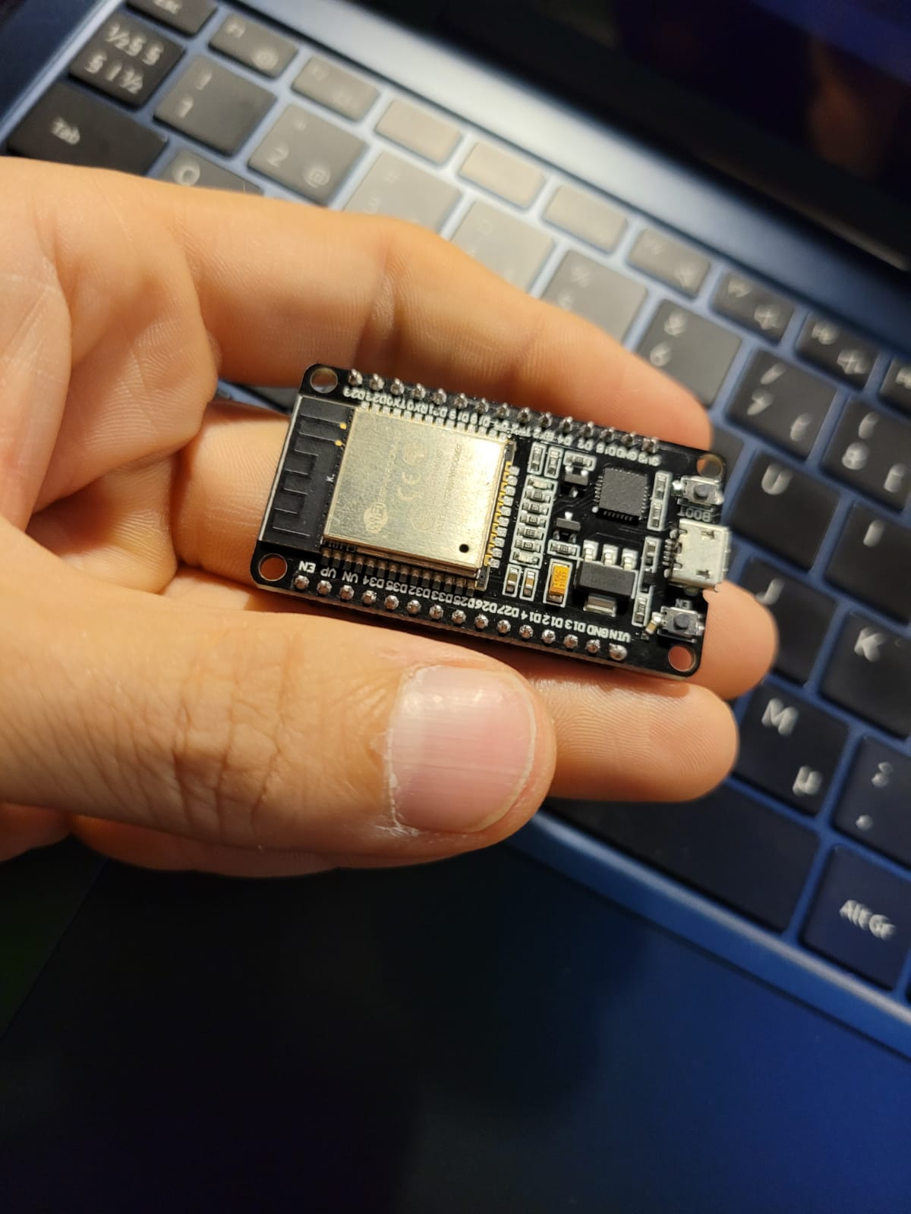

Barebones

Lähteenkorva Risto

Eficode IoT-project

Table of contests

Intoduction 3

ESP32 developmen board 4

PIR sensor 5

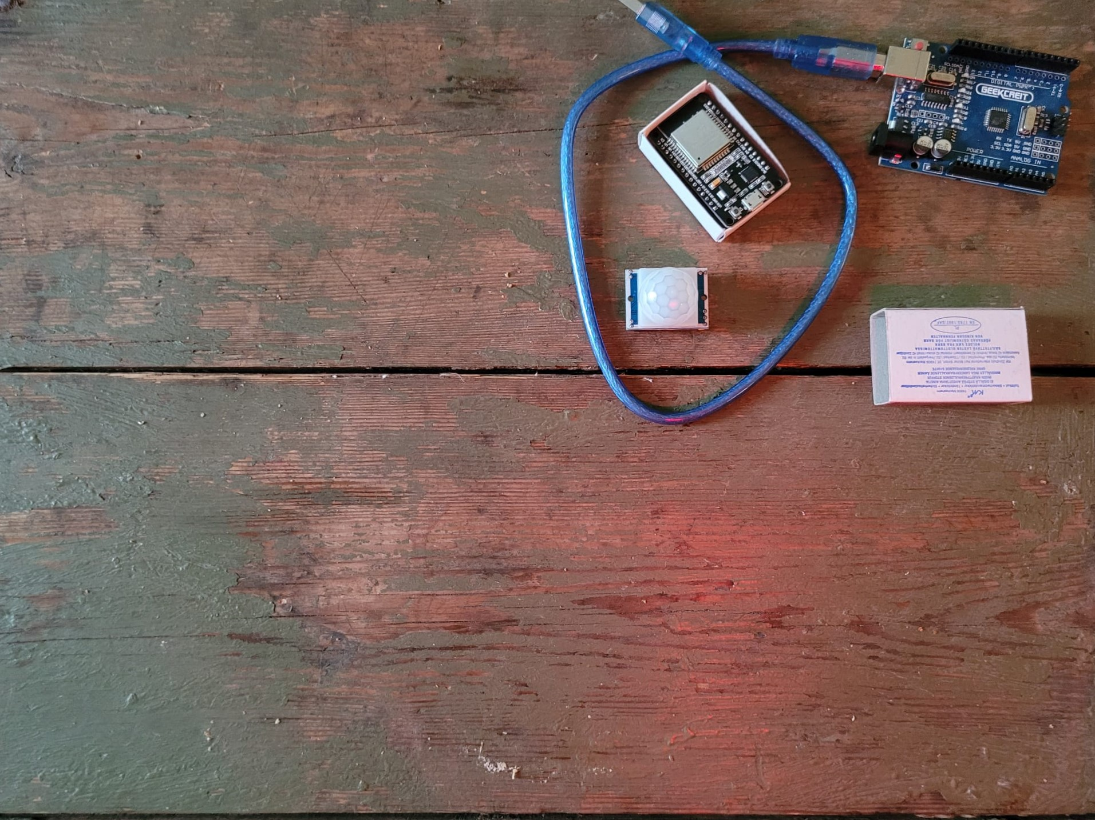

# Intoduction

This document is a very short explanation what is ESP32 development board and PIR-sensor and gives out some crucial information of those that is needed in our teams IOT-project. Document covers only most relevant information.

# ESP32 developmen board

ESP32 is development board for making prototypes of small IoT and other electric devices that needs to be controlled by some sort of software.

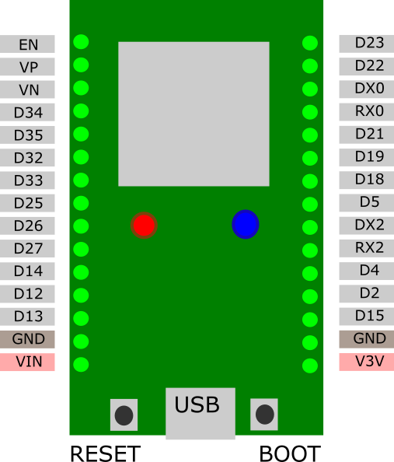Basic relevant information of board used in this project

Operating Voltage: 3.3V

Input Voltage: 7-12V

Digital I/O Pins (DIO): 25

Analog Input Pins (ADC): 6

Analog Outputs Pins (DAC): 2

Wi-Fi: IEEE 802.11 b/g/n/e/I and support for

WEP or WPA/WPA2 authentication, or open networks

Support for Bluetooth, Ethernet and Low power

In this project:

Board is powered through USB

Any of digital I/O pins with D+2 numbers can be used as input pins

Pin D2 is connected to internal led, so by using this pin signal of internal led can be shown in external device/light/whatever.

PIR-sensor is powered through VIN pin witch gives out input voltage before regulation, in this case USB voltage. (USB voltage is around 5V). Just to remind, If board is powered for example 12V power source, this pin cannot be used to power PIR because in that case this pin will provide 12V.

Board also provides regulated 3,3V output but that would need modified or different type of PIR.

Some boards need boot or reset button to be hold down while uploading new code to device.

# PIR sensor

PIR = Passive Infrared Sensor which means that it doesn’t include infrared light source and it operates in infrared zone. Practically this means that it detects movement of objects that emit heat or if being very precise, any rapid enough changes in amount of infrared light surrounding the sensor.

Basic information of similar PIR sensor. Exact model unknown and unselected.

voltage 5 VDC

delay 3-200 s

output level high = 3 V, low = 0 V

max. sensing distance 7 m

detection angle 120°

Link to datasheet: https://www.radioduo.fi/storage/product_files/4/WPSE314-vma314_a4v02.pdf

