Appendix

**Appendix A1** Performance Parameters of Devices in Federated Learning

|  |  |  |  |  |
| --- | --- | --- | --- | --- |
| Device | Type | Computational Resources | RAM (GB) | Number |
| Center server | CPU | AMD Ryzen5-3600@1.8GHz 12 cores | - | 1 |
| GPU | NVIDIA GeForce RTX 2060 CUDA 1920 cores | - | 1 |
| Client | Raspberry Pi 3B+ | Cortex-A53@1.4GHz CPU×1 | 1 | 5 |
| Nvidia Jetson Nano | Maxwell CUDA 128 cores GPU×1 | 4 | 10 |
| Nvidia Jetson TX2 | Pascal CUDA 256 cores GPU×1 | 8 | 5 |
| 0.8 CPU Docker | Ryzen5-3600@1.8GHz CPU×0.8 | 3 | 15 |
| 1.6 CPU Docker | Ryzen5-3600@1.8GHz CPU×1.6 | 3 | 15 |
| 2.4 CPU Docker | Ryzen5-3600@1.8GHz CPU×2.4 | 3 | 10 |
| 3.2 CPU Docker | Ryzen5-3600@1.8GHz CPU×3.2 | 3 | 10 |
| 4.0 CPU Docker | Ryzen5-3600@1.8GHz CPU×4.0 | 3 | 10 |
| 4.8 CPU Docker | Ryzen5-3600@1.8GHz CPU×4.8 | 3 | 10 |
| 5.6 CPU Docker | Ryzen5-3600@1.8GHz CPU×5.6 | 3 | 10 |

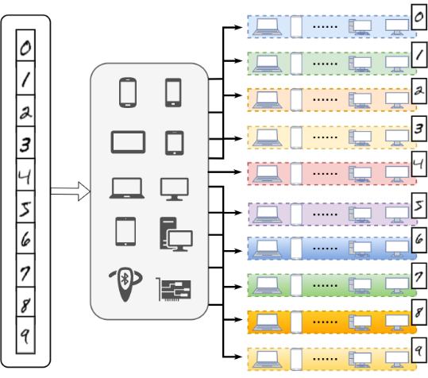

**Appendix A2** Generation of MNIST-Fed dataset.

|  |  |  |  |
| --- | --- | --- | --- |
|  |  |  |  |
| (a) | (b) | (c) | (d) |

|  |  |  |
| --- | --- | --- |
|  |  |  |
| (e) | (f) | (g) |

**Appendix A3** Datadistribution of each class in CIFAR-10-Fed. (a) Datadistribution when α = 10. (b) Datadistribution when α = 0.1. (c) Datadistribution when α = 0.01. (d) Classes. (e) Number of samples in each class when α = 10. (f) Number of samples in each class when α = 0.1. (g) Number of samples in each class when α = 0.01.