**1 a) Web Engineering is the application of systematic, disciplined and quantifiable approaches to development, operation, and maintenance of Web-based applications.**

**( janina )**

**b)**

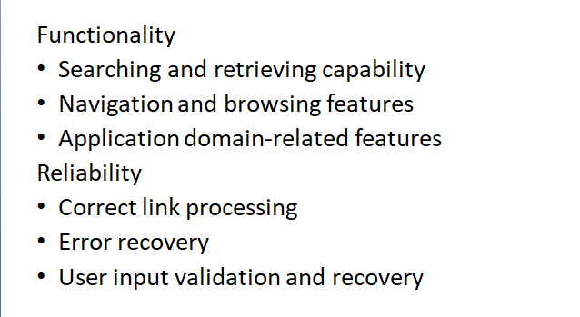

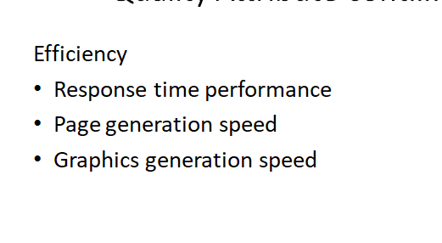

**2. Uniform Resource Locator (url)**

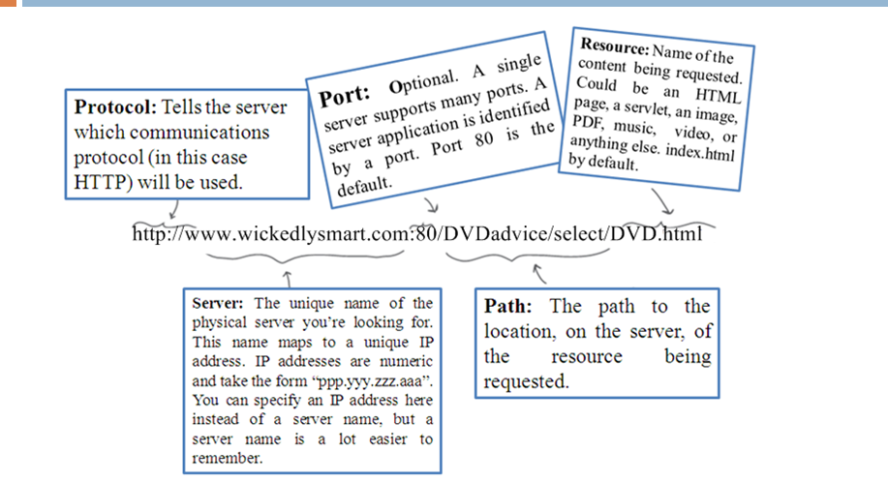

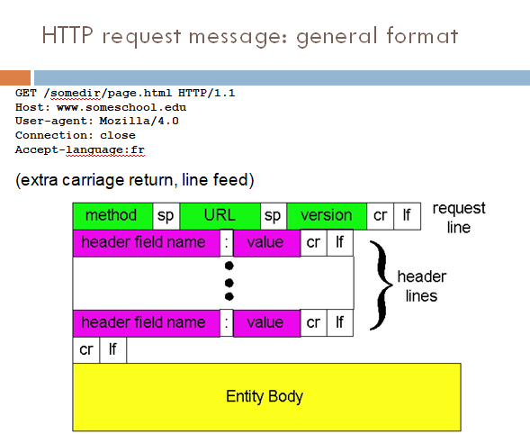

**B.**

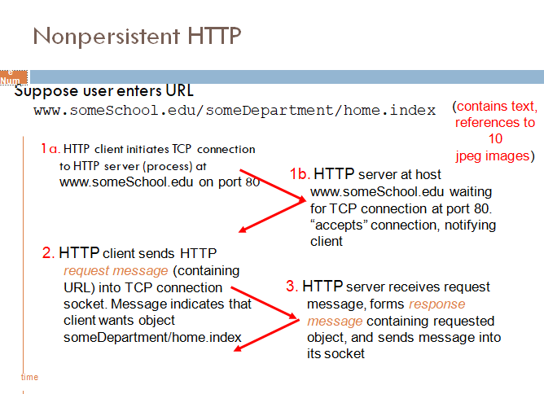

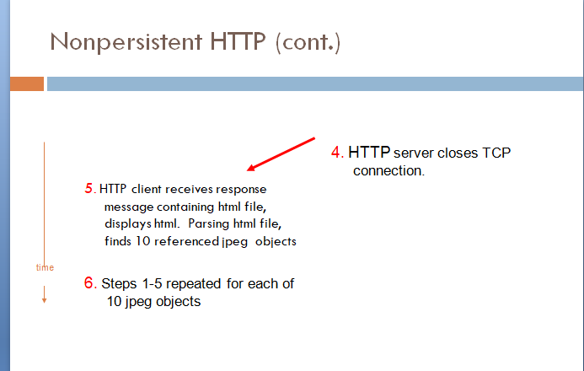

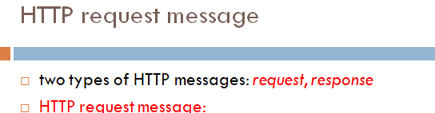

**3 . done**

**4 a.**

**Requirements** analysis, also called **requirements engineering**, is the process of determining user expectations for a new or modified product.

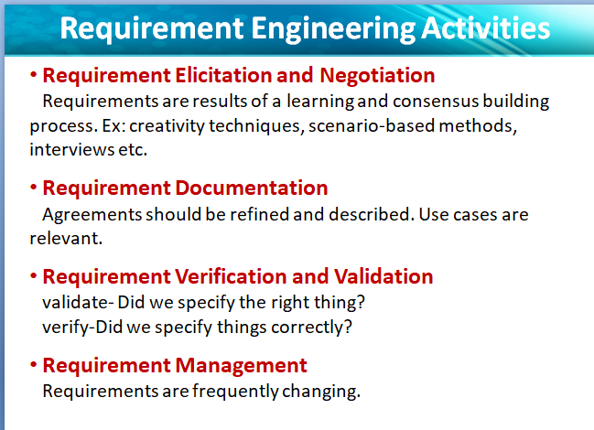

b. janina

c. janina

d. done