**NAME:** Bane, Jamewel P.

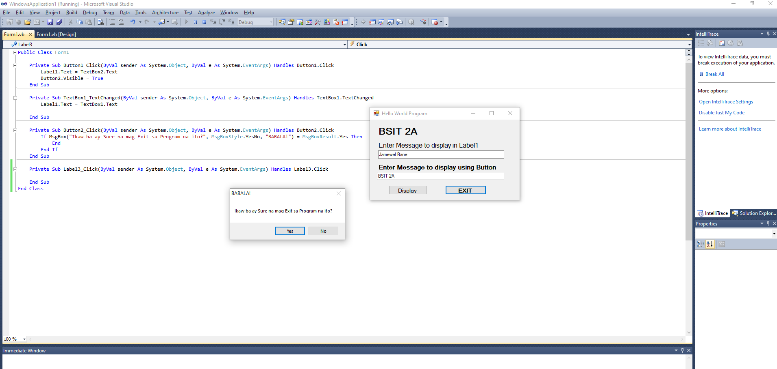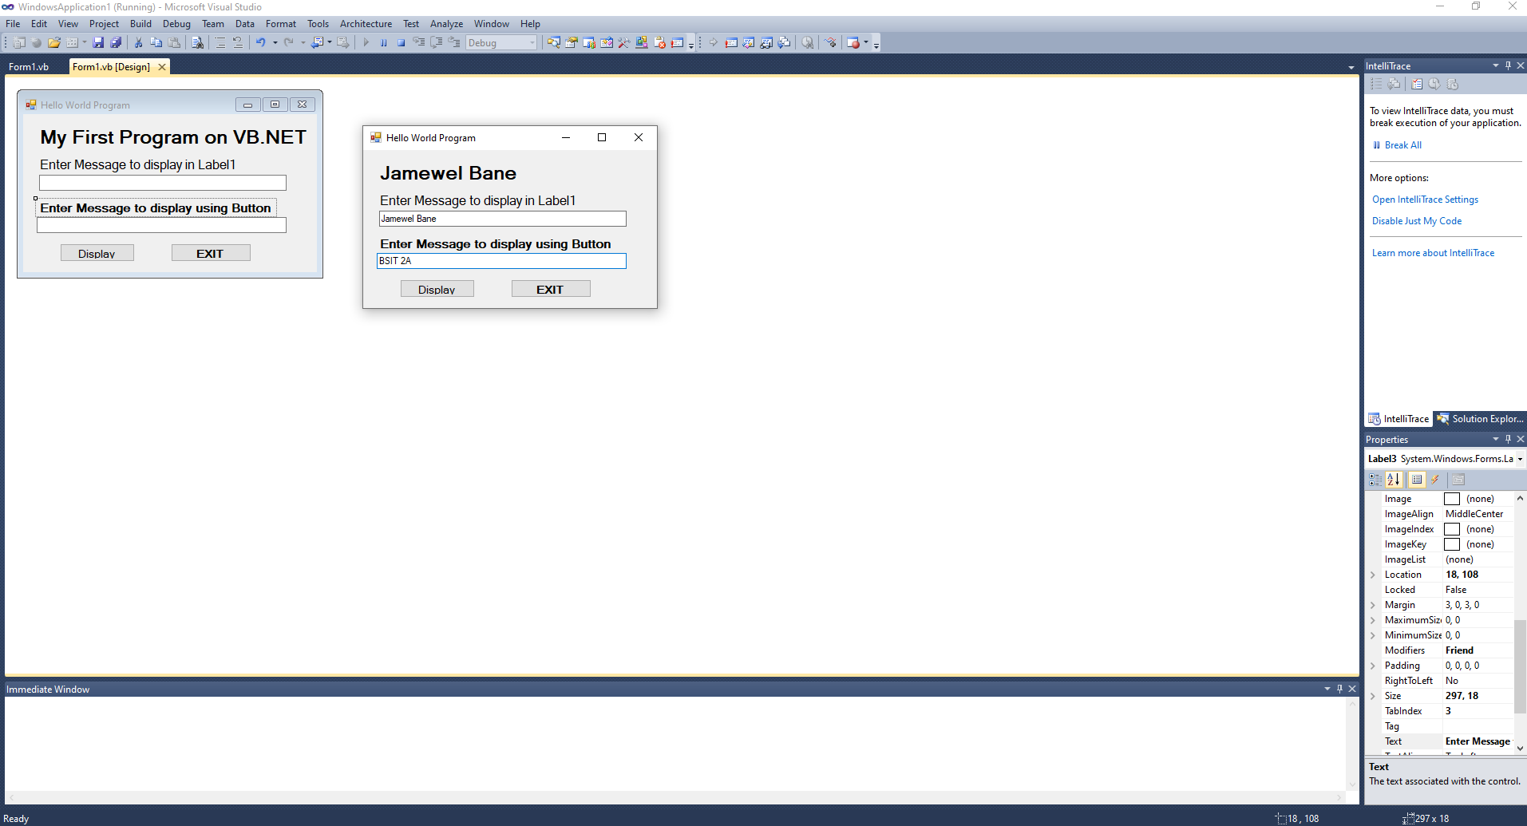**YEAR & SECTION:** BSIT – 2A