Epochs

Epochs=5

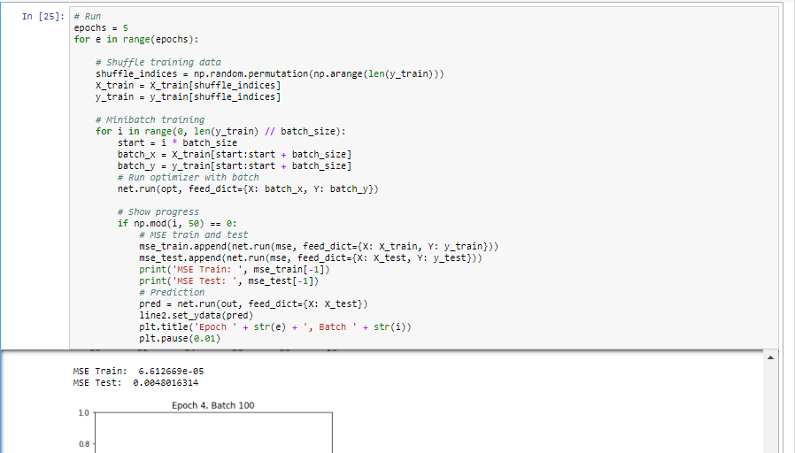



Epochs=6

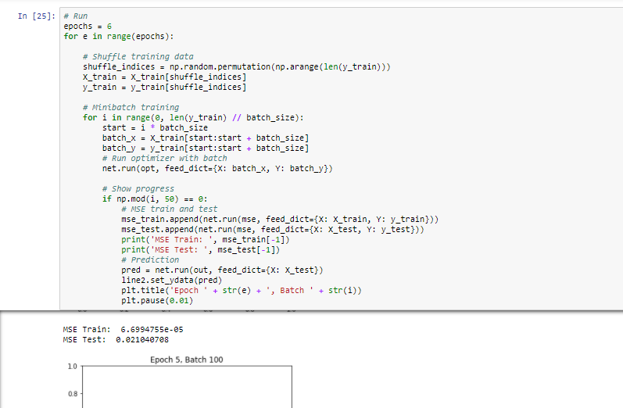



Epochs=8

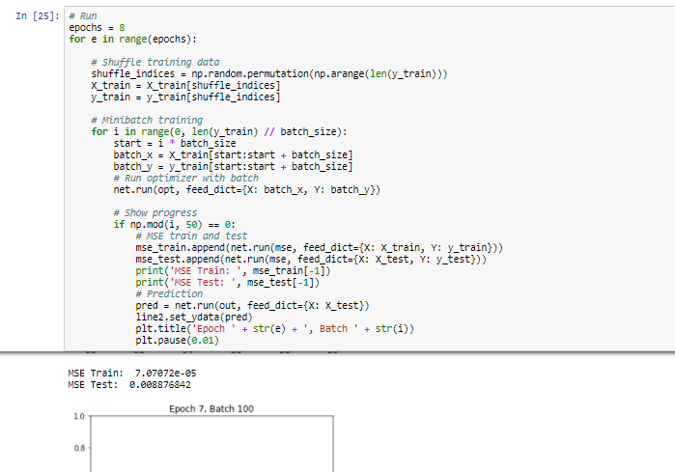



Activation Function

Relu



Elu



Tanh



SoftSign



Gradient Estimation

Adadelta Optimizer



RMSPropOptimizer

