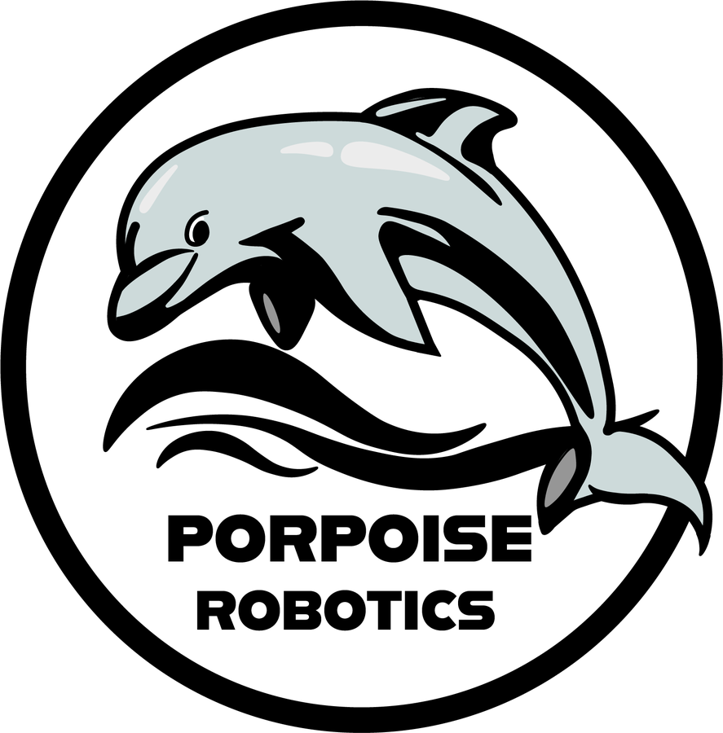
Pathfinder Explorers
A robotics course for ages 9 to 13, from Porpoise Robotics
Dear families,
Your child is joining Pathfinder Explorers, a twelve-lesson course in robotics and programming. In teams of three, students share a small four-wheel robot vehicle called a Pathfinder. Over twelve one-hour lessons they program its 32 lights, its four motors, and its wireless controller - and by the last lesson they have written the program that drives it.
No experience is needed. Everything is provided: the vehicles, controllers, laptops and batteries.

What your child will learn
• How robots sense, think and act - and how to give a computer exact instructions
• Real programming in the Arduino language: loops, choices, variables and functions
• Light and color, how motors work, and why Mars rovers have to drive themselves
• How engineers work: plan, build, test, and fix one thing at a time - as a team

Course details
Dates | [DATES]
Time | [START AND END TIME]
Location | [ROOM AND ADDRESS]
Instructor | [NAME]
Contact | [EMAIL] [PHONE]
Mission Day | Families are invited to Lesson 12, on [DATE AND TIME], to watch the teams drive the final course.

Safety
Every student learns and signs the Explorer Code in the first lesson. Vehicles sit on a stand whenever they are connected to a laptop, and drive only on the floor inside a taped arena. Students earn their speed: every vehicle starts at a reduced learner speed, raised only after a driving test. The vehicles run on rechargeable lithium batteries, which only adults charge or handle.

What to wear
Closed-toe shoes, and long hair tied back. Please avoid loose scarves or dangling cords - the wheels turn during some activities.

At home
Each student keeps a Mission Log: a workbook with a page for every lesson and a badge to earn each time. Ask your child to show it to you, and to explain one thing they programmed. Explaining is one of the best ways to learn.

Three short questionnaires
At the start of the course, halfway through, and at the end, students spend a few minutes on a questionnaire about what they know, how confident they feel, and which lessons they enjoyed. It is not a test and is never graded. Students write a code instead of their name, and the answers are used only to see how the class is growing and to improve the course.

Photos
[Delete this section if your organization uses its own photo release.] We would like to photograph the vehicles and the course for future lessons. We will only photograph your child with your permission. Please return the slip below.
We look forward to working with your Explorer!
[INSTRUCTOR NAME], for the Porpoise Robotics team
- - - - - - - - - - - - - - - - - - - - cut here - - - - - - - - - - - - - - - - - - - -
Student's name: |  | Grade:

☐ Yes, photos that include my child may be used for Porpoise Robotics lessons and materials.
☐ No photos of my child, please.
Parent or guardian: |  | Date:

