

**ASSUMPTION UNIVERSITY**

**FACULTY OF ENGINEERING**

REPORT

**EE3705:** Microprocessor and Microcontroller

**Class Project: Automatic Watering System for Smart Farm**

**Submitted to** **:** A. Sunphong Thanok

**ฃ**

1. **TOPIC**

**Automatic Watering System for Smart Farm**

1. **Introduction**

Currently, Thailand has a large population, causing increased consumption of various foods such as rice, vegetable gardens, etc. The group of farmers who grow vegetable gardens each year is less Because planting requires much space and is maintained all the time, such as watering, fertilizer and water spraying, or a fogging system for cooling. To reduce the problem of taking care of the vegetable garden of the farmers. Therefore, this project focused on designing and applying the automatic embedded brain system for irrigation, fertilizer, and water spray systems. The microcontroller is used to set various parameters, such as working times and data records. The microcontroller ESP32 is used to read the configuration data from the Blynk application by using a mobile application, which does analysis, receives data from all sensors, and controls all the systems.

1. **Material**

STM32F4

ESP32

Matlab

Arduino

Blynk Application

Line Application

1. **SOURCE CODES AND RESULTS**

program in STM32F4 with Matlab and ESP32 with Arduino:

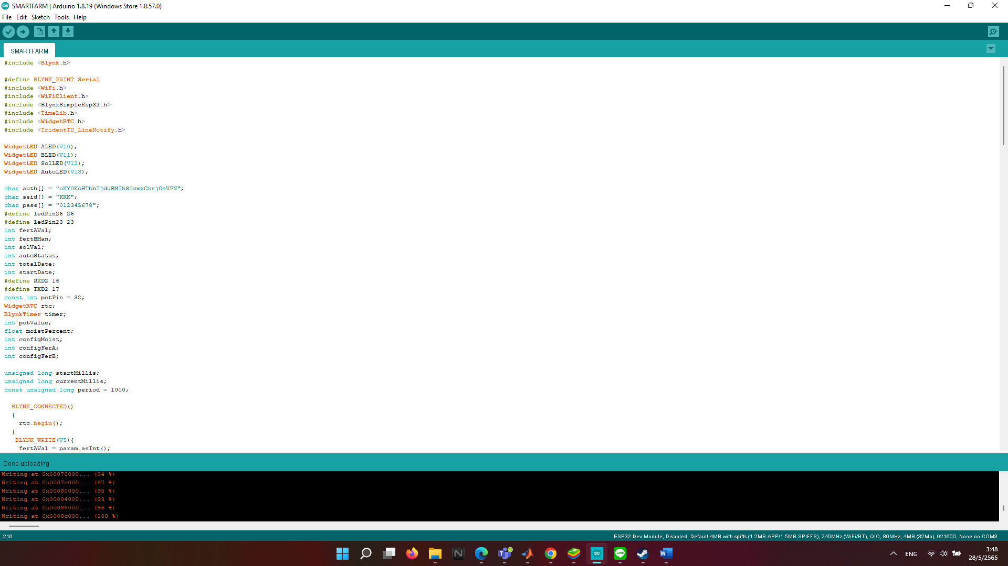

Set the parameter for a smart farm by Blynk Application:

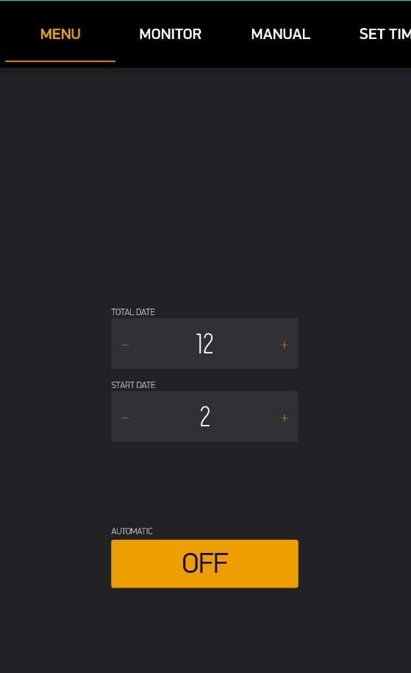

In this page users can set the total date and start date for the project Users can also turn on Automatic mode here. However, it is not working

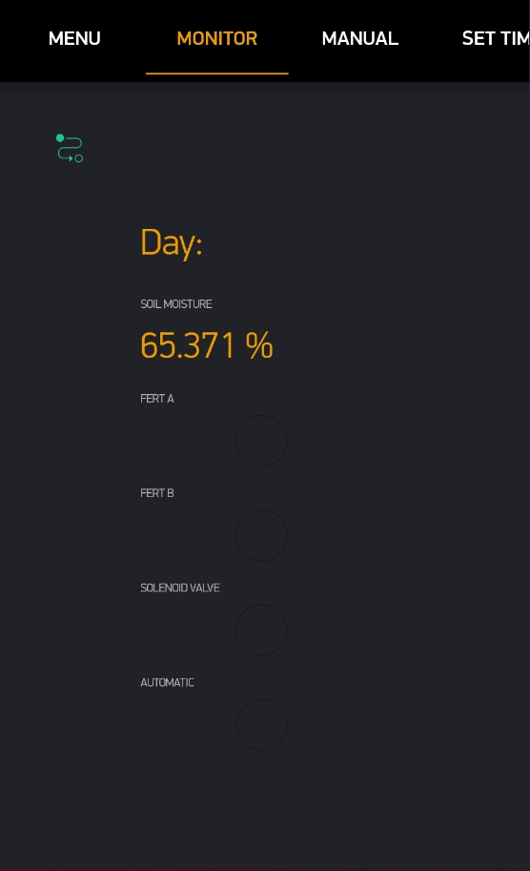

This page user can monitor and check the status of the Farm

Day: Show the day of the month

Soil Moisture show Moisture percentage

And all the LED will turn on when it is on

The Soil moisture and LEDS will also show in STM32F4

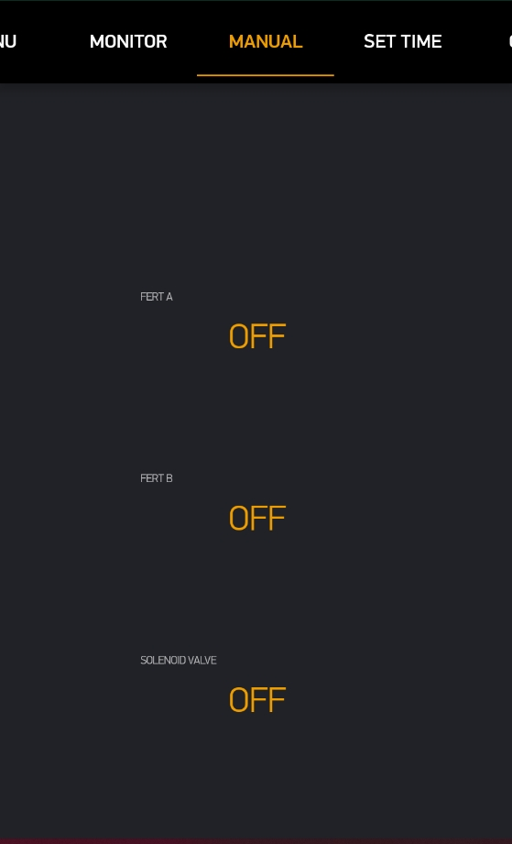

When user pressed the button LED in monitor page and STM32F4 will turn on

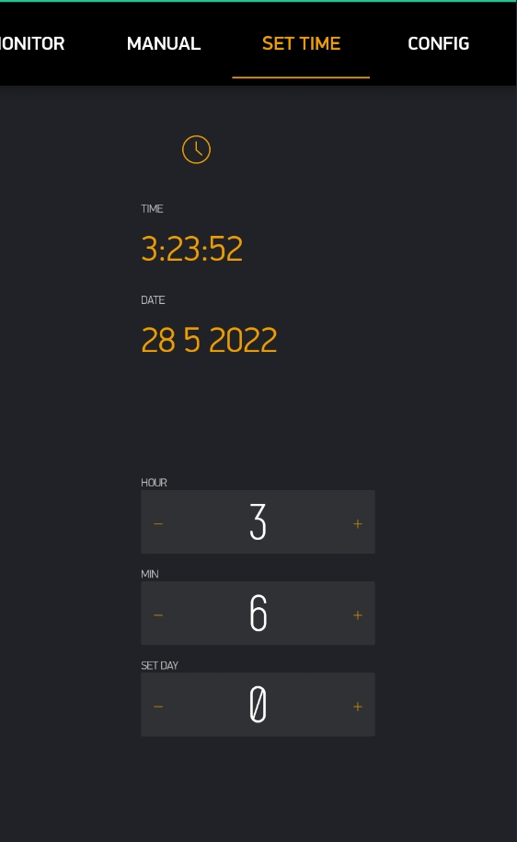

This page uses the RTC to get current time and current date

User can adjust the hour and minute and day in with the widget below

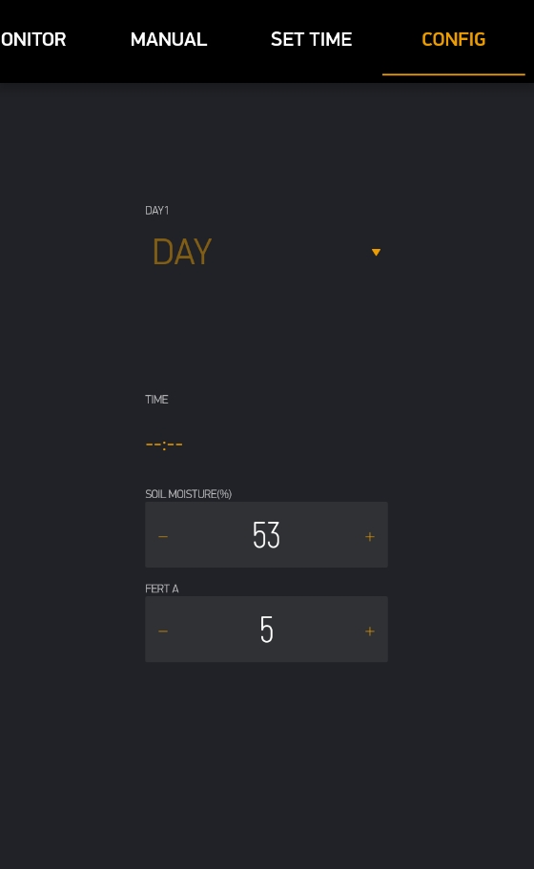

User can set the day and select related values for each day.

**LINE Notify:**

LINE NOTIFY WILL SEND a notification

WHEN

FERTILIZER OR SOLENOID VALVE IS TURNED ON

OR when total date and start date is changed.

VDO: https://drive.google.com/file/d/1neZRWJS9DmexH-pNydCytojxXrMVnquk/view?usp=sharing