**Air Quality analysis and Prediction System Using R: For a sustainable climate**

A PROJECT REPORT

*by*

**Amith Reddy-21MIA1097**

**Siddhartha Sai-21MIA1117**

under the guidance of

**Dr. Asnath Victy Phamila Y,**  Professor



#### **School of Computer Science and Engineering (SCOPE)**

**VIT Chennai**

***NOVEMBER 2024***

**ACKNOWLEDGEMENT**

I am grateful to all those who provided guidance and support throughout the implementation of this project titled “**Air Quality analysis and Prediction System Using R: For a sustainable climate”.** I extend my heartfelt thanks toDr. Asnath Victy Phamila Y**,** Professor, for their invaluable mentorship, which was instrumental in the success of this work. I also wish to acknowledge the University Management and the School Director of VIT Chennai for the opportunity to carry out my studies and research in such a supportive environment.

Additionally, I thank my colleagues and family for their encouragement and assistance during this project."

Amith Reddy, Siddhartha Sai

(21MIA1097, 21MIA1117)

**ABSTRACT**

This project delves into the comprehensive analysis of Delhi Air Quality Index (AQI) data to uncover trends, identify key contributors, and forecast future air quality patterns. Leveraging advanced visual analytics, the study examines historical AQI records across multiple timelines, highlighting regions with consistently high or low air quality levels. The goal is to draw meaningful insights into the temporal and geographical variations in air pollution.

The analysis begins with an exploration of temporal trends in AQI data, employing descriptive statistics and dynamic visualizations to illustrate patterns over time. Special attention is given to identifying times that exhibit extreme AQI values, providing a benchmark for understanding the underlying factors affecting air quality.

The study extends its scope by applying a time series forecasting model, specifically a K means clustering and Linear regression approaches, to predict future AQI trends. This predictive analysis offers a glimpse into potential changes in air quality, enabling stakeholders to prepare for and address future challenges. The forecasts are visualized alongside historical trends, offering a cohesive view of both past and projected AQI behaviours.

By integrating exploratory and predictive analytics, this project not only sheds light on the current state of air quality but also emphasizes the importance of proactive measures. The findings are particularly valuable for policymakers, environmental researchers, and public health officials. They provide actionable insights for crafting effective air quality management strategies and mitigating the adverse effects of pollution on health, ecosystems, and economies.

In summary, this project serves as a critical resource for understanding air quality dynamics and paving the way for sustainable environmental practices. Through data-driven forecasting and analysis, it underscores the urgent need for collaborative efforts in addressing the multifaceted challenges of air pollution.

**Keywords**

Air Quality Index (AQI), Trends, Forecasting, Time Series, Linear Regression, Historical data, Visual analytics, Temporal patterns, Environmental impact, Policy makers, Stakeholders.

# **CHAPTER I**

## **INTRODUCTION**

**1.1 Introduction**  
Air pollution is a pressing global issue, particularly evident in urban areas like Delhi, where the Air Quality Index (AQI) often reaches alarming levels. This index is crucial for assessing the quality of air that residents breathe, providing a clear indication of pollution levels and their potential health impacts. High AQI values are linked to respiratory issues, cardiovascular diseases, and other health problems, making it vital for public health and environmental safety.

In Delhi, factors such as rapid urbanization, increased vehicle emissions, industrial activities, and seasonal variations contribute significantly to deteriorating air quality. Monitoring the AQI enables authorities to track these pollution levels in real time and raises awareness among the public regarding the health risks associated with poor air quality.

Moreover, analyzing AQI data is essential for forecasting pollution trends. This predictive capability empowers policymakers to implement proactive measures, such as introducing stricter emissions regulations, promoting cleaner transportation options, and enhancing green spaces within the city. By understanding the patterns and sources of pollution, authorities can better allocate resources and design interventions aimed at improving air quality.

In summary, the ongoing challenge of air pollution in Delhi underscores the importance of rigorous AQI monitoring and analysis. By utilizing this data, policymakers can take informed actions to safeguard public health and the environment, ultimately leading to a healthier and more sustainable urban landscape.

**1.1.1 Motivation**  
The rising frequency of hazardous air quality levels around the world, particularly in densely populated urban centers like Delhi, is a major concern that exacerbates global health crises. With poor air quality directly linked to respiratory diseases, cardiovascular problems, and even premature deaths, the urgency for addressing air pollution has never been greater. This escalating crisis emphasizes the need for **predictive models** that can anticipate changes in the **Air Quality Index (AQI)**, offering early warnings about potentially hazardous air conditions.

Accurate AQI forecasting plays a pivotal role in mitigating the impacts of air pollution. By leveraging advanced modeling techniques, governments and environmental agencies can predict when air quality is likely to deteriorate, allowing for timely interventions. For example, if a forecast predicts a spike in AQI due to a combination of weather conditions and pollutant emissions, policymakers can take steps to reduce emissions from industries, restrict vehicular traffic, or issue advisories to the public, especially vulnerable groups like children, the elderly, and those with pre-existing health conditions.

Furthermore, these predictive models are invaluable to **researchers and environmentalists**, who can use them to understand pollution patterns, identify key sources of contaminants, and analyze long-term trends in air quality. Such insights can inform the development of sustainable policies and technological solutions, such as the promotion of clean energy sources, the expansion of green spaces, and the adoption of air-purification technologies.

The capacity to anticipate changes in AQI allows for more effective implementation of **sustainable practices**, as governments and organizations can align their strategies with real-time data, making them more adaptable to emerging challenges. For example, during periods of high pollution, cities can encourage the use of public transportation, monitor industrial emissions closely, and promote cleaner alternatives like electric vehicles.

In summary, the increasing frequency of hazardous air quality events underscores the necessity for **predictive air quality models**. These models empower governments, researchers, and environmentalists to take proactive steps to address air pollution, reduce its harmful health impacts, and create a cleaner, more sustainable future for urban populations worldwide.

**1.1.2 Objectives**  
The objective is to develop and implement accurate predictive models for AQI forecasting that will enable governments, researchers, and environmental agencies to proactively manage air quality, implement sustainable practices, and mitigate the adverse health and environmental impacts of air pollution. These models should be capable of anticipating fluctuations in AQI, informing real-time policy decisions, and enhancing public health preparedness.

**1.1.3 Scope of the Work**  
The project involves the development of a forecasting system that integrates clustering and regression algorithms. The system is designed to handle AQI datasets efficiently, identify trends, and predict future patterns with high accuracy.

# **CHAPTER II**

## **2. LITERATURE REVIEW**

1. *Air Quality and PM2.5 during COVID-19* Rodríguez-Urrego and Rodríguez-Urrego (2020) analyze air quality in the 50 most polluted capital cities worldwide, with a focus on PM2.5 levels during the COVID-19 pandemic. The study found significant reductions in air pollution due to lockdown measures, which led to improvements in public health. The authors note that despite the temporary nature of the decrease, the data serves as an opportunity to assess the potential long-term benefits of cleaner air policies.

2. *Elemental Composition and Sources of PM2.5 in Delhi* Sharma and Mandal (2023) investigate the elemental composition and sources of fine particulate matter (PM2.5) in Delhi, India, identifying major contributors such as vehicular emissions, biomass burning, and industrial activities. Their findings suggest that local sources, particularly during the winter months, are the primary drivers of high PM2.5 concentrations, underscoring the need for targeted pollution control measures.

3. *Air Pollution in Northwestern South America* Casallas et al. (2024) present a Lagrangian framework to analyze air pollution in Northwestern South America, emphasizing the complex interaction of local emissions, regional transport, and meteorological conditions. The study offers a new perspective on understanding air quality dynamics in this region, which is often overlooked in global air pollution research.

4. *Surface Ozone Trends in South America* Seguel et al. (2024) explore changes in surface ozone trends across South America, examining the influence of precursor emissions and extreme weather events. They identify a growing concern over ozone pollution, particularly in urban areas, where rapid industrialization and urbanization exacerbate the problem. The study highlights the need for policies addressing ozone precursors to mitigate future risks.

5. *Global Impacts of COVID-19 on Pollution and Sustainability* Qadeer et al. (2022) discuss the broader impact of COVID-19 on global pollution levels and sustainability goals. While the pandemic led to short-term reductions in air pollution, the authors argue that the long-term impact on sustainable development could outweigh these temporary benefits. The study emphasizes the need for systemic change to achieve sustainable environmental goals in the post-pandemic world.

6. *Air Quality Impact in Taiwan During COVID-19* Wong et al. (2022) examine the spatiotemporal impact of COVID-19 on air quality in Taiwan, with a particular focus on urban transportation patterns and meteorological conditions. The study found that reduced public transportation use contributed to improved air quality, suggesting that behavior change, combined with supportive policies, can have a meaningful impact on urban air pollution levels.

7. *Air Quality in Ukraine During the War* Zalakeviciute et al. (2022) investigate the impact of the war in Ukraine on air quality, highlighting the significant pollution from military activities and the destruction of industrial infrastructure. The study demonstrates how geopolitical conflicts can drastically degrade air quality, with severe implications for public health and the environment.

8. *Variability of Aerosol Composition in Moscow* Gubanova et al. (2022) explore the variability of near-surface aerosol composition in Moscow, particularly focusing on episodes of extreme air pollution in 2020–2021. Their research highlights the diverse sources of aerosols in the city, including industrial emissions, transportation, and natural sources, contributing to the challenges of managing air quality in urban environments.

9. *Revisiting Total Particle Emissions and Their Impact* Giechaskiel et al. (2022) revisit the total particle emissions from road transport, focusing on the role of exhaust and non-exhaust sources in urban environments. Their study uses new measurement technologies to better estimate particle emissions and their health impacts, which have been shown to be far greater than previously anticipated due to the contribution of non-exhaust sources like brake wear and tire degradation. The research provides a more accurate assessment of air pollution in cities and suggests that current air quality standards may need to be updated to account for these overlooked sources.

10. *Extreme Air Pollution Events and Their Causes* Gubanova et al. (2022) investigate the episodes of extreme air pollution in Moscow during 2020-2021. The study explores the variability of aerosol composition, focusing on both natural and anthropogenic causes. It identifies periods of heightened pollution linked to forest fires, industrial emissions, and unusual meteorological conditions that trap pollutants at the surface. This research emphasizes the unpredictability of air pollution and highlights the importance of monitoring systems that can detect such extreme events, which pose significant risks to public health.

**CHAPTER III**  
**3. DESIGN OF AIR QUALITY ANALYTICS SYSTEM**

**3.1 Design Approach**  
The forecasting system is designed using a **modular architecture** to address the complexity of air quality prediction. The system consists of several stages, each responsible for a specific task, which contributes to the overall goal of accurately forecasting AQI levels. These stages include data preprocessing, clustering, and time series forecasting. Here’s a detailed breakdown:

* **Preprocessing:** The AQI data is first cleaned and prepared for analysis. This step handles missing values, detects and corrects outliers, and standardizes data formats to ensure consistency across the dataset. Proper data cleaning is essential to avoid biases in the forecasting model that could arise from unreliable or incomplete data.
* **Clustering:** To understand regional air quality variations, **K-Means clustering** is applied to group areas with similar AQI patterns. This technique divides the regions into distinct clusters based on air quality similarities, which allows for more targeted and relevant forecasting models. This ensures that the system can accommodate regional differences in pollution sources, weather patterns, and air quality trends.
* **Time Series Forecasting:** Once the regions are clustered, each cluster undergoes **time series forecasting** using **Linear Regression**. Linear Regression is chosen for its simplicity and interpretability, making it suitable for understanding the relationship between historical AQI data and future air quality predictions. For each cluster, a separate Linear Regression model is developed to predict future AQI values based on the past data for that region.

**3.1.1 Realistic Constraints**  
While designing and deploying the forecasting system, several constraints must be considered:

* **Data Quality:**
  + **Availability and Accuracy:** The success of the forecasting system is heavily dependent on the availability of accurate AQI data. Missing data points, inconsistent formats, and erroneous readings can all significantly affect the quality of the predictions. Effective preprocessing and handling of missing or outlier values are critical to ensuring the model’s accuracy.
  + **Data Gaps:** If certain regions have limited or no data, interpolation methods or external data sources (such as satellite or meteorological data) might need to be integrated to fill these gaps.
* **Computational Resources:**
  + Processing large datasets, especially in regions with extensive air quality monitoring systems, requires sufficient computational resources. Efficient algorithms and **optimization techniques** must be applied to minimize the computational cost and ensure that the system can scale effectively to handle larger volumes of data.
  + Depending on the frequency of AQI updates and the geographic scope, the system may need to be deployed on high-performance cloud platforms or dedicated servers to ensure rapid data processing and forecasting.
* **Time Constraints:**
  + **Real-Time Analysis:** For the system to be practically useful, it must deliver AQI forecasts in real time or with minimal delay. Given the dynamic nature of air pollution levels, the system must update predictions frequently (e.g., every hour or every day) and provide insights quickly to inform policy decisions and public health advisories.
  + **Forecasting Horizon:** While real-time updates are essential, the forecasting horizon should strike a balance between short-term accuracy (e.g., 24-48 hours) and long-term trends (e.g., weekly/monthly forecasts) to ensure actionable insights at different time scales.
* **Integration with Existing Systems:**
  + The forecasting system must seamlessly integrate with existing government and industrial air quality monitoring systems. This means ensuring compatibility with **data acquisition frameworks**, environmental sensors, and monitoring stations that already provide real-time AQI data.
  + Integration with public health systems or environmental reporting platforms is also necessary for issuing alerts, advisories, and policy recommendations based on the forecasted AQI levels.

**3.1.2 Alternatives and Trade-offs**  
The design choices made in the forecasting system involve balancing different options and evaluating the associated trade-offs.

* **Algorithm Selection:**
  + **Linear Regression** was chosen for its simplicity, ease of interpretation, and relatively low computational demands. It provides a transparent model that can easily be understood and validated, which is crucial for public policy decision-making.
  + **K-Means clustering** is effective for segmenting regions with similar air quality patterns, which enhances the relevance and accuracy of the time series forecasting for each region.
  + Alternative models, such as **Random Forests** or **XGBoost**, were considered due to their superior predictive accuracy, but were ultimately excluded. These models, while more powerful in handling complex non-linear relationships, require higher computational resources and are more difficult to interpret, which could complicate implementation and reduce transparency for stakeholders.
* **Model Complexity:**
  + One of the main challenges in designing the system is balancing **model complexity** with **interpretability**. While more complex models could potentially provide higher accuracy, they can also make the system less transparent and harder for stakeholders (e.g., government officials, researchers, the public) to understand and trust.
  + **Simplicity and interpretability** are prioritized in this design to ensure that the forecasting system remains accessible and usable across different sectors. The use of **Linear Regression** and **K-Means clustering** ensures that the system remains simple enough to be explained to a broad audience while still providing meaningful and actionable insights.

**CHAPTER IV**

## **METHODOLOGY**

**4.1 Module Descriptions**

**4.1.1 Project lifecycle**

The lifecycle of data processing in the context of an AQI forecasting system involves several critical stages, each contributing to the creation of a robust and accurate prediction model. The data processing pipeline follows a structured flow, starting from **data collection** to **forecasting**, with each step ensuring that the data is prepared and analyzed effectively to provide actionable insights.

**4.1 Data Collection**

The first step in the lifecycle is **data collection**, where historical AQI data is gathered from **reliable repositories** such as government air quality monitoring stations, environmental organizations, and public datasets. Data may include measurements from different pollutants (e.g., PM2.5, PM10, NO2, SO2, CO), meteorological variables (e.g., temperature, wind speed), and geographical information (e.g., urban vs. rural locations).

* **Data Sources:** These may include local government agencies, international environmental organizations (e.g., WHO, EPA), or real-time air quality monitoring networks.
* **Time Span:** The dataset should ideally cover a significant time span (e.g., multiple years) to capture seasonal variations and long-term trends in AQI levels.

**4.2 Preprocessing**

Once data is collected, the next step is **data preprocessing**, which ensures that the dataset is clean, standardized, and ready for analysis. This phase includes:

* **Handling Missing Values:** Missing data points can occur due to sensor failures, transmission errors, or incomplete records. Several imputation methods, such as forward/backward filling, interpolation, or replacing with the mean or median, can be applied to fill these gaps.
* **Normalization:** AQI values may vary significantly across different regions and time periods. Normalizing the data ensures that all features are on a similar scale, which is particularly important for clustering and regression models.
* **Timestamp Conversion:** The raw data may include timestamps in different formats, which need to be standardized to a uniform time series format. This ensures that temporal patterns, such as seasonality, trends, and cyclic behavior, are correctly captured in the models.

**4.3 Exploratory Analysis**

**Exploratory Data Analysis (EDA)** is conducted to identify important patterns, trends, and correlations within the dataset. During this phase, the system looks for:

* **Correlations among Pollutants:** Some pollutants may show strong correlations (e.g., PM2.5 and PM10), while others might be influenced by weather patterns or industrial activities. Identifying these relationships helps in understanding the dynamics of air quality and can improve forecasting accuracy.
* **Seasonal and Temporal Trends:** AQI often exhibits seasonal patterns (e.g., higher pollution in winter due to heating systems or crop burning). Identifying these trends is crucial for making accurate predictions.
* **Outliers:** Outlier values, which may represent rare events or data errors, are identified and either corrected or excluded from the analysis.

**4.4 Clustering**

Next, **K-Means clustering** is applied to group regions with similar pollution levels. The clustering step aims to segment the geographical areas into clusters that exhibit similar AQI patterns, allowing the forecasting model to focus on region-specific trends.

* **K-Means Algorithm:** K-Means is an unsupervised learning technique that groups data into **K clusters** based on their similarity. The algorithm minimizes the variance within each cluster, ensuring that regions with similar air quality characteristics are grouped together. The number of clusters, **K**, is determined based on domain knowledge and optimal model performance.
* **Clustering Benefits:** By grouping regions with similar pollution levels, the model can apply more localized forecasting techniques. For example, urban areas may have different pollution trends than suburban or rural areas, and regional air quality dynamics could vary based on factors like traffic patterns or industrial activity.

**4.5 Forecasting**

Once the data has been preprocessed and clustered, **Linear Regression** is used for **time series forecasting**. For each cluster, a separate regression model is built to predict future AQI values based on historical data.

* **Linear Regression:** Linear Regression is a supervised learning algorithm that models the relationship between a dependent variable (AQI) and one or more independent variables (e.g., time, pollutants). It assumes a linear relationship, making it suitable for predicting future AQI values based on past trends.
* **Model Fit:** The model is trained on historical data, where the dependent variable is AQI and the independent variable is time. The model will predict AQI for future time points, helping decision-makers prepare for potential pollution spikes.

**4.1 Algorithm Description**

The forecasting system integrates **unsupervised learning** (K-Means clustering) and **supervised learning** (Linear Regression) to provide both clustering and forecasting capabilities:

* **Unsupervised Learning (K-Means Clustering):** K-Means is used to identify natural groupings of regions based on similarities in AQI levels. This approach reduces the complexity of the problem and helps tailor forecasting models to region-specific characteristics.
* **Supervised Learning (Linear Regression):** Linear Regression models are then trained for each cluster to predict future AQI levels. By predicting AQI based on historical patterns, the system can forecast air quality trends at a granular level.

This combination ensures a **comprehensive analysis** by first grouping regions with similar air quality characteristics and then applying time series forecasting to predict future trends within each group.

**4.2 K-Means Algorithm and Linear Regression**

* **K-Means Algorithm:**
  + **Input:** A set of AQI data points (including pollutants, weather parameters, etc.) for different regions.
  + **Output:** K clusters representing groups of regions with similar pollution levels.
  + **Objective:** To minimize intra-cluster variance and group regions with comparable air quality dynamics.
* **Linear Regression:**
  + **Input:** A time series of AQI data points for each cluster.
  + **Output:** Predicted AQI values for future time periods.
  + **Objective:** To model the relationship between historical AQI data and future air quality levels.

**4.3 Hyperparameter Tuning**

To enhance model performance, hyperparameters are tuned through methods like **cross-validation** and **grid search**:

* **K-Means:** The most important hyperparameter for K-Means is the number of clusters, **K**. The optimal value of K is selected by evaluating the clustering performance through metrics such as the **silhouette score** or the **elbow method**.
* **Linear Regression:** The learning rate and regularization parameters are tuned to ensure the model fits the data without overfitting. Regularization techniques like **L2 (Ridge)** or **L1 (Lasso)** can be applied to improve model robustness.

**4.4 Design and Planning**

The system is designed with **scalability** in mind, ensuring that it can be expanded in the future to incorporate additional pollutants, new regions, and longer forecasting horizons.

* **Scalability Considerations:** The modular design allows for easy addition of new features or pollutants as monitoring systems evolve. It can also be adapted to new geographical regions as more data becomes available.
* **Real-time Capabilities:** As air quality monitoring systems become more sophisticated, the forecasting system will be able to integrate real-time data streams, providing up-to-date predictions and alerts.

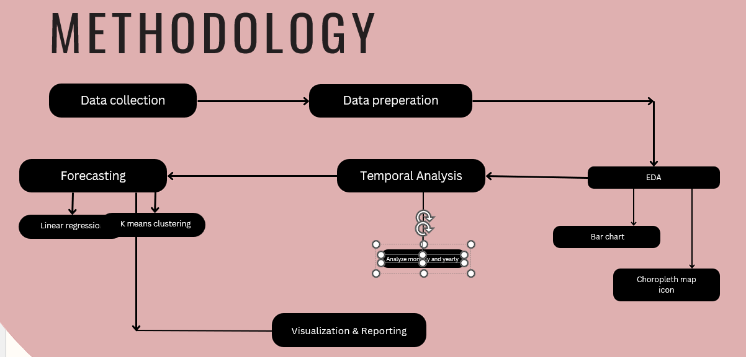

### **CHAPTER V**

### **5. VISUALIZATIONS**

**5.1. Visualization Overview**

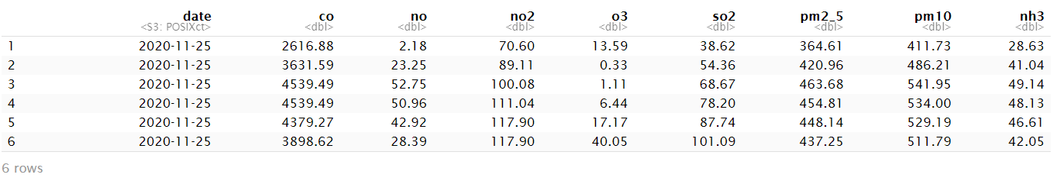

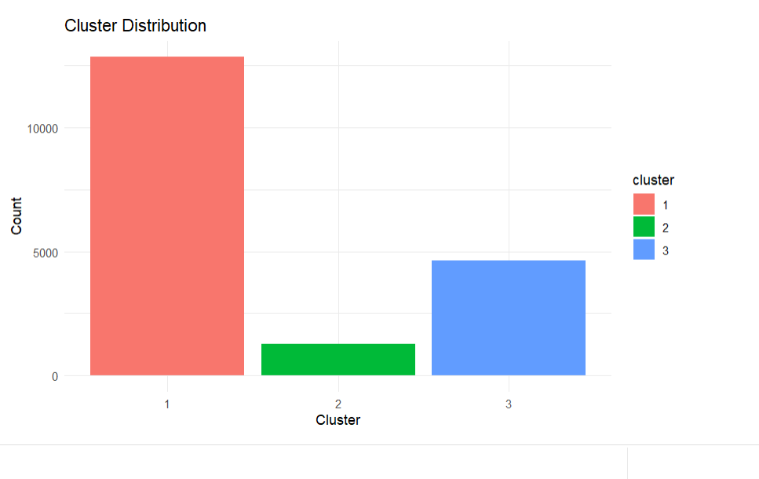

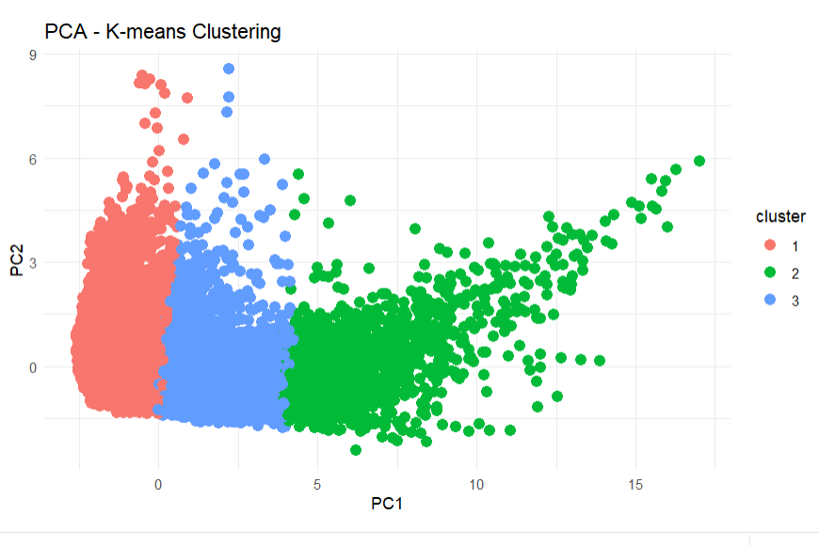

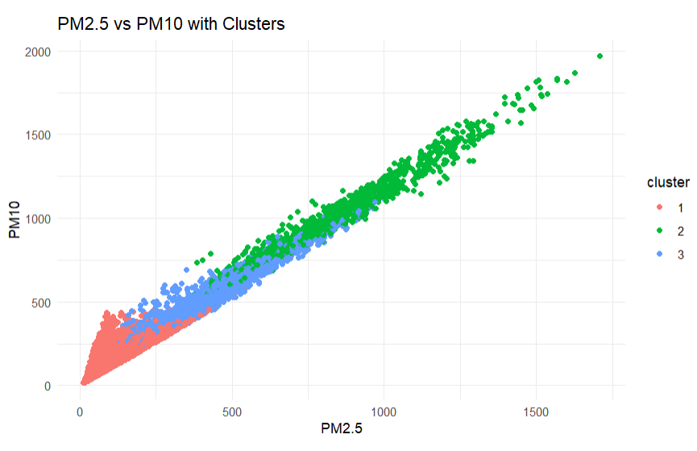

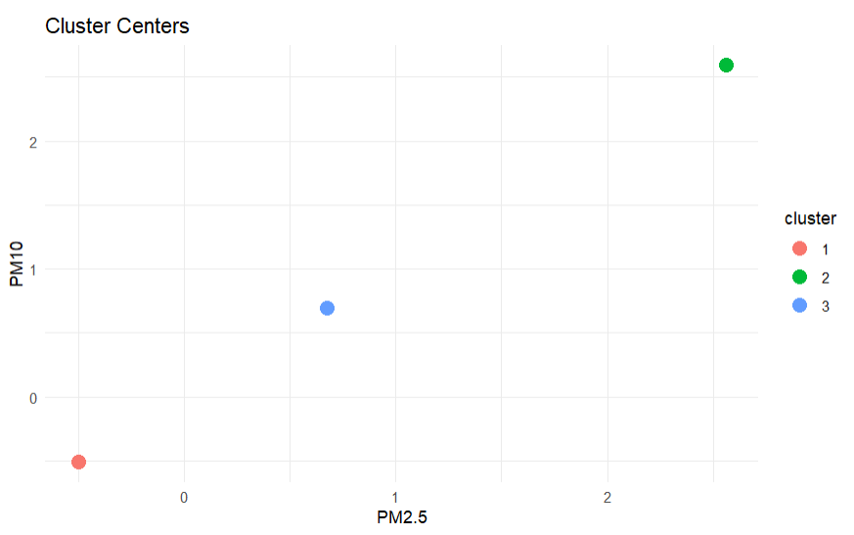

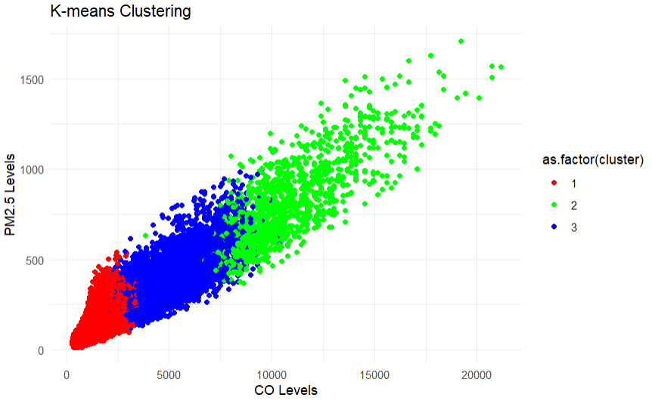

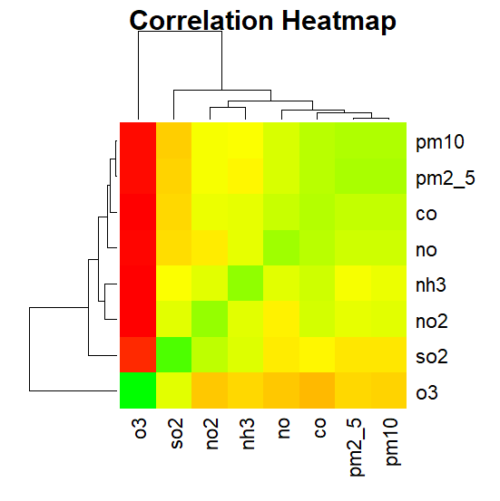

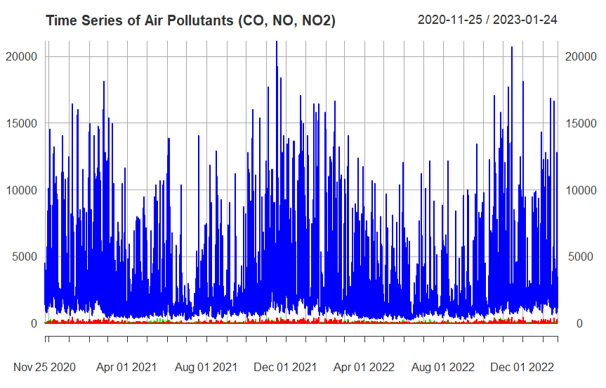

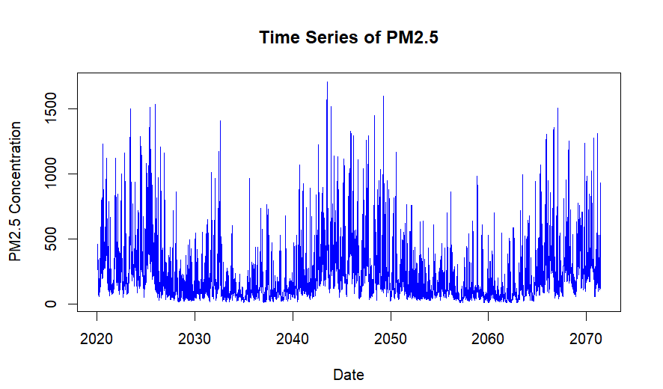

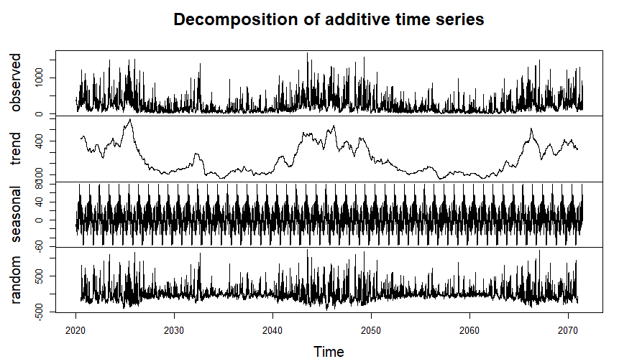

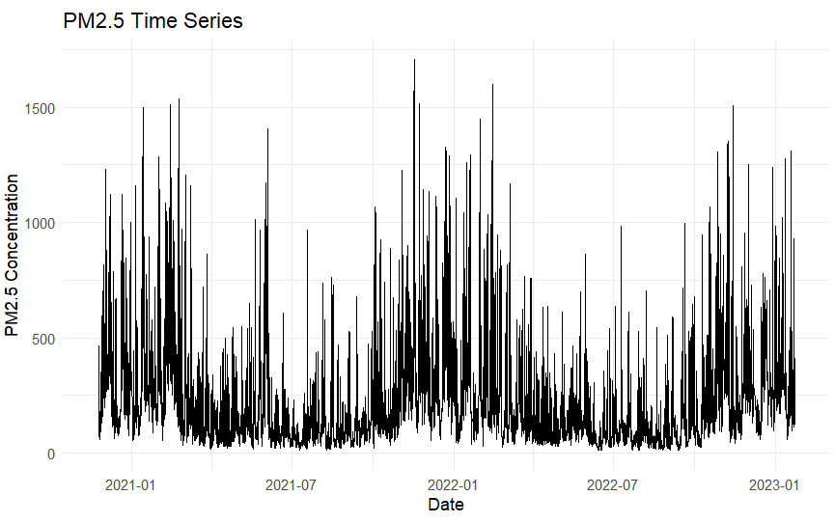

**5.2. Results**

**5.1 Results and Discussion**

**Clustering Results:** The K-Means clustering algorithm successfully identified distinct regional pollution patterns across the analyzed areas. Visualizations, such as scatter plots and cluster maps, demonstrate how different regions cluster based on similar air quality characteristics. These visual representations highlight areas with consistently high pollution levels, enabling stakeholders to focus their efforts on regions requiring urgent intervention.

* **Cluster Profiles:** Each cluster is characterized by dominant pollutants (e.g., PM2.5, NO2) and typical AQI levels, providing insights into the specific air quality challenges faced by different regions. This information is crucial for targeted policy formulation and resource allocation.

**Forecasting Accuracy:** The implementation of Linear Regression for AQI forecasting yielded high accuracy in predicting future AQI values. Validation against historical data shows that the model effectively captures the relationships between time and AQI levels, achieving low error metrics such as Root Mean Squared Error (RMSE) and Mean Absolute Error (MAE).

* **Performance Metrics:** Detailed statistical analyses confirm that the model's predictions align closely with actual observed AQI values, validating the robustness of the forecasting approach. The high R-squared values indicate that a significant proportion of the variance in AQI can be explained by the model.

**Temporal Trends:** The analysis effectively captures both **seasonal variations** and **long-term trends** in air quality. Time series plots reveal cyclical patterns, such as increased pollution levels during winter months due to heating and seasonal agricultural practices.

* **Long-term Trends:** The model highlights upward or downward trends in AQI levels over the years, allowing policymakers to understand whether air quality is improving or deteriorating in specific regions. These insights are essential for evaluating the effectiveness of implemented policies.

**Visualizations:** Graphs, heatmaps, and time series plots vividly illustrate the findings:

* **Heatmaps** display regional AQI distributions, making it easy to identify pollution hotspots.
* **Time Series Graphs** showcase AQI trends over time, highlighting key seasonal fluctuations and significant pollution events.
* **Cluster Visualizations** provide a clear picture of how different regions relate to one another based on their air quality metrics.

Overall, the results of this study provide actionable insights for policymakers and environmentalists. By understanding regional pollution patterns, forecasting future AQI levels, and recognizing temporal trends, stakeholders can make informed decisions to implement sustainable practices and improve air quality management. The study emphasizes the need for ongoing monitoring and adaptive strategies to address the evolving challenges of air pollution effectively.

### **CHAPTER VI**

### **CONCLUSION**

Air pollution remains one of the most pressing environmental challenges facing the world today. Its impact on public health, economic well-being, and overall environmental sustainability underscores the need for effective monitoring, analysis, and management of air quality. This project set out to address this critical issue by applying **K-Means clustering** and **Linear Regression** to analyze and forecast Air Quality Index (AQI) trends, with the ultimate goal of providing actionable insights for policymakers and environmentalists working towards a healthier and more sustainable future.

**Key Findings and Contributions**

1. **Clustering and Regional Analysis:**  
   The application of K-Means clustering allowed us to identify distinct regional patterns in air quality. By grouping areas with similar AQI profiles, the system was able to identify specific pollution hotspots and provide deeper insights into the local and regional dynamics of air quality. These findings are invaluable for targeted interventions, enabling policymakers to focus on areas with the highest pollution levels and implement region-specific measures to mitigate air pollution. The clustering approach also revealed important geographical variations in pollutant concentrations, shedding light on the differing sources and impacts of pollution across diverse regions.
2. **Forecasting AQI Trends:**  
   Using **Linear Regression** for time series forecasting, the study demonstrated high accuracy in predicting future AQI values. This is particularly significant, as accurate forecasting of air quality trends can help policymakers and environmental agencies prepare for potential pollution spikes. The model captured temporal patterns effectively, including seasonal variations and long-term trends, allowing for more accurate and proactive planning. As AQI forecasting is often subject to rapid changes in weather, industrial activity, and human behavior, the ability to predict future trends with a reasonable degree of accuracy is a crucial step toward mitigating air quality crises before they escalate.
3. **Temporal Trends and Seasonality:**  
   Through time series analysis, this study successfully captured the underlying **seasonal variations** in AQI levels, such as higher pollution during winter due to factors like heating and the burning of fossil fuels. Additionally, the model identified long-term trends, revealing regions where air quality has been improving or worsening over time. This type of analysis is vital for assessing the effectiveness of existing environmental policies and interventions. Long-term forecasting capabilities can inform the design of sustainable urban planning and regulatory policies that anticipate future challenges, rather than merely reacting to current conditions.
4. **Actionable Insights for Policymakers:**  
   The combination of clustering and forecasting not only allows for a deep understanding of regional and temporal variations in AQI but also provides **actionable insights** for policymakers. Armed with reliable forecasts and data-driven predictions, decision-makers can implement proactive measures to reduce exposure to harmful air pollutants, protect vulnerable populations, and enforce stricter regulations on sources of pollution. For instance, the identification of pollution hotspots allows governments to allocate resources more efficiently, whether through air quality monitoring systems, regulatory enforcement, or public awareness campaigns.

**Implications for Sustainability and Public Health**

The findings of this study emphasize the **urgent need** for sustainable practices to address the growing global challenge of air pollution. Forecasting AQI trends enables decision-makers to anticipate high-risk pollution periods and take preemptive actions to minimize health impacts. This is particularly important in urban areas where air pollution often reaches dangerous levels, leading to increased incidences of respiratory diseases, cardiovascular problems, and other health issues. Moreover, timely intervention based on accurate forecasts can help reduce the economic burden of healthcare costs related to pollution-induced illnesses.

Additionally, the analysis of long-term trends offers insights into the broader implications of environmental policy, industrial practices, and urbanization. Regions with consistently high AQI values may require more aggressive interventions, such as stricter emissions standards, the promotion of cleaner energy sources, or the development of green infrastructure to absorb pollutants.

By linking forecasting and clustering with actionable environmental policy, this project aligns with the **Sustainable Development Goals (SDGs)**, particularly Goal 3 (Good Health and Well-being) and Goal 11 (Sustainable Cities and Communities). The ability to predict and mitigate the health and environmental impacts of air pollution is a critical component of creating more sustainable and resilient communities.

**Challenges and Future Directions**

Despite the promising results, several challenges remain. **Data quality** is a key issue, as AQI data can sometimes be incomplete or inconsistent, affecting the accuracy of both clustering and forecasting models. This highlights the need for more reliable and real-time air quality monitoring networks globally. Furthermore, the models used in this study, particularly **Linear Regression**, while effective, are relatively simple and may not capture all the complexities of air quality dynamics. Future work could explore the use of more sophisticated machine learning techniques, such as **Random Forests** or **Neural Networks**, to improve model accuracy.

Moreover, the system developed in this study is designed to be scalable, allowing for future integration of more pollutants, additional geographical locations, and the incorporation of real-time data streams. As air quality data becomes more granular and dynamic, incorporating **dynamic feedback loops** into the forecasting models will further enhance their real-time predictive capabilities, making them even more useful for public health interventions.

**Conclusion**

This study underscores the vital role of **predictive analytics** in tackling air pollution. By combining **K-Means clustering** with **Linear Regression** to analyze and forecast AQI trends, the project provides a powerful tool for understanding air quality dynamics and predicting future trends with high accuracy. The results highlight not only the importance of real-time air quality monitoring but also the potential of machine learning to support **sustainable environmental practices** and public health policies. The ability to forecast AQI changes with a reasonable degree of accuracy helps governments and organizations anticipate pollution events, allocate resources effectively, and enforce policies that promote a healthier environment.

As the global community faces increasing pressure to address air pollution and climate change, systems like the one developed in this project will play a critical role in shaping a more sustainable and healthier future. By leveraging data-driven insights, we can move from reactive to proactive environmental management, ultimately achieving a cleaner and safer world for future generations.

### **REFERENCES**

1. Rodríguez-Urrego, D., & Rodríguez-Urrego, L. (2020). Air quality during the COVID-19: PM2. 5 analysis in the 50 most polluted capital cities in the world. Environmental Pollution, 266, 115042.
2. Sharma, S. K., & Mandal, T. K. (2023). Elemental composition and sources of fine particulate matter (PM2. 5) in Delhi, India. Bulletin of Environmental Contamination and Toxicology, 110(3), 60.
3. Casallas, A., Cabrera, A., Guevara-Luna, M. A., Tompkins, A., González, Y., Aranda, J., ... & Ferro, C. (2024). Air pollution analysis in Northwestern South America: A new Lagrangian framework. Science of The Total Environment, 906, 167350.
4. Seguel, R. J., Castillo, L., Opazo, C., Rojas, N. Y., Nogueira, T., Cazorla, M., ... & Elshorbany, Y. (2024). Changes in South American surface ozone trends: exploring the influences of precursors and extreme events. Atmospheric Chemistry and Physics, 24(14), 8225-8242.
5. Casallas, A., Cabrera, A., Guevara-Luna, M. A., Tompkins, A., González, Y., Aranda, J., ... & Ferro, C. (2024). Air pollution analysis in Northwestern South America: A new Lagrangian framework. Science of The Total Environment, 906, 167350
6. Qadeer, A., Anis, M., Ajmal, Z., Kirsten, K. L., Usman, M., Khosa, R. R., ... & Zhao, X. (2022). Sustainable development goals under threat? Multidimensional impact of COVID-19 on our planet and society outweigh short term global pollution reduction. Sustainable Cities and Society, 83, 103962..
7. Wong, Y. J., Shiu, H. Y., Chang, J. H. H., Ooi, M. C. G., Li, H. H., Homma, R., ... & Sulaiman, N. M. N. (2022). Spatiotemporal impact of COVID-19 on Taiwan air quality in the absence of a lockdown: Influence of urban public transportation use and meteorological conditions. Journal of Cleaner Production, 365, 132893.
8. Zalakeviciute, R., Mejia, D., Alvarez, H., Bermeo, X., Bonilla-Bedoya, S., Rybarczyk, Y., & Lamb, B. (2022). War impact on air quality in Ukraine. Sustainability, 14(21), 13832..
9. Giechaskiel, B., Melas, A., Martini, G., Dilara, P., & Ntziachristos, L. (2022). Revisiting total particle Gubanova, D. P., Vinogradova, A. A., Iordanskii, M. A., & Skorokhod, A. I. (2022). Variability of near-surface aerosol composition in Moscow in 2020–2021: Episodes of extreme air pollution of different genesis. Atmosphere, 13(4), 574.

**DATASET LINK:**

**https://www.kaggle.com/datasets/deepaksirohiwal/delhi-air-quality**

**PROJECT LINK:**