Data Mining Project
Master in Data Science and Advanced Analytics

NOVA Information Management School
Universidade Nova de Lisboa

Exploratory Data Analysis

Group 68

Diogo Reis, 20231962
João Correia, 20250384
Elton Silva, 20231976

Fall/Spring Semester 2024-2025

TABLE OF CONTENTS

1. Introduction 1
2. Data Analysis 1
2.1. Data Understanding 1
2.2. Data Quality and Insights 1
3. Feature engineering 3
3.1. Feature Engineering Overview 3
3.2. Feature Engineering Process and Insights 3
4. Conclusion 5
Appendix 6
Annexes 7
4.1. AI Usage Statement 7
4.2. Contribution Statement 7
4.3. Responsibility Statement 7

Introduction
Amazing international Airlines Inc. (AIAI) operates in one of the more competitive industries. The airline business endures constant strain from volatile fuel prices, increasing customer expectations, and competitive loyalty programs offered by both traditional airlines and low-cost competitors. In this scenario, understanding and anticipating client behavior has emerged as a critical strategic advantage. Traditional loyalty programs that reward passengers based purely on miles or expenditure are no longer sufficient, modern travelers need personalized experiences, and flexible reward systems.
To gain an edge in this competitive industry, AIAI must move from an outdated and generic marketing strategy to a segmentation-driven strategy. This new concept will allow us to differentiate customers by their economic value and travel habits. Using its massive three-year loyalty and flight-activity information, the company can identify relevant behavioral groups, such as regular long-range business travelers, price-sensitive holiday clients, or inactive member, and customize its retention and acquisition strategies appropriately.
Based on this, the project's discovery phase is organized around two research targets:
- Understand the structure and quality of AIAI's customer and flight data, identifying patterns that may indicate natural groups or abnormalities.
- To create a foundation for segmentation modeling by creating variables that reflect value further than the ones we already have such as (Customer Lifetime Value), as well as understanding the behaviors of our customer (Travel frequency, recency)

Data Analysis

Data Understanding
The data provided by AIAI consists of 2 relational sources: The Customer Database (DM_AIAI_CustomerDB.csv) and the Flights Database (DM_AIAI_FlightsDB.csv). The first contains the demographic, economic and loyalty status of around 16900 customers, whilst the second contains records of over 600000 flight records across the span of 3 years on a per month basis. Both datasets were merged using the unique Identifier (Loyalty#) – As shown in figures 1 and 2 in the appendix
The initial exploration focused on ensuring consistency across both data sources. The Customer records contain variables such as Gender, Education, Income and Marital Status. The Flight records on the other hand consisted of variables like NumFlights, DistanceKM, NumFlightsWithCompanions. After eliminating duplicate values (164 customer records and around 6000 flight records), and correcting inconsistent data types, the datasets were merged creating the df_final which consisted of 600000 observations and 29 columns.

Data Quality and Insights
Analysis of the data indicated isolated missing values in variables such as CancellationDate and Province or State, just as anticipated for inactive or abroad members. The bulk of quantitative variables had right-skewed distributions, indicating a typical loyalty-program structure in which a small number of high-value clients contribute disproportionately to total flights and points earned. Visualization outputs (histograms, boxplots and correlation heatmaps) highlighted a lot of useful information:
- A positive correlation between Customer Lifetime Value, DistanceKM and Income, which suggests that customers that earn more tend to travel longer distances and contribute more to the company’s value.
- NumFlights and PointsAccumulated showed strong relationship, demonstrating that flight frequency is till the primary driver of point accumulation.
- Outliers in PointsRedeemed and DistanceKM revealed the presence of abnormal passenger habits, which might indicate corporate or premium fliers.
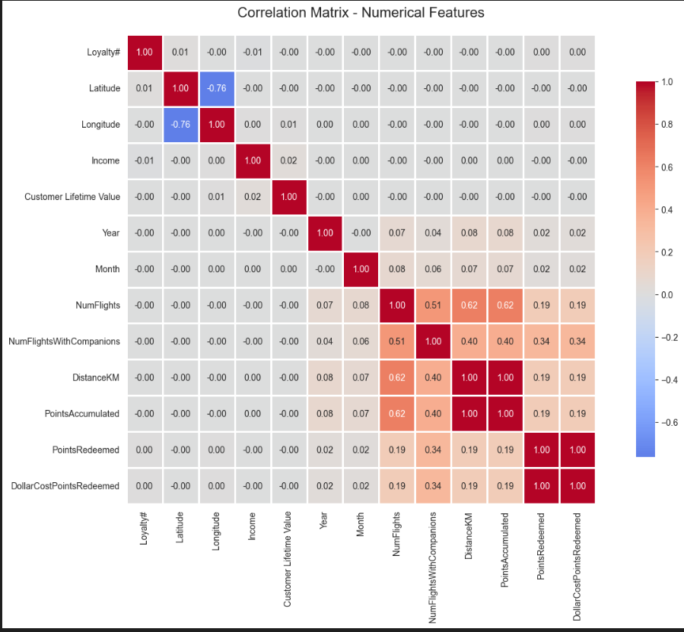
Figure 1 - Correlation heatmap
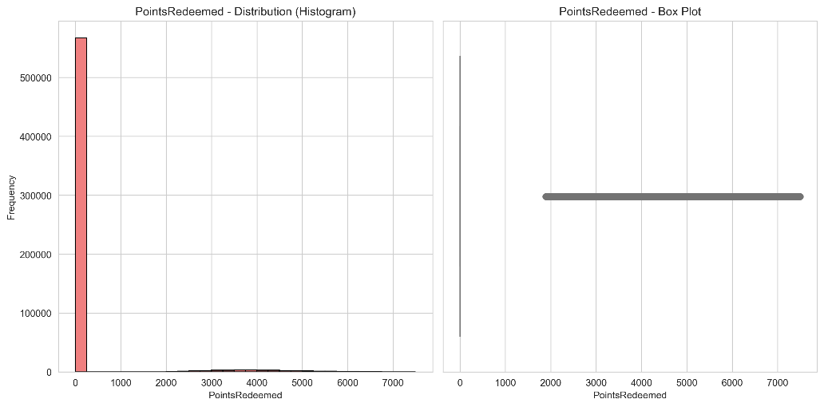
Figure 2 - Points redeemed plot
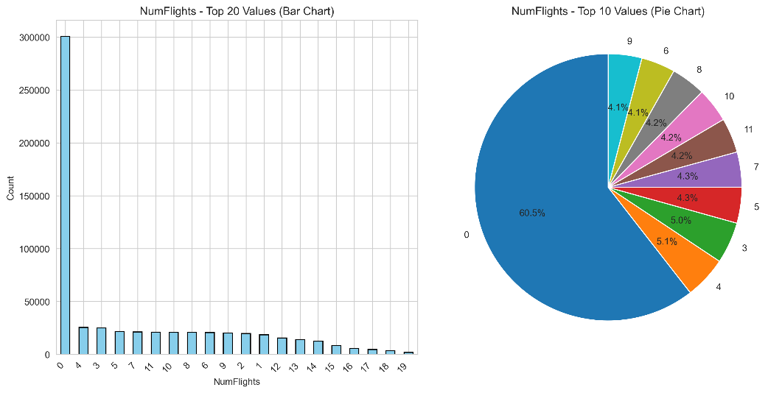
Figure 3 - Number of flights plot

Feature engineering

Feature Engineering Overview
Following the data quality analysis, we decided to create new features to help us capture deeper information and engagement patterns that aren’t directly represented in the original datasets. These new features are the following:
- Avg_km_per_flight
- Avg_points_per_flight
- Companion_ratio
- Active_days
- Months_since_flights
- Clv_per_flight
- Clv_to_salary_ratio
- Redemption_ratio
Each of these engineered features was examined using summary statistics and visual examination with plots like histograms and boxplots to ensure that their distributions were consistent and did not include false outliers or distortions that contradicted previous findings. Figure 6 in the Appendix shows that the engineered variables' distributions confirm predicted behavioral and value-based patterns across consumers. These new variables improve the dataset's interpretability, allowing for more accurate and meaningful clustering analysis in the next phase.

Feature Engineering Process and Insights
Each of the new features was computed using transformations and rations derived from already existing variables from the merged dataset, allowing therefore for deeper and richer information. Some of the formulas used to create these new features contain a + 1, to ensure mathematical stability by preventing division by zero errors.

Table 1 – Feature Construction Process
Avg_km_per_flight | DistanceKM / (NumFlights + 1) | Calculates the average distance traveled per trip, showing the distinction between short-haul commuters and long-haul passengers.
Avg_points_per_flight | PointsAccumulated / (NumFlights + 1) | Represents the efficiency of point accumulation each flight, showcasing consumers that maximize rewards with fewer flights.
Companion_ratio | NumFlightsWithCompanions / (NumFlights + 1) | Indicates social travel tendencies, separating lone business travelers from those traveling in groups or with families.
Active_days | Days between EnrollmentDateOpening and CancellationDate | Measures program duration and long-term participation.
Months_since_flight | Months since the last flight activity | Captures recency of engagement, helping identify dormant or potentially churned customers.
Clv_per_flight | Customer Lifetime Value / (NumFlights + 1) | Displays the monetary value created by each flight, differentiating premium from budget-conscious visitors.
Clv_to_salary_ratio | Customer Lifetime Value / (Income + 1) | Compares a customer's value contribution to their income, discovering aspirational spenders who spend more on travel than planned.
Redemption_ratio | PointsRedeemed / (PointsAccumulated + 1) | Measures the proportion of points redeemed, distinguishing long-term savers from frequent redeemers.

From these new variables we were able to identify the following trends:

- Travel Patterns: Customers with greater avg_km_per_flight tend to be high-income and contribute more to Customer Lifetime Value, indicating they are long-haul premium travelers. In contrast, low-distance, high-frequency fliers frequently represent domestic or commuter travelers.
- Loyalty Engagement: An inverse link was found between months_since_flight and points_balance. Active consumers collect points consistently, whereas inactive members have low balances and extended inactivity periods.
- Spending Habits: The clv_to_salary_ratio variable identified a category of aspirational travelers who have a high lifetime value compared to their income, indicating a strong emotional commitment to the brand.
- Redemption Ratio: The redemption_ratio identified two types of loyalty behavior: frequent use of points for upgrades or tickets, and long-term accumulation of large balances, indicating sustained engagement.

These newly developed features will serve as the foundation for the clustering in the project's next phase. Customers will be classified based on their behavior, engagement, and value qualities.

Conclusion
During the exploratory phase, we gained a thorough understanding of the AIAI's customer and flight data, resulting in a final database containing around 600,000 records and 29 variables. During the data quality phase, we determined that the data is right skewed in terms of loyalty distribution, with a small set of consumers contributing the majority of the revenue. Further study on new variables to help us comprehend the data was beneficial in better understanding some of the customer clusters we have, which will aid our analysis in the next phase of the project.

Appendix
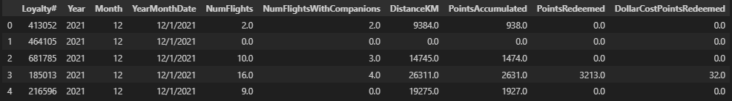
Figure 4 - Flights Records
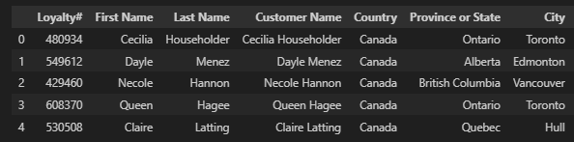
Figure 5 - Customer Records
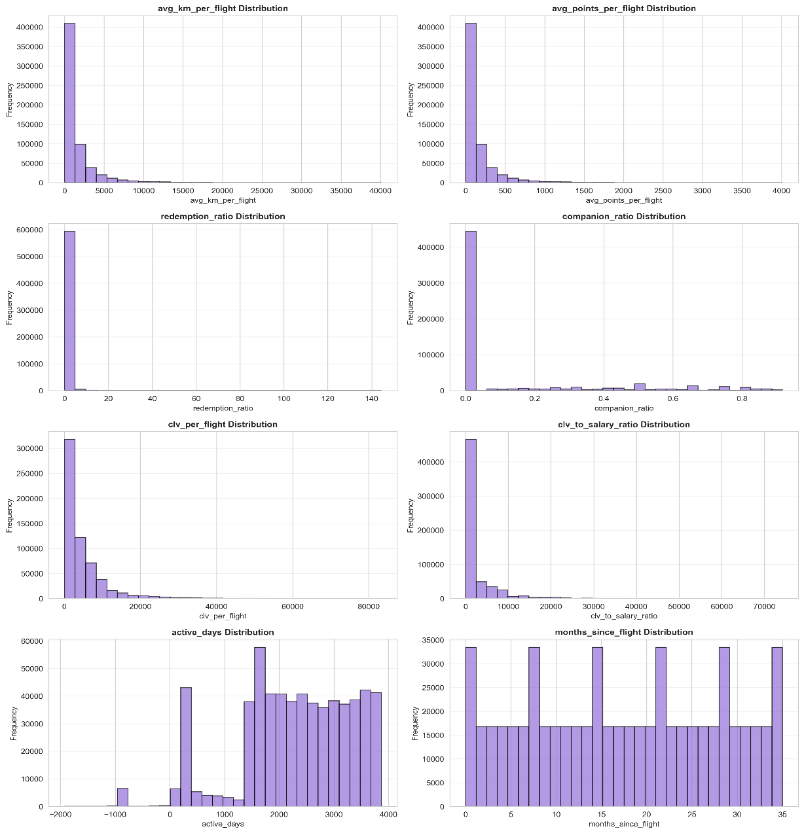
Figure 6 - Distribution of engineered Features

Annexes

AI Usage Statement
AI tools were used for coding syntax assistance, notebook markdown documentation (Github Copilot), language refinement (Quillbot) and review of analytical decisions done (ChatGPT).
All analytical insights, business interpretations, and strategic recommendations represent original group analysis and thinking.

Contribution Statement
Diogo Reis (Student ID: 20231962)
- Report and Poster
João Correia (Student ID: 20250384)
- Data Analysis
Elton Silva (Student ID: 20231976)
- Data Preprocessing and Cleaning

All members contributed to collaborative discussions and ideation.

Responsibility Statement
We, the group members listed above, certify that this report represents our original analytical work and interpretations. While AI tools were used as specified above, all insights, conclusions, and recommendations are the result of our independent analysis and critical thinking. We take full responsibility for the accuracy and quality of this submission.

