Data Mining Project
Master in Data Science and Advanced Analytics

NOVA Information Management School
Universidade Nova de Lisboa

Clustering Report

Group 68

Diogo Reis, 20231962
João Correia, 20250384
Elton Silva, 20231976

Fall/Spring Semester 2024-2025

TABLE OF CONTENTS

Table of Figures iii
1. Executive Summary 1
2. Introduction 1
3. Methodology 2
3.1. Feature Selection and Data Preparation 2
3.2. Clustering and Hyperparameter tuning 3
3.3. Multi-Method Comparison and Pipeline Implementation 4
4. Results & Validation 5
4.1. Internal Validation Metrics 5
4.2. PCA Separation & Segment interpretation 5
5. Strategic Recommendations 6
5.1. Recommendations based on Segments 6
5.1.1. High Engagement + High Value 6
5.1.2. High Engagement + Medium Value 6
5.1.3. High Engagement + Low Value 7
5.1.4. Medium Engagement + High Value 7
5.1.5. Medium Engagement + Medium Value 7
5.1.6. Medium Engagement + Low Value 8
5.1.7. Low Engagement + High Value 8
5.1.8. Low Engagement + Medium Value 8
5.1.9. Low Engagement + Low Value 9
6. Conclusion 9
Appendix A 10
Annexes 16
AI Usage Statement 16
Contribution Statement 16
Responsibility Statement 16

Table of Figures
Figure 1 10
Figure 2 10
Figure 3 10
Figure 4 10
Figure 5 11
Figure 6 11
Figure 7 11
Figure 8 12
Figure 9 12
Figure 10 13
Figure 11 13
Figure 12 14
Figure 13 14
Figure 14 15
Figure 15 15

Executive Summary
The goal of this project was to create a data-driven consumer segmentation approach for Amazing International Airlines Inc. (AIAI) by using different related approaches on customer behavior, value, and demographics. The idea is to expand beyond a simple description of the consumer's behavior and develop an understandable, actionable segmentation that can be used for targeted marketing, designing loyalty programs, and managing customer relationships.
This research starts by separating consumers into three groups: behavioral engagement (how they travel and interact with the airline), economic value (their contribution to the business), and demographics. Each perspective offers valuable insights on its own; these will later be combined into a final segmentation that takes the two most relevant components, namely customer behavior and customer value, into a single design.
The final design produced a two-dimensional grid of nine customer categories that combines three levels of engagement (low, medium, and high) with three levels of value (low, medium, and high). The groups offer unique customer profiles, ranging from highly engaged and highly valued consumers to financially important but detached customers, active but low-value customers, and completely dormant customers. Each group displays a separate pattern of contact with the airline and represents a potential, unique strategic opportunity.
These results will enable AIAI to transition from a standard customer strategy to a unique, customer-centric approach. High-value and highly engaged consumers may be prioritized for retention through premium services, tailored offers, and loyalty improvements, while medium-value segments represent opportunities for growth through focused upselling and engagement campaigns. Lower-value and disengaged groups can be handled with reactivation campaigns and limited-time discounted offers. By integrating marketing, service design, and loyalty efforts with these different customer groups, AIAI may increase client satisfaction, minimize disengagement risk, and better deploy commercial resources.

Introduction
In the first delivery of this project, the AIAI customer loyalty and flight activity data were analyzed in order to understand its structure, assess data quality, and identify meaningful patterns in customer behavior and value. This analysis showed that customers differ significantly in how often they fly, how far they travel, how engaged they are with the loyalty program, and how much value they generate for the airline. These disparities indicate that addressing all customers with the same approach is inefficient and that, going forward, in order to maximize profits, a segmentation strategy would be required. This allows the diversity of the clientele to be captured in a more organized and beneficial manner.
The second delivery builds on these findings by using clustering techniques to transform the previously observed behavioral and value patterns into structured client clusters. Rather than depending on predetermined business principles, this phase applies a data-driven approach to discover groups of consumers that behave similarly and have comparable levels of engagement and economic importance. This allows us to identify groups that are both data-supported and business-relevant.
The clustering process is based on the engineered features developed during the first delivery, which summarize key aspects of customer behavior, such as travel frequency, recency of activity, distance traveled, loyalty engagement, and value per flight. These features were identified and developed to capture client behaviors that are not readily evident in raw transactional data, leading to a more reliable basis for segmentation.
The goal of this project is not only to classify the clients into appropriate and statistically correct clusters, but also to provide insights about how to approach these clusters going forward. To achieve this, two clustering algorithms were used and compared across the different segmentation groups. The end result is a segment model that enables more targeted marketing, better loyalty program structure, and more effective customer relationship management.

Methodology

Feature Selection and Data Preparation
The clustering investigation begins with a cleaned, customer-level dataset obtained from transactional data (DM_AIAI_FinalCustomerSegments.csv, created as the first delivery final output). Because the original data is collected at the monthly activity level, records are first consolidated to the customer level using the unique identification Loyalty# to ensure that each customer is represented by a single, comprehensive record for analysis. -The selected combination techniques varied depending on each of the variables' semantic meaning: sums for activity and value variables (e.g., number of flights, points), modes for demographic variables, and minimum or maximum values for time-varying fields like last activity and enrollment.
Feature selection is based on three complementary segmentation perspectives to promote clarity and prevent combining conceptually different variables into the same space:
- Behavioral perspective:
NumFlights, avg_km_per_flight, avg_points_per_flight, months_since_flight, active_days, redemption_rate
- Value perspective:
Customer Lifetime Value, clv_per_flight
- Demographic perspective:
Income, Education, Marital Status
Although these variables were originally introduced during the first delivery, they are recalculated in this step to maintain compatibility with the final aggregate level, preprocessing choices, and scaling procedures used for clustering.
Categorical demographic data are one-hot encoded using
"X_demo_encoded = pd.get_dummies(X_demo_df, columns=["Education", "Marital Status"], drop_first=True)"
so that category membership may be represented numerically in the clustering procedure. Only demographic variables with the largest variation among cluster means are chosen for visualization and interpretation (e.g., radar plots), since they are the most discriminative and informative for segment comparison.
Finally, all numeric features are normalized with StandardScaler to assure cross-dimensional comparability, decrease the exaggerated impact of extreme values and outliers, and meet clustering algorithms' distance requirements.

Clustering and Hyperparameter tuning
This analysis uses and compares two distance-based clustering algorithms: K-Means clustering and agglomerative hierarchical clustering using Ward linkage.
K-Means: This is a centroid-based partitioning method that divides the groups into a fixed number of clusters based on distance to cluster centers. It was selected because it is computationally efficient, widely used, reliable for large datasets, and provides clear centroids that support interpretation.
Agglomerative Hierarchical: This method creates clusters by iteratively combining the most similar information using Ward linkage to reduce within-cluster variation. It was chosen as a complementary method since it does not require random initialization and produces stable, compact clusters.
The main hyperparameter tuned for both algorithms is the number of clusters (k). For each combination of feature set and clustering algorithm, a grid of [2, 10] was evaluated using internal validation metrics:
- Silhouette Score (to be maximized)
- Davies–Bouldin Index (to be minimized)
The Silhouette score was chosen as the primary criterion for selecting the optimal (k), while the other metric was used for additional context and robustness checking.
For K-Means, random_state = 42 and n_init = 20 are used to reduce sensitivity to random initialization and improve the reliability of the results. For hierarchical clustering, Ward linkage is applied with the understanding that it assumes Euclidean geometry, which further justifies the use of standardized features.

Multi-Method Comparison and Pipeline Implementation
The full pipeline follows a consistent structure:
- Load and aggregate customer data.
- Engineer and select features per perspective.
- Encode and scale features.
- Evaluate clustering performance across algorithms and (k).
- Fit final models using the selected configuration.
- Interpret and export results.
This process is executed separately for each segmentation perspective (behavioral, value-based, and demographic) and for each clustering algorithm, allowing systematic comparison across methods.
The results are organized into analysis tables and metric plots. Cluster separability is visually evaluated using two-dimensional PCA projections. Radar charts are used to demonstrate how clusters differ on important dimensions.

Results & Validation

Internal Validation Metrics
As previously mentioned in the section above, clustering quality was assessed using the Silhouette Score (higher is better), the Davies–Bouldin Index (lower is better), and for K-means, inertia was chosen as the metric.
Behavior features
- Agglomerative (Ward) achieves its highest Silhouette at k = 4, after which the score drops sharply, indicating over-fragmentation. Davies–Bouldin is also low around k = 4–5 (Appendix A, Figure 1), confirming good compactness and separation.
- K-Means reaches its best Silhouette at k = 3, while Davies–Bouldin is minimized at k = 5 (Appendix A, Figure 2). Inertia shows diminishing returns beyond k = 3–4.
- Therefore, k = 4 (Agglomerative) and k = 3 (K-Means) are selected for behavioral segmentation.
Value features
- Agglomerative (Ward) displays steady Davies-Bouldin values after reaching a maximum silhouette at k = 3 (Appendix A, Figure 3).
- K-Means achieves its best values at k = 2, and inertia exhibits a strong elbow between k = 2 and k = 3 (Appendix A, Figure 4).
- As a result, k = 3 (Agglomerative) and k = 2 (K-Means) are selected for value segmentation.
Demographic features
- For both methods, Davies-Bouldin decreases, while Silhouette increases inversely with k, capping at k = 9–10 (Appendix A, Figures 5 and 6).
- Inertia suggests an elbow around k = 4–6, but higher k reveals meaningful categorical subgroups.
- k = 10 is selected for demographic segmentation to capture fine-grained socio-demographic structure.

PCA Separation & Segment interpretation
The PCA projections validate the cluster configurations selected based on the internal validation metrics. Behavioral clusters obtained with Agglomerative clustering at k = 4 and K-Means at k = 3 are compact and well separated (Appendix A, Figures 7 and 8). Demographic clusters at k = 10 are almost linearly separable (Appendix A, Figures 11 and 12), while value-based clusters also form clearly distinct and well-separated structures (Appendix A, Figures 9 and 10).
Behavioral clusters vary significantly in terms of engagement, travel frequency, and rewards usage, according to the radar plots (Appendix A, Figures 13 and 14). Clusters related to education, income, and marital status are displayed in the demographic radar plots (Appendix A, Figure 15), creating social and demographic profiles that are very easy to understand.

Strategic Recommendations
The final segmentation model consists of the behavioral engagement and economic value to create a two-dimensional framework that distinguishes clients based on:
- Engagement (low, medium, high): reflecting flight frequency, recency, and interaction with the loyalty program.
- Value (low, medium, high): reflecting customer lifetime value and revenue contribution.

Recommendations based on Segments

High Engagement + High Value
These are the core customers of AIAI. Customers who are clustered together as frequent flyers with high spending, strong loyalty engagement, and consistent activity.
Strategy Ideas:
- Marketing: Personalized, relationship-based marketing rather than promotional discounts.
- Service: Priority services (fast-track boarding, lounge access, proactive disruption management).
- Loyalty: Exclusive tiers, experiential rewards (upgrades, partner benefits, invitations).
Objective: Maximum retention and satisfaction.

High Engagement + Medium Value
These are customers who are highly active but are not yet big spenders. This group demonstrates a cluster with high potential for revenue growth.
Strategy Ideas:
- Marketing: Targeted upselling (seat upgrades, premium routes).
- Service: Highlight convenience and comfort upgrades.
- Loyalty: Accelerated points earning for high-value actions (long-haul flights, premium cabin trials).
Objective: Increase average revenue per customer.

High Engagement + Low Value
This segment consists of highly active customers who primarily purchase lower-priced flights.
Strategy Ideas:
- Marketing: Cross-sell supplementary products (baggage, meals, seat selection).
- Service: Maintain efficiency and reliability rather than premium perks.
- Loyalty: Reward frequency with practical benefits (free baggage after X flights).
Objective: Improve unit profitability without increasing cost-to-serve

Medium Engagement + High Value
This consumer group is composed of individuals who spend a lot but have irregular activity.
Strategy Ideas:
- Marketing: Win-back and reactivation campaigns, personalized reminders.
- Service: Dedicated service agents or outreach when inactivity increases.
- Loyalty: Time-limited incentives to prevent disengagement (status protection, bonus miles).
Objective: Prevent churn among financially important customers.

Medium Engagement + Medium Value
These are the mainstream core travelers.
Strategy Ideas:
- Marketing: Campaign-based promotions and lifecycle communication.
- Service: Standard service with optional paid enhancements.
- Loyalty: Tier progression incentives and milestone rewards.
Objective: Maintain engagement and gradually migrate upward.

Medium Engagement + Low Value
Unlike the group in 4.1.4, this audience, whilst having a somewhat active engagement, tends to prefer cheaper flights
Strategy Ideas:
- Marketing: Price-based offers, seasonal promotions.
- Service: Digital-first, low-touch service model.
- Loyalty: Simple, transparent rewards to encourage repeat use.
Objective: Increase frequency or accept a low-cost relationship.

Low Engagement + High Value
This partition describes customers who were previously valuable customers who have since become inactive.
Strategy Ideas:
- Marketing: Personalized reactivation offers and feedback surveys.
- Service: Concierge outreach or targeted retention calls.
- Loyalty: “Welcome back” bonuses and tier recovery mechanisms.
Objective: Reactivate before permanent turnover.

Low Engagement + Medium Value
This set of customers has decreased in importance and shows decline in engagement.
Strategy Ideas:
- Marketing: Re-engagement campaigns with experiential messaging.
- Service: Highlight convenience and ease-of-use improvements.
- Loyalty: Temporary accelerators for reactivation.
Objective: Reignite engagement or reclassify as low priority.

Low Engagement + Low Value
These clients are regarded as low-revenue, inactive clients.
Strategy Ideas:
- Marketing: Low-cost, automated communication only.
- Service: No proactive investment beyond baseline.
- Loyalty: Passive program participation.
Objective: Minimize cost-to-serve.

This targeted approach to the different clusters of AIAI will allow for:

- More effective allocation of resources.
- Prioritization of high-value customer retention.
- Reduce customer turnover.
- Increase profitability through targeted upselling.

Conclusion
Leveraging behavioral engagement, economic value, and demographic traits, this project developed a data-driven customer segmentation strategy for Amazing International Airlines Inc. (AIAI). The analysis found secure and clear customer segments that represent substantial shifts in activity, loyalty engagement, and revenue contribution by applying and comparing K-Means and Agglomerative hierarchical clustering and validating the results with internal metrics and PCA projections.
Nine relevant customer groups were identified and converted into focused marketing, service customization, and loyalty program design strategies by combining behavioral and value features onto a two-dimensional segmentation framework. With the help of this approach, AIAI is able to transition from a general customer strategy to a more effective and personalized one, which promotes greater retention, higher profitability, and more effective use of business resources.

Appendix A
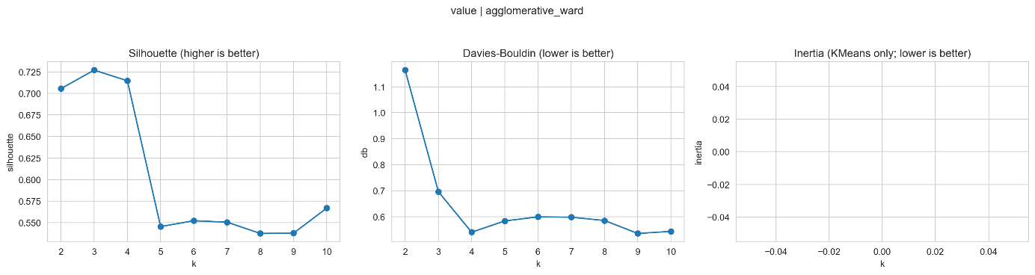
Figure 1
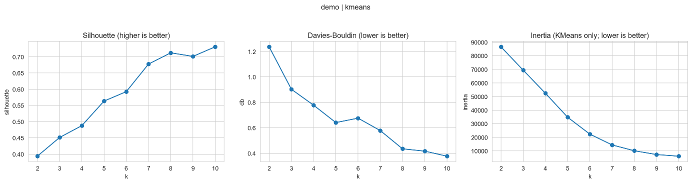
Figure 2
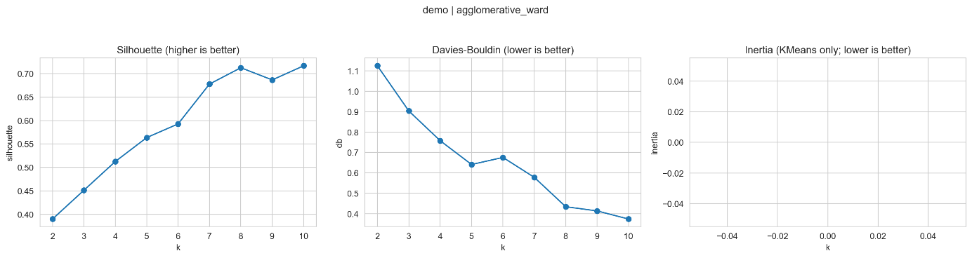
Figure 3
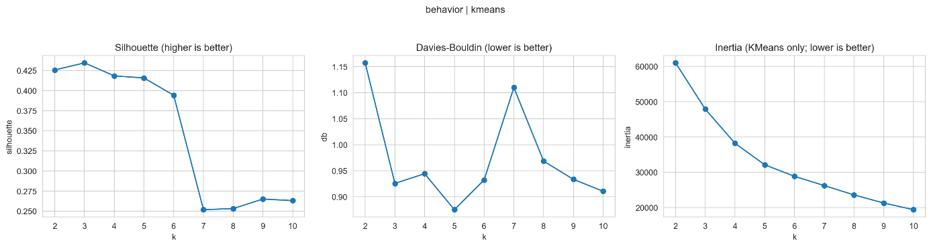
Figure 4
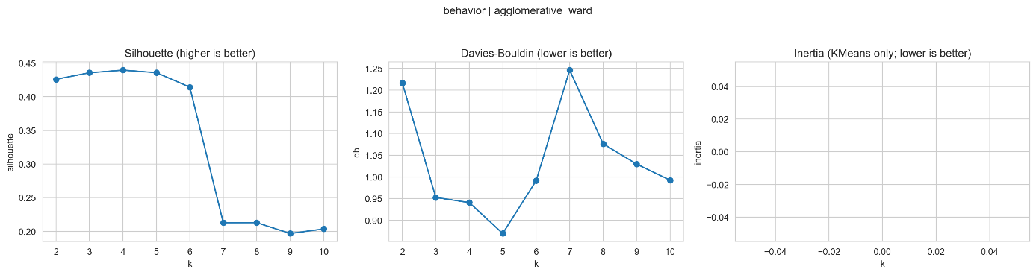
Figure 5
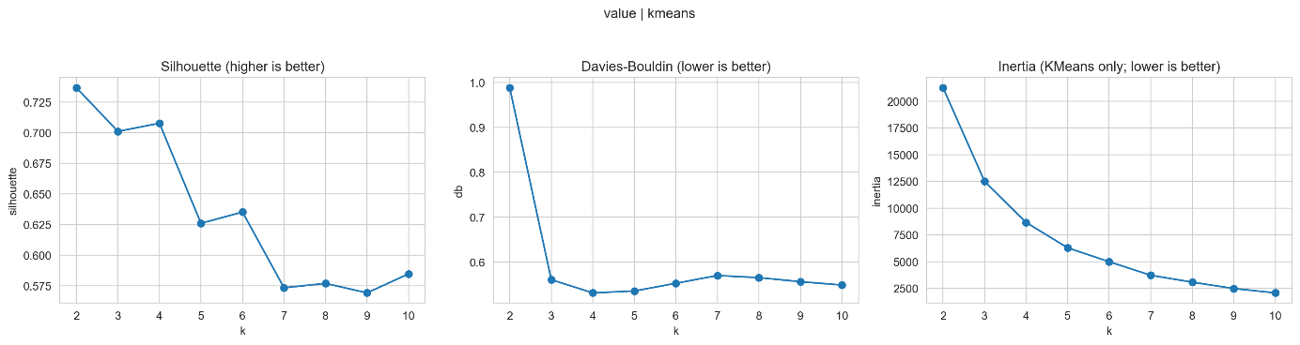
Figure 6
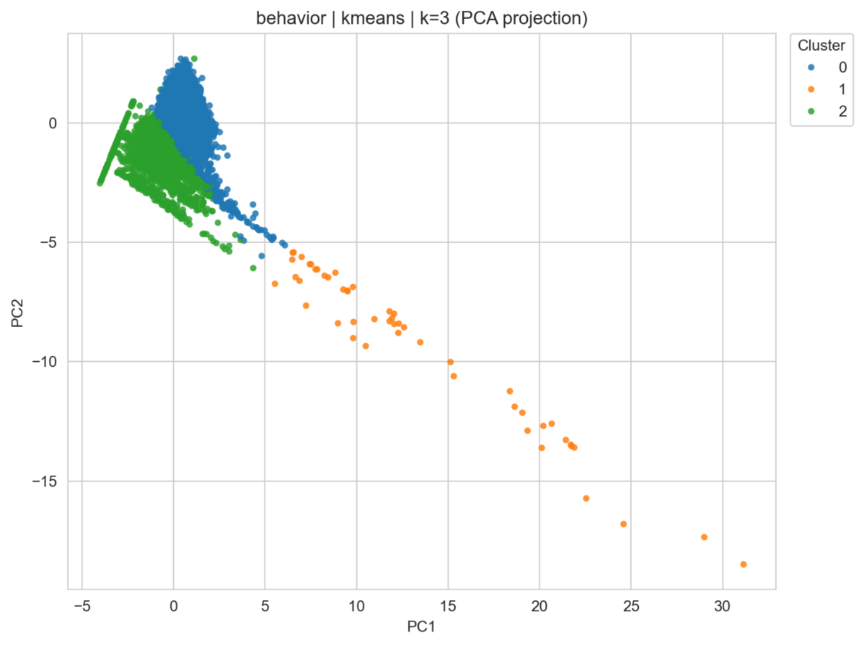
Figure 7
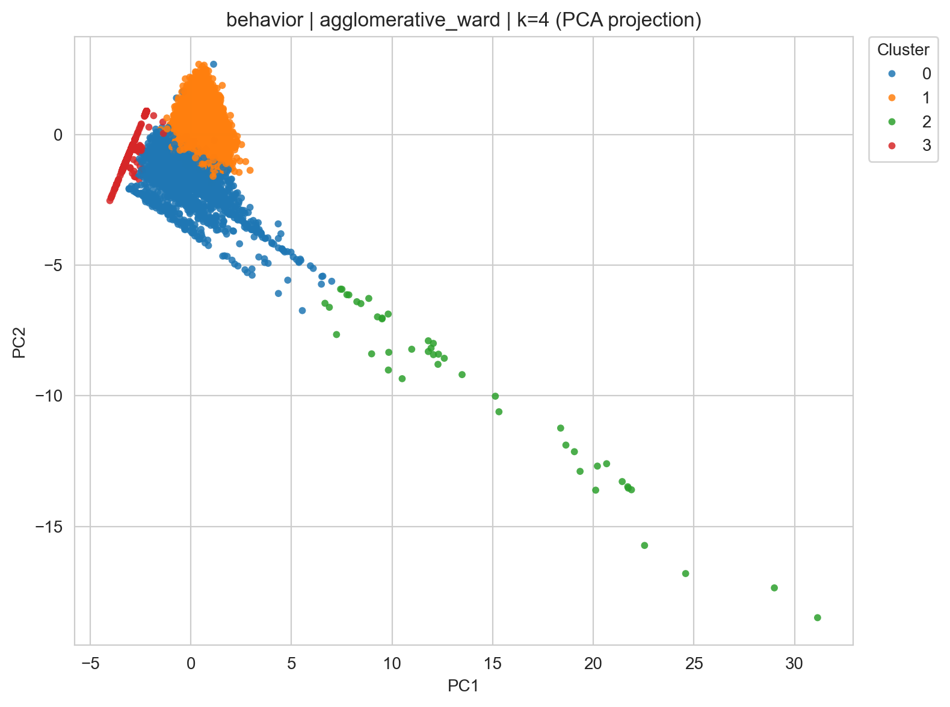
Figure 8
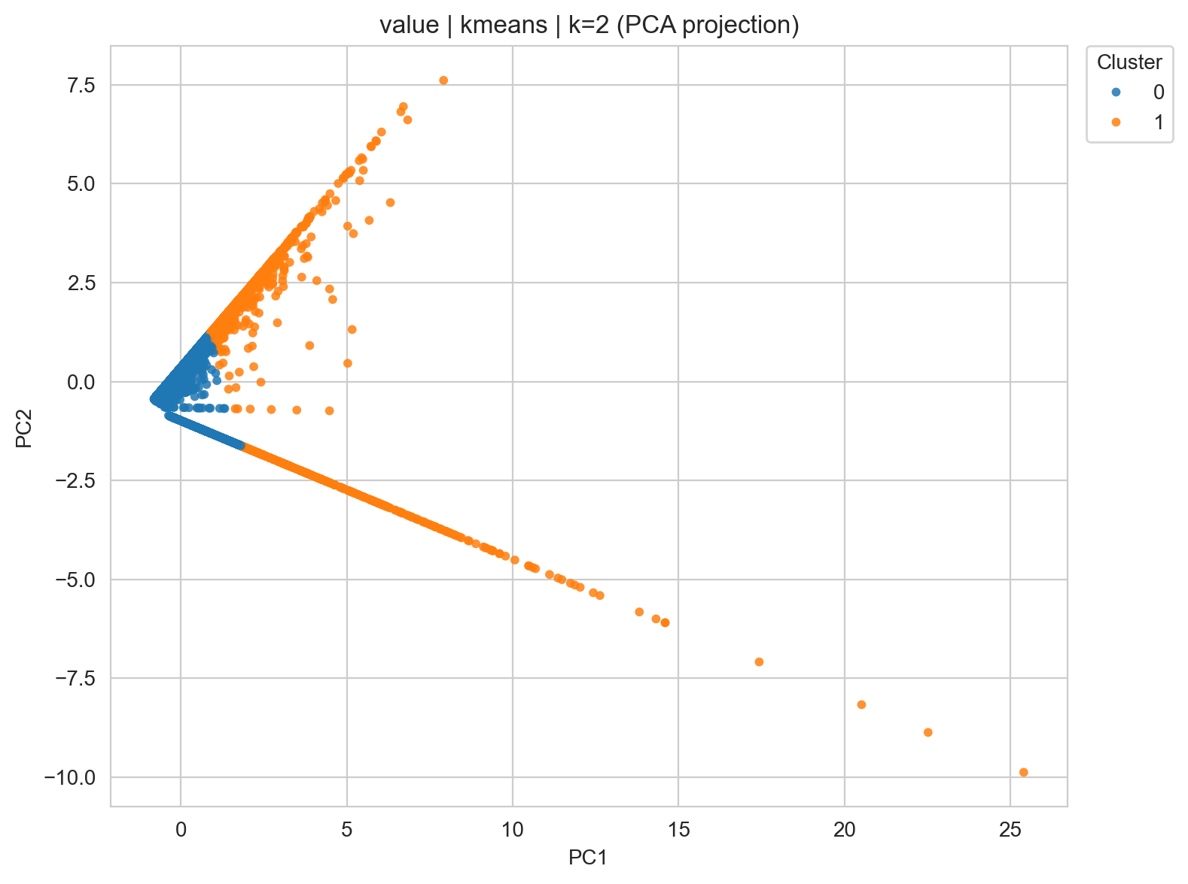
Figure 9
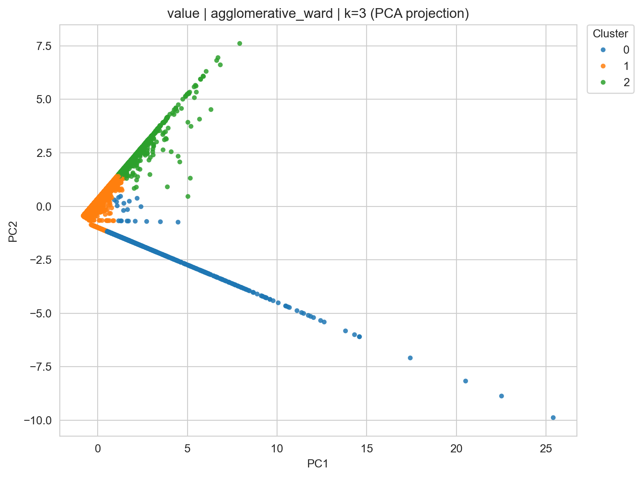
Figure 10
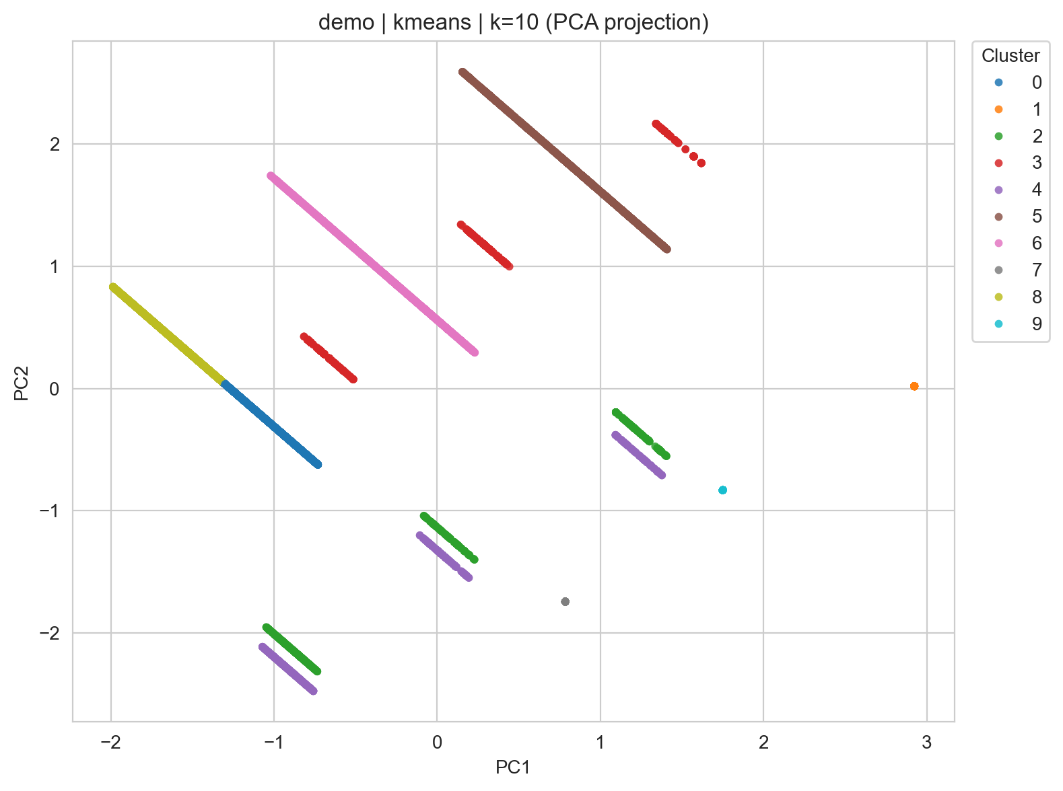
Figure 11
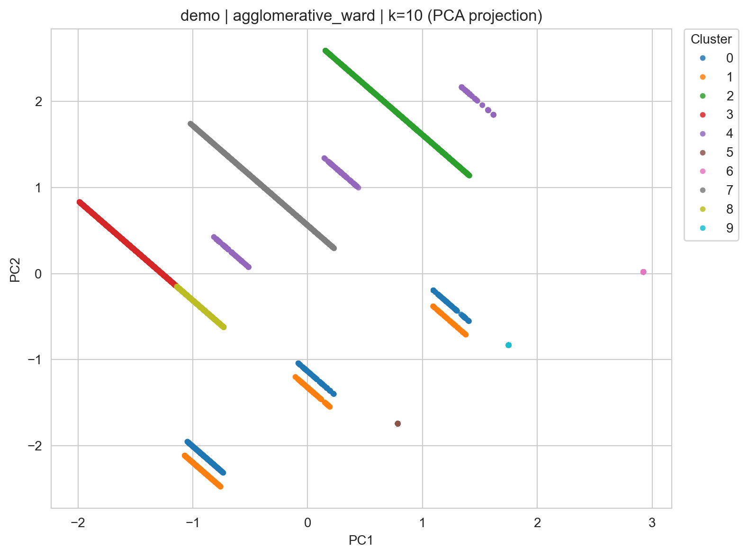
Figure 12
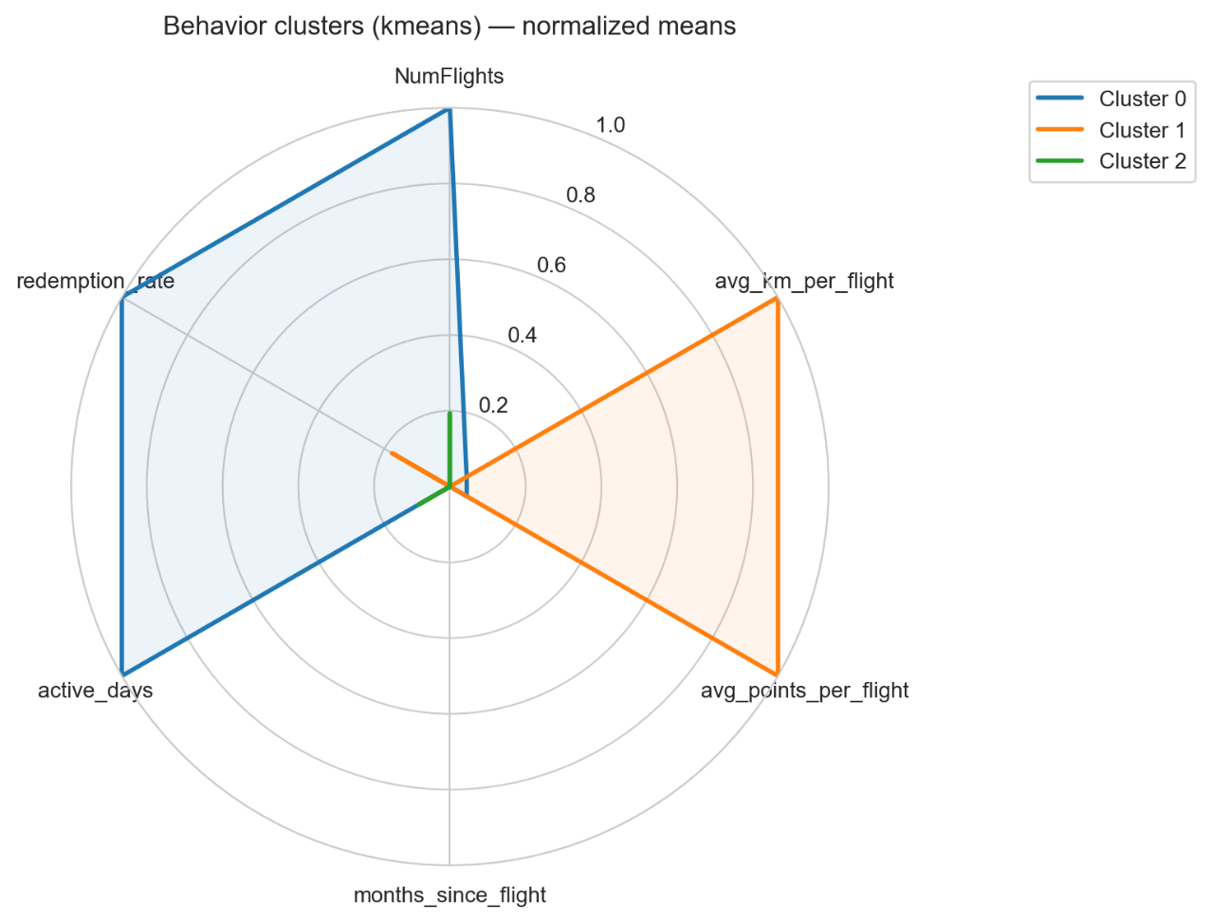
Figure 13
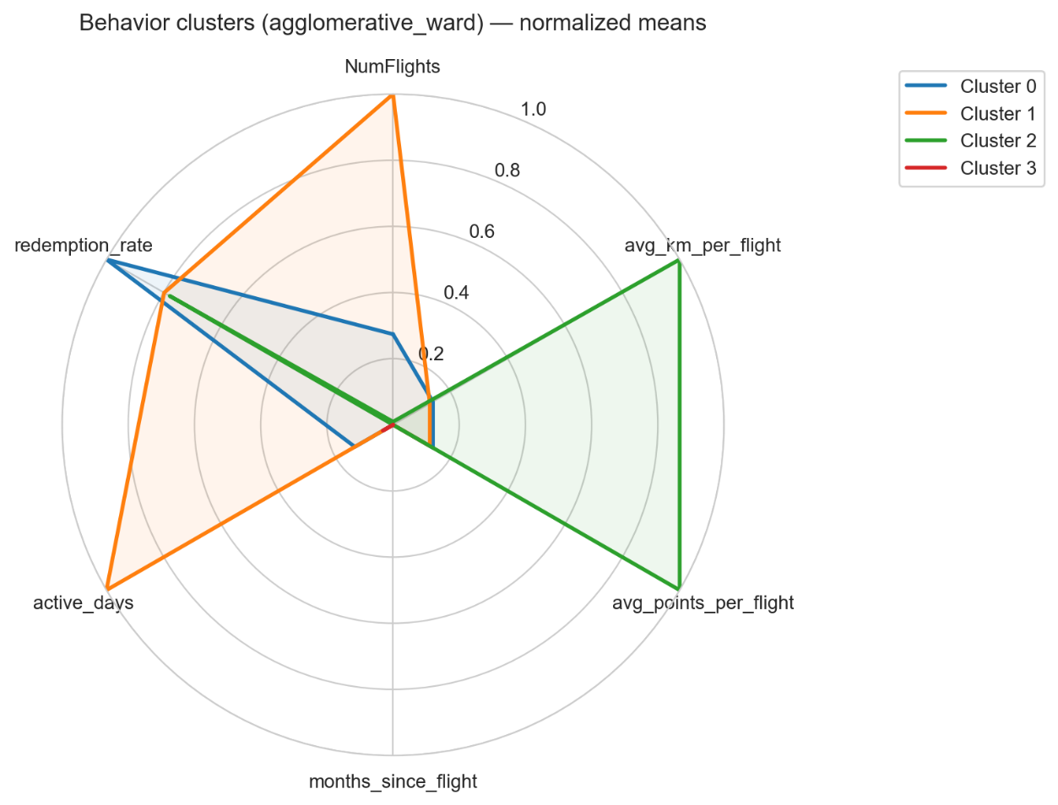
Figure 14
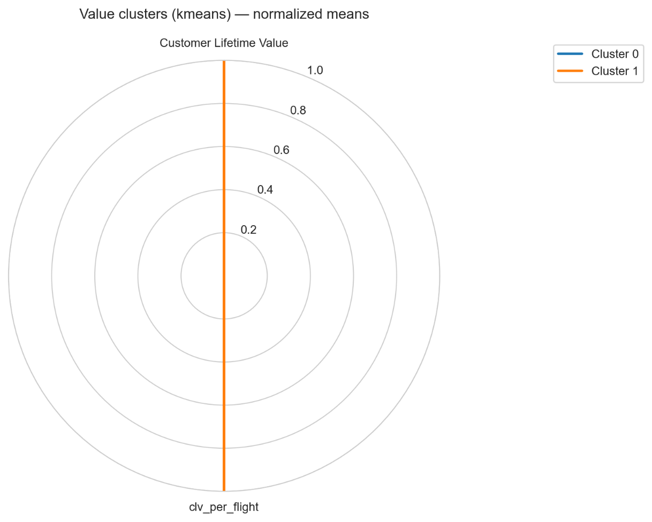
Figure 15

Annexes

AI Usage Statement
AI tools were used for coding syntax assistance, notebook markdown documentation (Github Copilot), language refinement (Quillbot, Grammarly) and review of analytical decisions done (ChatGPT).
All analytical insights, business interpretations, and strategic recommendations represent original group analysis and thinking.

Contribution Statement

Responsibility Statement
We, the group members listed above, certify that this report represents our original analytical work and interpretations. While AI tools were used as specified above, all insights, conclusions, and recommendations are the result of our independent analysis and critical thinking. We take full responsibility for the accuracy and quality of this submission.

