Experiment No.1
AIM:
To study and implement the half adder.
THEORY:
Half adder is a combinational arithmetic circuit that adds two numbers and produces a sum bit (S) and carry bit (C) as the output. If A and B are the input bits, then sum bit (S) is the X-OR of A and B and the carry bit (C) will be the AND of A and B. The half adder can add only two input bits (A and B) and has nothing to do with the carry if there is any in the input. So, if the input to a half adder have a carry, then it will be neglected it and adds only the A and B bits. That means the binary addition process is not complete and thats why it is called a half adder.
Sum=A xor B
Carry=AB

A | B | Sum | Carry
0 | 0 | 0 | 0
0 | 1 | 1 | 0
1 | 0 | 1 | 0
1 | 1 | 0 | 1

Using AND and XOR
STEPS:
- Open LabView and create a new VI file.
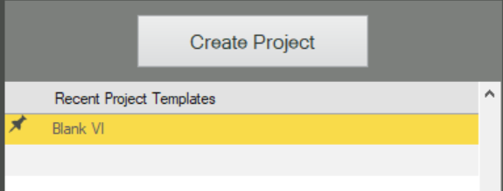

- In Font Panel, Click on View>Controls Palette.

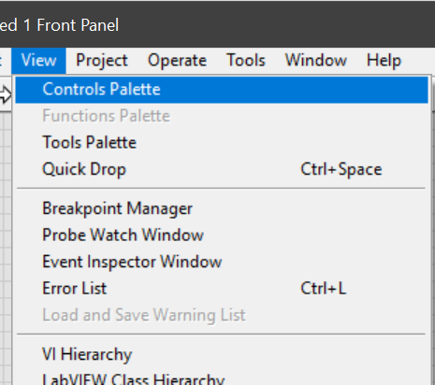

- In Controls Palette select Boolean.
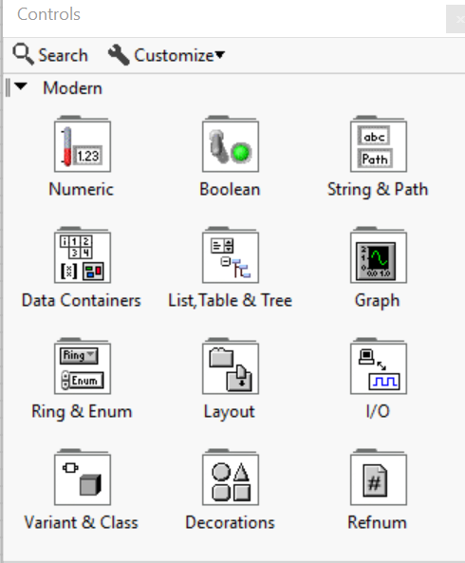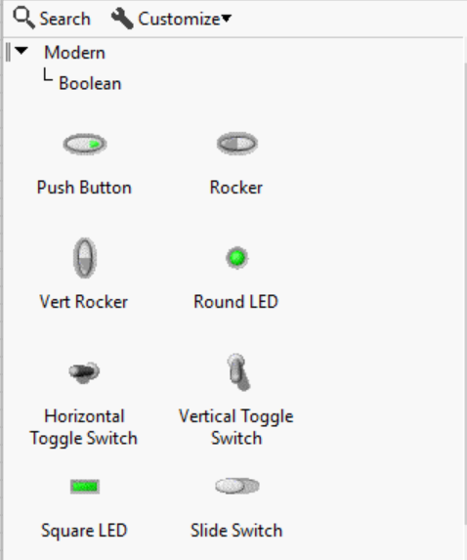

- Select and drop two Push buttons for input and two Led for output into the Font Panel.

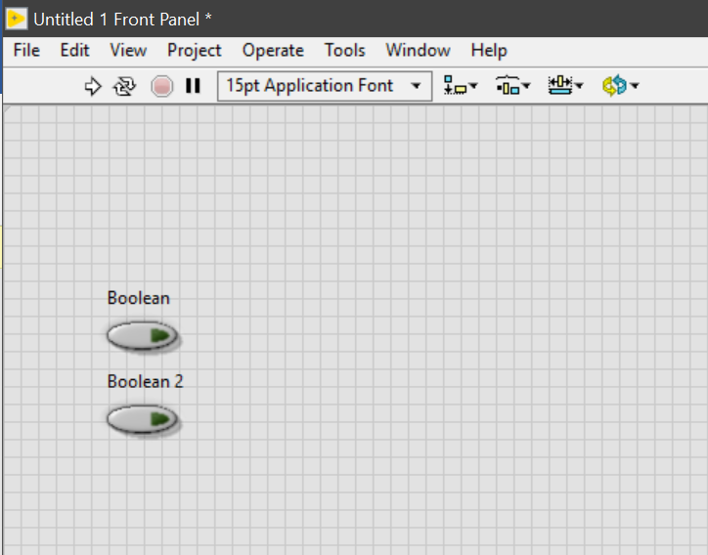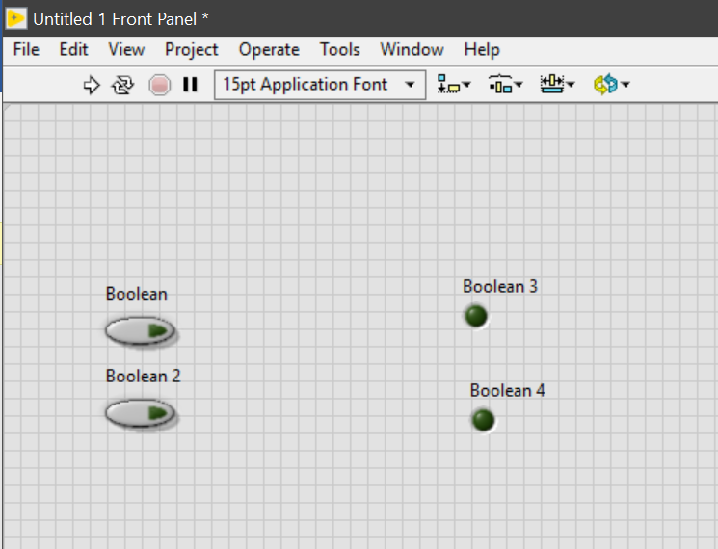

- In Font Panel ,Click on Windows>Show Block Diagram.

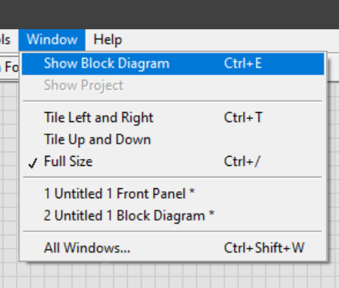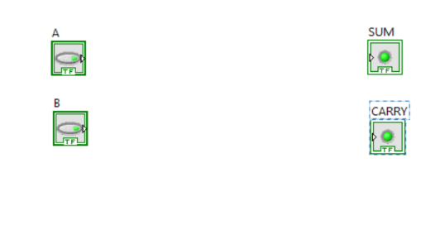

- In Block Diagram ,Click on Functions Palette.

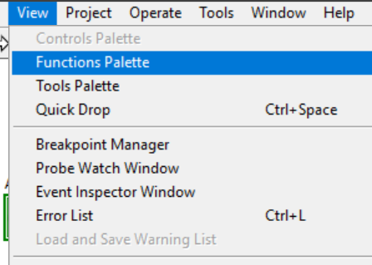

- Click on Boolean in Functions Palette.
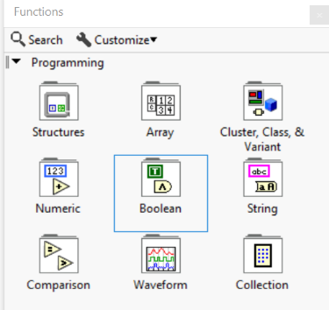
- Select and add XOR gate for sum and AND gate for carry in block diagram.
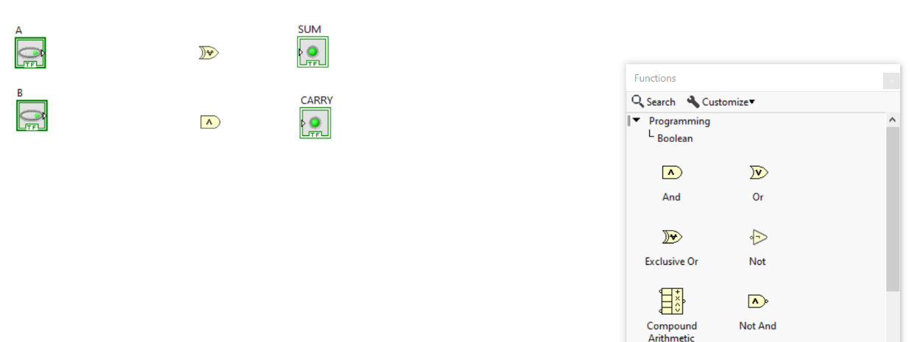

- Connect the A and B to AND gate as well as XOR gate.Connect output of XOR gate to sum and AND gate to carry.

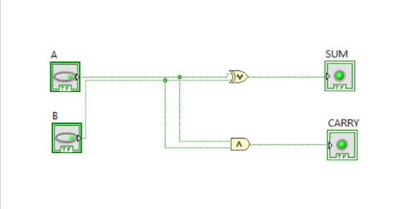

- Click on Run Continously and then move back to Font Panel.

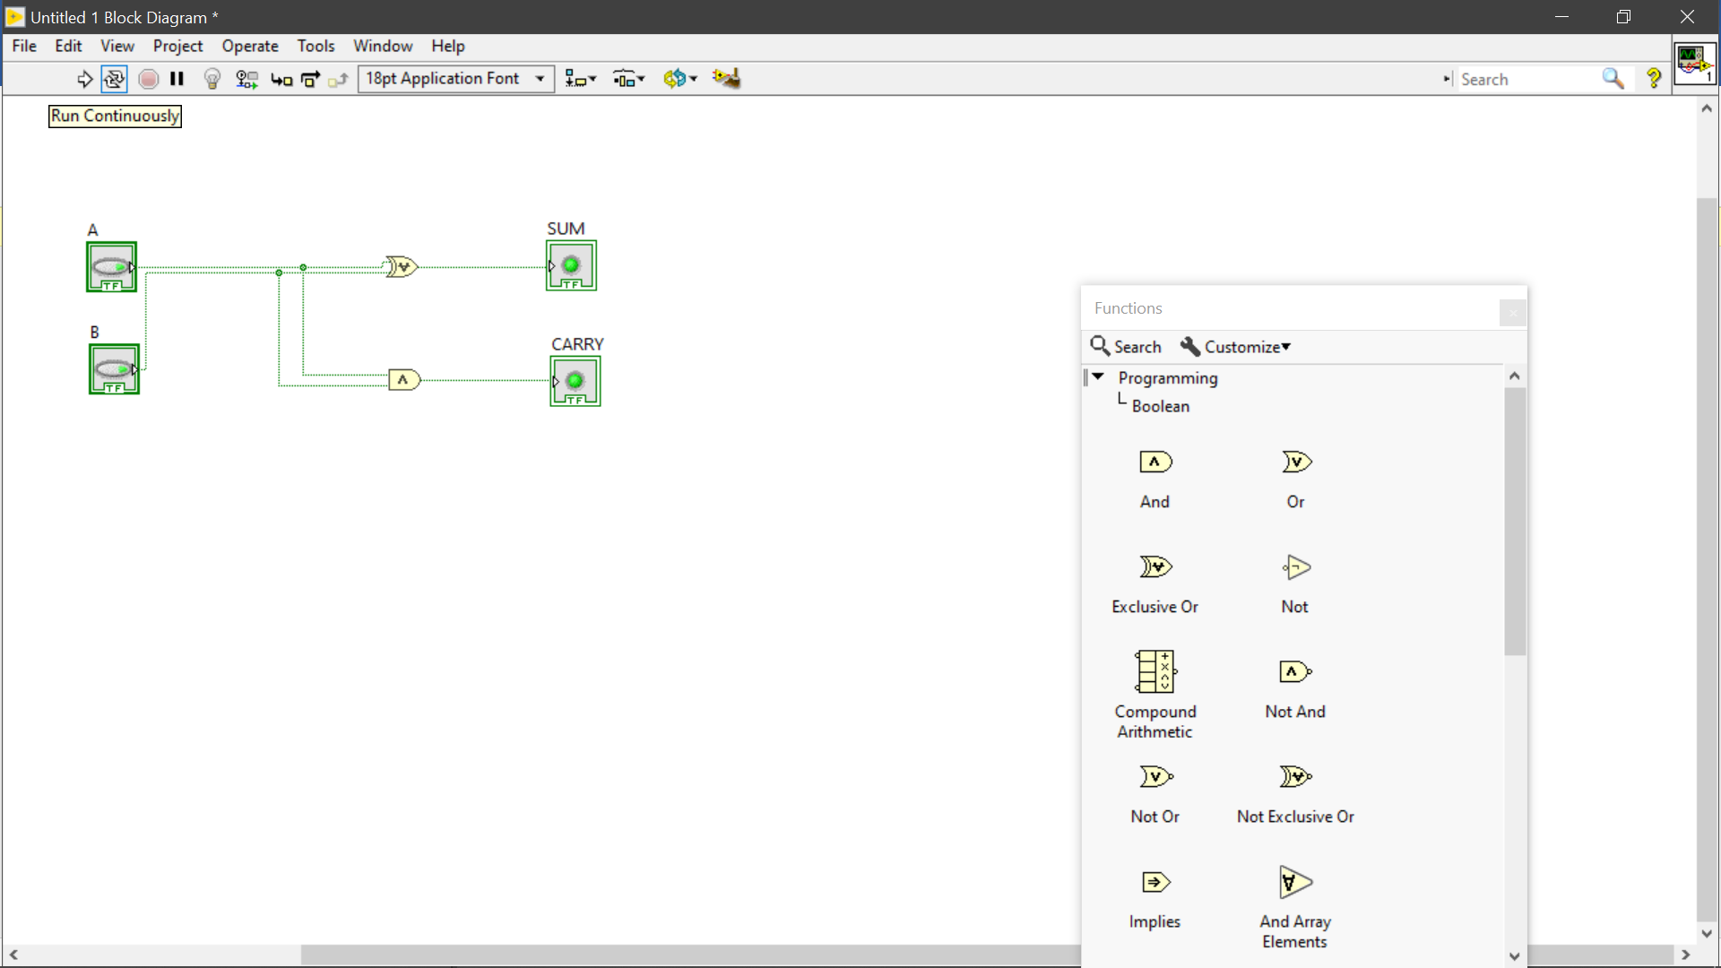
- Press A to give 1 and B remains 0. Sum is 1 and Carry=0.

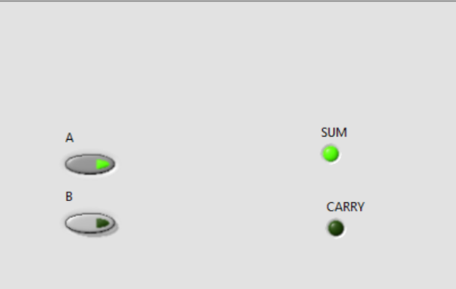
- Press A to give 1 and B remains 1. Sum is 0 and Carry=1.

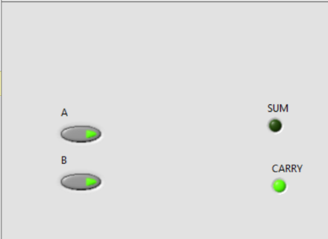

OBSERVATION:
It works according to the given logic in the truth table of half adder.

Experiment No.2
AIM:
To study and implement the full adder.
THEORY:
This type of adder is a little more difficult to implement than a half-adder. The main difference between a half-adder and a full-adder is that the full-adder has three inputs and two outputs. The first two inputs are A and B and the third input is an input carry designated as C. When a full adder logic is designed, we will be able to string eight of them together to create a byte-wide adder and cascade the carry bit from one adder to the next.
Sum=A xor B xor C
Carry=AB + (A xor B) C

A | B | C | Sum | Carry
0 | 0 | 0 | 0 | 0
0 | 0 | 1 | 1 | 0
0 | 1 | 0 | 1 | 0
0 | 1 | 1 | 0 | 1
1 | 0 | 0 | 1 | 0
1 | 0 | 1 | 0 | 1
1 | 1 | 0 | 0 | 1
1 | 1 | 1 | 1 | 1

Using AND, XOR, and OR
STEPS:
- Open LabView and create a new VI file.

- In Font Panel, Click on View>Controls Palette.

- In Controls Palette select Boolean.

- Select and drop three Push buttons for input and two Led for output into the Font Panel.

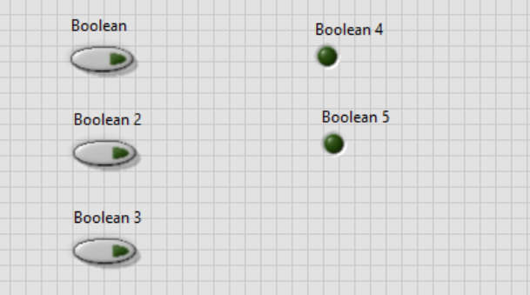

- In Font Panel ,Click on Windows>Show Block Diagram.

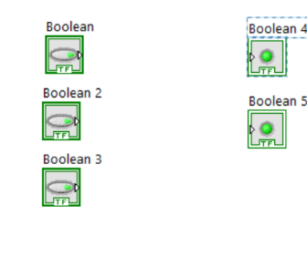

- In Block Diagram ,Click on Functions Palette.

- Click on Boolean in Functions Palette.
- Select and add required AND, OR,NOT & XOR gates for carry in block diagram.

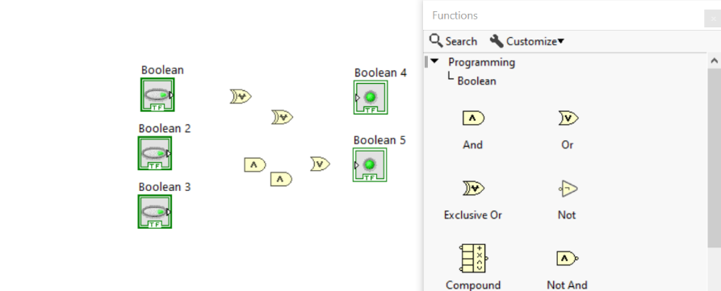

- Connect the gates to each other as well as input & output according to the equation of full adder.
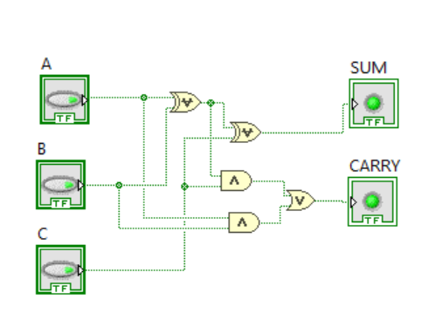

- Click on Run Continously and then move back to Font Panel.

- Press A to give 1 & B to give 1, and C remains 0. Sum is 0 and Carry=1.

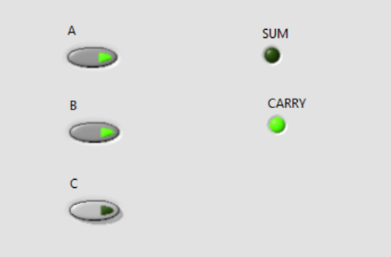
- Press A to give 1, B to give 1 and C to 1. Sum is 1 and Carry=1.

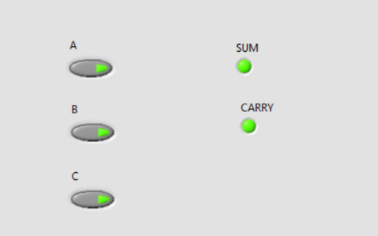

OBSERVATION:
It works according to the given logic in the truth table of full adder.

Experiment No.3
AIM:
To study and implement the subtractor.
Half Subtractor
THEORY:
As like addition operation of 2 binary digits, which produces SUM and CARRY, the subtraction of 2 binary digits also produces two outputs which are termed as DIFFERENCE and BORROW. They are referred as difference and borrow bit respectively. This borrow bit is used for subtraction of the next higher pair bit.
Difference= A xor B
Borrow= A’B

A | B | Difference | Borrow
0 | 0 | 0 | 0
0 | 1 | 1 | 1
1 | 0 | 1 | 0
1 | 1 | 0 | 0

Using AND, OR and NOT
STEPS:
- Open LabView and create a new VI file.

- In Font Panel, Click on View>Controls Palette.

- In Controls Palette select Boolean.

Using NAND
STEPS:
- Open LabView and create a new VI file.

- In Font Panel, Click on View>Controls Palette.

- In Controls Palette select Boolean.
Using NOR
STEPS:
- Open LabView and create a new VI file.

- In Font Panel, Click on View>Controls Palette.

- In Controls Palette select Boolean.

OBSERVATION:
It works according to the given logic in the truth table of half subtractor.

Full Subtractor
THEORY:
we can define full subtractor as a combinational circuit which takes three inputs and produces two outputs difference and borrow. Below is the truth table of the full subtractor, we have used three input variables A, B and C which refers to the term minuend, subtrahend and borrow bit respectively.
Difference= A xor B xor C
Borrow= A’B + (A xor B)’C

A | B | C | Difference | Borrow
0 | 0 | 0 | 0 | 0
0 | 0 | 1 | 1 | 0
0 | 1 | 0 | 1 | 0
0 | 1 | 1 | 0 | 1
1 | 0 | 0 | 1 | 0
1 | 0 | 1 | 0 | 1
1 | 1 | 0 | 0 | 1
1 | 1 | 1 | 1 | 1

Using AND, OR and NOT
STEPS:
- Open LabView and create a new VI file.

- In Font Panel, Click on View>Controls Palette.

- In Controls Palette select Boolean.

Using NOR
STEPS:
- Open LabView and create a new VI file.

- In Font Panel, Click on View>Controls Palette.

- In Controls Palette select Boolean.

Using NAND
STEPS:
- Open LabView and create a new VI file.

- In Font Panel, Click on View>Controls Palette.

- In Controls Palette select Boolean.

OBSERVATION:
It works according to the given logic in the truth table of full subtractor.

Experiment No.4
AIM:
To study and implement the Multiplexer.
2:1 MUX
THEORY:
It is a circuit with two inputs & one selection and one output. It passes one of the inputs as output depending on selection line.
STEPS:
- Open LabView and create a new VI file.

- In Font Panel, Click on View>Controls Palette.

- In Controls Palette select Boolean.

OBSERVATION:
It works according to the given logic in the truth table of 2:1 multiplexer.

4:1 MUX
THEORY:
It is a circuit with four inputs & two selection and one output. It passes one of the inputs as output depending on selection line.
STEPS:
- Open LabView and create a new VI file.

- In Font Panel, Click on View>Controls Palette.

- In Controls Palette select Boolean.

OBSERVATION:
It works according to the given logic in the truth table of 4:1 multiplexer.

8:1 MUX
THEORY:
It is a circuit with eight inputs & three selection and one output. It passes one of the inputs as output depending on selection line.
STEPS:
- Open LabView and create a new VI file.

- In Font Panel, Click on View>Controls Palette.

- In Controls Palette select Boolean.

OBSERVATION:
It works according to the given logic in the truth table of 8:1 multiplexer.

Experiment No.5
AIM:
To study and implement the De-Multiplexer.
1:2 DMUX
THEORY:
It is a circuit with one inputs & one selection and two output. It passes the inputs to one of the outputs depending on selection line.

STEPS:
- Open LabView and create a new VI file.

- In Font Panel, Click on View>Controls Palette.

- In Controls Palette select Boolean.

OBSERVATION:
It works according to the given logic in the truth table of 1:2 demultiplexer.

1:4 DMUX
THEORY:
It is a circuit with one input & two selection and four output. It passes the inputs to one of the outputs depending on selection line.

STEPS:
- Open LabView and create a new VI file.

- In Font Panel, Click on View>Controls Palette.

- In Controls Palette select Boolean.

OBSERVATION:
It works according to the given logic in the truth table of 1:4 demultiplexer.

1:8 MUX
THEORY:
It is a circuit with one input & three selection and eight output. It passes the inputs to one of the outputs depending on selection line.
STEPS:
- Open LabView and create a new VI file.

- In Font Panel, Click on View>Controls Palette.

- In Controls Palette select Boolean.

OBSERVATION:
It works according to the given logic in the truth table of 1:4 demultiplexer.

Experiment No.6
AIM:
To study and implement the Decoder.
2:4 Decoder
It is a circuit with two input and four output. It decodes a BCD signal to Binary one.
THEORY:
STEPS:
- Open LabView and create a new VI file.

- In Font Panel, Click on View>Controls Palette.

- In Controls Palette select Boolean.

OBSERVATION:
It works according to the given logic in the truth table of 2:4 decoder.

3:8 Decoder
THEORY:
It is a circuit with three input and eight output. It decodes a BCD signal to Binary one
STEPS:
- Open LabView and create a new VI file.

- In Font Panel, Click on View>Controls Palette.

- In Controls Palette select Boolean.

OBSERVATION:
It works according to the given logic in the truth table of 3:8 decoder

3:8 Decoder (Using 2:4)
THEORY:
It is a circuit with three input and eight output. It decodes a BCD signal to Binary one
STEPS:
- Open LabView and create a new VI file.

- In Font Panel, Click on View>Controls Palette.

- In Controls Palette select Boolean.

OBSERVATION:
It works according to the given logic in the truth table of 3:8 decoder.

Experiment No.7
AIM:
To study and implement the Encoder.
4:2 Encoder
THEORY:
It is a circuit with four input and two output. It decodes a Binary signal to BCD one
STEPS:
- Open LabView and create a new VI file.

- In Font Panel, Click on View>Controls Palette.

- In Controls Palette select Boolean.

OBSERVATION:
It works according to the given logic in the truth table of 4:2 encoder.

8:3 Encoder
THEORY:
It is a circuit with eight input and three output. It decodes a Binary signal to BCD one
STEPS:
- Open LabView and create a new VI file.

- In Font Panel, Click on View>Controls Palette.

- In Controls Palette select Boolean.

OBSERVATION:
It works according to the given logic in the truth table of 8:3 encoder

Experiment No.8
AIM:
To study and implement the SR and JK flip-flop.
SR Flip-Flop
THEORY:
The SR flip-flop can be considered as a 1-bit memory, since it stores the input pulse even after it has passed. The SR (Set-Reset) flip-flop is one of the simplest sequential circuits and consists of two gates such that the output of each gate is connected to one of the inputs of the other gate, giving a form of positive feedback or ‘cross-coupling’. The circuit has two active low inputs marked S and R, ‘NOT’ being indicated by the bar above the letter, as well as two outputs, Q and Q.

STEPS:
- Open LabView and create a new VI file.

- In Font Panel, Click on View>Controls Palette.

- In Controls Palette select Boolean.

OBSERVATION:
It works according to the given logic in the truth table of RS flip-flop.

JK Flip-Flop (+ve triggered)
THEORY:
The master-slave flip-flop eliminates all the timing problems by using two SR flip-flops connected together in a series configuration. One flip-flop act as the “Master” circuit, which triggers on the leading edge of the clock pulse while the other acts as the “Slave” circuit, which triggers on the falling edge of the clock pulse. This results in the two sections; the master section and the slave section being enabled during opposite half-cycles of the clock signal.
STEPS:
- Open LabView and create a new VI file.

- In Font Panel, Click on View>Controls Palette.

- In Controls Palette select Boolean.

OBSERVATION:
It works according to the given logic in the truth table of JK flip-flop. . It works when clock changes from zero to one.

JK Flip-Flop (-ve triggered)
THEORY:
The master-slave flip-flop eliminates all the timing problems by using two SR flip-flops connected together in a series configuration. One flip-flop act as the “Master” circuit, which triggers on the leading edge of the clock pulse while the other acts as the “Slave” circuit, which triggers on the falling edge of the clock pulse. This results in the two sections; the master section and the slave section being enabled during opposite half-cycles of the clock signal.
STEPS:
- Open LabView and create a new VI file.

- In Font Panel, Click on View>Controls Palette.

- In Controls Palette select Boolean.

OBSERVATION:
It works according to the given logic in the truth table of JK flip-flop. It works when clock changes from one to zero.

Experiment No.9
AIM:
To study and implement the following problem.
PROBLEM:
Design a LED warning system in which led turns on in the following condition-
- Switch A, B, C are on.
- Switch A and B are off, while C is on.
- Switch A and C are on but B is off.
- Switch B and C is off but switch is on.

Using AND, OR and NOT
STEPS:
- Open LabView and create a new VI file.

- In Font Panel, Click on View>Controls Palette.

- In Controls Palette select Boolean.

OBSERVATION:
It works according to the requirement of given problem.

Using NAND
STEPS:
- Open LabView and create a new VI file.

- In Font Panel, Click on View>Controls Palette.

- In Controls Palette select Boolean.

OBSERVATION:
It works according to the requirement of given problem.
Using NOR
STEPS:
- Open LabView and create a new VI file.

- In Font Panel, Click on View>Controls Palette.

- In Controls Palette select Boolean.

OBSERVATION:
It works according to the requirement of given problem.

Experiment No.8
AIM:
To study and implement the comparator.
2-Bit Comparator
THEORY:
It compares two set of two bits and check which is greater, less or equal.
STEPS:
- Open LabView and create a new VI file.

- In Font Panel, Click on View>Controls Palette.

- In Controls Palette select Boolean.

OBSERVATION:
It works according to the logic of two-bit comparator.

3-Bit Comparator
THEORY:
It compares two set of three bits and check which is greater, less or equal.
STEPS:
- Open LabView and create a new VI file.

- In Font Panel, Click on View>Controls Palette.

- In Controls Palette select Boolean.

OBSERVATION:
It works according to the logic of three-bit comparator.

