PoS System
Use Case Specification: Close Cash Accounts

Version 1.0

Revision History
Date | Version | Description | Author
24.11.16 | 1.0 | Creation of document | Sven Baumann

Table of Contents
Table of Contents 3
1. Use-Case Close Cash Accounts 4
1.1 Brief Description 4
2. Flow of Events 4
2.1 Basic Flow 4
3. Special Requirements 5
3.1 Other devices 5
4. Preconditions 5
4.1 Entering the view 5
5. Postconditions 5
6. Extension Points 5

Use-Case Specification: Close Cash Accounts

1. Use-Case Close Cash Accounts

1.1 Brief Description
At the end of each day the last user has to close the cash accounts. Therefore he has to count the amount in the cash. To make it easier the user only has to count every sort of coin and banknote. After that, he will see which amount should be in the cash. He can now count again or close the cash.

2. Flow of Events

2.1 Basic Flow
Activity Diagram:
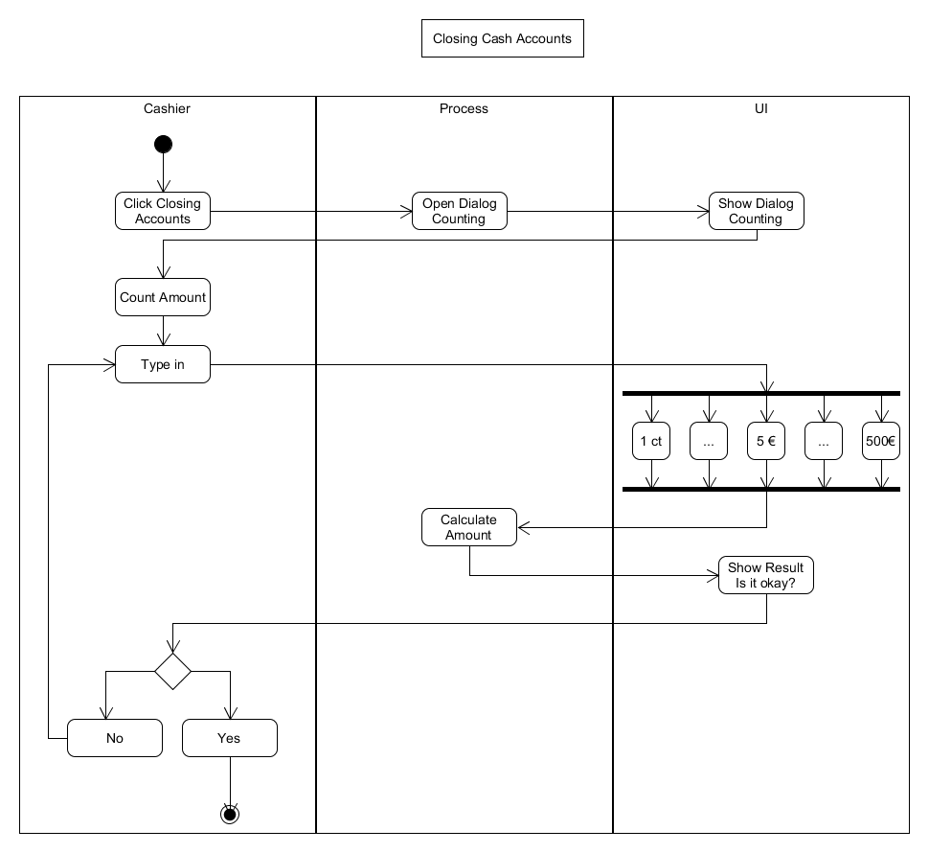
Feature-Datei:
Closing Cash Accounts Feature-Datei

Mockup:

3. Special Requirements

3.1 Other devices
As this POS application is targeted towards small retail business we expect it to run on screen sizes of desktop computers. As this is a web application and as such can potentially be used in mobile devices too, we should keep in mind to make singular UI components not too large to make it easier to adapt to smaller screens should the need arise. This explicitly is not a must and must in no way stand in the way of other important design decisions.

4. Preconditions

4.1 Entering the view
The user has to click to button to start the action.

5. Postconditions
n/a

6. Extension Points
n/a

