PoS System
Use Case Specification: Cash Opening Entry

Version 1.0

Revision History
Date | Version | Description | Author
24.11.16 | 1.0 | Creation of document | Sven Baumann

Table of Contents
Table of Contents 3
1. Use-Case Cash Opening Entry 4
1.1 Brief Description 4
2. Flow of Events 4
2.1 Basic Flow 4
3. Special Requirements 5
3.1 Other devices 5
4. Preconditions 5
4.1 Entering the view 5
5. Postconditions 5
6. Extension Points 5

Use-Case Specification: Cash Opening Entry

1. Use-Case Cash Opening Entry

1.1 Brief Description
Each day, during the first start of the cash, the user has to type in the amount of the cash.

2. Flow of Events

2.1 Basic Flow
Activity Diagram:
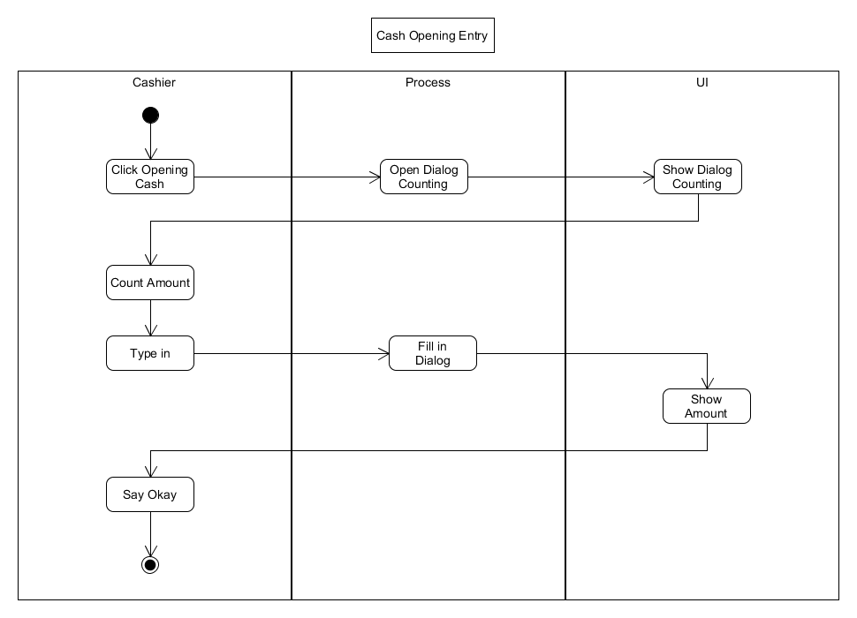
Feature-Datei:
Cash Opening Entry Feature-Datei

Mockup:

3. Special Requirements

3.1 Other devices
As this POS application is targeted towards small retail business we expect it to run on screen sizes of desktop computers. As this is a web application and as such can potentially be used in mobile devices too, we should keep in mind to make singular UI components not too large to make it easier to adapt to smaller screens should the need arise. This explicitly is not a must and must in no way stand in the way of other important design decisions.

4. Preconditions

4.1 Entering the view
The window will only appear during the first start of the cash at a day.

5. Postconditions
n/a

6. Extension Points
n/a

