PoS System
Use Case Specification: Manage Product Groups

Version 1.3

Revision History
Date | Version | Description | Author
30.10.2016 | 1.0 | Creation of document | Sandra Kramlich
04.11.2016 | 1.1 | -added mockup | Sven Baumann
10.11.2016 | 1.2 | -added CRUD-Graphic to description | Sven Baumann
16.11.2016 | 1.3 | -added link to .feature | Sven Baumann

Table of Contents
1. Use-Case Select betweenManagement-Area/Cash-Area 2
1.1 Brief Description 2
2. Flow of Events 2
2.1 Basic Flow 2
3. Special Requirements 2
3.1 Other devices 2
4. Preconditions 2
4.1 Entering the view 2
5. Postconditions 2
6. Extension Points 2

Use-Case Specification: Manage Product Group

1. Use-Case Manage Product Group

1.1 Brief Description
This use case allows the user, the manager of the PoS System, to edit and create new product groups. This means he has the possibility to create new product groups with their name, their number (ID) and their profit margin. He also can change already existing product groups.
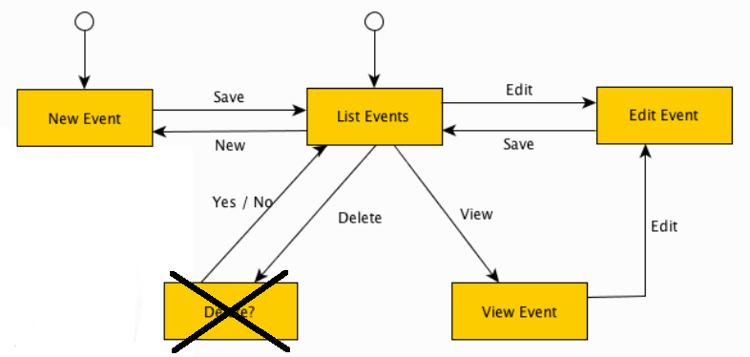

2. Flow of Events

2.1 Basic Flow
Activity Diagram:
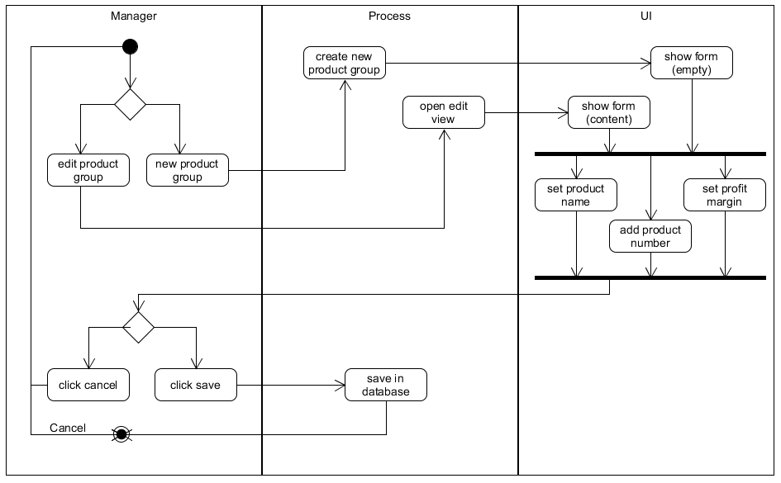
Feature-Datei:
Manage Product Group Feature-Datei

Mockup:

3. Special Requirements

3.1 Other devices
As this POS application is targeted towards small retail business we expect it to run on screen sizes of a desktop computers. As this is a web application and as such can potentielly used in mobile devices too, we should keep in mind to make singular ui components not too large to make it easier to adapt to smaller screens should the need arise. This explicitly is not a must and must in no way stand in the way of other important design decisions.

4. Preconditions

4.1 Entering the view
The user only can change or create new product groups if he first has logged in as a manager and then chose the management view.

5. Postconditions
n/a

6. Extension Points
n/a

