PoS System
Use Case Specification: Select between Management- & Cash-Area

Version 1.3

Revision History
Date | Version | Description | Author
30.10.2016 | 1.0 | Creation of document | Sandra Kramlich
02.11.2016 | 1.1 | -marked as CRUD  -changed UCD | Sandra Kramlich
04.11.2016 | 1.2 | -added mockup | Sven Baumann
16.11.2016 | 1.3 | -added link to .feature | Sven Baumann

Table of Contents
1. Use-Case Select between Management & Cash-Area 4
1.1 Brief Description 4
2. Flow of Events 4
2.1 Basic Flow 4
3. Special Requirements 5
3.1 Other devices 5
4. Preconditions 5
4.1 Entering the view 5
5. Postconditions 5
6. Extension Points 5

Use-Case Specification: Select between Management-& Cash-Area

1. Use-Case Select between Management & Cash-Area

1.1 Brief Description
This Use-Case is a CRUD and allows the user, the manager of the PoS System, to choose between two views. One view redirects on the use case „Use Management Area“, the other one on the use case „Use Cash Area“. Only the manager is allowed to see the use management area.

2. Flow of Events

2.1 Basic Flow
Activity Diagram:
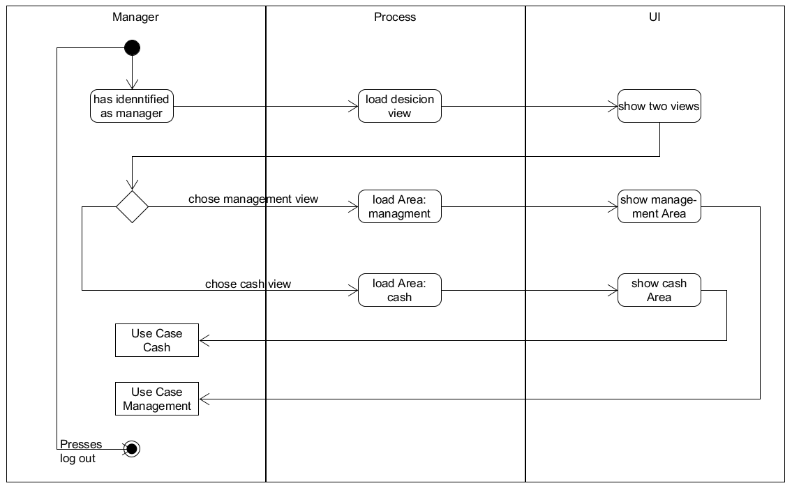
Feature-Datei:
Select between Management- & Cash-Area Feature-Datei

Mockup:

3. Special Requirements

3.1 Other devices
As this POS application is targeted towards small retail business we expect it to run on screen sizes of desktop computers. As this is a web application and as such can potentielly used in mobile devices too, we should keep in mind to make singular ui components not too large to make it easier to adapt to smaller screens should the need arise. This explicitly is not a must and must in no way stand in the way of other important design decisions.

4. Preconditions

4.1 Entering the view
That the user can come to the „Select betweenManagement-Area/Cash-Area“ view, he first must be sight in as a manager. Normal cashiers will never see this view with their log in.

5. Postconditions
n/a

6. Extension Points
n/a

