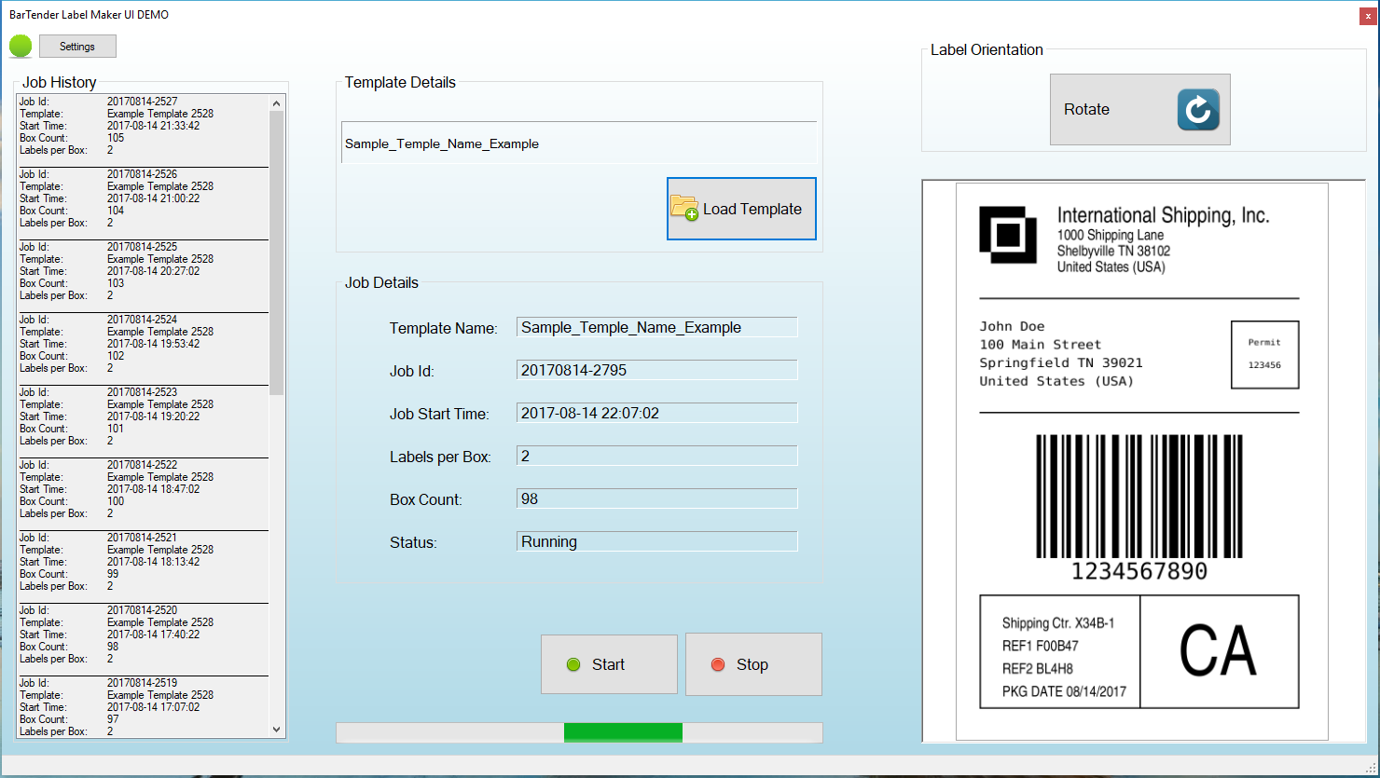

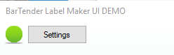

The green circle is the Heart Beat. It will blink to show that the system is connected and running

The Settings button is there to allow for adjusting settings such as the size and position of the application. This is here to provide admin functionality as opposed to end user functionality.

_______________________________________________________________________________________

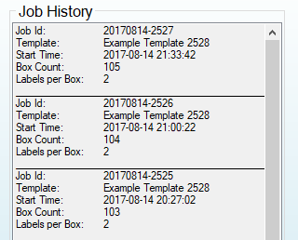

This shows a log of the history of the application. It can be saved to a text file for now, but there are no real plans for this section at this time.

_______________________________________________________________________________________

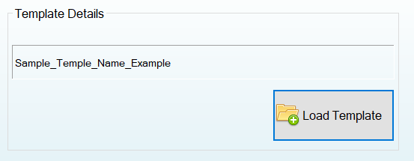

This button loads the template file from either the USB flash drive or from the local storage. When a template file is uploaded from the USB flash drive it will be saved to the local storage location. Pressing this button opens the standard Windows dialog box for selecting the template file.

_______________________________________________________________________________________

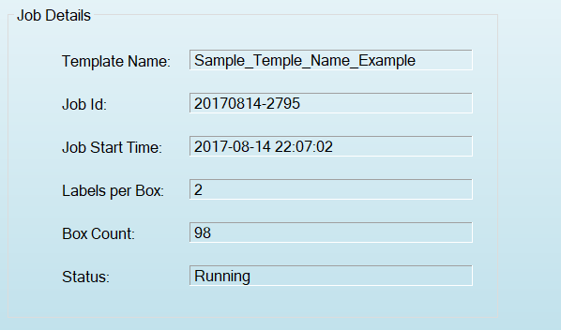

Displays various details about the current configured job. The box count updates in real time as each box is processed.

_______________________________________________________________________________________

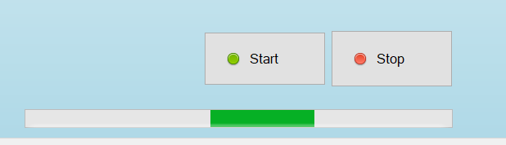

Start and stop buttons to control the process. The green bar displays in “marquee” fashion to show that the process is running. When the process is stopped or complete it will turn red.

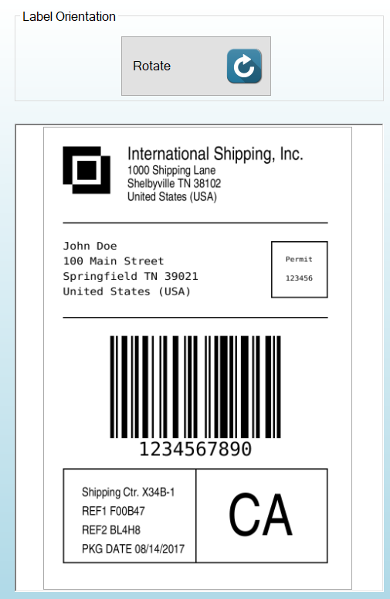

The label display area. The label orientation is rotated 90 degrees by pressing the **Rotate** button.