我是标题哈哈哈

段落1...

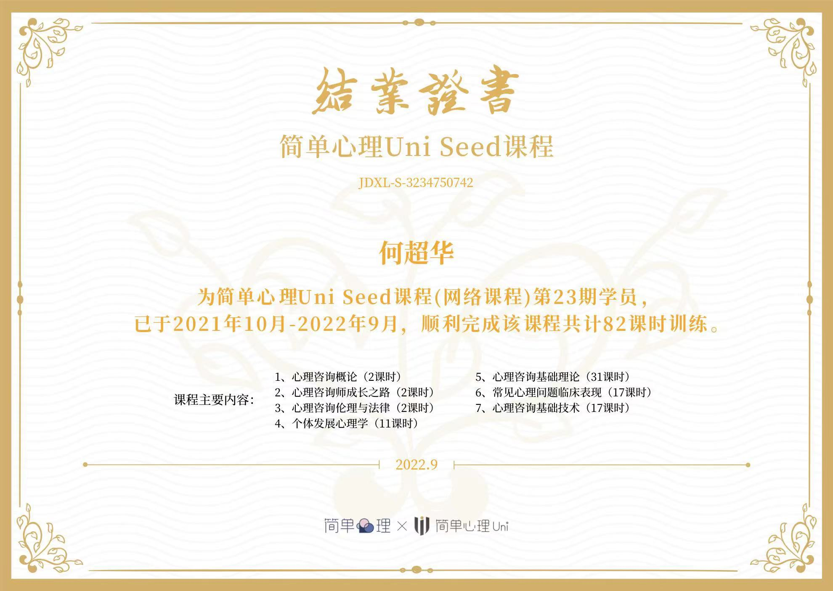

|  |  |  |  |  |  |
| --- | --- | --- | --- | --- | --- |
| name | age | sex |  |  |  |
| xiaohong | 10 | boy |  |  |  |
| xiaohei | 11 | girl |  |  |  |
| john | 16 | boy |  |  |  |
|  |  |  |  |  |  |
|  |  |  |  |  |  |