Appendix: Sensitivity analysis
To examine the impact of varying levels of supervision costs on the strategic choices of governmental regulators, we conducted an analysis while maintaining all other parameters held constant and set the strict supervision costs C_{gh} at 50, 100, and 150, respectively. The resulting evolutionary trajectory of governmental regulators’ strategic decisions is shown in Figure 10, illustrating the complex interplay between supervision costs and regulatory strategies.
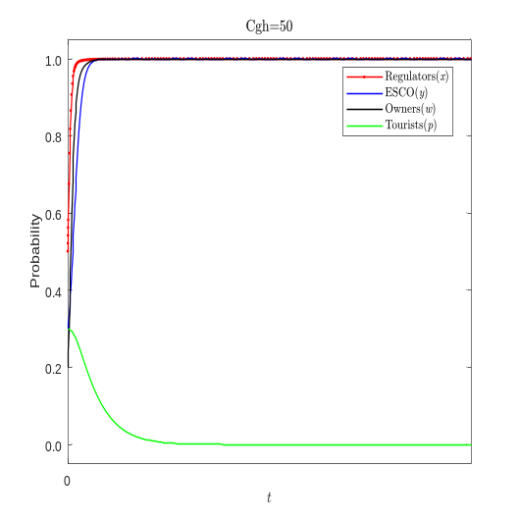 |  | 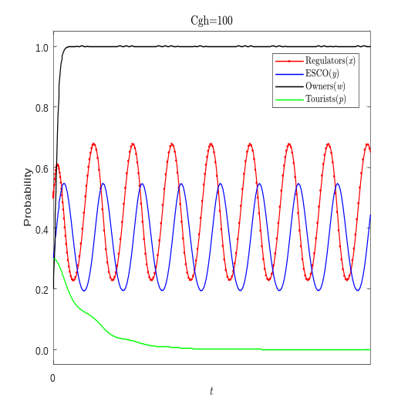
(a) |  | (b)
 | 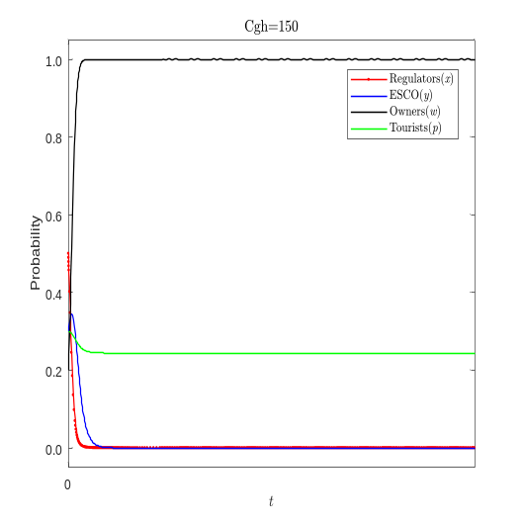
 | (c)
Figure 10. The sensitivity analysis examines the evolutionary path of the governmental regulators in relation to parameter C_{gh}. This analysis compares the original value of C_{gh} (C_{gh}=100) with both a higher value(C_{gh}=150) and a lower value(C_{gh}=50).
To investigate the influence of varying levels of green incentive benefits on ESCOs and their subsequent impact on the evolution of all players within the system, we conducted an analysis by setting the parameter L to 10, 20, and 30, respectively. The resulting trajectory of strategic choices and adaptations within the system is shown in Figure 11, providing a comprehensive visualization of the intricate interplay between policy incentives and strategic behavior.
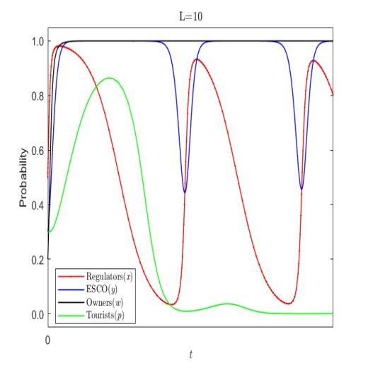 |  | 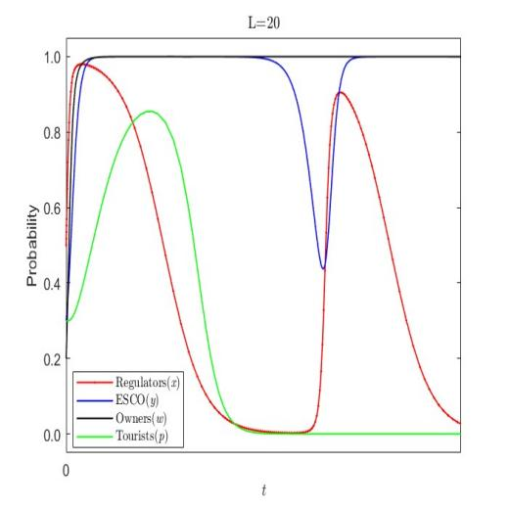
(a) |  | (b)
 | 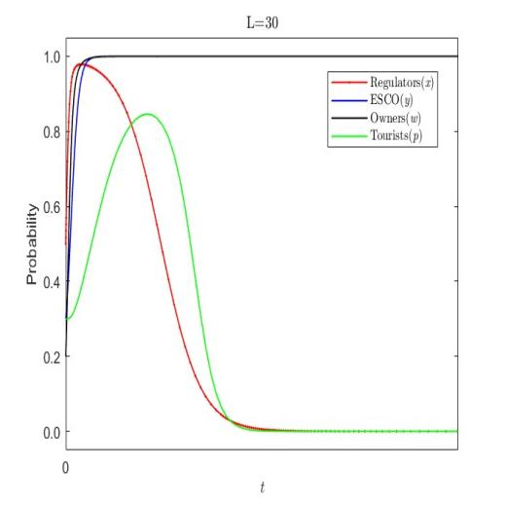
 | (c)
Figure 11. The sensitivity analysis of evolutionary path of ESCOs with respect to parameter L is shown, comparing the original value of L=20 with a higher value ( L=30) and a lower value ( L=10).
Figure 11 illustrates a clear correlation between the expected benefit L and the evolutionary behavior of the ESCOs in adopting a “Green Retrofit” strategy. As L increases, ESCOs show a faster convergence toward the “Green Retrofit” strategy, indicating that higher expected benefits significantly boost their willingness to incorporate green technologies. This trend underscores that anticipated financial incentives can effectively encourage ESCOs to engage in environmentally sustainable practices. Similarly, as shown in Figure 11(c), the speed at which governmental supervision stabilizes accelerates, indicating a regulatory framework that adapts in response to ESCOs’ changing incentives. This trend emphasizes the significant role that anticipated benefits play in shaping ESCOs’ behavior in historical building retrofit projects. When expected benefits reach a sufficient threshold, ESCOs are more likely to adopt green building technologies, thereby advancing environmental sustainability and energy efficiency. Additionally, Figure 11 reveals a dynamic interplay between ESCOs’ strategic choices and governmental responses. As ESCOs increasingly adopt the “Green Retrofit” strategy, the intensity of governmental supervision gradually declines. This observation suggests a mutually reinforcing relationship between regulatory incentives and market behavior, whereby a proactive regulatory approach can promote the widespread adoption of environmentally sustainable practices among ESCOs.
Under strict supervision of governmental regulators, owners of historical buildings will suffer extra loss for accepting non-green retrofit. To assess the influence of extra loss on the strategy choice of the ESCOs, we analyzed a range of R_{m ,} specifically, 5, 10 ,and 15. Figure 12 illustrates the trajectory of strategic choices by each participant.

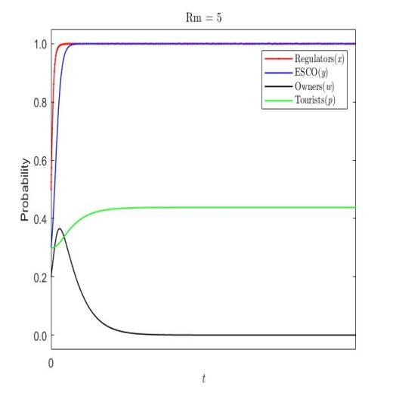 |  | 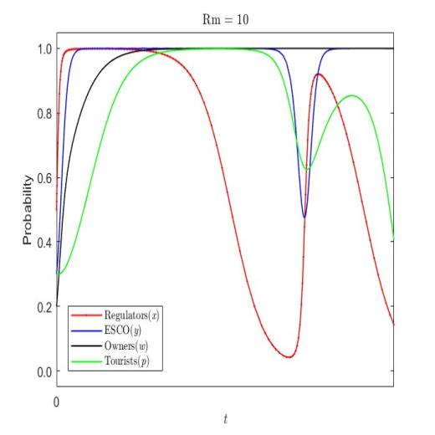
(a) |  | (b)
 | 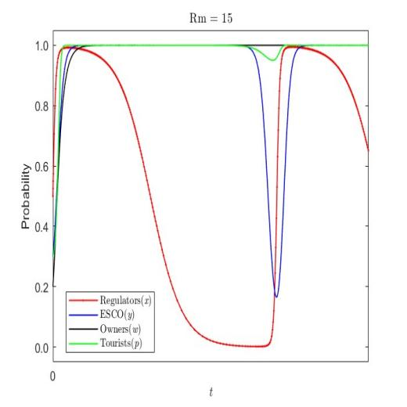
 | (c)
Figure 12. The sensitivity analysis of the evolutionary path of owners with respect to parameter R_{m} is illustrated, comparing the original value of R_{m} (R_{m}=20) with a higher value of R_{m} (R_{m}=30) and a lower value of R_{m} ( R_{m}=10).
Figure 12 shows that owners of historical buildings are increasingly inclined to adopt green retrofitting as the costs associated with non-green retrofitting rise. Initially, at lower cost levels, owners demonstrate reluctance toward green retrofitting. However, under strict government supervision, the additional financial penalties associated with avoiding green retrofitting act as a strong incentive, ultimately increasing the likelihood that owners will choose green retrofitting to reduce losses and protect their property.
To explore the impact of tourists’ benefits on the strategic evolution within the system, we conducted a simulation study by varying the parameter T_{p}, representing tourists’ benefits, across three levels: 5, 15, and 50. This analysis allowed us to assess the system’s sensitivity to changes in tourists’ incentives. The results shown in Figure 13, illustrate the evolution of strategies under different level of benefits, proving insights into the complex relationships between tourists’ preferences and overall strategic choices.

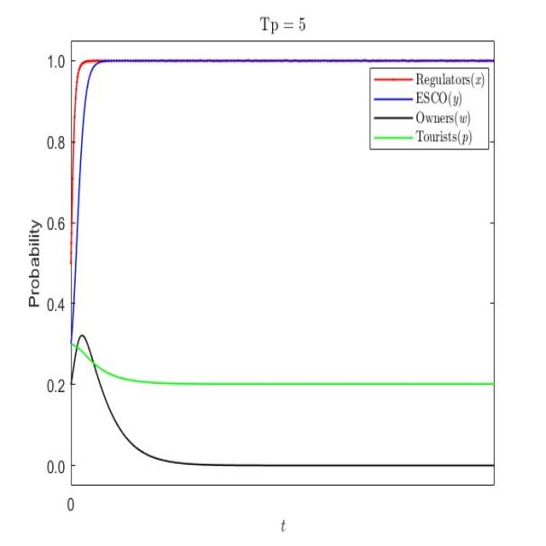 |  | 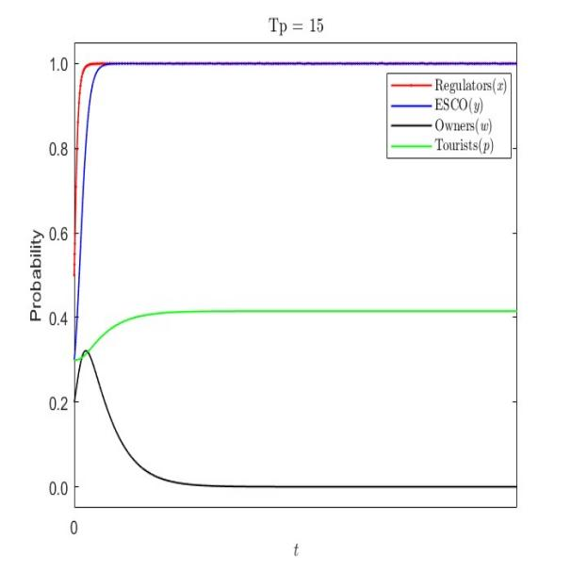
(a) |  | (b)
 | 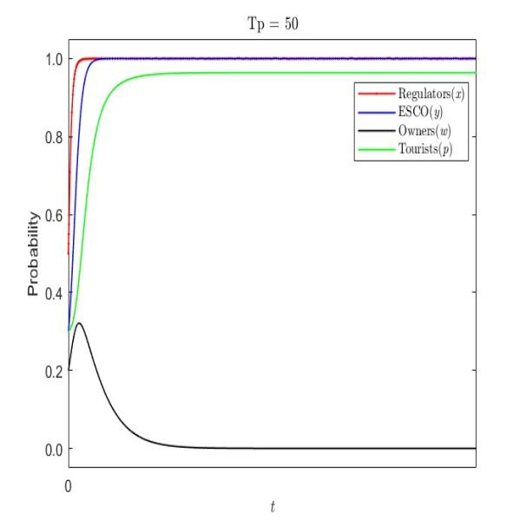
 | (c)
Figure 13. The sensitivity analysis of evolutionary path of tourists with respect to parameter T_{p}. Is presented, comparing the original value of T_{p} (T_{p}=15) with a higher value of T_{p} (T_{p}=50) and a lower value of T_{p} ( T_{p}=5).
As shown in Figures 13(a) and 13(c), as the additional benefit for tourists increases from 5 to 50, their willingness to pay for green retrofits also rises and eventually stabilizes. This trend reflects the positive reception of green building technologies when applied to historical buildings.

