**Kickstarter campaigns**

**Conclusions**

Upon analyzing 30% of approximately 300,000 Kickstarter campaign projects that made through the funding process with a positive outcome, the following conclusions can be made:

1. Based on the comparison of outcomes by category as shown in the Figure below, Kickstarter projects have a higher probability to succeed. Out of 4114 Kickstarter campaigns: more than 53% succeeded, 37% failed, while cancellations were approximately 8.5%. Specifically, theater, music, and film & videos were the most popular categories that attracted more funding and had greater amount of successful projects. For example: the theater category had 839 successful, 493 failed and only 37 cancelled projects. Conversely games, food, publishing and photography were the least preferred categories with higher failure rates, while journalism had no traction. Notably the failure rate for food projects was 70% and about 30% of technology projects were cancelled. This analysis is provides valuable information on preferred and likely to be funded projects. Similarly, backers can also factor in these results when deciding on future participation.

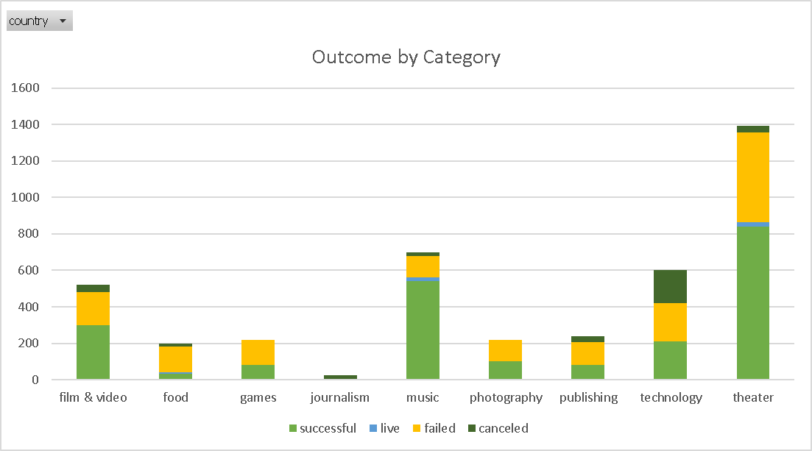

2. A focus on subcategories as depicted in the graph below provides more detailed information on performance. For instance, although theater was the highest funded and successful category, success for subcategory: plays account for about 83%. On the other hand subcategory: musical which accounts for 10% of the funded projects had a 42% failure rate plus 14% cancelled projects. For music category, several subcategories were 100% successful including rock, pop, metal and electronic music; jazz and faith subcategories failed, and only world music was cancelled. Similarly, the food category underperformed, but the small batch category was 85% successful with 15% live projects. Even though the interest may be to focus on highly backed and historically successful projects and be logically inclined to cut down failed, zooming into subcategories provides more detailed information about specifics including those of successful but small sized subcategories (with successful or unsuccessful categories) that exhibit potential to grow, and vice versa.

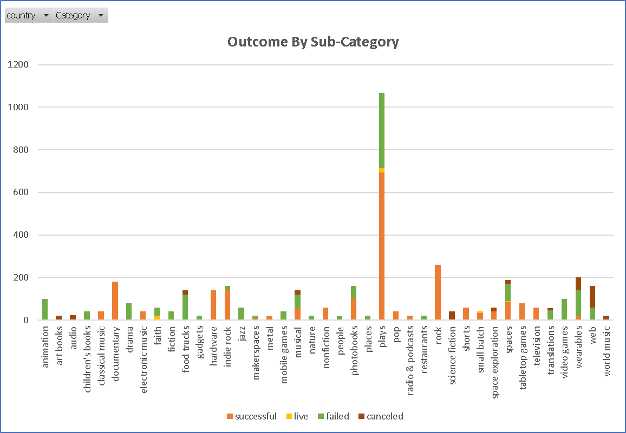

3. Based on the graph below project campaigns appear to be more successful towards the month of May up to June. December month appears to be the worst month to launch a campaign project, it is the only month where the success/failed lines intersect and the failed count surpasses successful one. A deduction can also be made that most activities slow down towards the end of the year and often pick up slowly in the New Year, therefore launching campaigns around May to June may lead to the reduction of failed campaigns. However, in order to make well-informed decision, there is a need for an in-depth analysis on various aspects such as the type of projects, funding/backers, success rate and peak times to establish whether there are any forms correlations and ways to capitalize on data.

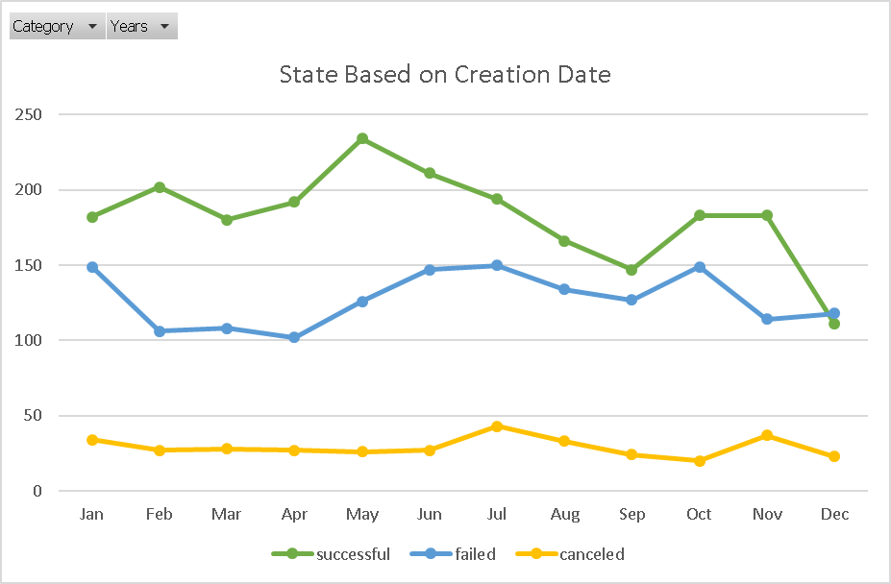

**Limitations of this Dataset**

The main limitation is dataset (sample) is not large enough. Some results: success of fail may seem to be statistically insignificant due to the sample size. A much larger dataset on all categories and subcategories can improve the statistics and the decision to source in funding or back a given project.

Data on whether all these projects survived beyond their deadlines can enhance the decision making process.

**Other Possible Tables and/or Graphs**

There are several graphs that can be generated including:

1. A graph that shows projects by country and the amount of funding. Even though about 80% of this projects are in the US, the comparison could shed light on the difference of similarities with regards to the choice of projects and success.

Further, a success graph by states can provide more information about the type, location, consumer patterns and so forth

2. A scatter graph (line) on goal versus pledged funding for all successful campaigns can provide statistics on donations, and whether there is a close relationship between the goal and what was pledged. This can also help in identifying outliers and evaluate the associated impact.

3. A bar graph to evaluate the projects by duration (date created conversion and date ended conversion) to establish whether there is a correlation between successful and unsuccessful projects, and the length of the project.