**13. Design PDA using simulator to accept the input string aabb.**

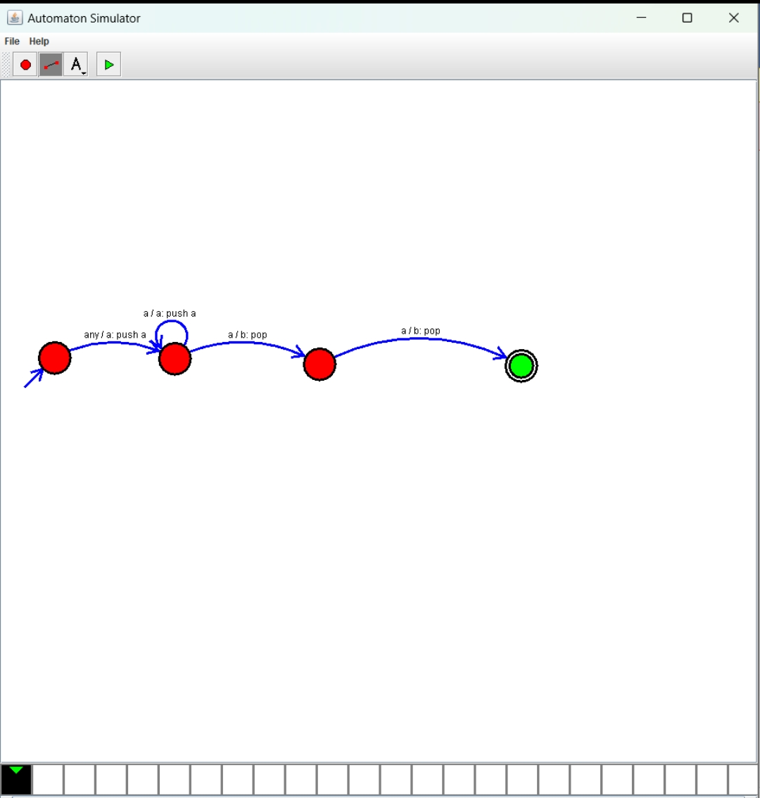

**Result: Hence, we Design PDA using simulator to accept the input string aabb.**