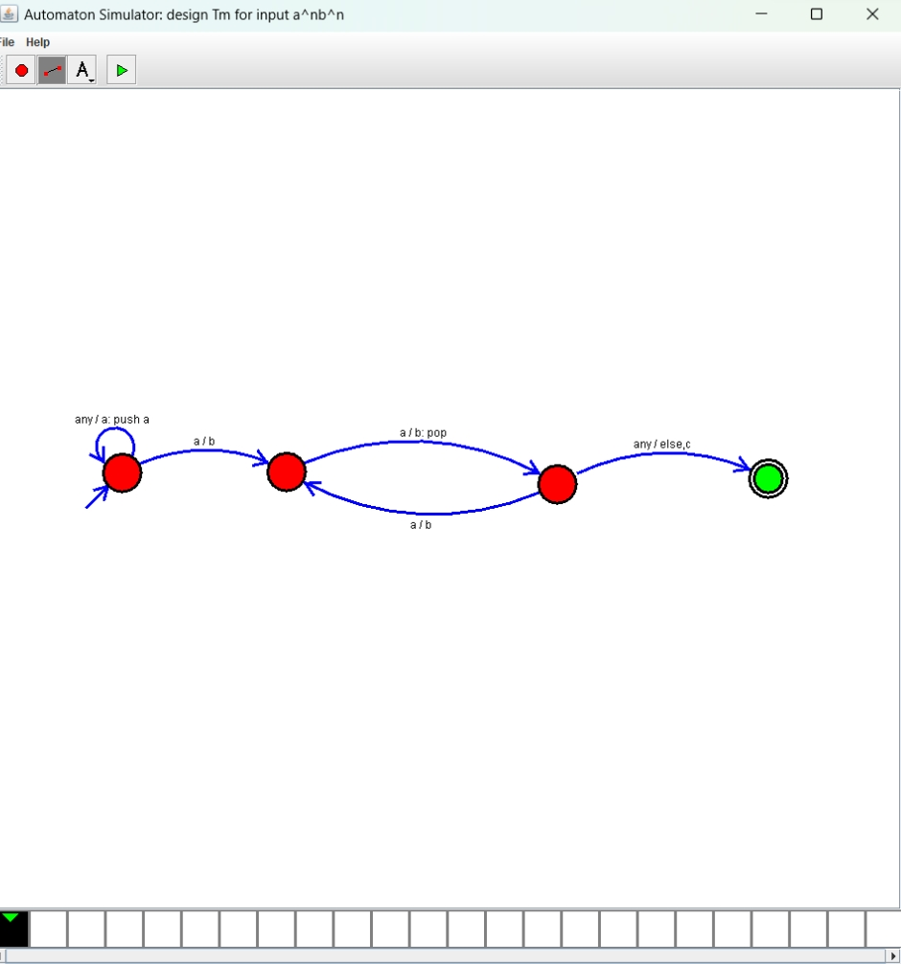**14. Design PDA using simulator to accept the input string anb2n.**

**Result : Hence, we Design PDA using simulator to accept the input string anb2n**