**15. Design TM using simulator to accept the input string anbn.**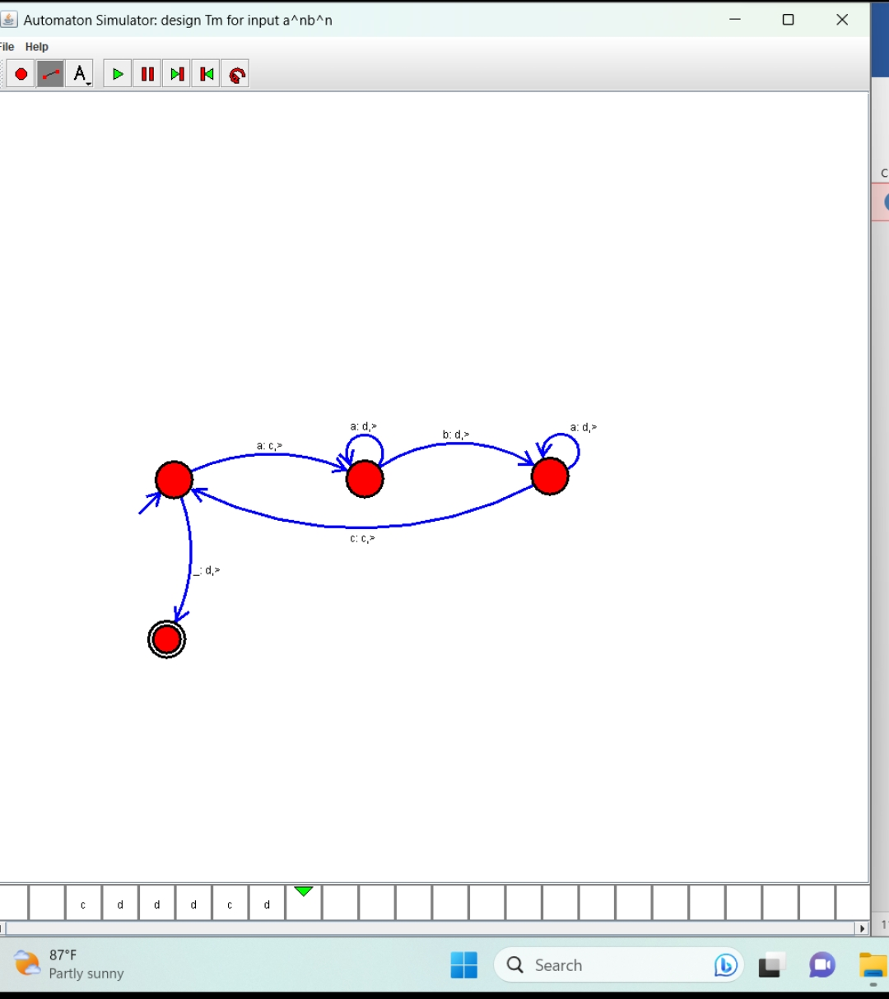

**Result: Hence, we Design TM using simulator to accept the input string anbn**