**17. Design TM using simulator to accept the input string Palindrome ababa**

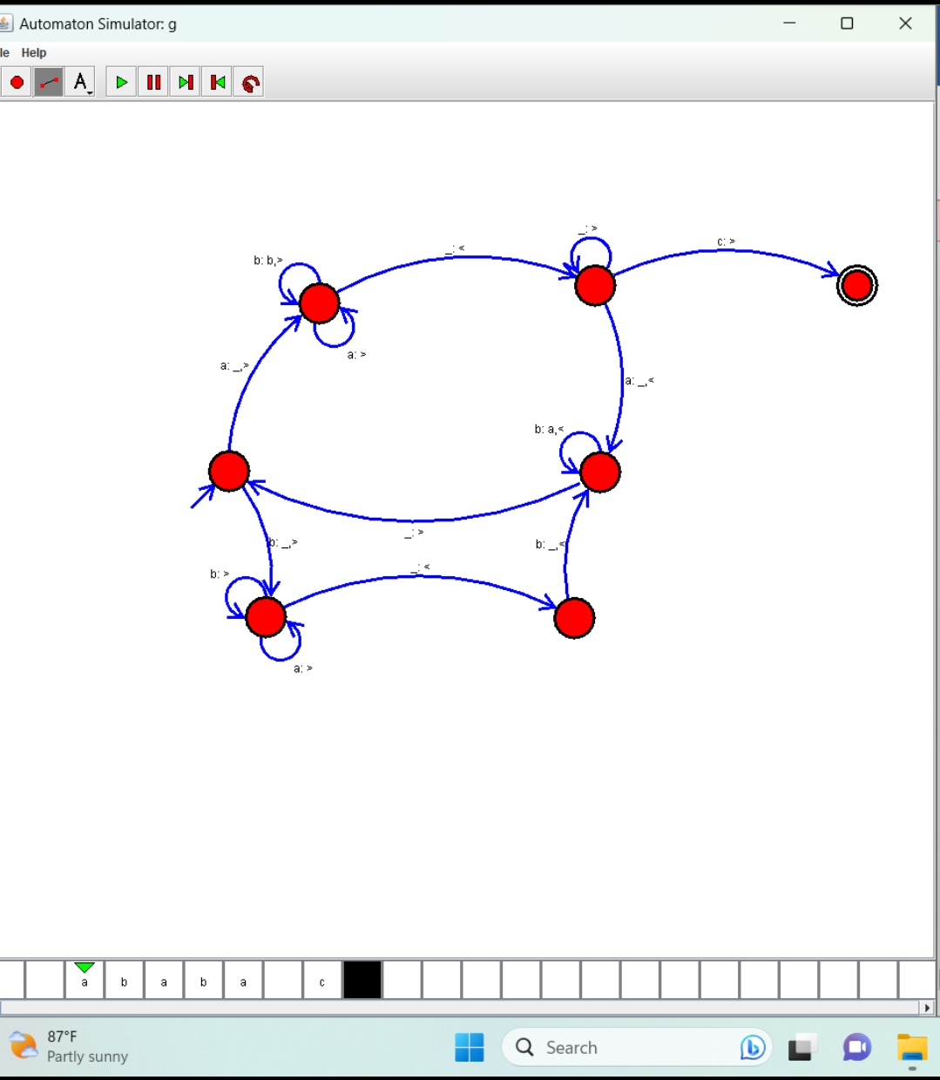

**Result : Hence, we Design TM using simulator to accept the input string Palindrome ababa.**