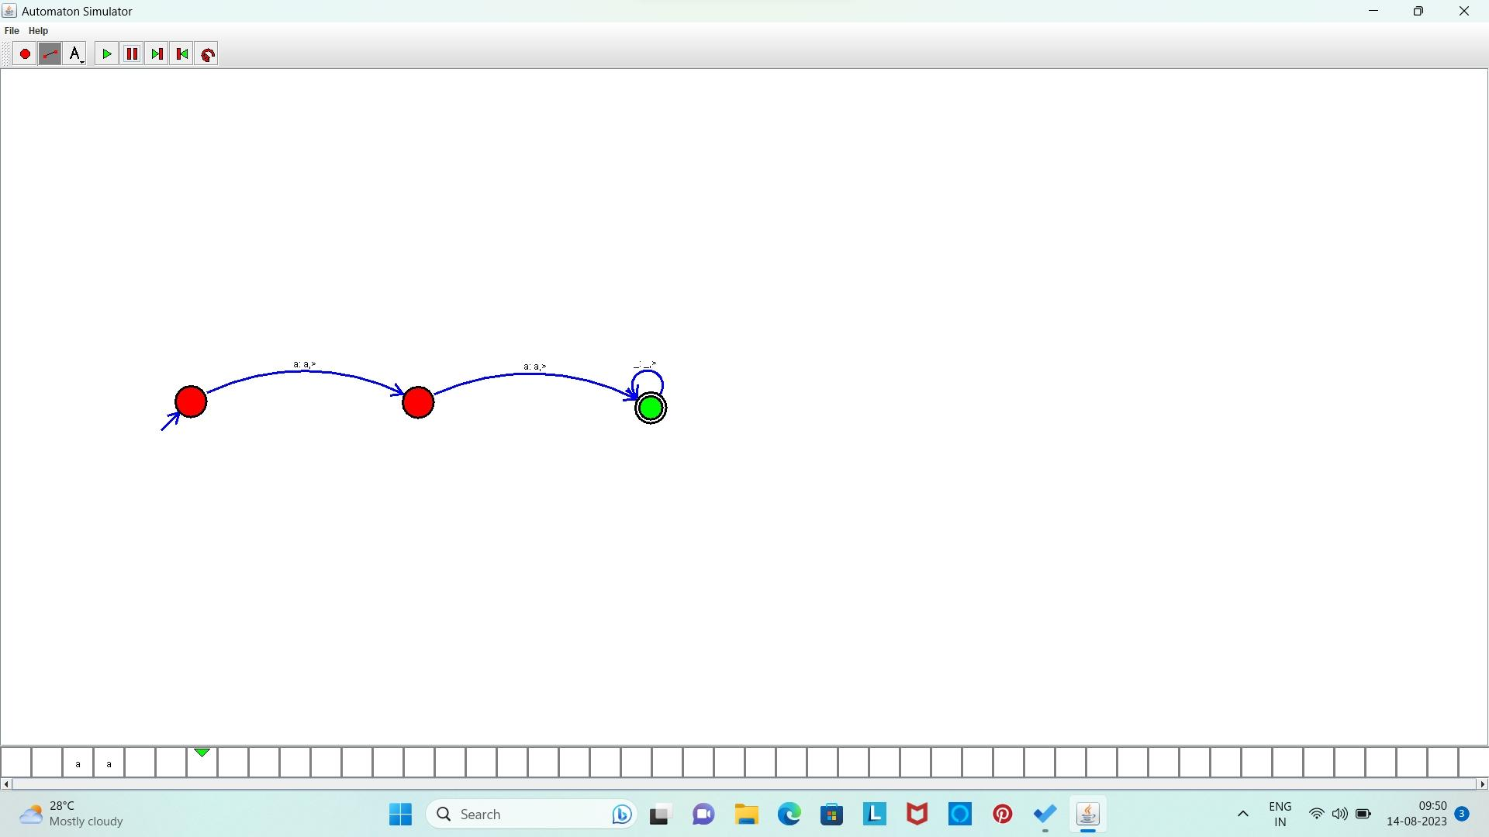18. Design TM using simulator to accept the input string ww

**Result:** Hence, we designed TM using simulator to accept the input string ww