19. Design TM using simulator to perform addition of ‘aa’ and ‘aaa’

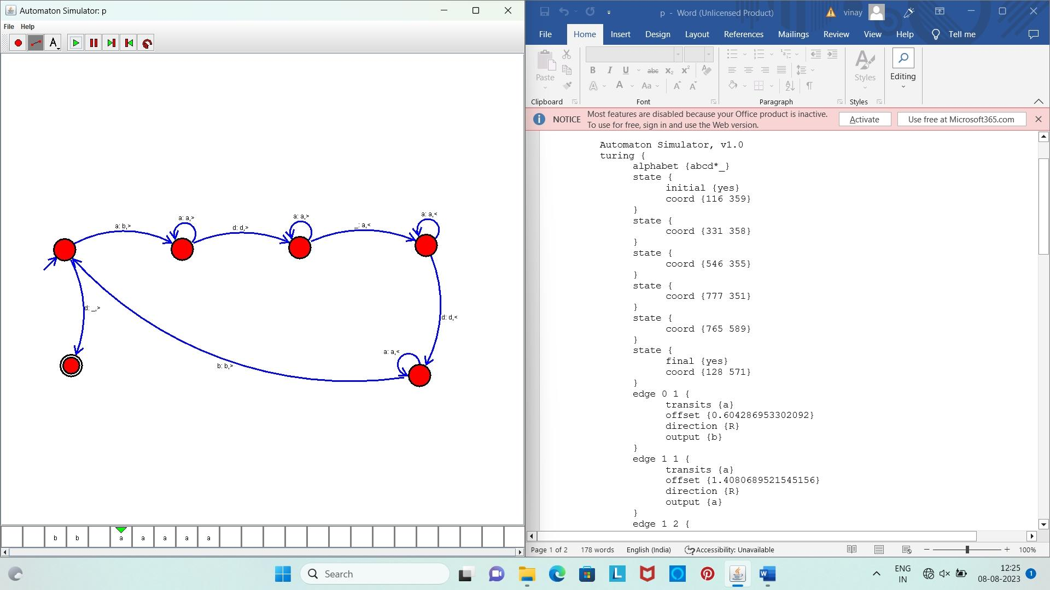

**Result:** Hence, we designed TM using simulator to perform addition of ‘aa’ and ‘aaa’