21. Design DFA using simulator 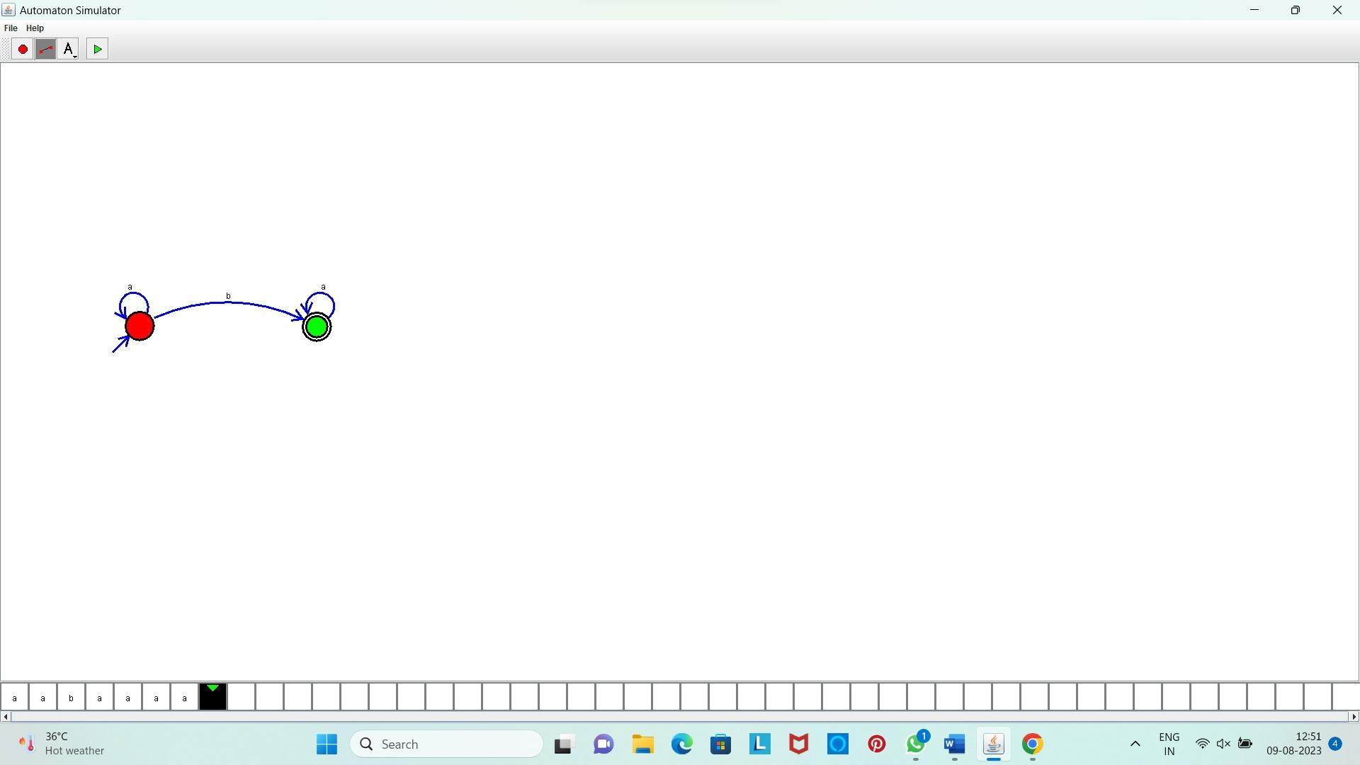to accept even number of a’s.

**Result:** Hence, We designed a DFA using simulator to accept even number of a’s.