22. Design DFA using simulator to accept odd number of a’s

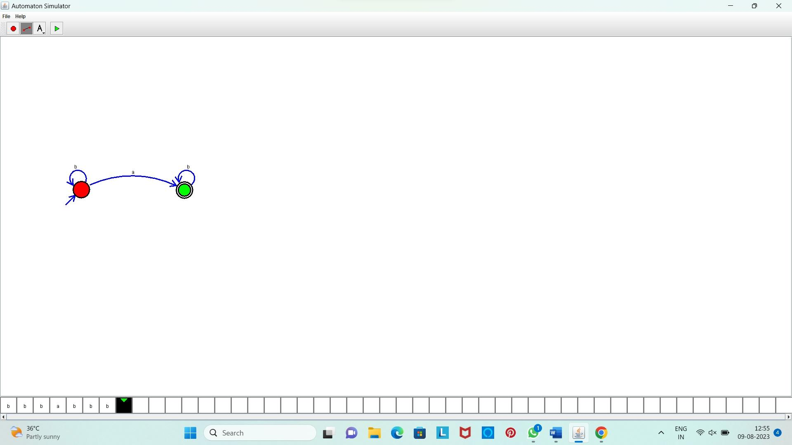

**Result:** Hence, we Designed DFA using simulator to accept odd number of a’s