* Design DFA using simulator to accept the input string “bc” ,”c”,and ”bcaaa”.

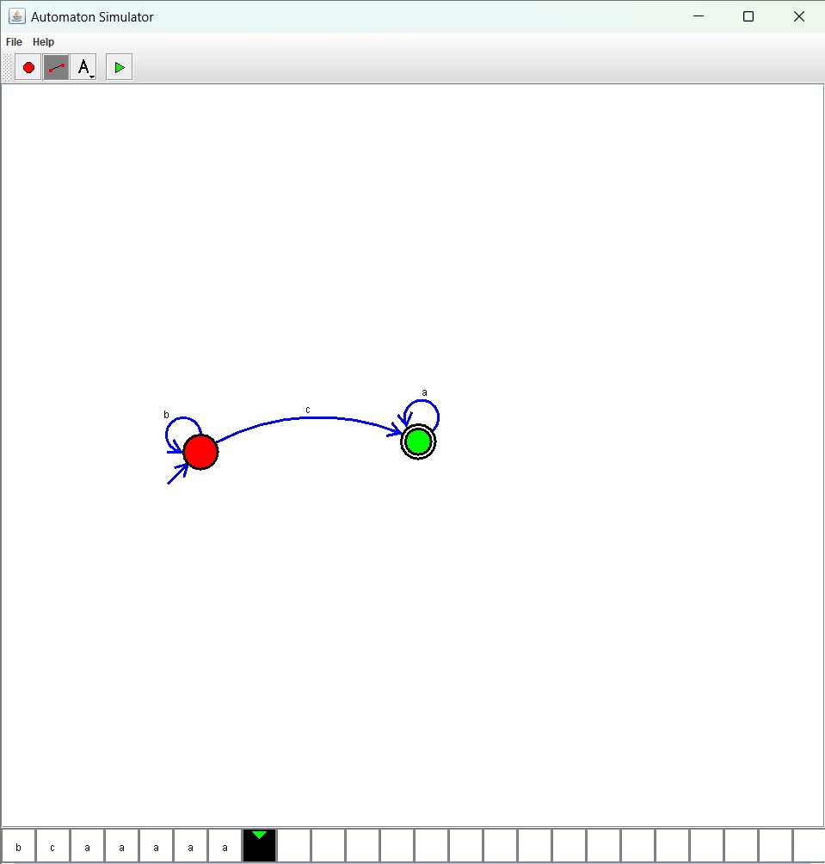

Result:

The given input string is accepted (“b,c”,”c”,”bcaaa”) by using the above DFA simulator