* Design NFA to accept any number of a’s where input={a,b}.

*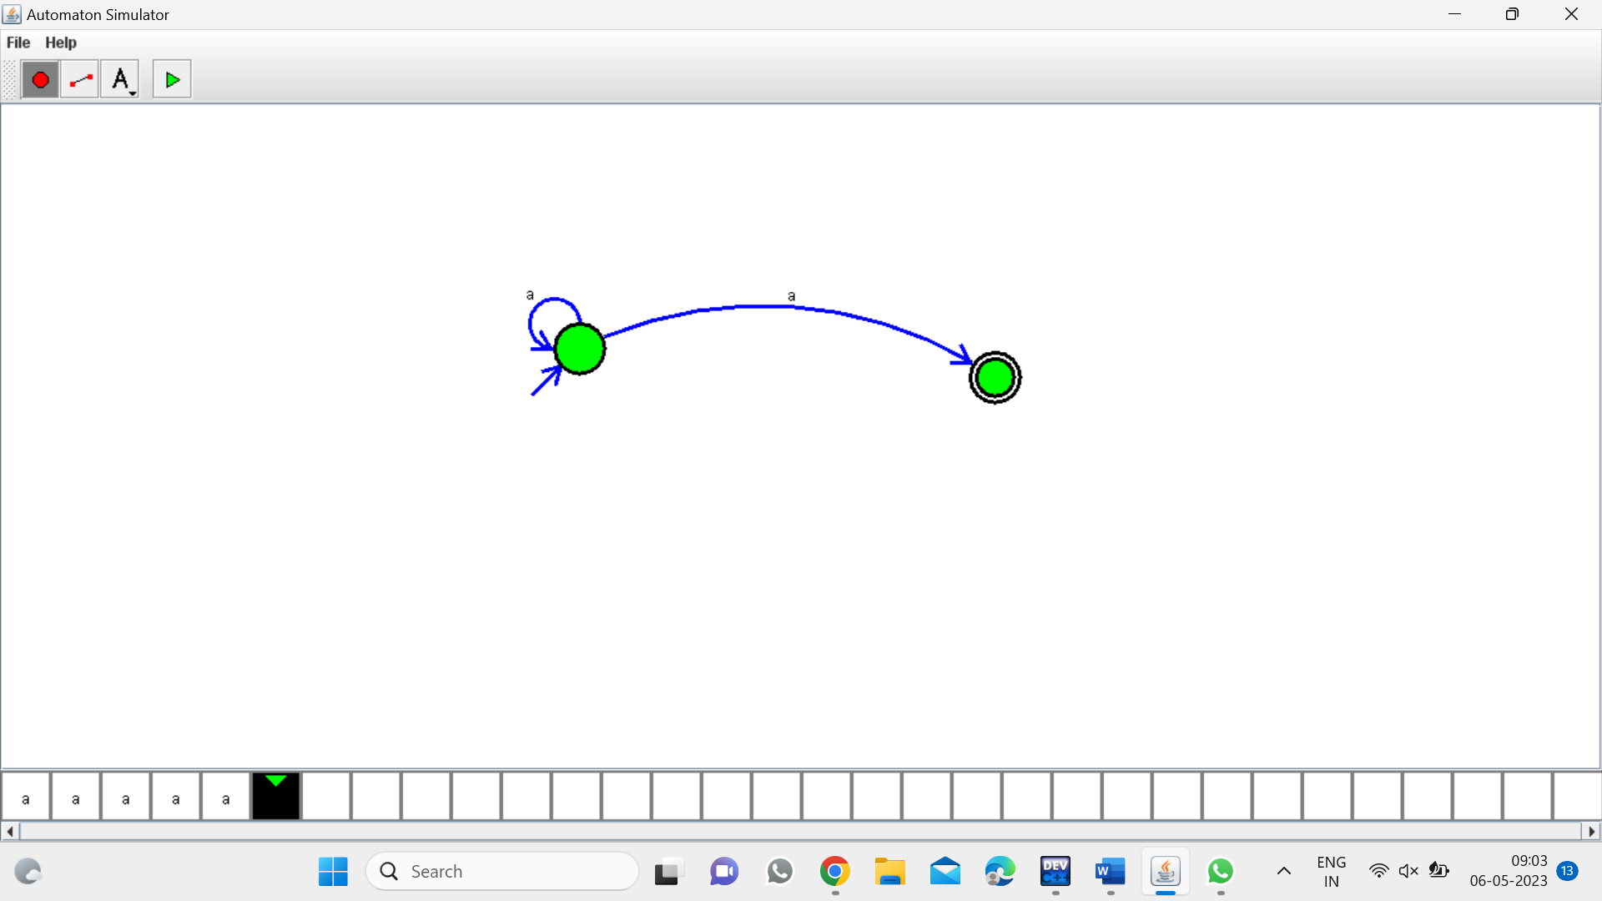*

Result:

The given input string is accepted by the simulator by using the above NFA diagram