* Design DFA using simulator to accept the string having ‘abc’ as substring over the set {a,b,c}

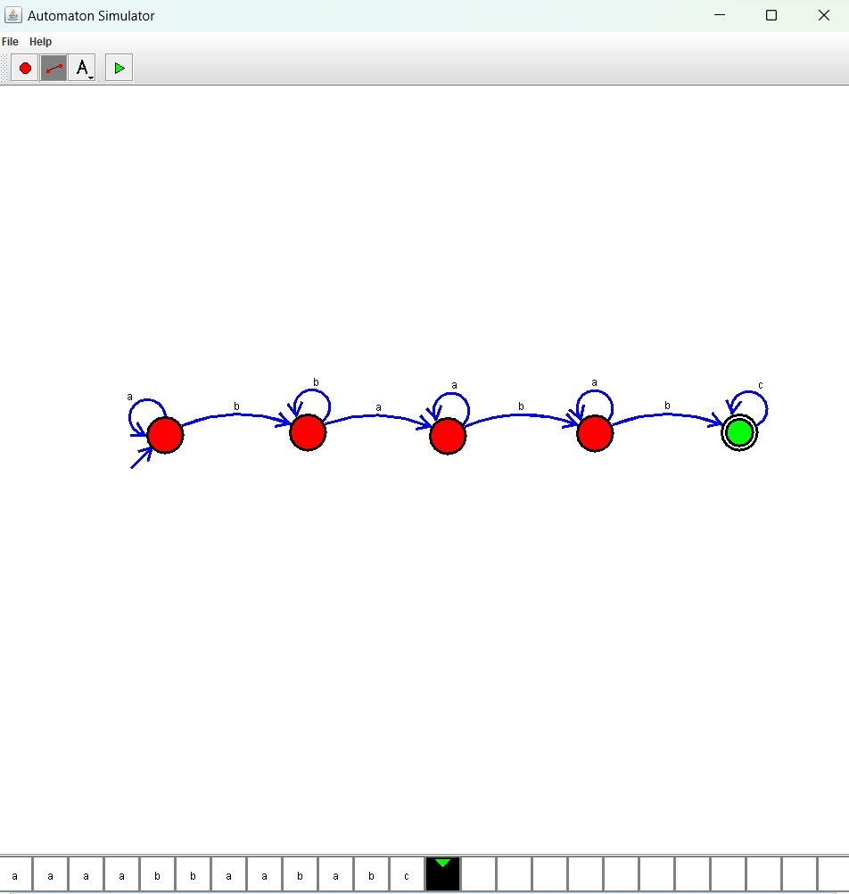

Result :

The given string and substring accepted by the simulator by using the above DFA diagram