* Design NFA using simulator to accept the string the start with a and end with b over set {a,b} and check W= abaab is accepted or not.

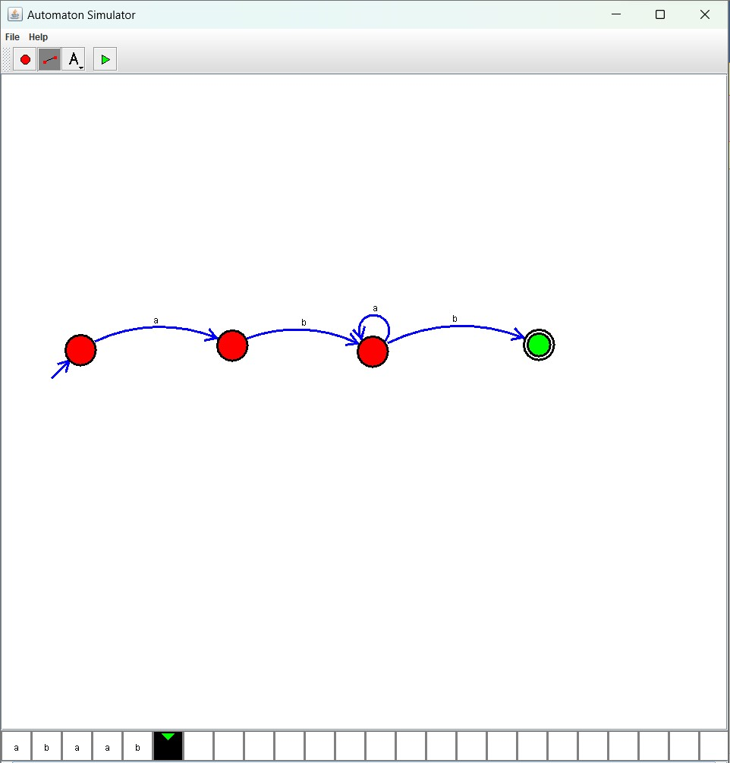

Result :

The simulator is accepted the string that start with a and end with b over set {a,b} and check W= abaab by using the above NFA diagram