* Design NFA using simulator to accept the input string “bbc” ,”c”,and ”bcaaa”.

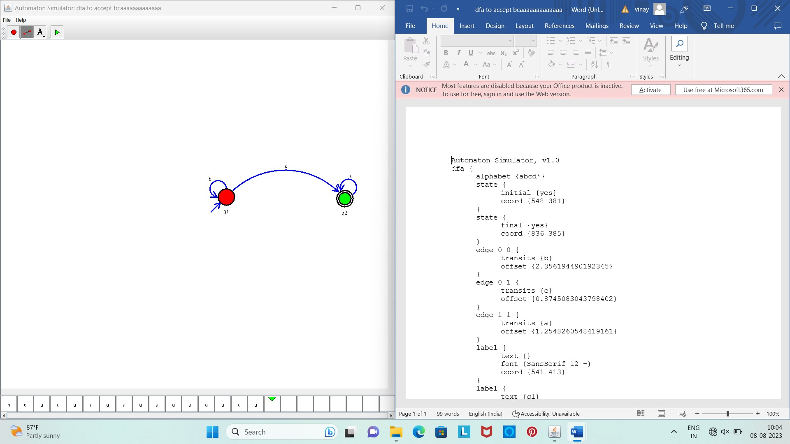

Result :

The simulator is accepted the input string “bbc” ,”c”,and ”bcaaa” by using the above NFA diagram