* Design DFA using simulator to accept the string the end with abc over set {a,b,c)

W= abbaababc

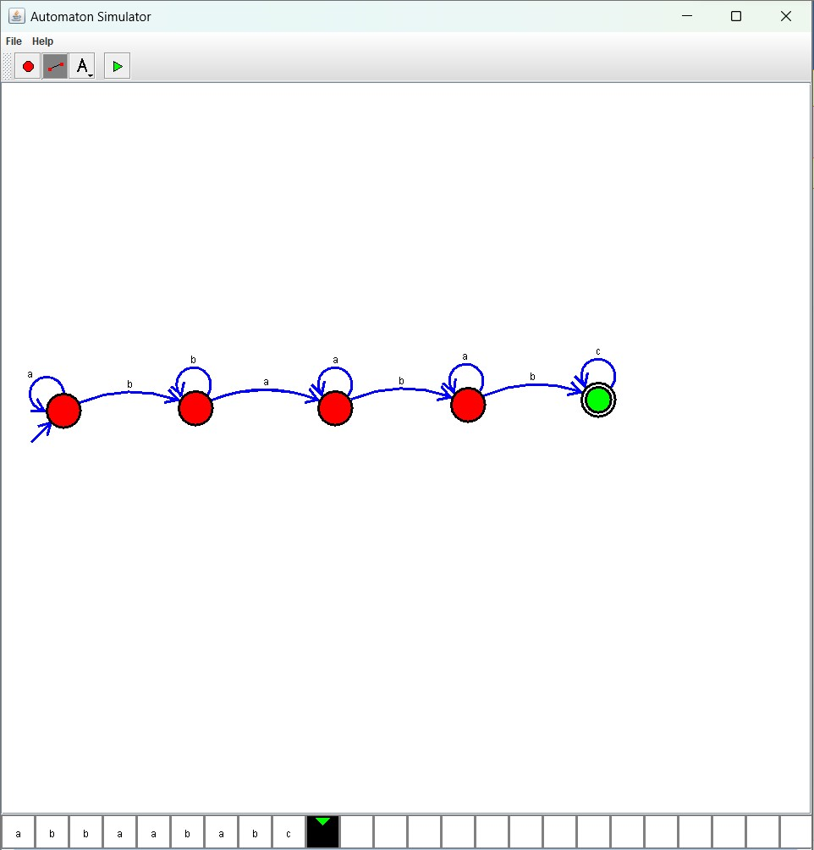

Result :

* The simulator is accepted accept the string the end with abc over set {a,b,c) W=abbaababc by using the above DFA diagram